**Plot_1_Q00.1.svg**

**Answering on behalf of**

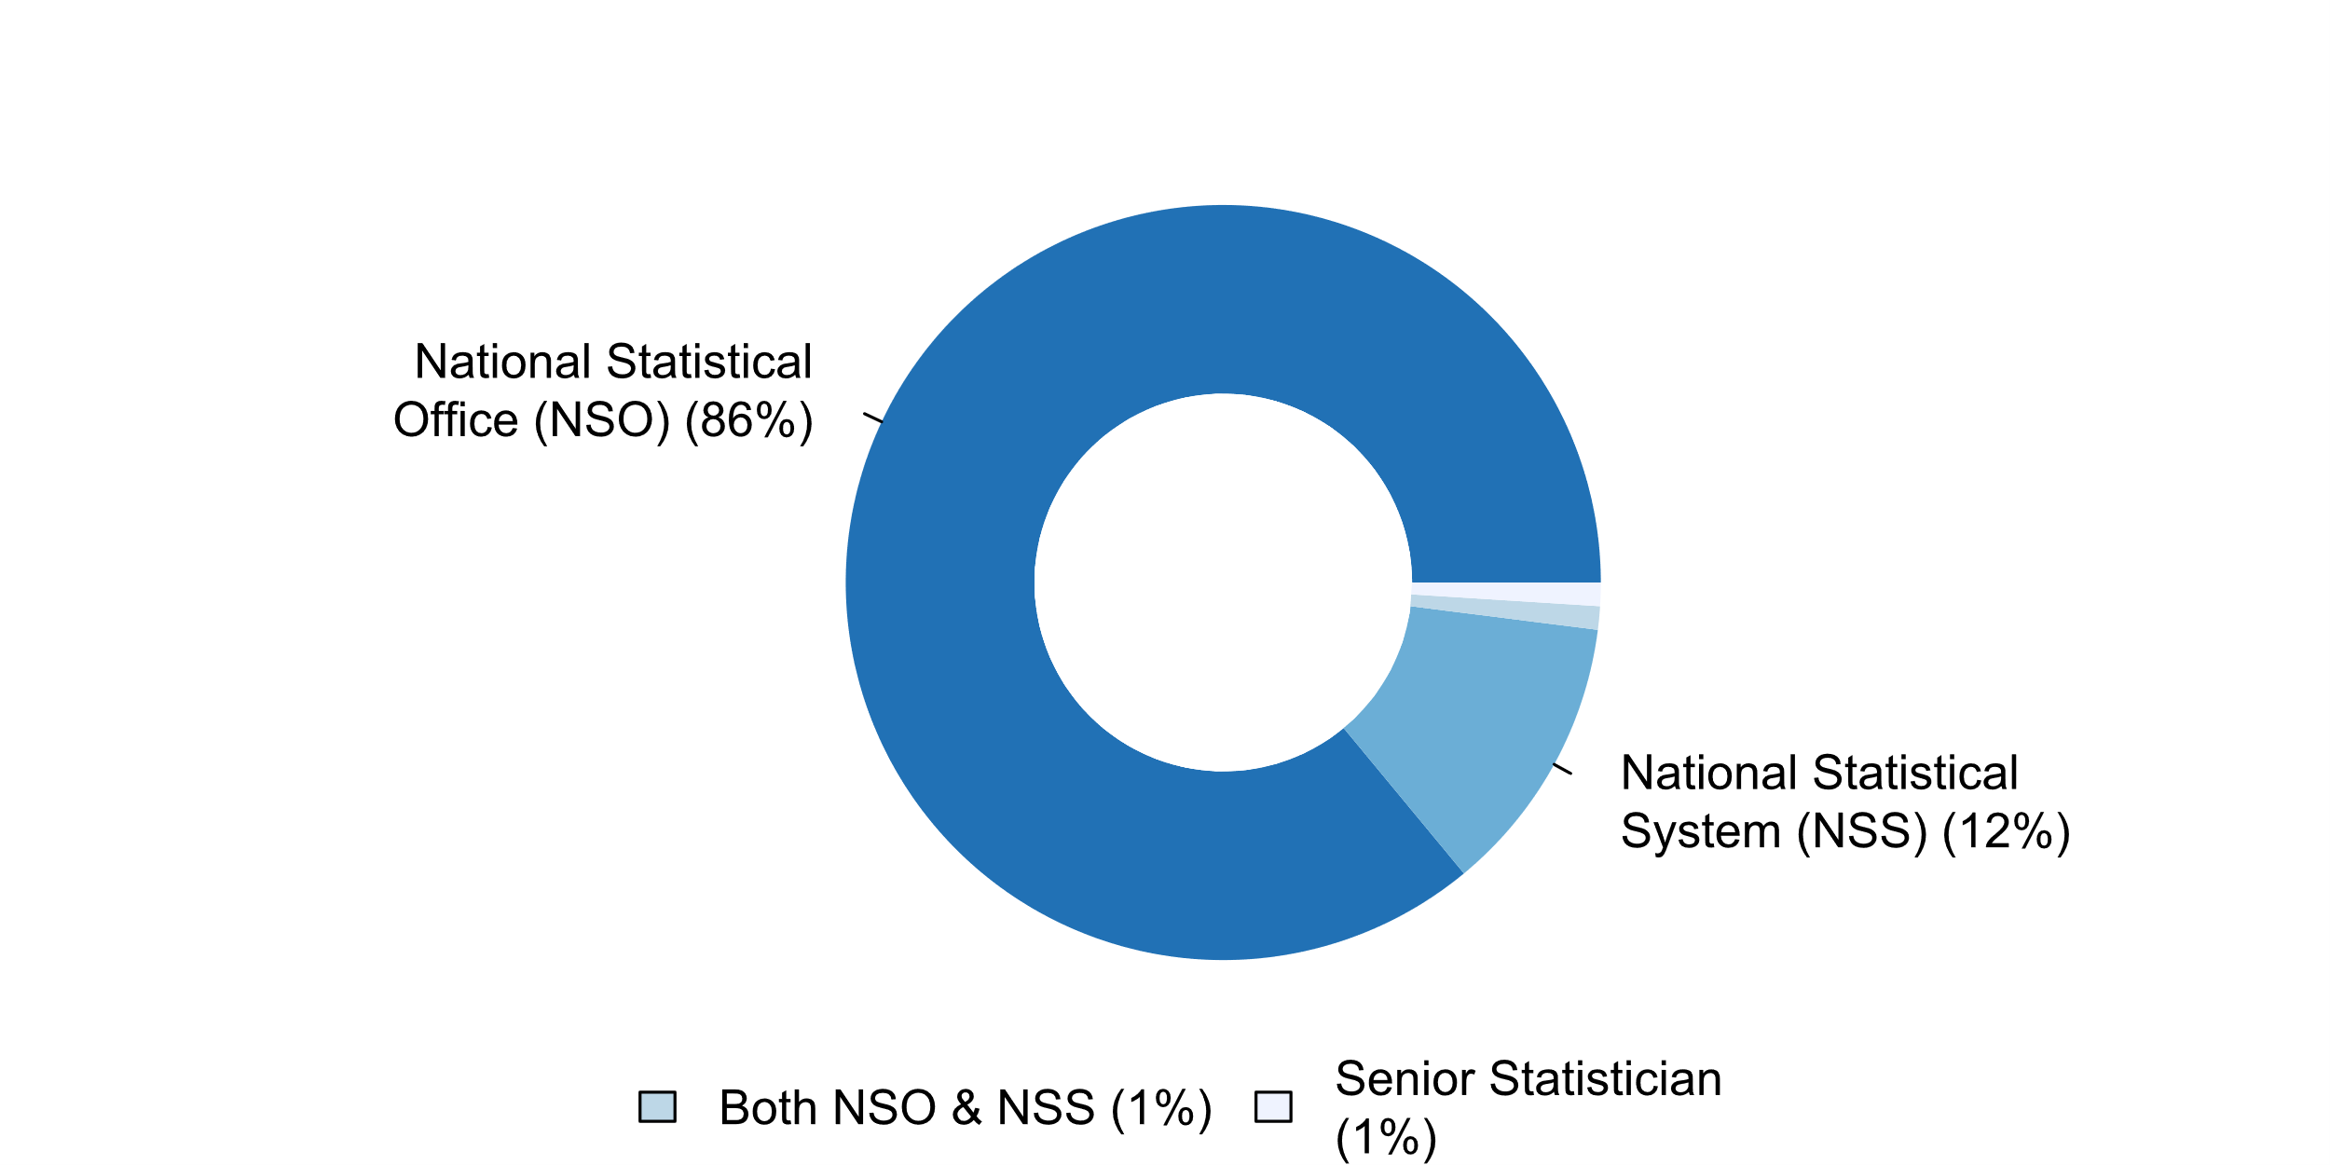

|  |  |  |  |  |  |  |
| --- | --- | --- | --- | --- | --- | --- |
| **Answer** | **Africa** | **Americas** | **Asia** | **Europe** | **Oceania** | **TOTAL** |
| National Statistical Office (NSO) | 15 | 10 | 22 | 30 | 3 | **80** |
| National Statistical System (NSS) | 1 | 2 | 2 | 5 | 1 | **11** |
| Both NSO & NSS |  | 1 |  |  |  | **1** |
| Senior Statistician | 1 |  |  |  |  | **1** |
|  | 17 | 13 | 24 | 35 | 4 | 93 |

|  |  |  |  |  |  |  |
| --- | --- | --- | --- | --- | --- | --- |
| **Answer** | **Africa** | **Americas** | **Asia** | **Europe** | **Oceania** | **TOTAL** |
| National Statistical Office (NSO) | 88 | 77 | 92 | 86 | 75 | **86** |
| National Statistical System (NSS) | 6 | 15 | 8 | 14 | 25 | **12** |
| Both NSO & NSS |  | 8 |  |  |  | **1** |
| Senior Statistician | 6 |  |  |  |  | **1** |
|  | 100 | 100 | 100 | 100 | 100 | 100 |

**Plot_2_Q00.2.svg**

**Awareness of existence UNFPOS**

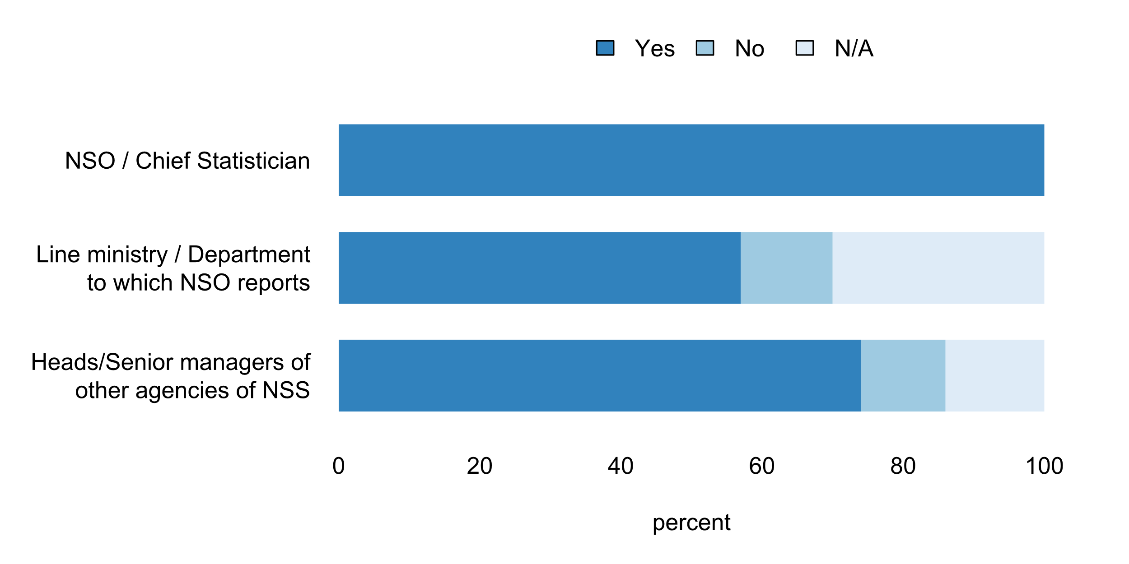

|  |  |  |  |  |  |  |  |
| --- | --- | --- | --- | --- | --- | --- | --- |
|  | **Answer** | **Africa** | **Americas** | **Asia** | **Europe** | **Oceania** | **TOTAL** |
| NSO / Chief Statistician | Yes | 17 | 13 | 24 | 35 | 4 | **93** |
| Heads/Senior managers of other agencies of NSS | Yes | 13 | 7 | 19 | 27 | 3 | **69** |
| N/A | 2 | 2 | 3 | 6 |  | **13** |
| No | 2 | 4 | 2 | 2 | 1 | **11** |
| Line ministry / Department to which NSO reports | Yes | 12 | 6 | 18 | 15 | 2 | **53** |
| N/A | 3 | 4 | 6 | 13 | 2 | **28** |
| No | 2 | 3 |  | 7 |  | **12** |

|  |  |  |  |  |  |  |  |
| --- | --- | --- | --- | --- | --- | --- | --- |
|  | **Answer** | **Africa** | **Americas** | **Asia** | **Europe** | **Oceania** | **TOTAL** |
| NSO / Chief Statistician | Yes | 100 | 100 | 100 | 100 | 100 | **100** |
| Heads/Senior managers of other agencies of NSS | Yes | 76 | 54 | 79 | 77 | 75 | **74** |
| N/A | 12 | 15 | 13 | 17 |  | **14** |
| No | 12 | 31 | 8 | 6 | 25 | **12** |
| Line ministry / Department to which NSO reports | Yes | 71 | 46 | 75 | 43 | 50 | **57** |
| N/A | 18 | 31 | 25 | 37 | 50 | **30** |
| No | 12 | 23 |  | 20 |  | **13** |

**Plot_3_Q00.3.svg**

**Extent to which UNFPOS are integrated into the NSS institutional framework**

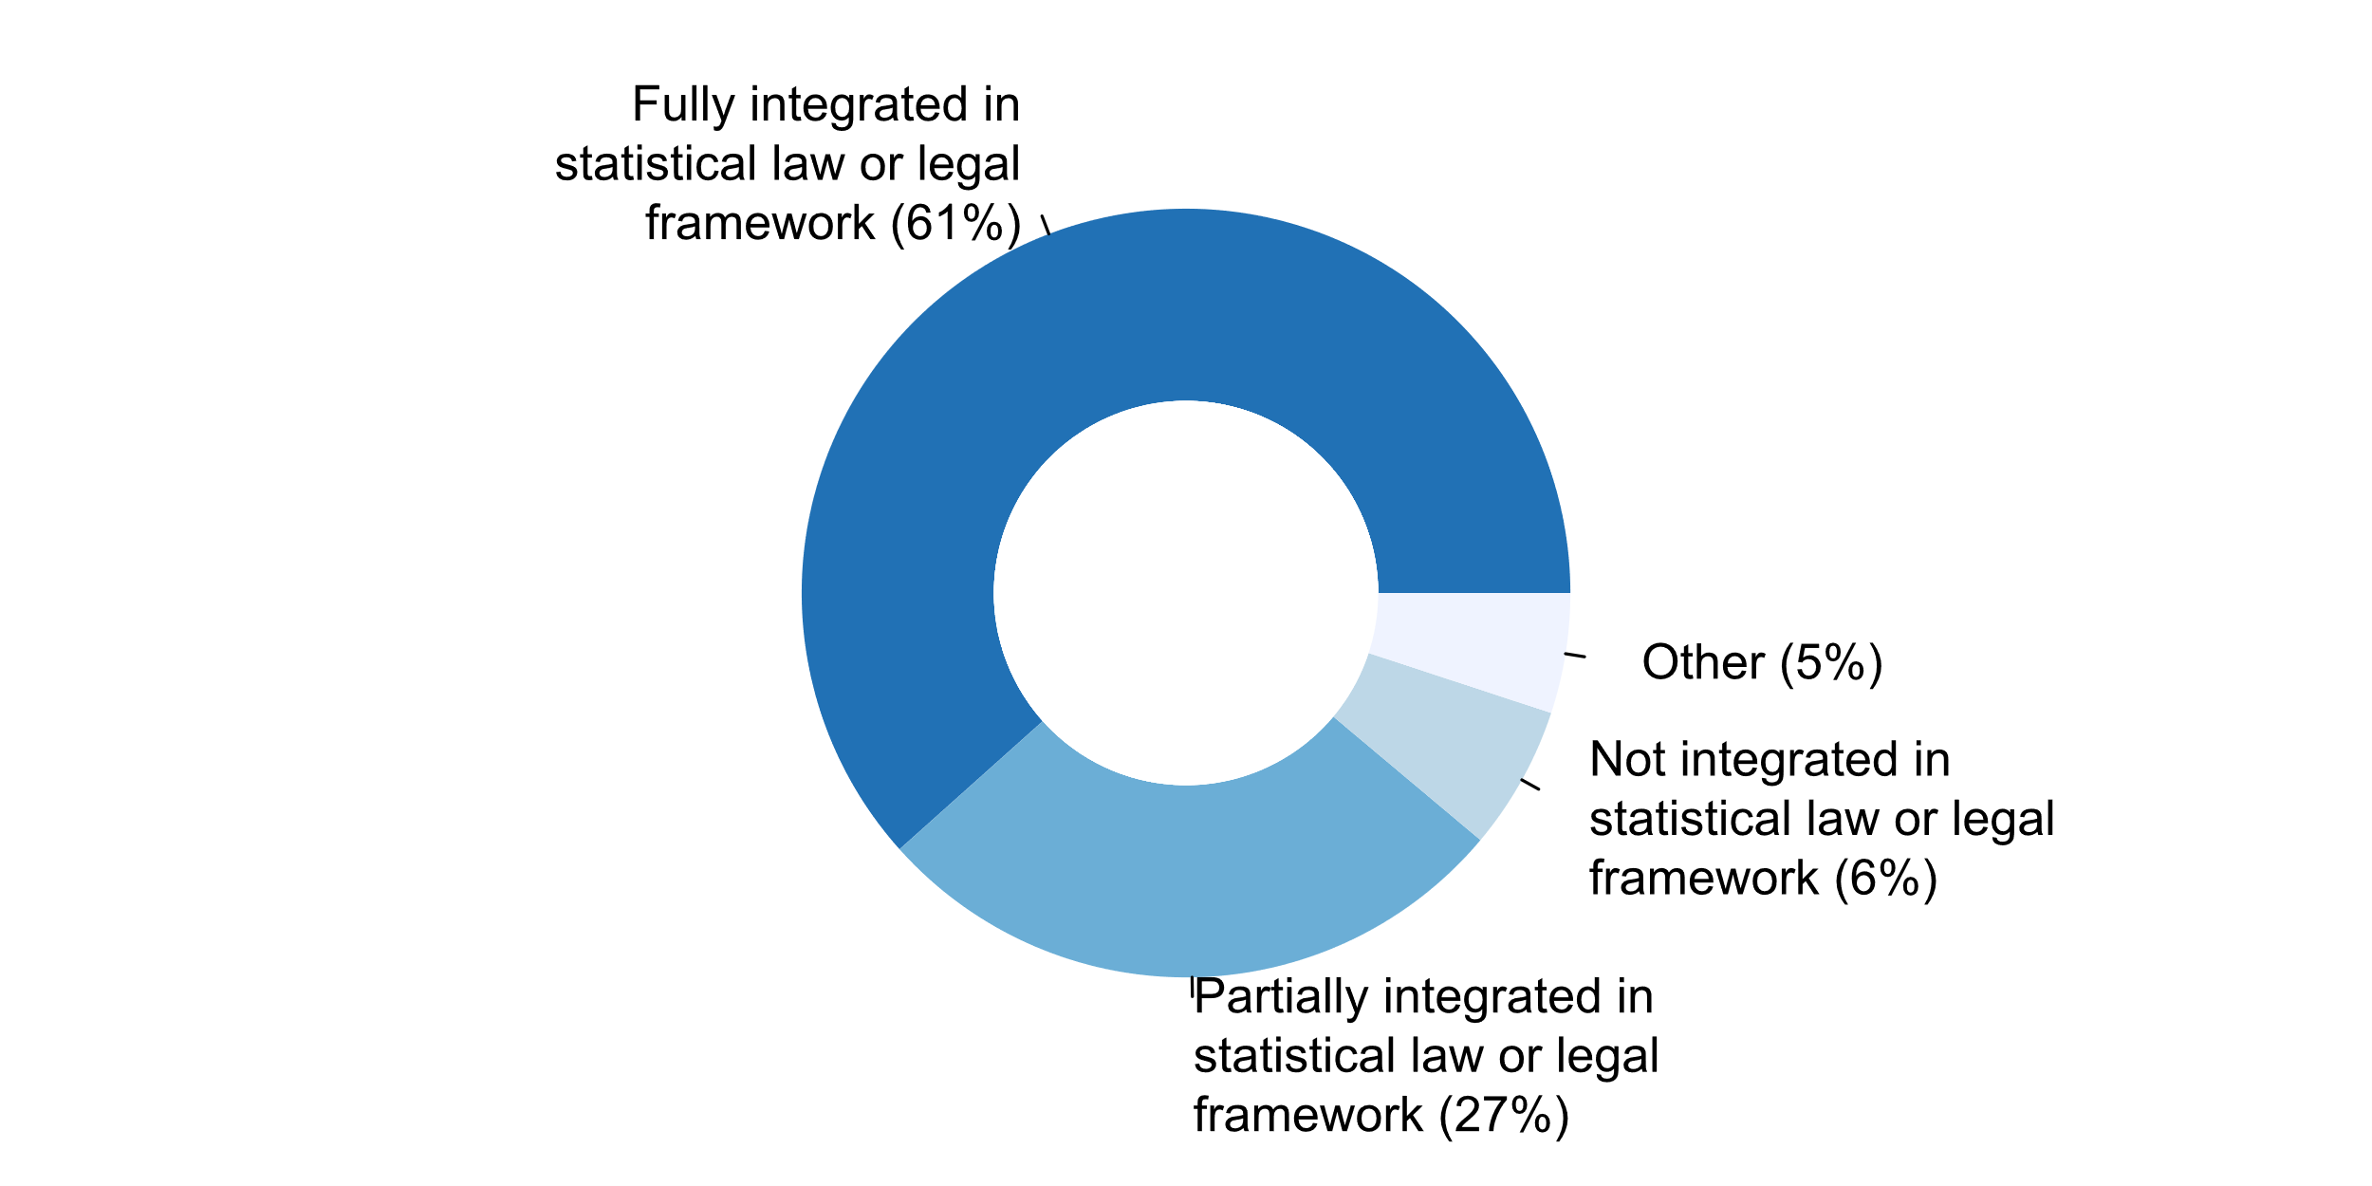

|  |  |  |  |  |  |  |
| --- | --- | --- | --- | --- | --- | --- |
| **Answer** | **Africa** | **Americas** | **Asia** | **Europe** | **Oceania** | **TOTAL** |
| Fully integrated in statistical law or legal framework | 14 | 4 | 15 | 22 | 2 | **57** |
| Partially integrated in statistical law or legal framework | 3 | 7 | 8 | 5 | 2 | **25** |
| Not integrated in statistical law or legal framework |  | 1 |  | 5 |  | **6** |
| Other |  | 1 | 1 | 3 |  | **5** |

|  |  |  |  |  |  |  |
| --- | --- | --- | --- | --- | --- | --- |
| **Answer** | **Africa** | **Americas** | **Asia** | **Europe** | **Oceania** | **TOTAL** |
| Fully integrated in statistical law or legal framework | 82 | 31 | 63 | 63 | 50 | **61** |
| Partially integrated in statistical law or legal framework | 18 | 54 | 33 | 14 | 50 | **27** |
| Not integrated in statistical law or legal framework |  | 8 |  | 14 |  | **6** |
| Other |  | 8 | 4 | 9 |  | **5** |

* Statistical law makes reference to European Statistics Code of Practice
* There is no formal NSS or institutional framework
* There is no statistical Law of legal framework
* UNFPOS adherence, though, not explicitly written in legal framework
* We follow European Statistics Code of Practice

**Plot_4_Q00.4.svg**

**How UNFPOS are communicated to raise awareness at the national level**

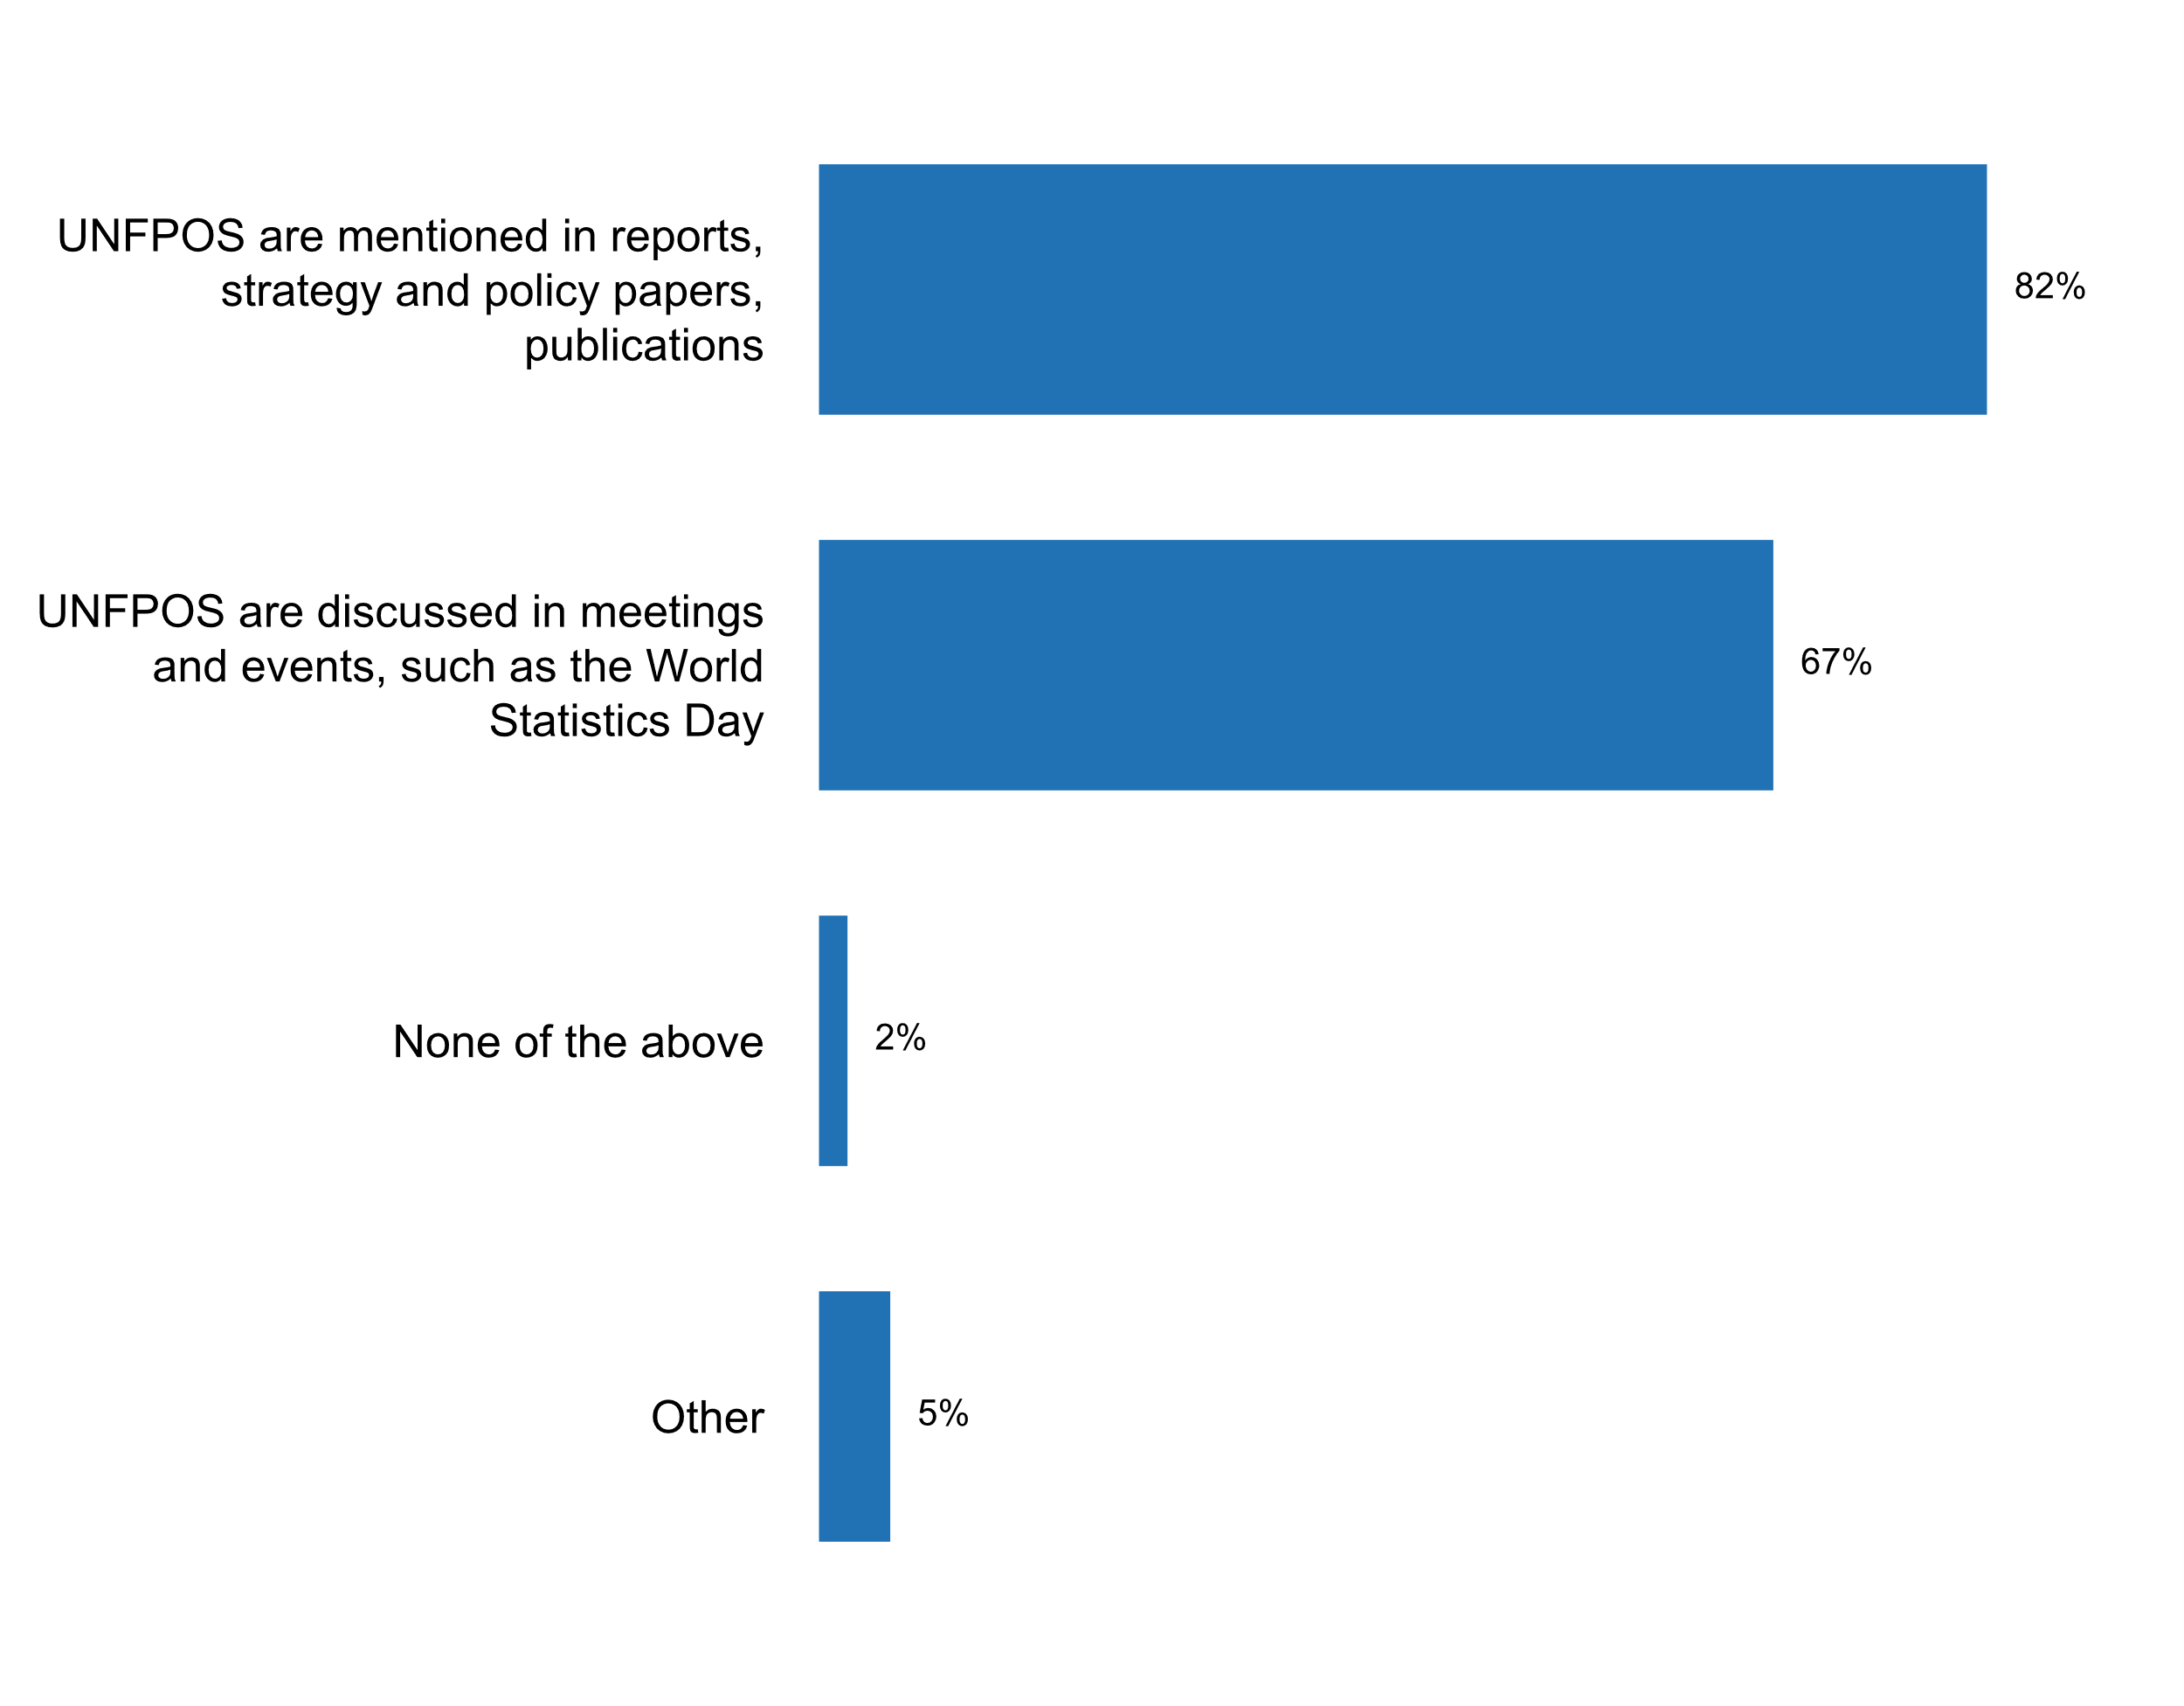

|  |  |  |  |  |  |  |
| --- | --- | --- | --- | --- | --- | --- |
| **Answer** | **Africa** | **Americas** | **Asia** | **Europe** | **Oceania** | **TOTAL** |
| UNFPOS are mentioned in reports, strategy and policy papers, publications | 15 | 11 | 18 | 28 | 4 | **76** |
| UNFPOS are discussed in meetings and events, such as the World Statistics Day | 12 | 12 | 19 | 16 | 3 | **62** |
| None of the above |  |  |  | 2 |  | **2** |
| Other | 1 | 1 |  | 3 |  | **5** |

|  |  |  |  |  |  |  |
| --- | --- | --- | --- | --- | --- | --- |
| **Answer** | **Africa** | **Americas** | **Asia** | **Europe** | **Oceania** | **TOTAL** |
| UNFPOS are mentioned in reports, strategy and policy papers, publications | 88 | 85 | 75 | 80 | 100 | **82** |
| UNFPOS are discussed in meetings and events, such as the World Statistics Day | 71 | 92 | 79 | 46 | 75 | **67** |
| None of the above |  |  |  | 6 |  | **2** |
| Other | 6 | 8 |  | 9 |  | **5** |

* provisions on UNOFPS are made in the law on official statistics, developed based on GLOS (http://www.statistica.md/public/files/despre/legi_hotariri/Law_on_official_statistics__2017.pdf, article 5);- mentioned in annual plans and NSDS (http://www.statis
* Alot of the concepts follow our "best practices" applications, which is agency-specific.
* During presentation and discussions reference is always made to the UNFPoS
* European Code of practice is very similar to UNFPOS and is a key issue in all policy within the organization.
* In addition information is provided during official events such as the national conferences of statistics organised by Istat every two years or during training sessions devoted to high level officials of the statistical offices of bodies belonging to the NSS.
* Integral part of the principles of the National Statistical System
* Law on Official Statistics at https://www.armstat.am/file/doc/99509428.pdfUNFPOS are posted on the website under the Heading Key Documents at https://www.armstat.am/en/?nid=69 (in English and Armenian) The current three year statistical program that is a Law and posted on the website at https://www.armstat.am/file/doc/99498783.pdfNew five year Statistical Program for 2019-2023 that is posted on the website at https://www.armstat.am/file/draft3/2019-2023-hngamya.pdf (Armenian version, we are translating it into English).INFORMATION DISSEMINATION AND COMMUNICATION POLICY paper at https://www.armstat.am/file/doc/99503388.pdf.Quality Policy paper, where the quality system is based on the 15 principles of the European Statistics Code of Practice at https://www.armstat.am/file/doc/99509313.pdf. CATALOGUE of Statistical Publications 2018 at https://www.armstat.am/file/article/catalogue_2018_00.pdf, Statistical Program for 2019-2023 that is a strategic development document (in Armenian, we are translating into English) at https://www.armstat.am/file/draft3/2019-2023-hngamya.pdf. INFORMATION DISSEMINATION AND COMMUNICATION POLICY paper at https://www.armstat.am/file/doc/99503388.pdf. Quality Policy paper were the quality system is based on the 15 principles of the European Statistics Code of Practice at https://www.armstat.am/file/doc/99509313.pdf. CATALOGUE of Statistical Publications for 2018 at https://www.armstat.am/file/article/catalogue_2018_00.pdf.
* Mentioned in the Strategic Plan of the Economics and Statistics Office and presented in the National Statistics Coordination Committee meetings.
* NONE
* National Statistics Committee (NSC) was established in 2012 with the main objective to collaborate with Government departments in the collection, compilation and publication of statistical information, including statistics derived from the activities of those departments. Meetings of the National Statistics Committee (NSC) are conducted frequently to ensure the effectiveness and coordination of the National Statistical System (NSS).
* Other: Communicated as an integral part of the Code of Practice of European statistics, which is a part of reports, papers and publications
* Other: Les UNFPOS sont enseignés à  l'Ecole nationale de statistique et d'analyse économique. Loi nÂ° 2004-21 du 21 juillet 2004 portant organisation des activités statistiques Article 4 : Dans l'exercice de leurs missions de production et de diffusion des données statistiques, les composantes du système statistique national se conforment aux principes fondamentaux de la statistique officielle, notamment le respect du secret statistique ainsi que celui des normes, des méthodes et concepts utilisés au plan international en matière statistique.
* Other: On the official websites of statistical bodies. Below we provide information on how each of the 10 Fundamental Principles is fixed in the Law on State Statistics of the Republic of Belarus http://www.belstat.gov.by/upload-belstat/upload-belstat-pdf/o-belstate/Zakon_ogs.pdf (page number of the Law where the principle is mentioned is indicated) Pages Principle 1: Relevance, impartiality and equal access 3;4;8;15-16 Principle 2: Professional standards and ethics 3;4;12;13;15;16 2;3;4;8;9;11;12;13;14 7;11 Principle 5: Sources of official statistics 2;4 4;14-15;16 1;3;8;11 4;5;11;12;14 Principle 9: Use of international standards 3;8;12;13 4;7
* Other: Published on the website of Statistics Lithuania (https://www.stat.gov.lt/kokybes-vadyba)
* Other: Published on website. Published in Norwegian and English at the webpage https://www.ssb.no/omssb/styringsdokumenter/lover-og-prinsipper/fns-prinsipper-for-offisiell-statistikk
* Other; Mentioned on the website http://www.statistics-suriname.org/index.php/stichting-abs/historie-en-juridisch-kader
* Placed on the website of the NSO. Always a banner at stakeholder meetings. Concepts are built in the communication plan
* Policy paper is presented on NSO webpage:http://bip.stat.gov.pl/dzialalnosc-statystyki-publicznej/jakosc-w-statystyce/rekomendacje-miedzynarodowe/
* Principles of activity of Ukraine's state statistics bodies Policy for disseminating statistical information by the state statistics bodies. SSSU policy in the sphere of cooperation with respondents and suppliers of administrative data Quality policy in the state statistics bodies
* Reference to the UNFPOS is made on ELSTAT's policies (Statistical Confidentiality Policy and Dissemination Policy). Relevant links:http://www.statistics.gr/documents/20181/1609796/ELSTAT_Statistical_Confidentiality_Policy_EN.pdf/c79e5ac8-469c-433d-b4e6-8433319b21d2http://www.statistics.gr/documents/20181/1609796/Dissemination_Policy_of_ELSTAT_en.pdf/8c399d64-9611-4d55-b514-56ea51ac1ecf
* Se realizaron reuniones especà­ficas para dar a conocer los principios.
* Strategic plan directly refers to UNFPOS. UNFPOS can be derived from the European Code of Practice that is referred to within the Regulation on European Statistics.
* THE FPOS ARE RELEASE IN THE NEW LAW STATSITICAL DURING : THE NSS MEETING AND THE COLLECT OF DATA
* The 13th Five Year Plan of statistical Reform and development.
* The Article 160 of Law 1753/ 2015 leads to: (1) legally consolidate the Colombian National Statistical System (NSS) by defining its composition and the statistical operations and confirming DANE's role as coordinator and governing body of the NSS; (2) create a National Advisory Council for Statistics; (3) provide legal means to guarantee DANE's access to administrative sources for the production of official statistics; (4) create the obligation for DANE to formulate a five year National Statistical Plan agreed by all members of the NSS and approved by the future National Advisory Council for Statistics; and (5) ensure the exchange of micro-data for statistical purposes between members of the NSS. On the other hand, in the Law's regulation established in the Article 2.2.3.2.2 of the Decree 1743/2015, Colombia adopts the Fundamental Principles of Official Statistics issued by the Economic and Social Council of the United Nations. Additionally, in all the documents related to statistical policy, the DANE presents the adoption of the Fundamental Principles of Official Statistics issued by the Economic and Social Council of the United Nations, as a reference. This is especially important in documents such as the National Statistical Plan 2017-2022; the Technical Standard for the Quality of the Statistical Process, among others.
* The Estatistical Good Practices Code of Costa Rica, include the UNFPOS.
* The European Code of Practice is communicated within the NSS. Principles of the European statistics Code of Practice are communicated in reports, policy papers, meetings etc.
* The French NSO communicates on the European Statistics Code of practice instead of on UNFPOS.
* The National Strategy of Development of Statistics 2016-2020 Il assure également une meilleure coordination et efficace de l'activité statistique. à€ propos de ce que nous avons défini sur les investissements et les investissements sur les investissements et les investissements sur le système national de la statistique, 2016-2020. The National Strategy of Development of Statistics 2016-2020 le Plan national de développement économique et social (PNDES), les objectifs de développement durable (ODD) et d'autres engagements nationaux, régionaux et internationaux. Stratégie nationale de développement de la statistique 2016-2020 constitue, pour le gouvernement et les partenaires techniques et financiers, le seul cadre d'interventions et d'investissements dans le domaine des statistiques. L'Anstar of the First Generation of National Strategy for the Development of Statistics (SNDS), la nouvelle stratégie nationale de statistiques a été élaborée selon les directives méthodologiques de PARIS21 élaborée en 2004. Elle est le fruit d'une étroite collaboration entre tous les acteurs du système statistique guinéen. for this document of consensuel for Strategic Planning of Development Statistic. Le gouvernement saisit cette occasion pour réaffirmer son attachement aux principes fondamentaux des statistiques officielles proclamées par les Nations Unies et la Charte africaine de la statistique ainsi que les initiatives régionales, sous-régionales, multilatérales et bilatérales. statistique.
* The New NSS law was designed according to the UNFPOS.
* The SIB has and continues to include the UNFPOS in its sensitization and public awareness efforts, especially as it pertains to the agencies that comprise the NSS. The Code of Good Practice in Statistics for Latin America and the Caribbean is disseminated on the SIB's website.
* The Statistician-General has been given the powers by the Statistics Act to be independent and advise the Minister accordingly. There are no interferences by the political heads and/or other stakeholders such as the Board members in the production of the official statistics. This means that the UNFPOS are fully adhered to.
* The Thailand National Statistical Office (TNSO) has instructed and distributed Thai publication of the Fundamental Principles of Official Statistics regularly to other government agencies, stakeholders within the national statistical system and to interested people for developing official statistics according to Fundamental Principles.
* The UN Fundamental Principles of Official Statistics are included in the Code of Ethics of the National Statistical System of Mexico and they are also available for users and producers of information at INEGI's website: http://www.inegi.org.mx/est/contenidos/proyectos/aspectosmetodologicos/principiosfundamentales/default.aspx
* The UNFPOS are integrated into institutional framework and communicated through the EU Code of Practice.
* The UNFPOS are laid down in the Strategy for Development of the National Statistical System, 2013-2017, amended by an extension until 2020 as well as in Guidelines on quality criteria in the NSS of Bulgaria
* The UNFPOS is cited under Rule 3, Article 4, of the "Implementing Rules and Regulations of Republic Act No. 10625, Otherwise Known as the Philippine Statistical Act of 2013."
* The awareness is raised through workshops and meetings, as part of the implementation of the Botswana National Strategy for the Development of Statistics (NSDS), the sectors/ministries enrolled into the process are trained or sensitized on the Fundamental Principles of Official Statistics; these also includes agencies which the NSO has singed Memorandum of Understanding with them. In other platform and forums where the NSO makes a presentation to the stakeholders about the role and importance of Official Statistics, the NSO always makes it a point to include the FPO .
* The fundamental principles of the statistical offices are considered in the Code of Good Practices Statistics of Ecuador. This Code has been socialized with all the entities of the SEN through technical meetings, as well as being contained in the National Statistics Program
* They are also communicated on our website
* They are mainly communicated in speeches during events.
* UNFPOS are partially integrated in the law of 1999 but with the new project of law itis fully integrated
* UNFPOS is not mentioned in the law but the principles of the European Statistics Code of Practice are.
* We have made reference in government briefings and documents where relevant. The UNFPOS are referenced in our Release Practices policy. The UNFPOS also underpin our Tier 1 statistics principles and protocols here.
* Workshops in national statistical day, as well as African statistic's day. In addition, the NSO has organized meetings involving users and producers to present instruments of coordination specially NSS law full integrating the UN principals on statistics, African Chart of Statistics and Code of Good Practice both integrating the UN principals.
* advocating by ensuring the implementation of the law included the 10 principles of Official Statistics.
* les principes fondamentaux de la statistiques des nations unies sont communiqués dans le cadre de la loi statistique adoptée en 2013; ces principes sont également repris dans le cadre de l'élaboration de différents plans et stratégies relatifs au Développement de la Statistique;Ces principes sont vulgarisés suivant le respect des principes scientifiques et de règles déontologiques, les méthodes et les procédures de collecte, de traitement, de stockage et de diffusion des données statistiques dans toutes nos opérations statistiques.**Plot_5_Q01.1.svg**

**Source of feedback from users on statistical products and services (e.g. needs, satisfaction) sought in the past five years**

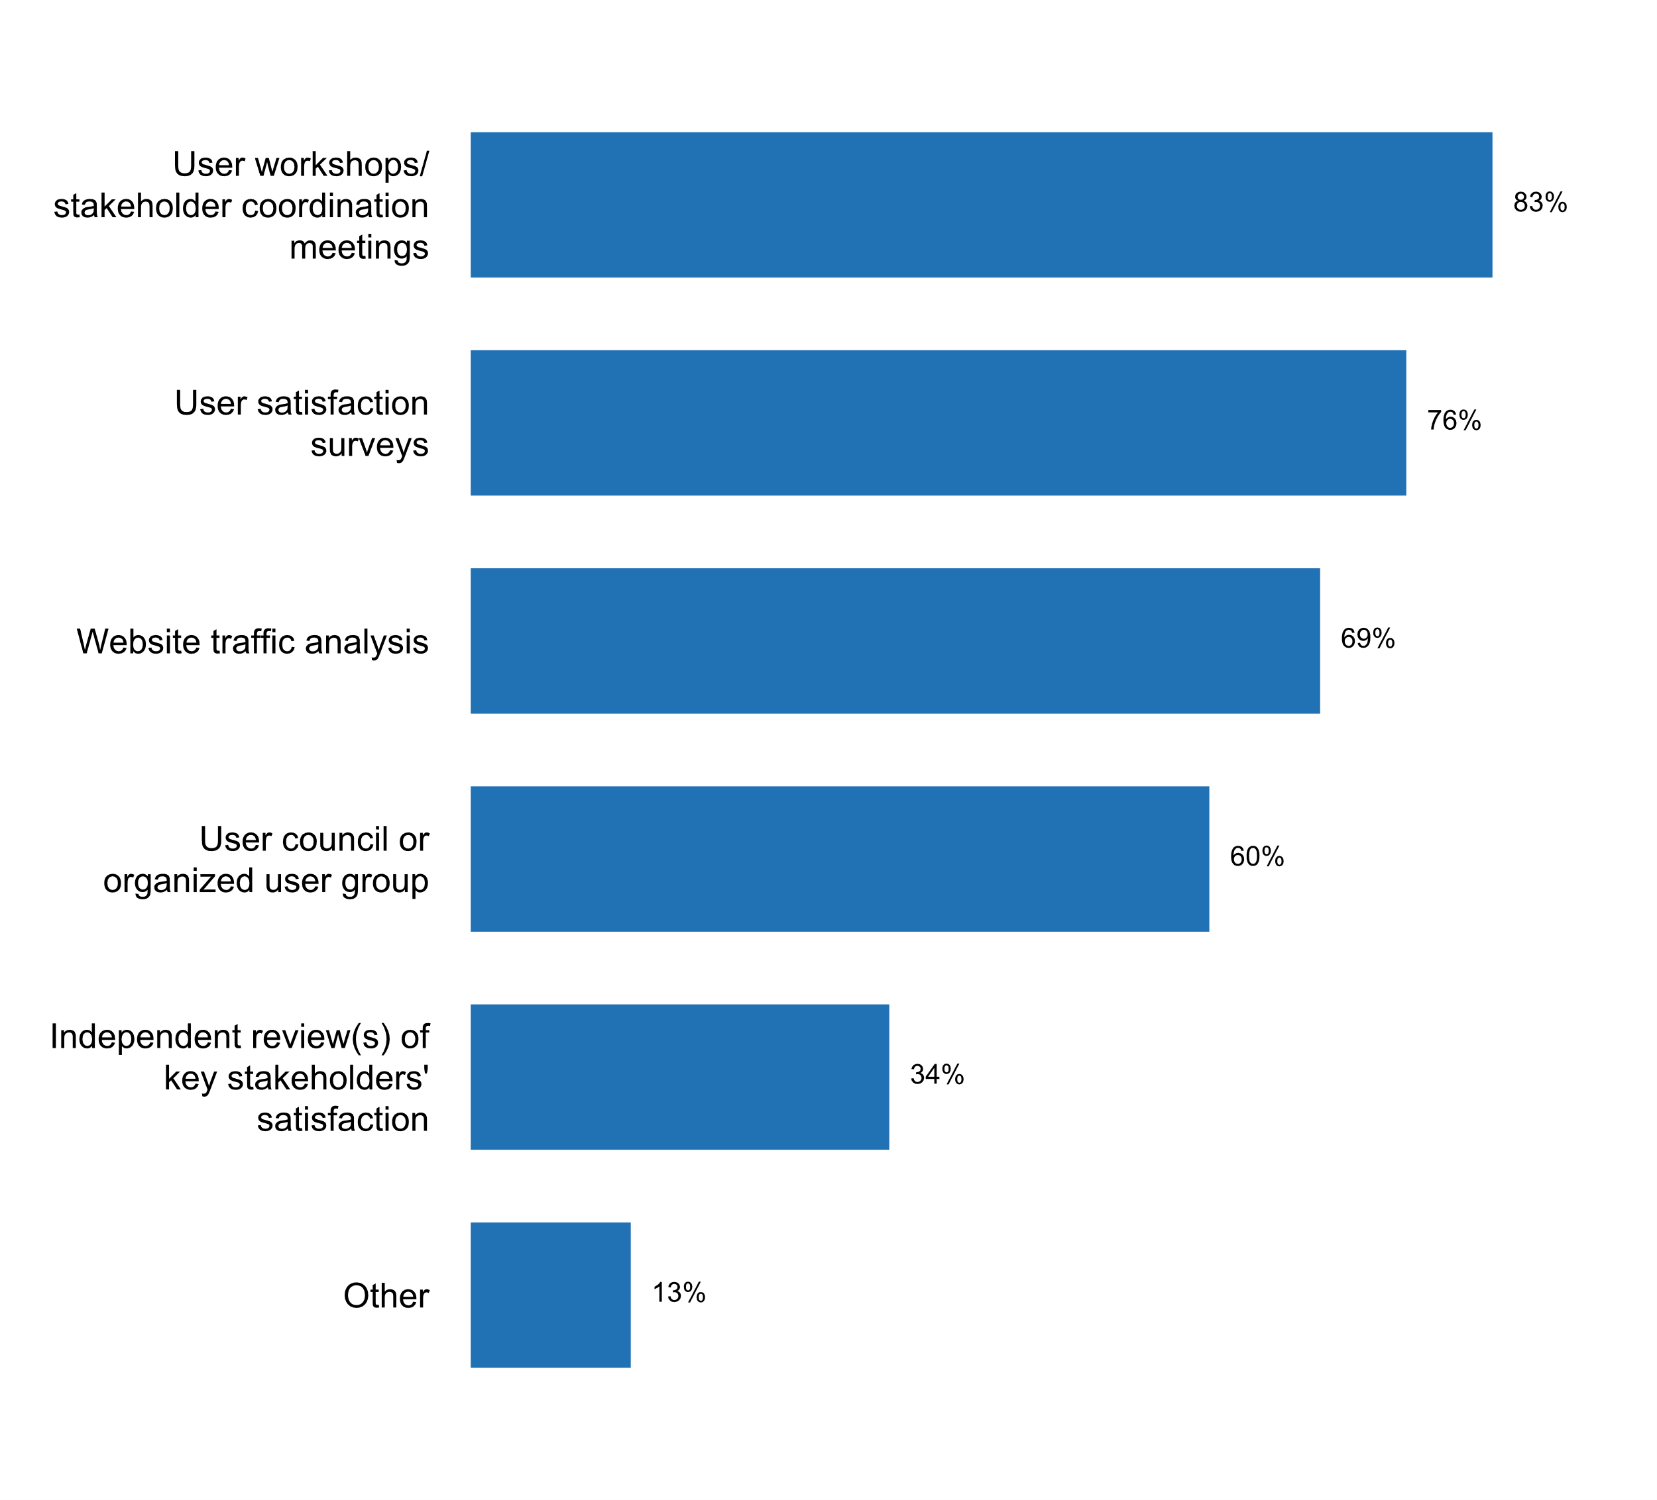

|  |  |  |  |  |  |  |
| --- | --- | --- | --- | --- | --- | --- |
| **Answer** | **Africa** | **Americas** | **Asia** | **Europe** | **Oceania** | **TOTAL** |
| User workshops/ stakeholder coordination meetings | 13 | 10 | 21 | 29 | 4 | **77** |
| User satisfaction surveys | 9 | 9 | 17 | 33 | 3 | **71** |
| Website traffic analysis | 7 | 10 | 13 | 31 | 3 | **64** |
| User council or organized user group | 6 | 5 | 13 | 30 | 2 | **56** |
| Independent review(s) of key stakeholders' satisfaction | 6 | 4 | 9 | 11 | 2 | **32** |
| Other | 2 | 4 | 2 | 4 |  | **12** |

|  |  |  |  |  |  |  |
| --- | --- | --- | --- | --- | --- | --- |
| **Answer** | **Africa** | **Americas** | **Asia** | **Europe** | **Oceania** | **TOTAL** |
| User workshops/ stakeholder coordination meetings | 76 | 77 | 88 | 83 | 100 | **83** |
| User satisfaction surveys | 53 | 69 | 71 | 94 | 75 | **76** |
| Website traffic analysis | 41 | 77 | 54 | 89 | 75 | **69** |
| User council or organized user group | 35 | 38 | 54 | 86 | 50 | **60** |
| Independent review(s) of key stakeholders' satisfaction | 35 | 31 | 38 | 31 | 50 | **34** |
| Other | 12 | 31 | 8 | 11 |  | **13** |

* Analysis of Information Requests
* Articles regarding methodologies and/or experimental estimates invite data user feedback
* Emails, verbal or written comments from users
* Hotline, social network
* INFORMATION REQUESTS
* Independent reviews purchased by Statistics Norway
* Registre des visites de la bibliothèque de l'ANSD
* Since 2012, the Rosstat has a Public Council, which is designed to ensure that the needs and interests of citizens of the Russian Federation are taken into account when implementing state policy in the field of official statistics, as well as with a view to undertake public control over Rosstat activities.
* Social media
* We do not have feedback methods yet.
* Workshop with data journalists
* gathering feedback from users requesting statistical information

**Plot_6_Q01.1a.svg**

**Mandate of user council or organized user group**

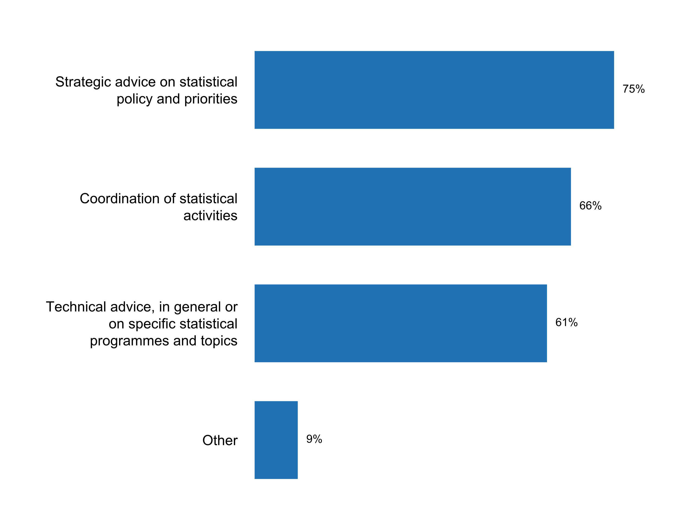

|  |  |  |  |  |  |  |
| --- | --- | --- | --- | --- | --- | --- |
| **Answer** | **Africa** | **Americas** | **Asia** | **Europe** | **Oceania** | **TOTAL** |
| Strategic advice on statistical policy and priorities | 4 | 4 | 12 | 21 | 1 | **42** |
| Coordination of statistical activities | 6 | 4 | 11 | 15 | 1 | **37** |
| Technical advice, in general or on specific statistical programmes and topics | 4 | 3 | 10 | 15 | 2 | **34** |
| Other | 1 | 1 |  | 3 |  | **5** |

|  |  |  |  |  |  |  |
| --- | --- | --- | --- | --- | --- | --- |
| **Answer** | **Africa** | **Americas** | **Asia** | **Europe** | **Oceania** | **TOTAL** |
| Strategic advice on statistical policy and priorities | 67 | 80 | 92 | 70 | 50 | 75 |
| Coordination of statistical activities | 100 | 80 | 85 | 50 | 50 | 66 |
| Technical advice, in general or on specific statistical programmes and topics | 67 | 60 | 77 | 50 | 100 | 61 |
| Other | 17 | 20 | 0 | 10 | 0 | 9 |

* Over a total of 56 responses

* Comité de pilotage d'enquàªte
* One of the functions of the Rosstat Public Council is the consideration of Rosstat's plans for activities.
* SURS established statistical advisory committees for individual fields of national statistics. They have a long tradition in the national statistics in Slovenia; they were established in the 1980s and were formally introduced in 1995 with the Decree on the Establishment of Statistical Advisory Committees on the basis of Article 15 of the National Statistics Act. Statistical advisory committees have a significant impact on the development of national statistics in Slovenia at expert level and in cooperation of institutions in common efforts to provide quality, timely and relevant statistics. Rules of procedures: https://www.stat.si/dokument/5184/StatisticalAdvisoryCommittees_RulesofProcedure_EN.pdf List of statistical advisory committees: Administrative Data Sources Advisory Committee, National Accounts and Financial and Monetary Statistics Advisory Committee, Regional Statistics Advisory Committee, Price Statistics Advisory Committee, Labour Statistics Advisory Committee, Energy Statistics Advisory Committee, Construction Statistics Advisory Committee, Industry and Mining Statistics Advisory Committee, Information Society Statistics Advisory Committee, Education and Training Statistics Advisory Committee, Agriculture, Forestry and Fisheries Statistics Advisory Committee, Crime Statistics Advisory Committee, Culture Statistics Advisory Committee, Natural Resources and Environment Statistics Advisory Committee, Real Estate Statistics Advisory Committee, Domestic Trade and Services Statistics Advisory Committee, Population Statistics Advisory Committee, Research and Development, and Technology Statistics Advisory Committee, Transport Statistics Advisory Committee, Tourism Statistics Advisory Committee, External Trade Statistics Advisory Committee, Health Advisory Committee, Standard of Living and Social Protection Statistics Advisory Committee, Business Statistics Advisory Committee
* Various Advisory Committees from public, private, nonprofit and academia stakeholders
* we have both user groups and Statistical Council, council deals with stategic advice and a bit of coordination, while user groupps give tehnical advice on specific statistical areas

**Plot_7_Q01.1b.svg**

**Stakeholders represented in user council or organized user group in the past five years**

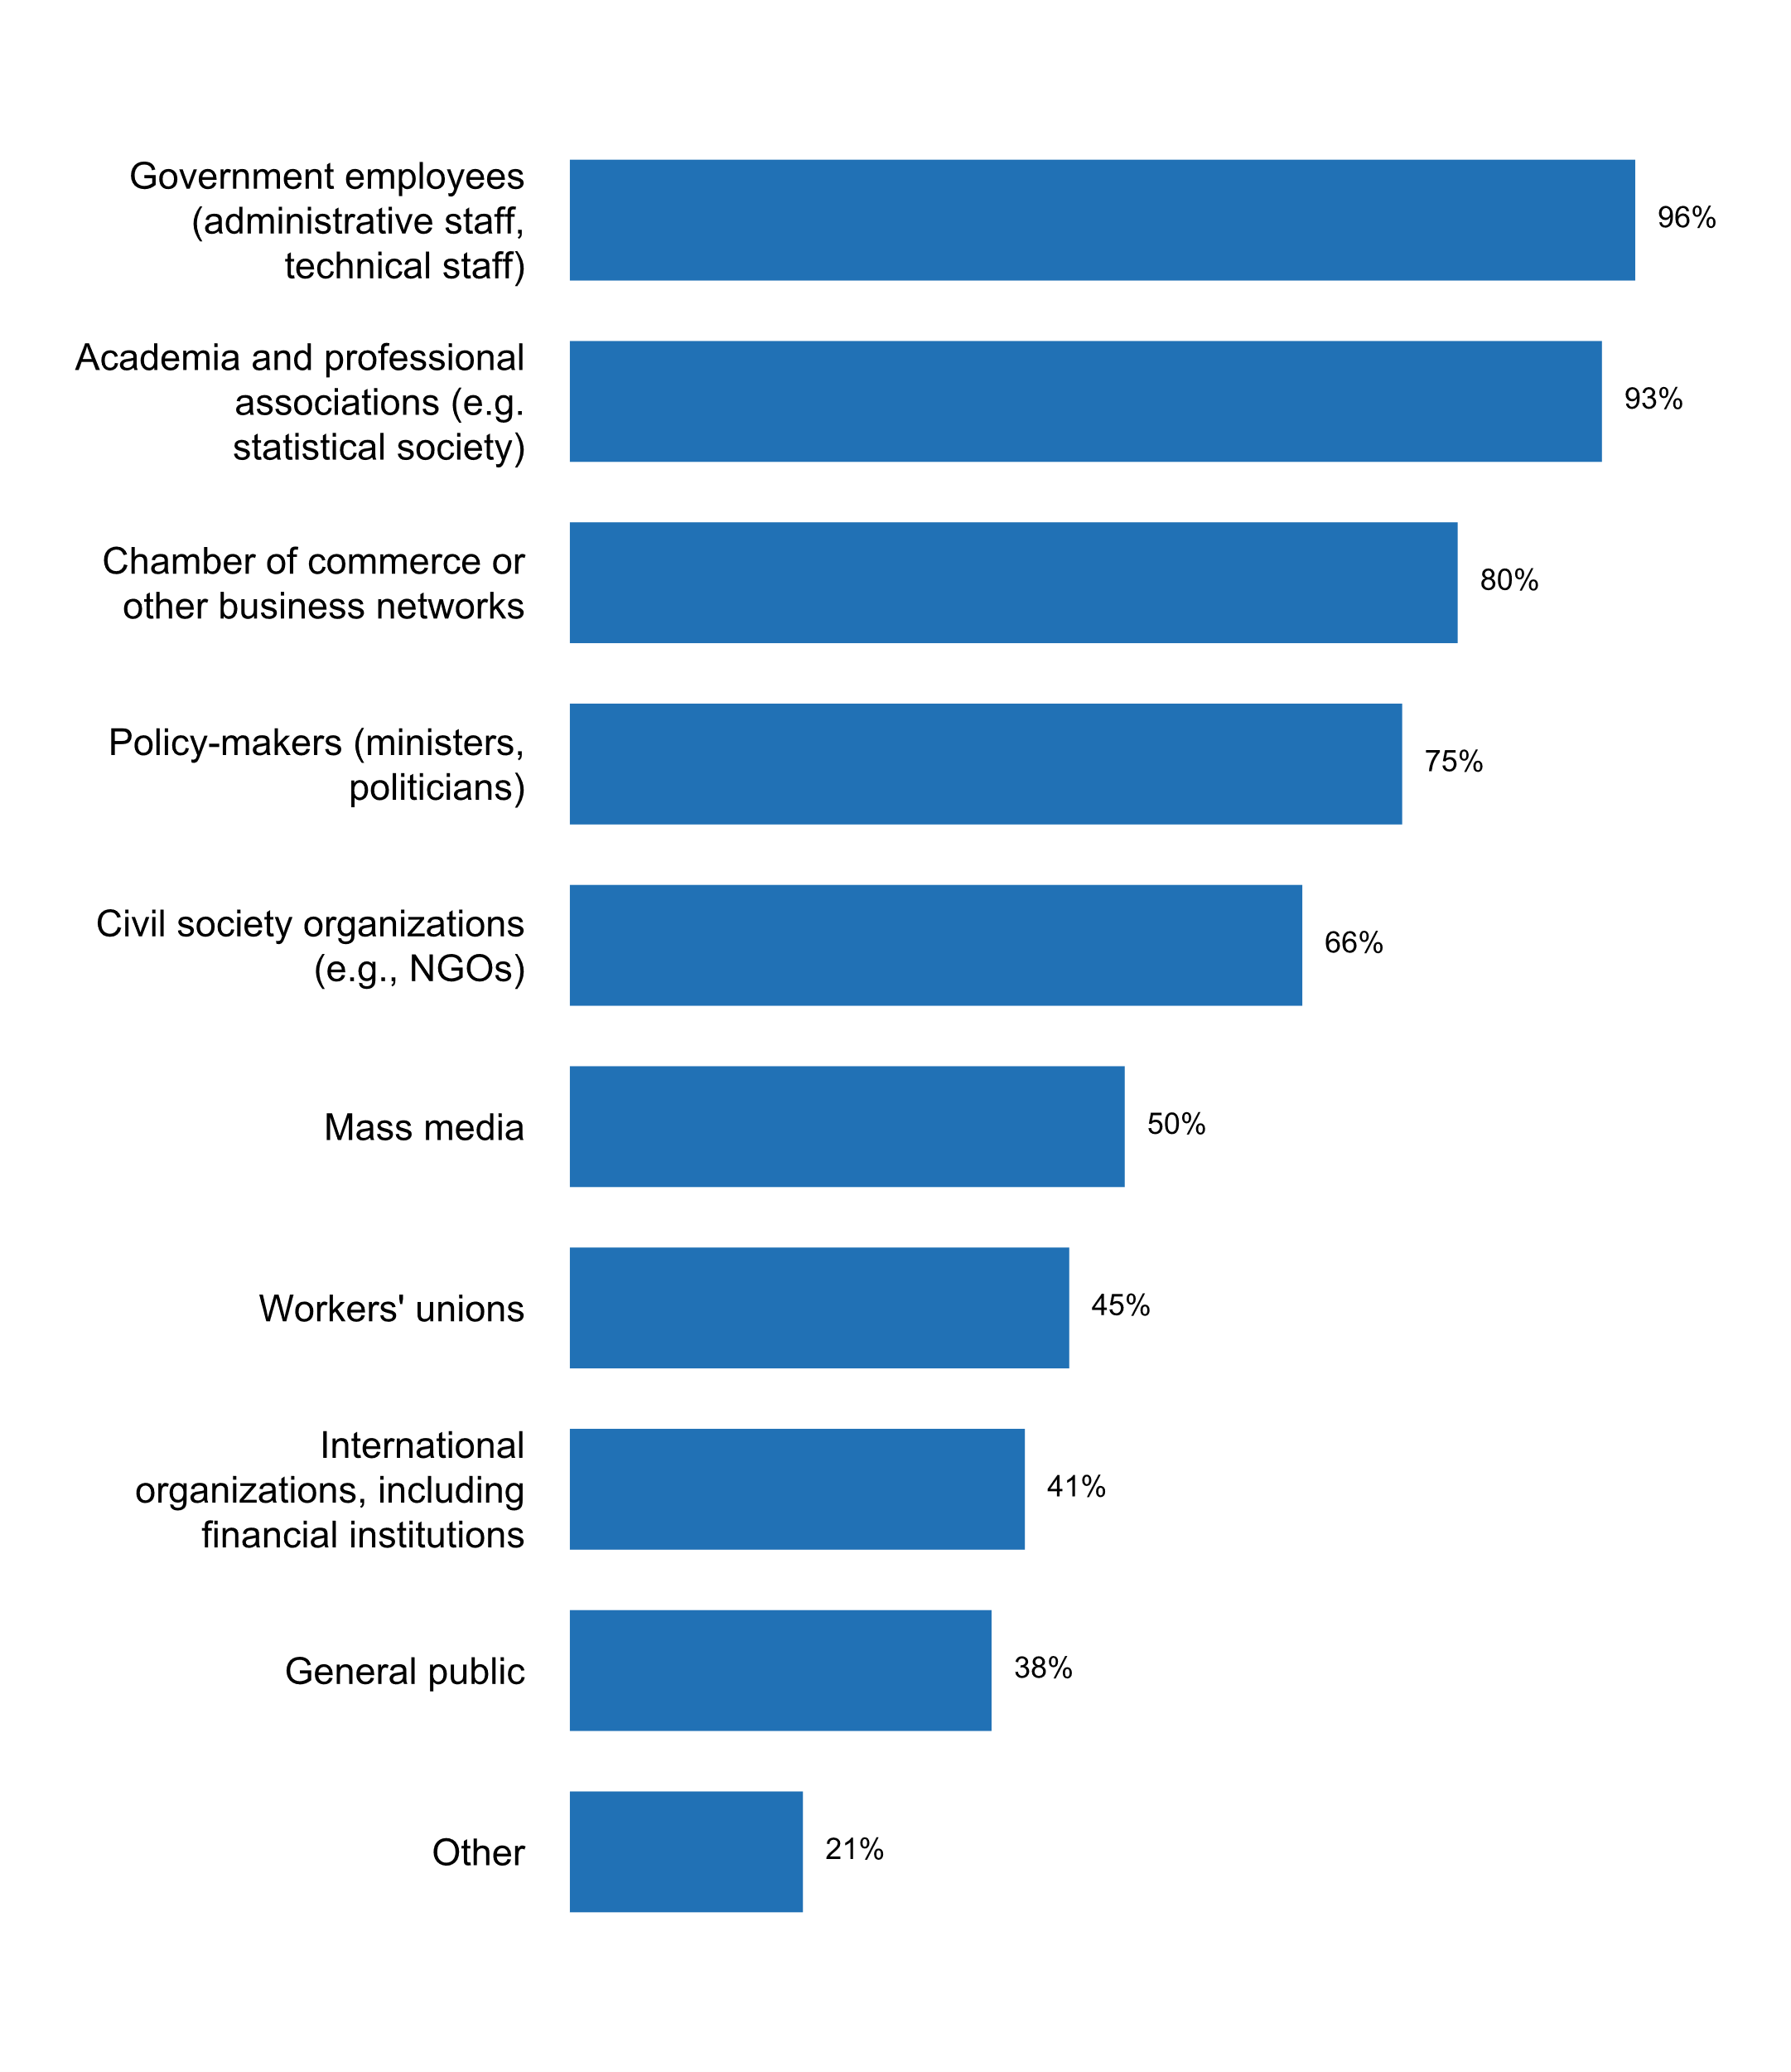

|  |  |  |  |  |  |  |
| --- | --- | --- | --- | --- | --- | --- |
| **Answer** | **Africa** | **Americas** | **Asia** | **Europe** | **Oceania** | **TOTAL** |
| Government employees (administrative staff, technical staff) | 6 | 5 | 13 | 28 | 2 | **54** |
| Academia and professional associations (e.g. statistical society) | 6 | 4 | 11 | 29 | 2 | **52** |
| Chamber of commerce or other business networks | 6 | 3 | 8 | 27 | 1 | **45** |
| Policy-makers (ministers, politicians) | 6 | 4 | 11 | 19 | 2 | **42** |
| Civil society organizations (e.g., NGOs) | 5 | 3 | 8 | 19 | 2 | **37** |
| Mass media | 5 | 2 | 6 | 15 |  | **28** |
| Workers' unions | 4 | 1 | 2 | 18 |  | **25** |
| International organizations, including financial institutions | 5 | 3 | 7 | 7 | 1 | **23** |
| General public | 3 | 2 | 7 | 8 | 1 | **21** |
| Other | 2 | 1 | 1 | 8 |  | **12** |

|  |  |  |  |  |  |  |
| --- | --- | --- | --- | --- | --- | --- |
| **Answer** | **Africa** | **Americas** | **Asia** | **Europe** | **Oceania** | **TOTAL** |
| Government employees (administrative staff, technical staff) | 100 | 100 | 100 | 93 | 100 | 96 |
| Academia and professional associations (e.g. statistical society) | 100 | 80 | 85 | 97 | 100 | 93 |
| Chamber of commerce or other business networks | 100 | 60 | 62 | 90 | 50 | 80 |
| Policy-makers (ministers, politicians) | 100 | 80 | 85 | 63 | 100 | 75 |
| Civil society organizations (e.g., NGOs) | 83 | 60 | 62 | 63 | 100 | 66 |
| Mass media | 83 | 40 | 46 | 50 | 0 | 50 |
| Workers' unions | 67 | 20 | 15 | 60 | 0 | 45 |
| International organizations, including financial institutions | 83 | 60 | 54 | 23 | 50 | 41 |
| General public | 50 | 40 | 54 | 27 | 50 | 38 |
| Other | 33 | 20 | 8 | 27 | 0 | 21 |

* Over a total of 56 responses

* Analysts, tourism industry, Eurostat
* Central Bank; Ministry of Finance
* Environmental associations
* Lithuanian Bishops' Conference
* Ministries and Government bodies, Professional Associations
* Ministry representatives
* National Bank
* National Central Bank, local authorities
* Parlement; Banque centrale
* Research organizations
* Researchers from public, private and academia
* Students, researchers and businesses

**Plot_8_Q01.2.svg**

**Planning instruments currently being used by the NSS/NSO**

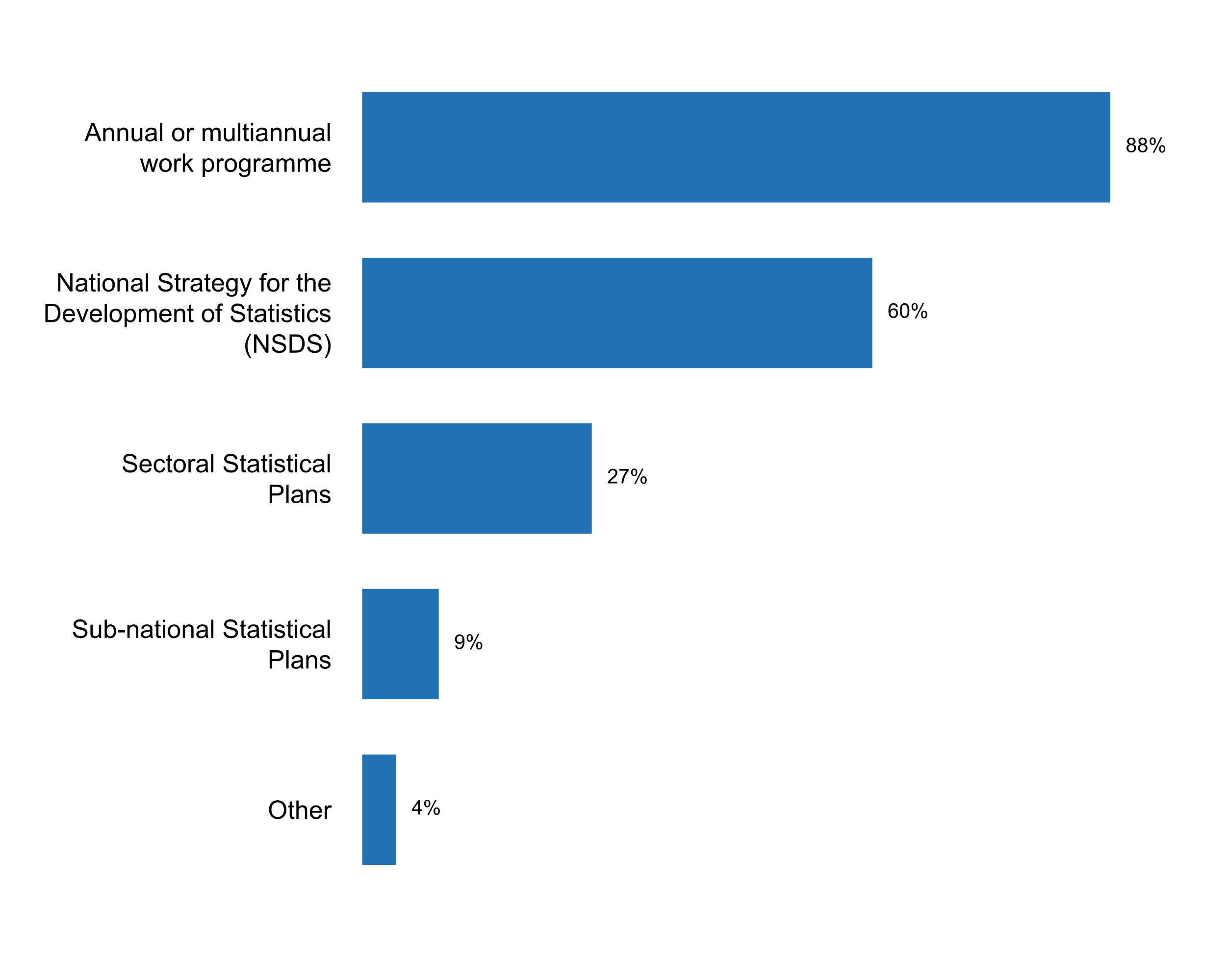

|  |  |  |  |  |  |  |
| --- | --- | --- | --- | --- | --- | --- |
| **Answer** | **Africa** | **Americas** | **Asia** | **Europe** | **Oceania** | **TOTAL** |
| Annual or multiannual work programme | 13 | 10 | 21 | 34 | 4 | **82** |
| National Strategy for the Development of Statistics (NSDS) | 13 | 6 | 15 | 20 | 2 | **56** |
| Sectoral Statistical Plans | 5 | 3 | 7 | 10 |  | **25** |
| Sub-national Statistical Plans | 1 | 1 | 2 | 4 |  | **8** |
| Other | 1 | 2 |  |  | 1 | **4** |

|  |  |  |  |  |  |  |
| --- | --- | --- | --- | --- | --- | --- |
| **Answer** | **Africa** | **Americas** | **Asia** | **Europe** | **Oceania** | **TOTAL** |
| Annual or multiannual work programme | 76 | 77 | 88 | 97 | 100 | **88** |
| National Strategy for the Development of Statistics (NSDS) | 76 | 46 | 63 | 57 | 50 | **60** |
| Sectoral Statistical Plans | 29 | 23 | 29 | 29 |  | **27** |
| Sub-national Statistical Plans | 6 | 8 | 8 | 11 |  | **9** |
| Other | 6 | 15 |  |  | 25 | **4** |

* ABS Corporate Plan
* Statistical Plan of Employment
* The NSDS is only being implemented now.
* federal agencies typically submit 5-yr strategic plans

**Plot_9_Q01.2a.svg**

**Time span of current NSDS**

|  |  |  |  |  |  |  |  |
| --- | --- | --- | --- | --- | --- | --- | --- |
|  | **Answer** | **Africa** | **Americas** | **Asia** | **Europe** | **Oceania** | **TOTAL** |
| From | 2011 |  |  | 1 |  | 1 | **2** |
| From | 2013 | 2 |  |  | 4 |  | **6** |
| From | 2014 | 1 |  |  | 1 |  | **2** |
| From | 2015 | 2 | 1 | 2 | 2 |  | **7** |
| From | 2016 | 3 | 1 | 3 | 3 |  | **10** |
| From | 2017 | 3 | 2 | 3 | 2 |  | **10** |
| From | 2018 | 1 | 2 | 4 | 6 | 1 | **14** |
| From | 2019 |  |  | 1 | 2 |  | **3** |
| To | 2018 |  |  | 1 |  |  | **1** |
| To | 2019 | 2 |  |  | 2 |  | **4** |
| To | 2020 | 5 | 2 | 4 | 10 |  | **21** |
| To | 2021 | 1 |  | 3 | 1 | 1 | **6** |
| To | 2022 | 3 | 3 | 3 | 6 |  | **15** |
| To | 2023 |  |  | 2 | 1 |  | **3** |
| To | 2025 | 1 |  | 1 |  |  | **2** |
| To | 2027 |  |  |  |  | 1 | **1** |
| To | 2040 |  | 1 |  |  |  | **1** |

|  |  |  |  |  |  |  |  |
| --- | --- | --- | --- | --- | --- | --- | --- |
|  | **Answer** | **Africa** | **Americas** | **Asia** | **Europe** | **Oceania** | **TOTAL** |
| From | 2011 | 0 | 0 | 7 | 0 | 50 | 4 |
| From | 2013 | 17 | 0 | 0 | 20 | 0 | 11 |
| From | 2014 | 8 | 0 | 0 | 5 | 0 | 4 |
| From | 2015 | 17 | 17 | 14 | 10 | 0 | 13 |
| From | 2016 | 25 | 17 | 21 | 15 | 0 | 19 |
| From | 2017 | 25 | 33 | 21 | 10 | 0 | 19 |
| From | 2018 | 8 | 33 | 29 | 30 | 50 | 26 |
| From | 2019 | 0 | 0 | 7 | 10 | 0 | 6 |
| To | 2018 | 0 | 0 | 7 | 0 | 0 | 2 |
| To | 2019 | 17 | 0 | 0 | 10 | 0 | 7 |
| To | 2020 | 42 | 33 | 29 | 50 | 0 | 39 |
| To | 2021 | 8 | 0 | 21 | 5 | 50 | 11 |
| To | 2022 | 25 | 50 | 21 | 30 | 0 | 28 |
| To | 2023 | 0 | 0 | 14 | 5 | 0 | 6 |
| To | 2025 | 8 | 0 | 7 | 0 | 0 | 4 |
| To | 2027 | 0 | 0 | 0 | 0 | 50 | 2 |
| To | 2040 | 0 | 17 | 0 | 0 | 0 | 2 |

* Over a total of 54 responses

**How did the NSS decide on statistical plans and budget allocations in the past five years? Who was consulted and who approved the plan?**

* A major part of the statistical plans is allocated to the execution of the requirements of the European Annual Working Program. Other Requests are processed on a user-by-user basis if the planning and the budget allow it.
* According to art. 18 paragraph. 1 of the Law on Official Statistics, the Program of statistical surveys of public statistics is determined annually by the Council of Ministers by means of a regulation. However, financing of statistical surveys, in accordance with art. 50 paragraph. 1, comes from the funds of the state budget, to the amount determined annually in the budget statute. The signing of the budget act by the Government is preceded by inter-ministerial and social consultations Annual work programme is based on arrangements with interested parties, consultations with statistical information users, approved by Prime Minister.
* According to the Act on Statistics, the statistical data collections of the official statistical service - with the exception of those regulated by an Act of Parliament - are included in the annual national statistical data collection programme of the official statistical service. Censuses are regulated individually by an Act of Parliament. National statistical data collection programme has been issued by a Government Decree (Government Decree 288/2009. (XII. 15.)) and is amended each year according to the changes in the data collections. The Government Decree contains the reference to the mandatory nature of OSAP, the frequency of the survey, a description of the respondents, the deadline for submitting the data.The draft programme is compiled by HCSO based on the proposals of the members of the official statistical service. HCSO submits the draft programme to the National Statistical Council to request its opinion and for approval.The budget of the HCSO is decided upon annually by the Parliament and relates to one calendar year. The budget is based on the principle of institutional financing, which means that during the planning procedure the expenditure needs of the institution as a whole is estimated based on the expenditures of the previous year.
* All members of the NSS participated in elaborating the document. NSS was first approved by the NSS council and then Cabo Verde Government.
* All official statistics in the NSS of Lithuania is produced according to the Official Statistics Work Programme. The Programme is an annual planning document; comprising all statistical works (surveys) performed in Lithuania and required funds. Compilation of the Programme is regulated by the National Law on Statistics and coordinated by Statistics Lithuania. Institutions producing official statistics in the country (ONAs) provide Statistics Lithuania with information on statistical works inclusion in the Programme. The Draft Programme is deliberated by the Advisory Commission of DG of Statistics Lithuania and by the Statistical Council. When the opinion from the Statistical Council is received, the draft Programme is provided to ONAs and society at large via the Legislation Information System of Republic of Lithuania for final consultation. The Programme is approved by the Minister of Finance.Moreover, every year Statistics Lithuania prepares the Strategic Action Plan, which is a 3-year rolling activity planning document elaborated in accordance with the Government Resolution establishing strategic planning methodology in the Republic of Lithuania. Compilation of the Strategic Action Plan is obligatory for all state authorities, managing budget appropriations. The Strategic Action Plan links the mission, strategic objectives and tasks delegated to the institution with the programmes performed and budget allocated. Strategic Action Plan of Statistics Lithuania is approved by the Minister of Finance.Every five years, Statistics Lithuania develops the 5-year Strategy, where the main trends of SL's activity are laid down. The current strategic period covers years of 2018â€“2022. The Strategy of SL is deployed via the Strategic Action Plan and annual activity plans of SL. The strategy and annual activity plans are approved by the DG of Statistics Lithuania.Planning system of Statistics Lithuania is regulated by the Orders of DG of Statistics Lithuania on the action planning procedures and budget planning procedures, as well as by the Government Resolution on Strategic Planning Methodology.Budget appropriations for Statistics Lithuania for each year are approved by the Law of the Republic of Lithuania on the State budget and financial indicators of municipal budgets.
* Article 7 of the Law on Official Statistics specifies that Geostat shall work out a statistical activity programme, that consists of the list of works to be carried out and their descriptions and implementers, source and instruments, the frequency of observation and dates of publishing. The Board of Geostat has responsibility to review the statistical activity programme submitted by the Executive Director and to determine relevant recommendations Preparation process of the programme envisages consultations with all relevant government agencies. Geostat drafts a budget independently, presents for information to the Board of Geostat and sends it to the Ministry of Finance for revision. While drafting the budget Geostat acts according to the “Budget Code”, government decrees, regulatory acts issued by the Ministry of Finance and Geostat internal instructions. Heads of Geostat subject matter departments participate in the drafting process and present their proposals to the top management of the Geostat. After discussing them the draft budget (with summary parameters and number of employees) is sent to the MoF. After that the MoF approves the maximum budget. The amount can be increased if negotiated with the MoF. After the approval of the Law on state budget the executive director of Geostat approves the detailed budgets for each survey.
* Budget allocation is aligned with our yearly projects/ activities and plans and approved by line ministry, the Ministry of Finance and Economy.
* Consultation of the statistical commission (user council) and approved by the government.
* DG signed departments' plans and budget allocations. Ministry of Finance approved the plan on a general level
* Dans l'attente de la mise en place du Conseil National de la Statistique (CNStat, l'INS assure la coordination technique du système statistique national. A cet effet, dans le cadre de l'élaboration du programme annuel ou pluriannuel, l'INS centralise l'ensemble des plans d'activités statistiques préalablement validées par la tutelle des structures statistiques publiques. la démarche est la màªme en ce qui concerne l'élaboration de la SNDS.S'agissant d'allocation budgétaire, les structures statistiques dans leur majorité ne disposent pas de budget spécifique dédiées à  la production statistique. Néanmoins, elles bénéficient d'appuis financiers ponctuels des partenaires au Développement dans le cadre de l'éxécution de certaines activités.
* Data users, owners of administrative sources, statistics producers and all relevant stakeholders were taken into account when developing plans in the past five years. The draft Work Plan shall be considered the Work Plan of the Agency once approved by the relevant state authorities (Council of Ministers of the B&H).
* Draft program is discussed with main stakeholders and posted on the website for comments and proposals. The final draft is presented to Public Council of Users. The State Council on Statistics adopts annual and multiannual programs. Budget allocations are provided on the basis of the RA Law on the State Budget according to the Budgetary Functional Classification.
* During the preparation of the annual statistical plan all producers of official statistics were consulted, and consolidated version of the plan is communicated with the Statistical Council. After that, final version is sent to all relevant public institutions for the opinion. At the end, Government approves the plan. The producers of official statistical data make decision on financial planning without any consultation and Ministry of Finance approved budget for certain producer.
* ELSTAT, following the advisory opinion of the Advisory Committee of the Hellenic Statistical System (SYEPELSS) adopts every three years the Hellenic Statistical Program (ELSP). The ELSP is approved by the end of March of the year preceding the year of its implementation. The ELSP sets out the major fields and objectives of the actions scheduled by the agencies of the Hellenic Statistical System (ELSS) for a three (3) year period. It determines the priorities concerning the information needs of ELSTAT, and of the other ELSS agencies so as they can meet their Community and international obligations, and the required statistics for compilation, after having weighted the required human and financial resources as well as the administrative cost which the compilation of statistics entails for the agencies in question. The ELSP is submitted to the Hellenic Parliament and to the Minister of Finance, it is published in the Government Gazette and on ELSTAT's website. Each ELSS agency sets up an annual statistical work program based on the ELSP, which is submitted to ELSTAT for approval by the end of January of the year preceding the implementation year, and is accompanied by the annual evaluation report of the statistical work program of the previous year. ELSTAT, before the end of May of the year preceding the implementation year and following the advisory opinion of the SYEPELSS compiles its corresponding annual statistical work program.
* Each ministry puts the budget of its plan to the general budget
* Each sector decides on the budget allocation of its implementation as it is the responsibility of each sector to secure funding for implementation of its statistical activities. The NSO also has its own statistical program. However, the NSO plays a critical role in ensuring that implementation of the sectoral statistics plans is budgeted, monitored and evaluated as the NSDS is coordinated by the NSO. And the Statistics Act,2009 gives the NSO a mandate to coordinate the NSS, and has to be accountable to all statistical activities in the entire NSS by ensuring adherence to the International Standards and classifications, as well as Fundamental principles of official statistics. Each Sector under the NSDS has a focal person who sits in the Inter Agency Statistics Committee which provides an advisory role for the NSDS implementation as well as how the NSS can effectively be developed and making coordination effective.
* Every statistical institution planned its statistical production budget within the internally. Statistical institutions coordinate the planned budget with the ministries they are subordinate to, as well as with the Ministry of Finance. The budget is approved by the Cabinet of Ministers and by the Parliament.
* Following the guidelines of the Committee for Directing and Coordinating Statistical Information (Comstat), the National statistical Institute (Istat) drafts a three-year National Statistical Program which identifies the statistical surveys of public interest to be carried out by all the bodies of the NSS. In its preparation Istat is assisted by the User Council and is supported by several advisory groups (called “equality groups”), one for each topic included in the program. The groups are permanent bodies, made up of producers and users of official statistics representing public and private actors belonging or not to NSS (e.g. bank and credit system, academic world, trade unions). After decision by Comstat, the NSP is submitted for opinion to the Commission for the Protection of Statistical Information, the Unified Conference State-Regions and the Data Protection Supervisor and later for deliberation to the Inter-ministerial Committee for Economic Planning. It is finally issued with a Decree by the President of the Republic.
* Higher Steering committee FCSA Board of Directors
* In collaboration with the government agencies, the statistical requirements and needed activities are surveyed and decided. Plan and Budget Organization
* In the planning process is involved all stakeholders namely: Organs of NSS and all members of NSS (ministries, delegated authorities to produce official statistics and other public agencies), users through consultations meetings and workshops. The High Council of Statistics in Mozambique is responsible by approving all statistical plans of NSS.
* It was based on projects to be undertaken by the office, taking into consideration national & international reporting obligations as well as emerging issues of national interest. The Ministry of Finance and Economic Development (parent ministry) was consulted and the plan approved.
* La SNDS est élaborée par le Comité technique des Programmes statistiques (CTPS) et approuvée par le Conseil national de la Statistique (CNS). Le Ministre de l'Economie, des Finances et du Plan, qui est actuellement Ministre chargé de la Statistique et aussi chargé du Secrétariat du CNS, assure les allocations budgétaires.
* La stratégie nationale pour le développement de la statistique 2016-2020 s'articule autour de quatre priorités stratégiques, à  savoir: - Axe 1: Opérationnalisation du cadre institutionnel et organisationnel en vue d'une meilleure gouvernance du système statistique national; - axe 2: amélioration de la couverture et qualité de la statistique de la production; - axe 3: l'efficacité des services statistiques; - Axe 4: Amélioration de l'archivage, de la diffusion, de l'utilisation des données statistiques et de la promotion de la recherche. Ces domaines d'intervention ont été définis en objectifs. Objectifs Objectifs Objectifs Objectifs Objectifs Analyse analytique statistique statistique globale et statistique de la Commission du Conseil national. 2, les objectifs sont OBJECTIFS, CANDY REALITY, STRATà‰GIE INDUSTRIELLE DU SYSTàˆME MONDIAL STRATEGIE DU SYSTàˆME MONDIAL, STUDIO STUDIO, REING FOR TEXT FOUNDATION, LE STUDIO MEDICAL ET LES PRODUITS DE REAMING. utilisation d'outils standard et harmonisés, respectant les normes de qualité. Le niveau de la statistique nationale. Ce sera principalement: i) améliorer la qualité et la qualité des ressources humaines et assurer la bonne gestion; ii) les statistiques nationales; (iii) assure le financement de statistiques de manière durable par la création d'un Fonds national de la statistique. S'étant de l'objectif 4 . Le coà»t global de la mise en œuvre du plan d'action de la Stratégie nationale de développement de la statistique 2016-2020 s'élève à  444,2 milliards de GNF (54,8 millions USD), dont 110,5 milliards de GNF (24,9%) et 179,8 milliards de GNF (40,5%) Partenaires techniques financiers. Le montant total à  rechercher est de 153,9 milliards de GNF (34,6%), soit près de 19 millions USD. Le budget de la Stratégie nationale pour le développement de la statistique 2 servira principalement à  améliorer la qualité et la couverture de la production statistique (74,7%) et à  renforcer les capacités du système statistique national (21,3%). Le reste sera affecté à  l'amélioration de l'archivage, à  la diffusion, à  l'utilisation de données statistiques, à  la promotion de la recherche (2,7%) et au renforcement du système institutionnel et organisationnel du système statistique national (1,3%). Au cours de la mise en œuvre de la stratégie nationale pour le développement de la statistique 2016-2020, l'à‰tat devra progressivement assumer le financement des statistiques officielles actuelles. D'autres créneaux pourraient àªtre explorés pour la mobilisation de ressources externes, notamment l'utilisation des installations disponibles aux niveaux sous-régional, régional et international, notamment: - le projet de la Banque mondiale sur la modernisation et l'harmonisation des enquàªtes sur les ménages, qui visait à  établir des indicateurs de pauvreté et à  suivre les objectifs de développement durable (ODD); - La Stratégie mondiale pour l'amélioration des statistiques agricoles et rurales, sous l'égide conjointe de la Commission de l'Union africaine (UA), de la BAD, de la CEA et de la FAO; - le programme de plate-forme Open Data lancé par la BAD en 2013 dans le cadre de l'initiative "Autoroute de l'information" visant à  améliorer la gestion et la diffusion des données en Afrique; - le programme d'appui institutionnel dans le domaine des statistiques et de l'économie du onzième FED de l'Union européenne; - Le projet ECOAGRIS de CEDEAO (Système d'information agricole) a été mis en œuvre par le Centre régional AGRHYMET avec un financement de l'Union européenne - etc.
* NSO MAKE THE PORPOSITIONS THAR ARE AGREE TO SUPERIOR STATISTICAL COMMISSION. IT IS THE MINISTRY OF PLAN, STATISTICAL AND REGIONAL INTREGATION THAT WAS CONSULTED AND APPROVED THE PLANS AND BUDGET.
* NSS implementation plan is being drafted with several consultations with all stakeholder since last 2 year. The implementation will take place soon after finalizing it.
* NSS not in place
* Plans are approves by respective authorities in the line ministries. Consultations were made to key stakeholders in the NSS
* SI follows the European statistical program and incorporates it into its national program and consults the prime ministers office on budgetary matters.
* Se realizan reuniones con los representantes de las Oficinas Sectoriales de Estadà­stica, asà­ como el titular de la entidad.
* Sector Statistics Committees using a bottom -up approach and involving all.
* Stakeholder - Through various government committees and working groups. More broadly through engagement activities including a user conference (as per our current legislation) Priorities - Through government budget and prirority setting processes with our Minister and other stakeholders. Purchase advice can be provided to Ministers on invesrments. Approval is by the Government Statstician informed by conversations with the Minister and stakeholders.
* Statistical plans are debated and endorsed by the National Statistical Council and approved by Government Decision.
* Statistical plans were decided and approved by Committee on the Management the NSS (3 Major area: Social,Economic, and Natural Resource and Environment).
* Statistics Programme (http://www.officialstatistics.gov.tr/?q=en/node/224) is prepared for a 5 year period in order to determine bacis principles and dissemination of official statistics since 2007 and the current programme is the third one. “The Official Statistics Programme establishes the framework for official statistics that shall be produced on subjects required at national and international level. Censuses and surveys are carried out within the framework of this Programme.”.... “The Programme is drafted by the Presidency for a term of five years in line with the advisory comments of the Council and submitted to the Council of Ministers. The Programme shall be put into effect upon the publication of the decision of the Council of Ministers in the Official Gazette. When needed, amendments to the Programme, proposed by the Presidency after soliciting the opinion of the related organisations, are made with the decision of the Council of Ministers, and published in the Official Gazette. The Presidency is in charge of implementing the Programme.” (Article 3 of Turkish Statistics Law) Each institution within the NSS has its own budget. The meetings realized within this framework (both meetings of OSP and related Working Groups) are funded through the budget of TurkStat.
* Strategic plans an annual plans at top management level with endorsement from the Board of Statistics Norway (external)Budget allocation letter with the Ministry of Finance
* THE 5 YEARS PLAN SENT TO THE SUPREME COUNCIL FOR PLANING
* THE OPERATIONAL PLANS ARE FRAMED IN THE COUNTRY PLAN.
* The CZSO has the sole responsibility for statistical planning (respecting requests of European Statistical System). It also has a separate chapter in the state budget. The proposal of the state budget is approved by the parliament applying the procedure, which is common for all ministries and central agencies.
* The Government represented in MOP Ministry of Planning and Ministry of Finance make statistical plans and approve budget in the past five years.
* The Ministry to which the NSO is attached
* The NSDS was approved in 2015 and in the last three years our activities plans were approved by National Statistics Council and the annual plans are elaborated basing on General State budget.
* The NSDS was developed by SBS and its stakeholders with technical assistance provided by Paris21. The annual budget is determined by SBS depending on annual activities.
* The NSO prepares annual work plans and budgets based on continuity of core statistical products, user needs/demands, and institutional strengthening initiatives. There is as yet no coordinated planning of an NSS-wide budget or work plan. The NSDS was developed in late 2017 in consultation with the broad NSS membership and central government. It was based on months-long study of the gaps and needs of the NSS. The primary goal of the NSDS is to establish the coordination of and build capacity within the NSS (including the NSO).
* The NSS currently decide on their own individual budgets while the Namibia Statistics Agency (NSA) does its own plans and budgets which are approved by the NSA Board.
* The NSS statistical program is prepared by INSTAT in collaboration with other producers of official statistics, taking into account user needs and the implementation of strategic objectives. The draft-Program is discussed by the Statistical Council (composed by 11 members, representatives of statistical users), government and Parliament. the Draft-Program is discussed by the government also to ensure the allocation of state budget funds. The 5-year Program enters into force after approval of the Parliament
* The National Statistical Plan is the instrument whereby the strategic guidelines and the actions for the development of statistical production are established, taking into account the information needs of the country. The preparation of the plan is led by DANE and performed in coordination with all members of the NSS. The document, which should be formulated every five years, will be taken to CANE for approval. In a like manner, DANE will monitor the implementation of the Plan. Periodically, DANE presents progress reports to the CANE. The main National Statistical goal is in 2022, the country will guarantee to count with pertinent official statistics in order to know its economic, sociodemographic and environmental reality, based on the coordination of the entities belonging to National Statistical System. The document was approved by the council in April of 2017. The budget expected in order to implement the National Statistical Plan for the next five years is close to USD219 million. This is an estimated value which corresponds to operational cost.
* The National Statistical Programme shall be adopted annually by the Council of Ministers on a proposal from the president of the NSI within one month after submission of a draft. The National Statistical Council, a consultative body to the President of the NSI discusses the proposals of the statistical authorities and gives recommendations for including in the draft National Statistical Programme specific statistical surveys defined by type, scope and implementation staff.The NSI budget in the past five years is as follows:2018 - 21281300 BGN;2017 - 19591400 BGN;2016 - 18852100 BGN;2015 - 17452100 BGN;2014 - 18185600 BGN.
* The National statistical institute carries out a three-year programming exercise twice a year. This exercise allows to evaluate the human and financial resources needed to carry out the statistical and IT work.
* The SSO as coordinator of the NSS consult and include all official producer of official statistical in preparation of the five year statistical programme and annual report . The programme is adopted by the governement.
* The State Program of the Russian Federation “Economic Development and Innovation Economy” was approved by the Government of the Russian Federation on April 15, 2014 N 316. The procedure for developing, implementing and evaluating the effectiveness of state programs of the Russian Federation was approved by the Government of the Russian Federation of August 2, 2010 No. 588. In the framework of the development and implementation of subprogramme 9 “Official statistics” Rosstat cooperates with federal executive bodies.
* The Statistical Programme (current for 2018-2022) is approved with the Government Decree.The Strategy of the Estosnian Statistics (current 2018-2022) is approved by the Ministry of Finance.Before approval the Statistics Estonia always consults with the stakeholders, i.e ministries, research institutions, media, etc.
* The US budget process for a decentralized federal statistical system (of over 125+ agencies) is more complex than can be explained via answering this question.After a budget is passed for the fiscal year, agency budget allocations are done at the Department-level. For example, when the Department of Commerce (DOC) receives budget for the FY, they decide how to allocate it amongst DOC agencies-- Census Bureau, Bureau of Economic Analysis, NOAA, NIST, etc. Allocations are based on fiscal year projects that are indicated in the agency's strategic plan. During a decennial census, it would make sense that the Census Bureau budget increases substantially, then, drop after it is over.
* The board of the NSS and its relevant committees
* The budget allocations of the members of the Argentine NSS are independent of the country's NSO. The NSS currently does not issue, as a single entity, any Statistical Plan. This process will begin in 2019, and it will be leaded by INDEC (Argentina's NSO).
* The budget is allecated by the national government to all public sector entities. For the preparation of the Statistical Plan (National Statistics Program), a compilation of all the statistical operations that the NSS produces and updates annually is carries out
* The first indent of Article 1 of the National Statistics Act (Uradni list RS*, No 45/95 and No 9/01; hereinafter: the NSA) (https://www.stat.si/dokument/5186/NationalStatisticsAct.pdf) states that the national statistics is a professionally independent activity of implementing the programme of statistical surveys. According to Article 25, the Annual Programme of Statistical Surveys is determined each year by the head of SURS in cooperation with other authorised producers of national statistics. The main elements on which the programme is based are the Medium-term Programme of Statistical Surveys, the European Statistical Programme, the Statistical Work Programme of the Commission, and consultations with national stakeholders through statistical advisory committees and other forms of consultations. At the end of the year the Management Board of SURS discusses and evaluates the progress in achieving the main objectives of national statistics determined by the medium-term programme. The conclusions of this discussion are the basis for the preparation of the annual report. The annual report presents the work performed by SURS and authorised producers according to the annual programme of statistical surveys. The draft is discussed by the statistical advisory committees and is then submitted to the Statistical Council. According to Article 18 of the NSA, SURS as a professionally independent government office, is directly involved in the phase of preparation and harmonization of the national budget.
* The formulation of the NSDS and the allocation of budget took into consideration the following: (1) Reorganization of the Philippine Statistical System (PSS) and the establishment of the Philippine Statistics Authority (PSA); (2) medium-term national development plan; (3) new challenges such as data revolution; (4) use of open data, big data and other non-official data sources, as well as administrative-based data; and the (5) Sustainable Development Goals (SDGs). The formulation process involved the various agencies and interagency committees which spearheaded the crafting of respective sectoral statistical plans, the regional/provincial statistics committees which led the drafting of the statistical plans at the subnational level, resource persons, development partners, and the public and private sector participants in the consultative workshops. The medium-term statistical development plan for the Philippines known as the Philippine Statistical Development Program (PSDP) was approved by the PSA Board which is chaired by the Socioeconomic Planning Secretary. The PSDP includes the budget requirements for each program/activity.
* The institutions of the Sistema de Estadà­stica Nacional (SEN) and its main users (academia, researchers, public institutions, employers organizations, trade unions, media, etc.) were consulted. It was ruled by the Consejo Nacional Consultivo de Estadà­stica (CONACE) and approved by the Consejo Directivo del Instituto Nacional de Estadà­stica y Censos (INEC).
* The majority of funding for official statistics in Australia is provided through annual government appropriation or through user funding of specific statistical collections. There is also an annual government budgeting process through which agencies may seek additional funding for specific initiatives or to respond to cost pressures. Governments must balance the extent to which statistical authorities are funded with other competing priorities. To deliver the best value while working within these resources, each statistical authority in the national statistical service must manage and prioritise statistical production. In real terms the funding of the ABS has reduced substantially in recent years and this trend is set to continue. ABS is working with government funding agencies and key users to retain a workable and stable financial situation, so that it can continue to deliver the official statistics Australia needs to the high levels of quality expected. The adequacy of resources is regularly monitored by statistical authorities in order to effectively manage and prioritise the statistical work program and leverage the regular government budget processes. The ABS Resource Prioritisation and Finance Committee and associated Working Group, for example, meet at least quarterly, or as frequently as weekly when required, to oversee and monitor allocations and expenditure to ensure rigour, discipline and transparency. The Committee comprises senior staff including the ABS Chief Financial Officer. There are a number of strategies that enable the production of official statistics within available resources. For example, the Australian Bureau of Statistics (ABS) has: 1. focused on achieving efficiencies by reducing corporate overheads, including reducing property costs through activity based working; 2. increased the use of administrative and transactional data collected by other entities in order to reduce direct costs to collect information from households and businesses; and 3. prioritised statistical activities and ceased some activities. The ABS classifies its statistical work program in four tiers, which are used to assist with prioritisation undertaken by the ABS. The tiers were informed by the development of the list of Essential Statistical Assets for Australia. The Essential Statistical Assets (ESA) for Australia initiative highlights statistics which are critical to decision making in Australia. The initiative contributes to effective prioritisation of investment by governments to improve the overall quality of Australia's official statistical assets, enhance their utilisation and allow for more effective integration to increase the value of the National Statistical System. The ESA was developed in consultation with the community as well as users and producers of statistics in Australia
* The provision about the funding of state statistical activity from the national budget is fixed in article 15 of the Law on State Statistics of the Republic of Belarus: http://www.belstat.gov.by/o-belstate_2/pravovye-osnovy-gosudarstvennoi-statistiki-respubl/zakon-respubliki-belarus-o-gosudarstvennoi-statist/ http://www.belstat.gov.by/en/o-belstate/pravovye-osnovy-gosudarstvennoi-statistiki-respubl/zakon-respubliki-belarus-o-gosudarstvennoi-statist/ Based on the above, the law on the national budget for specific financial year makes provisions for the funds to be allocated for the activities of state statistics bodies.
* This is not applicable as yet as we are in the process of drafting our first NSDS for the South African NSS.
* Through the National Program of Statistics and Geography and the Annual Work Program of the National Statistical System, which is approved by the Governing Board and the President of INEGI.
* To strengthen the principles of proper planning to serve the statistical system to serve the general trends of the government in general and the trends of the statistical system in particular, the Central Statistical Organization provides data and information on all activities to be implemented within the annual plan of action to assist decision makers according to the data available in his hands
* Under the "Statistics Act 1965 (Revised 1989), the Department's mandate is to collect and interpret statistics for the formulation or implementation of government policies in whatever fields as needed by the government or for fulfilling the requirements of trade, commerce, industry, agriculture or others. Therefore, the statistical plans is decided based on the requirements of national development policies, development of global statistics, as well as users' expectations. These requirements are then linked to the development of competent human capital and information and communications technology (ICT) requirements. The budget is allocated annually by the government for the statistical activities and the plans will be presented in the Main User Committe (MUC) comprise of government agencies and stakeholders for acknowledgement.
* Very little as it is not sector-wise.
* Within the endorsement and attempt of the Palestinian Cabinet to work on drafting the National Policy Agenda for the years 2017-2022 and as a consequence of the priorities and political interventions matrix that has been submitted and approved by the Palestinian Cabinet for the years 2017-2022, to link the mentioned methodology with the requirements of the Sustainable Development Goals (SDGs), and provided that PCBS is a governmental institution, it prepared the National Strategy for the Development of Official Statistics (NSDS) 2018-2022 in coordination, cooperation and partnership with the components of the NSS to correspond to the reference period of the National Policy Agenda and to ensure conformity of the strategy with the Government's sectorial strategies. The NSDS 2018-2022 was approved by the Advisory Council for Official Statistics in February 2018 and the Palestinian Cabinet in March 2018.
* the planning was done internally but the plans were consulted with line ministries, civil society, academia and the general public. Both the annual and multiannual plans as well as the NSDS were approved by the Statistical Council, the Government and the Parliament, without amendments.
* the statistical plan covered the development plan of the country for 5 years

**Plot_10_Q01.4.svg**

**Measures currently in place for disseminating statistics**

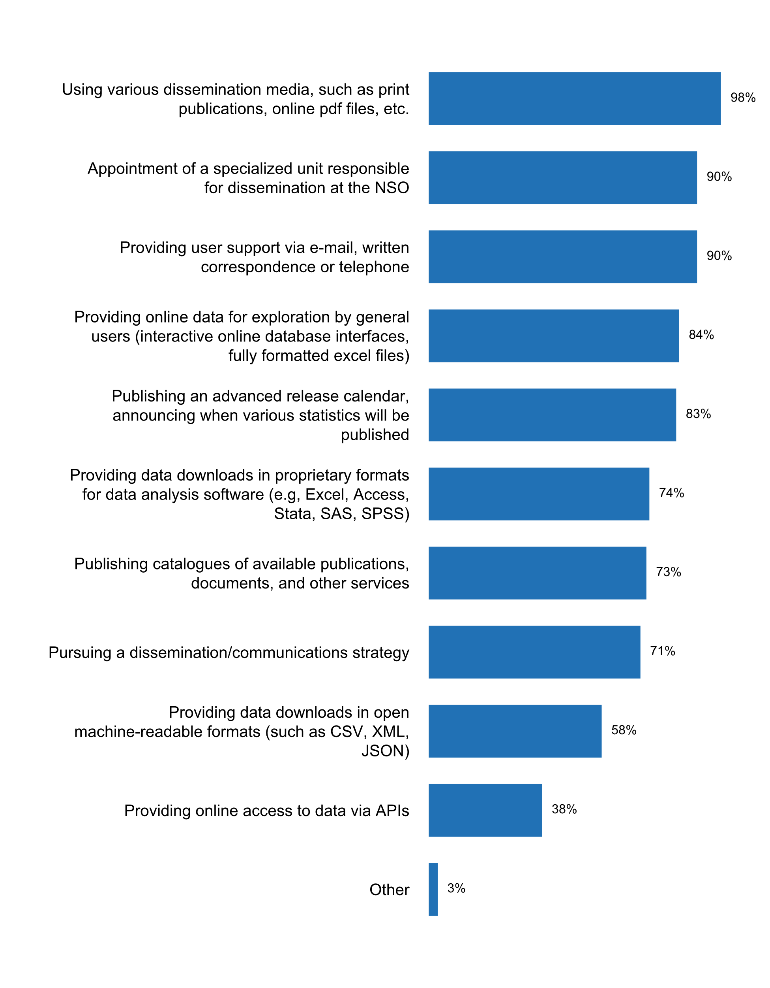

|  |  |  |  |  |  |  |
| --- | --- | --- | --- | --- | --- | --- |
| **Answer** | **Africa** | **Americas** | **Asia** | **Europe** | **Oceania** | **TOTAL** |
| Using various dissemination media, such as print publications, online pdf files, etc. | 16 | 13 | 24 | 35 | 3 | **91** |
| Appointment of a specialized unit responsible for dissemination at the NSO | 15 | 12 | 22 | 33 | 2 | **84** |
| Providing user support via e-mail, written correspondence or telephone | 12 | 12 | 21 | 35 | 4 | **84** |
| Providing online data for exploration by general users (interactive online database interfaces, fully formatted excel files) | 10 | 12 | 21 | 32 | 3 | **78** |
| Publishing an advanced release calendar, announcing when various statistics will be published | 10 | 12 | 18 | 35 | 2 | **77** |
| Providing data downloads in proprietary formats for data analysis software (e.g, Excel, Access, Stata, SAS, SPSS) | 8 | 9 | 18 | 30 | 4 | **69** |
| Publishing catalogues of available publications, documents, and other services | 12 | 9 | 17 | 27 | 3 | **68** |
| Pursuing a dissemination/communications strategy | 13 | 9 | 14 | 28 | 2 | **66** |
| Providing data downloads in open machine-readable formats (such as CSV, XML, JSON) | 4 | 7 | 11 | 29 | 3 | **54** |
| Providing online access to data via APIs | 4 | 5 | 5 | 20 | 1 | **35** |
| Other |  | 2 |  | 1 |  | **3** |

|  |  |  |  |  |  |  |
| --- | --- | --- | --- | --- | --- | --- |
| **Answer** | **Africa** | **Americas** | **Asia** | **Europe** | **Oceania** | **TOTAL** |
| Using various dissemination media, such as print publications, online pdf files, etc. | 94 | 100 | 100 | 100 | 75 | **98** |
| Appointment of a specialized unit responsible for dissemination at the NSO | 88 | 92 | 92 | 94 | 50 | **90** |
| Providing user support via e-mail, written correspondence or telephone | 71 | 92 | 88 | 100 | 100 | **90** |
| Providing online data for exploration by general users (interactive online database interfaces, fully formatted excel files) | 59 | 92 | 88 | 91 | 75 | **84** |
| Publishing an advanced release calendar, announcing when various statistics will be published | 59 | 92 | 75 | 100 | 50 | **83** |
| Providing data downloads in proprietary formats for data analysis software (e.g, Excel, Access, Stata, SAS, SPSS) | 47 | 69 | 75 | 86 | 100 | **74** |
| Publishing catalogues of available publications, documents, and other services | 71 | 69 | 71 | 77 | 75 | **73** |
| Pursuing a dissemination/communications strategy | 76 | 69 | 58 | 80 | 50 | **71** |
| Providing data downloads in open machine-readable formats (such as CSV, XML, JSON) | 24 | 54 | 46 | 83 | 75 | **58** |
| Providing online access to data via APIs | 24 | 38 | 21 | 57 | 25 | **38** |
| Other |  | 15 |  | 3 |  | **3** |

* Data users are also able to sign up for email notifications
* Quarterly press conferences
* geoportal, infographics, etc.

**Statistics covered in the calendar**

* All from the statistical operations of the INEC.- All macroeconomic statistics provided by the Banco Central de Costa Rica (BCCR).- Educational statistics of the Ministerio de Educacià³n Pàºblica (MEP).
* 1 Survey on the Wage of Workers engaged in Development Projects 2 Survey on Hire of Machinery and Equipment Used in the Development Projects 3 Construction Materials Price Survey 4 Survey on Building Permits 5 Survey on Price and Rental Rate of Housing in the Nation's Cities 6 Survey on Price and Rental Rate of Housing in Tehran 7 Survey of the Manufacturing Establishments with 10 and More Workers 8 Survey on the Nation's Operating Mines 9 Energy Consumption Survey in the Manufacturing Establishments with 10 or More Workers 10 Survey on Environmental Characteristics of the Operating Mines 11 Survey on Research and Development 12 Comprehensive Survey of Trade and Services 13 Survey of National Tourists 14 Survey of Household Behavioral Culture 15 Labour Force Survey (Annual results) 16 Labour Force Survey (Quarterly results) 17 Rural Households Income and Expenditure survey 18 Urban Households Income and Expenditure survey 19 Iran's Population and Health indicators in the year 1395 20 Selection of National Housing and Population Census Indicators, the years 1390 and 1395 21 Horticulture Survey 22 Livestock Slaughtering, the year 1396 23 Quarterly results of Livestock Slaughtering, the year 1397 24 Updating the Frame for the Survey of Broiler Farms 25 Updating the Frame for the Survey of Layer farms 26 Report of the Performances of the Statistical Centre of Iran 27 National Strategy for Development of Statistics National Statistical Plan) 28 The Consumer Price Index of Rural households (Monthly results) 29 Consumer Price Index of Rural households (Annual results) 30 Consumer Price Index of Urban Households (Monthly results) 31 Consumer Price Index of Urban Households (Annual results) 32 Consumer Price Index for Goods and Services of the Nation's households (National-monthly index) 33 Consumer Price Index for Goods and Services of the Nation's households (National-annual index) 34 Consumer Price Index for Goods and Services of Urban Households by Expenditure Deciles (monthly) 35 Consumer Price Index for Goods and Services of Urban Households by Expenditure Deciles (Annually) 36 Report of Average Price of Selected Food Items in Urban Areas- Monthly for the year 1396 37 Quarterly Results of the Producer Price Index (Monthly) 38 Annual Results of the Producer Price Index 39 Annul Results of the Survey on Prices in the Service Sector 40 Quarterly result of the Survey on Price index of services (s) 41 Price Index of Exported Goods (Annual report) 42 Price Index of Exported Goods (Quarterly report) 43 Price Index of Imported Goods ( Annual report) 44 Price Index of Imported Goods (Quarterly report) 45 Producer Price Index of Modern Cattle Farms Products ( Quarterly results) 46 Producer Price Index of Modern Cattle Farms Products (Annual results) 47 Producer Price Index of Modern Cattle Farms Products (Quarterly results) 48 Producer Price Index of Modern Cattle Farms Products (Annual results) 49 Quarterly Results of the Survey on the Prices Index in the Energy Sector 50 Annual Results of the Survey on the Prices Index in the Energy Sector 51 Producer Price Index of Manufacturing sector (Quarterly results) 52 Producer Price Index of Manufacturing Sector (Annual results) 53 Producer Price Index of Mining Sector (Quarterly results) 54 Producer Price Index of Mining sector (annual results) 55 Price Index of Sale and Expense of Agricultural Products and Services in Rural Areas (Quarterly results) 56 Price Index of Sale and Expense of Agricultural Products and Services in Rural Areas (Annual results) 57 Price Index of Residential Buildings Inputs in Tehran (Quarterly results) 58 Price Index of Residential Buildings Inputs in Tehran (Annual results) 59 Average Price Index of Sale and Expense of Agricultural Products and Services in Rural Areas (Quarterly results) 60 Average Price Index of Sale and Expense of Agricultural Products and Services in Rural Areas ( Annual results) 61 Iran Statistical Yearbook (Persian Version) 62 Iran Statistical Yearbook (English Version) 63 Iran Statistical Pocketbook (Persian Version) 64 Iran Statistical Pocketbook (English Version) 65 Quarterly Report of Iran's Economy 66 List and Profile of government agencies' Indicators 67 Iran National Accounts- Production method (national production) 68 Iran National Accounts- Expenditure method (national expenditure) 69 Quarterly National Accounts at Current and Constant Prices (Production Method) 70 Quarterly National Accounts at Current and Constant Prices (Expenditure Method) 71 Regional Accounts 72 Quarterly Report of Foreign Trade (Rial and dollar) 73 Index of Production in the Manufacturing Sector 74 Index of Production in the Agriculture Sector 75 Index of Production in the Mining sector
* 48 group, 82 set, 346 indicators
* According to the IMF regulations
* Agriculture, Industrial, Construction, Education, Health, Population, Standard Numbers, Transport and Communications, Trade, Environment, Living Conditions, Human Development
* Agriculture, forestry and fishery Catering and tourism Census Construction Culture Descriptive indicators and econometric analyzes Domestic trade Education Elections Energy Environment Household budget Survey, Income and Living conditions Survey Industry Judiciary Labour market National accounts Population Prices Register of spatial units Science, Technology and Innovation Statistical business register Transport and telecommunications Usage of ICT
* All Economic, social and Demographic Statistics are included.
* All information on economic, sociodemographic and environmental statistics and other domains included in the Inventory od Statistical Operations of the National Statistics Program
* All official publications.
* All official statistical products by UK government departments are announced and linked via the release calendar https://www.gov.uk/government/statistics . Devolved governments in Wales, Scotland and Northern Ireland have local websites for their statistical products: Scotland https://www2.gov.scot/Topics/Statistics, Wales: https://gov.wales/statistics-and-research/?lang=en and Northern Ireland: https://www.nisra.gov.uk/
* All official statistics produced by the Central Statistical Bureau of Latvia.
* All our data and statistics are released through the calendar.
* All our statistics are included in the release calendar
* All press release and publication that are produced from statistical surveys. The release calendar are up date once per year and is published on SSO Web site.
* All publications
* All statistical data are specified in the Plan of Statistical Observation for the current year
* All statistical domains are covered in the calendar.
* All statistical products
* All statistical products that are to be disseminated
* All statistical publications - Foreign Trade, CPI, LFS, National Accounts, BOP/IPP, Compendium of Statistics, Census, HBS, OWS and other occasional surveys
* All statistical topics: http://www.pcbs.gov.ps/calender.aspx?CurrentMonth=true
* All statistics are covered
* All statistics covered in the advanced released calendar are available at TurkStat’s website (http://www.tuik.gov.tr/takvim/tkvim.zul#tb1) and the web-page dedicated to OSP (http://www.officialstatistics.gov.tr/?q=en/content/national-data-release-2018-calendar).
* All statistics is covered in the calendar posted on the website at https://www.armstat.am/en/?nid=33
* All statistics produced by Statistics Belgium
* All the socio-demographic and economic Technical Reports issued by all the GSBPM related areas of the NSO.
* All the statistics produced by DANE are in the calendar. Dane produces close to 108 statistical operations. Please find in the following link the calendar in which it is possible to identify the release of the statistical production by 12 months in advance: http://www.dane.gov.co/index.php/calendario/year.listevents/2018/11/01/-
* All the statistics produced by NSO
* All the statistics released by DOSM and release calendar link is as follows:https://www.dosm.gov.my/v1/index.php?r=column/carc&menu_id=dkJWZjFlYnVsYXNCa09HNGVMSWRpQT09
* All the statistics released by INE: https://www.ine.es/daco/daco41/calen.htm
* All.
* Allhttps://www.czso.cz/csu/czso/catalogue-of-products
* An advanced release calendar covers all domains, themes, and forms (publications, data base events, releases) of statistics.
* An example: The Schedule of Release Dates for the Principal Federal Economic Indicators (PFEI) are published by the end of the prior fiscal year. For example, the 2019 PFEIs were posted by September 30, 2018.https://www.whitehouse.gov/wp-content/uploads/2018/09/pfei_schedule_releasedates_2019.pdf
* CPI, GDP, Trade Statistics, Wages and Prices in the Construction Industry (LPB), Annual an Quarterly Economic Statistics (EJS/EKS)
* Consumer Price Index (monthly) Foreign Trade (quarterly) Survey of Guest Movements in Hotel Establishments (annual) Transportation Statistics (quarterly)
* Consumer price Index, producer price Index, Annual and Quarterly GDP, Construction sector Indices
* Demography and social statistics Economic statistics Business statistics Agriculture, environment and regional statistics Multi-domain stats
* Economic and Financial Statistics;Social Statistics and; Monetary Statistics.
* Every November, SURS publishes a Release Calendar of announced publications for the following year. A publicly released Release Calendar for the current and previous years is easily accessible from SURS's website (https://www.stat.si/StatWeb/en/ReleaseCal). It covers all statistics defined in European regulations and agreements, and statistics covering national requirements and needs. The release calendar includes all releases, i.e. first releases, updates of the SI-STAT database and all other publications. The search engine allows browsing by title, producers, date, theme and sub-theme. Release Calendar also includes releases from authorized producers (NSS) with a link to the release on their website.
* For information on release calendar please refer to: https://www.istat.it/en/analysis-and-products/press-releases The press release for 2018 is available in Italian at https://www.istat.it/it/files//2013/12/calendario_2018.pdf
* Full content of the calendar can be found at: http://www.ksh.hu/katalogus/#/enIt covers the dates of publication of the following products in all subject matter statistcs:news releasespublicationspredefined (STADAT) tabledatasets of Dissemination database
* In the four-month calendar :ILO unemployment and labour market-related indicators (results of the labour force survey) Payroll employment Quarterly national accounts (first estimate) General government national accounts(first results) Industrial Production Index Monthly business survey (good producing industries) Quarterly business survey (good producing industries) Monthly survey of building Bi-monthly survey of wholesaling Monthly survey of retailing Monthly survey of services Industrial investment survey Enterprises births Business climate indicator and turning point indicator Flash estimate of payroll employment Household consumption expenditure on goods Monthly consumer confidence survey Consumer price index (provisional results) Consumer price index (final results) Industrial producer and import price indices Rent reference index Indexes of prices of second-hand dwellings Quarterly national accounts (second estimate) Quarterly national accounts (detailed figures) Debt of the general government according to the Maastricht definition Annual national accounts (first results)In the weekly calendar : Chiffre d'affaires dans l'industrie et la construction Enquàªte trimestrielle de conjoncture dans la promotion immobilière Enquàªte trimestrielle de conjoncture dans les travaux publics Volume des ventes dans le commerce; réparation d'automobiles et de motocycles Indice de production dans les services Chiffre d'affaires des grandes surfaces alimentaires Fréquentation touristique dans les hà´tels, campings et autres hébergements collectifs touristiques en France métropolitaine Enquàªte trimestrielle dans l'artisanat du bâtiment Enquàªte crédit-bail Indice du coà»t horaire du travail révisé - tous salariés Indices du coà»t du travail dans l'industrie, la construction et le tertiaire "L'emploi dans la fonction publique" "Les salaires dans la fonction publique" Indice des prix à  la consommation (moyennes annuelles) Indice des prix dans la grande distribution Indice des prix des logements neufs et anciens Prix du pétrole et des matières premières importées "Indices des prix agricoles" Indice du coà»t de la construction Indice des loyers commerciaux Indice des loyers des activités tertiaires Indices des prix à  la production des services aux entreprises Indice des prix de l'entretien-amélioration de logements Index bâtiment, travaux publics et divers de la construction Indice des coà»ts de production dans la construction
* In this point each year all members of NSS enrolled in Annual Plan they have obligation of presenting data of publication for all statistical products planned to be published. Then the calendar of publication is released in page web of NSO. For 2018, is already there in www.ine.gov.mz. For next year in January will be there. Once the calendar of publication is there the users has been communicated.
* Information disclosure calendar is publish on the website, include: CPI, IIP, and report on social economic
* Las producidas por el INEI, econà³micas, sociales y demogrà¡ficas. Contiene 21 boletines que se difunden en base a un calendario que se cumple.
* Monthly CPISectoral ReportsQuarterly Trade Statistics BulletinAnnual Trade Statistics BulletinQuarterly GDPAnnual National Accounts National Surveys such as: Annual Labour Force Survey; National Household Income and Expenditure Survey (NHIES);Ad Hoc Surveys in collaboration with the NSS
* National AccountsLabour ForceConsumer price IndexProducer Price IndexInternational Merchandise TradePopulation estimatesFrom Other AgenciesGovernment Finance StatisticsMonetary StatisticsBalance of Payments
* NÂ° Titre de publication Périodicité 1 Produit intérieur brut annuel Annuelle 2 Banque de Données Economiques et Financières Annuelle 3 Evolution annuelle de l'Indice Harmonisé des Prix à  la Consommation Annuelle 4 Projections démographiques Annuelle 5 Note d'Analyse du Commerce Extérieur Annuelle 6 Rapports du RGPHAE 2013 : Population Annuelle 7 Enquàªte Emploi Trimestrielle 8 Indices des Prix de Production des Services (IPPS) Trimestrielle 9 Note sur les Evolutions Economiques Récentes Trimestrielle 10 Produit intérieur brut trimestriel (base 2014) Trimestrielle 11 Indice du Coà»t de la Construction Trimestrielle 12 Note d'Analyse des Prix à  la Consommation Trimestrielle 13 Bulletin Mensuel des Statistiques Economiques Mensuelle 14 Repères Statistiques Mensuelle 15 Indice National des Prix à  la Consommation Mensuelle 16 Indice des Prix des Matériaux de Construction Mensuelle 17 Indice Harmonisé des Prix à  la Consommation Mensuelle 18 Production Industrielle mensuelle Mensuelle 19 Indice des Prix à  la Production Industrielle Mensuelle 20 Indice Mensuel des Prix du Commerce Extérieur Mensuelle 21 Bulletin Mensuel des Statistiques du Commerce Extérieur Mensuelle
* Please refer to the Advance Release Calendar via https://www.singstat.gov.sg/whats-new/advance-release-calendarThe following statistics are covered in the advance release calendar : National Accounts â€¢ Merchandise Trade â€¢ Manufacturing â€¢ Labour, Employment, Wages and Productivity â€¢ Prices and Price Indices â€¢ Services â€¢ Business Expectations â€¢ Public Finance â€¢ Finance and Insurance â€¢ Balance of Payments â€¢ External Debt â€¢ International Investment Position â€¢ Household Sector Balance Sheet â€¢ Population and Population Structure â€¢ Building, Construction, Real Estate and Housing
* Press releases, current data, statistical publications (data books and bulletins), statistical reviews for public holidays.
* Release calendar covers all statistical outputs for the current year. Calendar is updated in accordance with the annual statistical programme. The release calendar is available on the website.
* Statistics whose publication is foreseen in the Annual Statistical Work Program.
* Such as census of agricultureà€census of economic...
* The ABS disseminates statistics covering economic, social, population and environment domains. The ABS release calendar is available here
* The Advance Release Calendar (or ARC) covers statistics that are deemed most critical and essential for social and economic planning/analysis, e.g., population, health, national accounts, price index, inflation rate, rice/corn stocks, visitor arrivals, etc. This is as provided under Executive Order No. 352 - "Designation of Statistical Activities that will Generate Critical Data for Decision-Making of the Government and the Private Sector," which laid down the Philippines' System of Designated Statistics.
* The Institute's core statistics: GDP, CPI, External Trade, Labor Force
* The Official Statistics Act states that the Statistics Estonia shall disseminate official statistics in an objective and impartial manner and pursuant to the release calendar published on its website. A producer of official statistics shall not disseminate official statistics prior to the due date indicated in the release calendar.So, there is no publication of any statistics not included in the release calendar.
* The advance release calendar is accessible at: http://statsmauritius.govmu.org/English/Publications/Pages/Publication-Programme.aspxIt covers demographic, economic, financial, environmental and social statistics except Health statistics, which is produced by the Ministry of Health and Quality of Life and External Sector Statistics (E.g. Balance of Payments) and Monetary/Financial statistics, produced by the Bank of Mauritius.
* The advanced release calendar is IMF SDDS conform.
* The calendar covers all main statistics and publications such as: publications of services of official statistics, communications and announcements by the President of Statistics Poland, news releases of Statistics Poland and publications of other institutions that conduct statistical surveys withinPolish official statistical system.
* The calendar covers all the information of INEGI and the National Interest Information produced by the State Units and the release dates for the next year are updated every six months.
* The release calendar is found at: https://www150.statcan.gc.ca/n1/dai-quo/cal3-eng.htm Release dates for all major economic indicators are published a year in advance and a two week look ahead is provided for all releases.
* http://www.insse.ro/cms/files/catalog/Catalogul-publicatiilor_INS_2018.pdf
* http://www.statistica.md/pageview.php?l=en&id=5861&idc=213
* labour, population, household income & expenditure, agriculture, industrial, ICT , health, religious & culture, education.
* social and population and economic and data
* the statistics in relation with the standard NSDD

**Plot_11_Q01.4b.svg**

**Time span of the calendar**

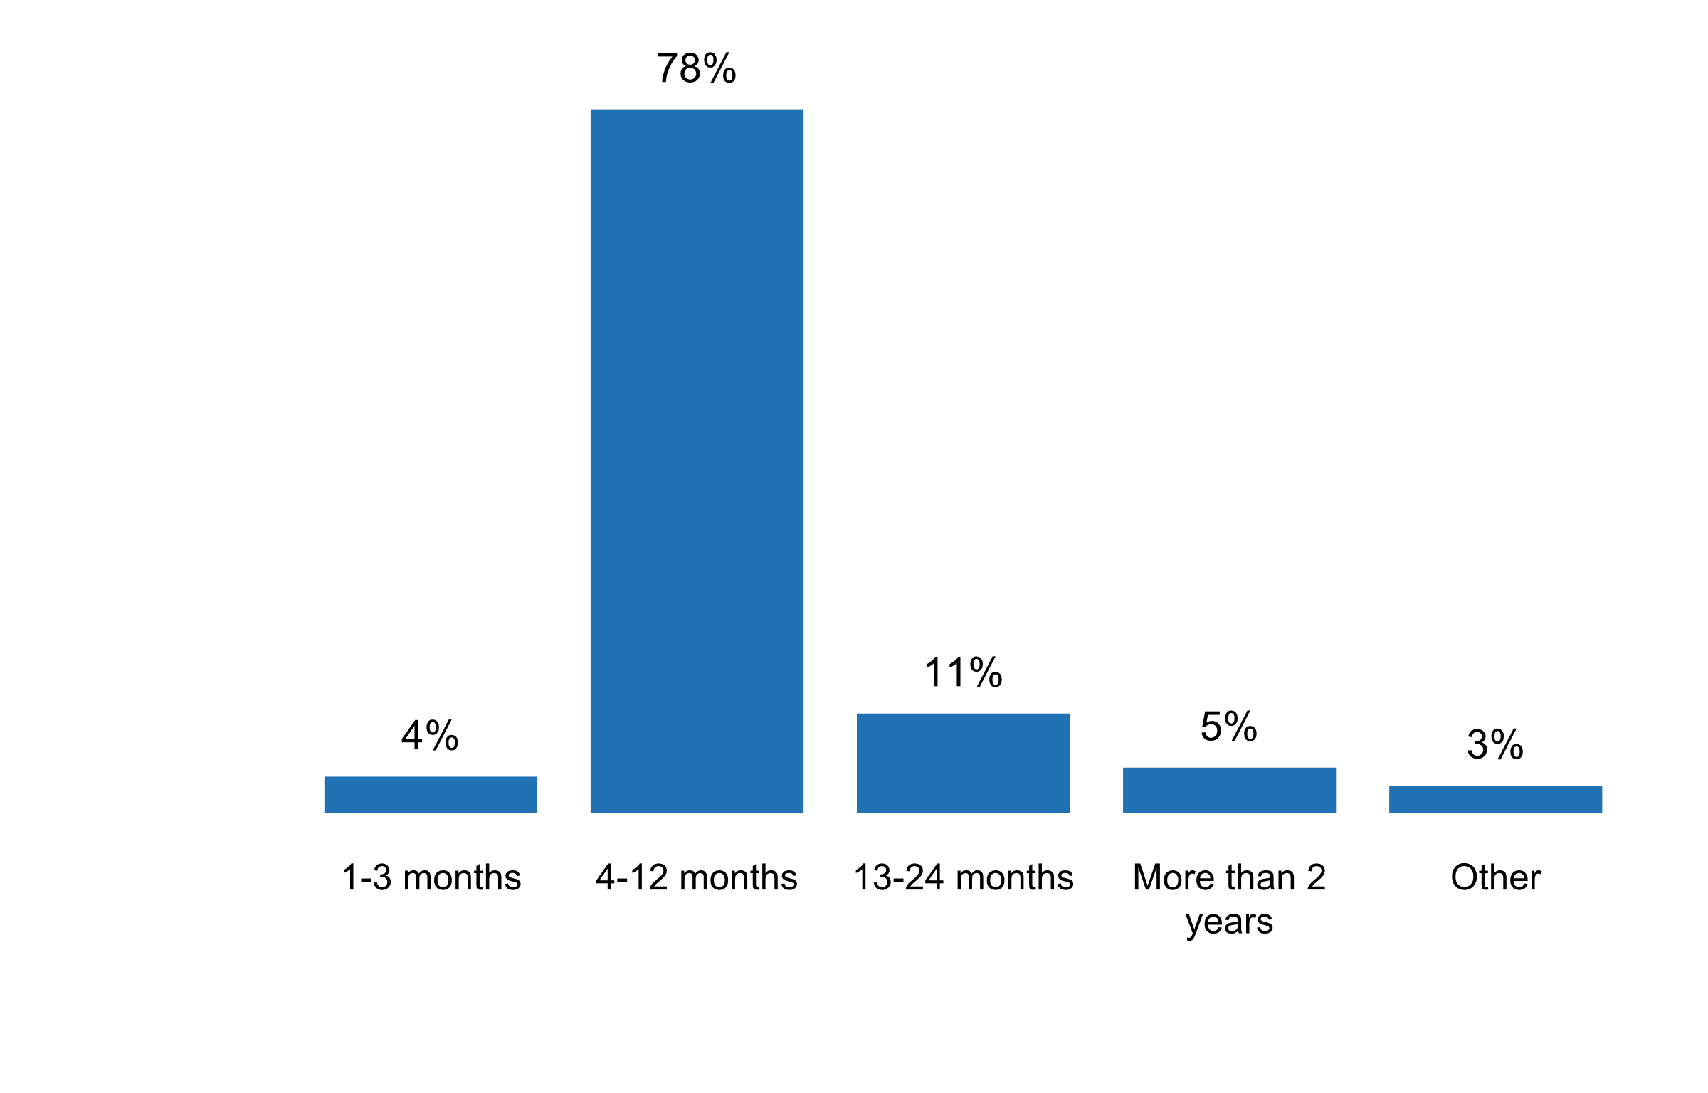

|  |  |  |  |  |  |  |
| --- | --- | --- | --- | --- | --- | --- |
| **Answer** | **Africa** | **Americas** | **Asia** | **Europe** | **Oceania** | **TOTAL** |
| 1-3 months |  |  | 3 |  |  | **3** |
| 4-12 months | 9 | 10 | 12 | 26 | 2 | **59** |
| 13-24 months | 1 | 1 | 1 | 5 |  | **8** |
| More than 2 years |  |  | 2 | 2 |  | **4** |
| Other |  | 1 |  | 1 |  | **2** |

|  |  |  |  |  |  |  |
| --- | --- | --- | --- | --- | --- | --- |
| **Answer** | **Africa** | **Americas** | **Asia** | **Europe** | **Oceania** | **TOTAL** |
| 1-3 months | 0 | 0 | 17 | 0 | 0 | **4** |
| 4-12 months | 90 | 83 | 67 | 76 | 100 | **78** |
| 13-24 months | 10 | 8 | 6 | 15 | 0 | **11** |
| More than 2 years | 0 | 0 | 11 | 6 | 0 | **5** |
| Other | 0 | 8 | 0 | 3 | 0 | **3** |

* 1-12 months
* 6-18 months

**Circumstances under which NSS needed approval to publish statistical information, and from whom, in the last five years**

* During the last 5 years, NBS did not need anyone approval for the publications
* We have 5 technical divisions comprising about 10-14 staff per division plus another two divisions for IT/Data processing and Corporate Services. Each of the 5 technical divisions is responsible for their own publicity/advocacy programs depending on the cycle of their work and depending on their own resources from both local and donor partners.
* Any approval by other than management of the HCSO concerning publications is only required if the product is the result of a collaboration between institutions (for example of a number of NSI-s or various ministries).
* Approval is not required, but advance submission for notation by Cabinet is required.
* Au cours des cinq dernières années, le Système Statistiques n'a eu recours à  aucune autorisation pour publier les informations statistiques.
* Committee on the Management the NSS (3 Major area: Social,Economic, and Natural Resource and Environment).
* Director of the Agency for statistics of the B&H
* El INEI autoriza mediante norma legal encuestas y censos del sistema estadà­stico nacional.
* For the Central Statistical Bureau of Latvia - never.
* Généralement, dans le Système statistique national (SSN), l'ANSD n'a pas besoin d'approbation pour publier ses statistiques; ce qui n'est pas souvent le cas des autres structures du SSN.
* INEGI is an autonomous Institution; therefore, it can establish its publication dates, always considering the principle of timeliness and following the recommendations and best international practices
* Il n'a pas besoin d'autorisation
* In case of current publications all members of NSS have their structure to publish their products. In case of NSO all publications are approved by the Head of the NSO.
* In the NSS, the head of each entity formally approves the dissemination of the information produced by the entity. In the case of the INEC, it is the Executive Director, who approves the publication of the information produced by the institute.
* It should be noted that the above platform are applicable to the NSO, however some members of the NSS use some platforms NOT all for disseminating. The NSDS is trying to address the limitations and shortfalls experienced by the members of the NSS.The Statistics Law gives the NSO a full mandate of independence, therefore when releasing / publishing statistical information--- the office does not need permission nor be influenced by anyone, the Statistician General/Chief Statistician is empowered by the Act to release the statistical information independently.
* Many a times the NSS publish (unofficial statistics) as part of their administrative records and as part of their annual reports.The Ministry of Home Affairs and immigration has entrusted the NSA to publish the CRVS statistics report.
* Many times during the period when INDEC suffered a political intervention (from January, 2007 until December 9, 2015).
* N/a
* NA
* NONE
* NSO never needed approval but is aware that some other producers do need ministerial approval
* NSS not in placeThe NSO does not need approval to publish statistics
* Never
* Never. Final approval to publish statistical information rests with the Chief Statistician.
* No
* No approval is required as the Director of Statistics decide on which statistical information is to be published.
* No approval needed
* No approval was needed.
* No cases of this type have been reported.
* No need.
* No, the State Council on Statistics approves it.
* No. The National Statistician releases statistical reports produced by NSO.
* None
* None excluding situations where Stats NZ sought a confidentiality waiver.
* Not applicable
* Not required as the Law on State Statistics of the Republic of Belarus enshrines the responsibility of state statistics bodies and authorized producers of official statistics to provide and disseminate the official statistical information and to ensure equal access of users to the official statistical information and its compilation methodology.
* Only in the case of surveys commissioned by international partners (UNICEF, ILO, UNDP), for which these agencies first review statistics produced and reports prepared prior to publication.
* Only the Board or the General Director of the NSO for NSO products
* SURS and authorized producers (equal Slovenian NSS) do not need any approval to publish statistical information.
* Section 2 - Declaration of Policy, of RA 10625, provides for an integrated statistical system characterized by independence, objectivity and integrity so as to enhance responsiveness to the requirements of equitable national development. Based on this provision, the PSA publishes statistical information as mandated by the statistical act and related laws such as Executive Order No. 352 which identifies and prescribes the schedule of generation/dissemination of critical statistics for planning purposes. Within the purview of these statutes, the PSA decides on publishing statistical information without interference nor needing prior approval from other entities.
* Statisticl information is published accordind to the Plan of state statistical observation for the cuurent year
* Such approval was not needed. The dissemination policy is the competence of NSI.
* Survey and Census reports needed to get approval from respective ministry. But for the later on, since new statistics law (2018) affected the departments or gov agencies need to get approval from Central Committee for Data Accuracy and Quality of Statistics which was chaired by vice president.
* The Census and Statistics Act 1905 (CSA): â€¢ requires the Australian Statistician to conduct the Census of Population and Housing every five years â€¢ requires the Australian Statistician to publish a quarterly population estimate for each Australian state and territory â€¢ empowers the Australian Statistician to collect statistical information on a broad range of demographic, economic, environmental and social topics â€¢ enables the Australian Statistician to legally direct a person to provide statistical information, and provides penalties for non-compliance with such a direction â€¢ requires the ABS to publish the results of all statistical collections.
* The INE (Spanish NSO) does not need approval to publish statistical information: INE is an independent institution that follows the calendar previously published, stated at the annual programmes and according to European Statistics Regulations and agreements.
* The NSO simply informs one day before the line Ministry and publishes.
* The NSS doesn't need approval to publish any statistical information from anyone.
* The National statistician has full independence
* The SSO does not make consultation and needs no approvment to publishe statistical information.
* The Statistics and Registration Services Act 2007 sets out the powers and responsibilities of the UK Statistics Authority, UK government departments and devolved administrations in publishing statistical information. Under the Act, the Authority (and NSO) can produce and publish statistics relating to any matter relating to the United Kingdom or any part of it without seeking further permission. The Authority reports directly to Parliament and is independent of ministerial control.
* The approval is not needed, because only the Director General of the Statistics Estonia shall decide on the use of statistical methods and standards, and on the content, form and term of dissemination of data subject to dissemination.
* The publication of statistics of Statistics Belgium is not subject to prior approuval.
* The validation of the information is internal. Each sector validases its data and publishes it then
* There are no restrictions on publication other than in violation of the law
* There has been no need for any approvement.
* There is no intervention from any party regarding the publication of statistics.
* There was no such phenomenon. Otherwise, it would result in noncompliance with the Professional Independence Principle, defined in the National Law of Statistics.
* WHEN IT HAS TO ORGANISE WORKSHOPS IN THE BIG LADDER.
* We do not register this type of circumstances in the NSS.
* We publish basic national data and to regulatly disseminate to the general public statistical information with regard to the national economic and social development.
* Within the framework of NSDS and approval of the High Council of Statistics
* each secretary of state has a planning unit that is responsible for making its institutional publications, and as NSS the publication is done by the ONS performed by the ONS in the national statistical yearbook
* from General Director, and Statistic Integrated Department
* the NSI didn't need approuval to publish statistical information we just send un email for the minister to inform him that statistics are poublished on the web site

**Plot_12_Q01.4c.svg**

**Frequency of adjustments to the release dates specified in the calendar**

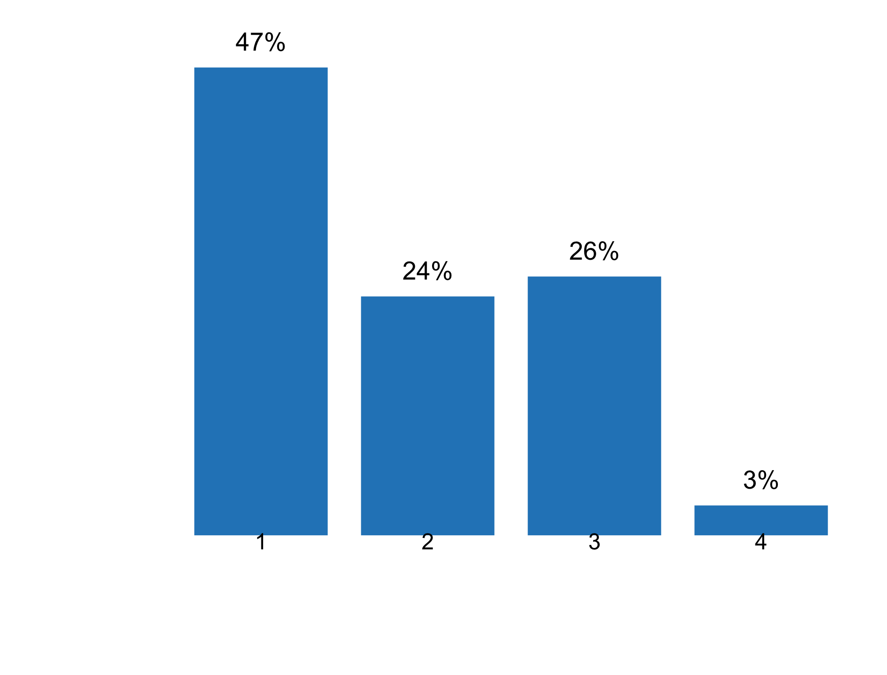

|  |  |  |  |  |  |  |
| --- | --- | --- | --- | --- | --- | --- |
| **Answer** | **Africa** | **Americas** | **Asia** | **Europe** | **Oceania** | **TOTAL** |
| 1 | 4 | 7 | 8 | 17 |  | **36** |
| 2 | 1 | 3 | 4 | 9 | 1 | **18** |
| 3 | 5 | 2 | 5 | 7 | 1 | **20** |
| 4 |  |  | 1 | 1 |  | **2** |

|  |  |  |  |  |  |  |
| --- | --- | --- | --- | --- | --- | --- |
| **Answer** | **Africa** | **Americas** | **Asia** | **Europe** | **Oceania** | **TOTAL** |
| 1 | 40 | 58 | 44 | 50 | 0 | **47** |
| 2 | 10 | 25 | 22 | 26 | 50 | **24** |
| 3 | 50 | 17 | 28 | 21 | 50 | **26** |
| 4 | 0 | 0 | 6 | 3 | 0 | **3** |

**Plot_13_Q01.6.svg**

**Groups of users given access to statistics prior to their public release in the past five years**

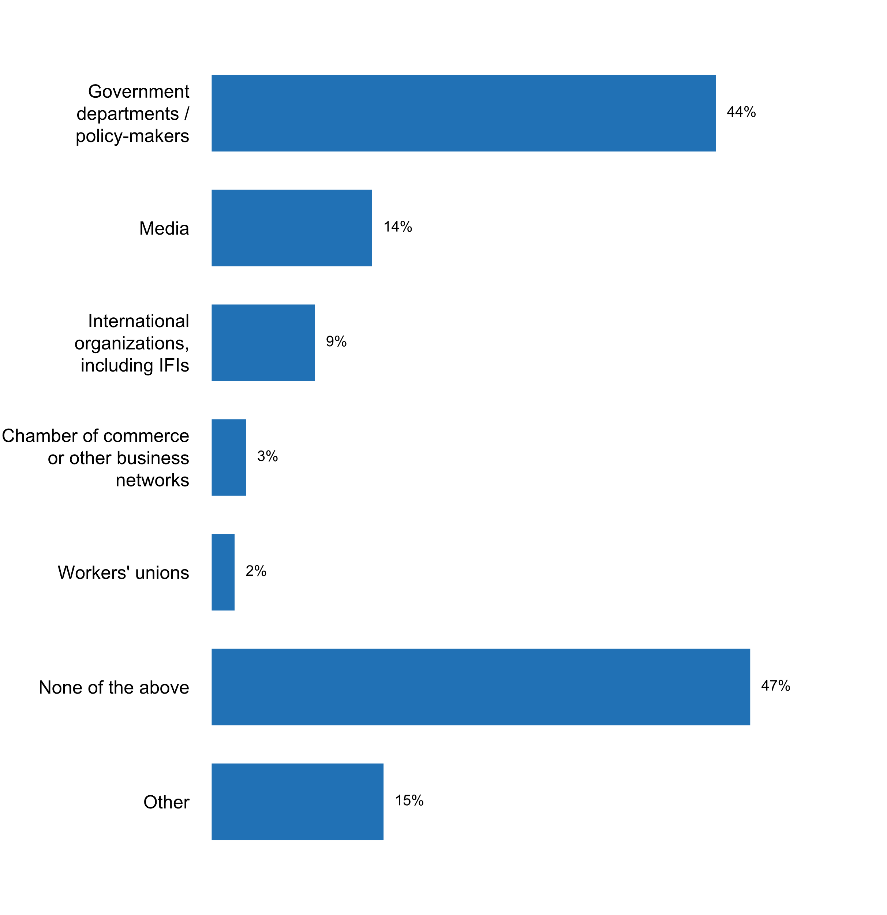

|  |  |  |  |  |  |  |
| --- | --- | --- | --- | --- | --- | --- |
| **Answer** | **Africa** | **Americas** | **Asia** | **Europe** | **Oceania** | **TOTAL** |
| Government departments/policy-makers | 7 | 9 | 10 | 12 | 3 | **41** |
| Media | 1 |  | 5 | 6 | 1 | **13** |
| International organizations, including IFIs | 3 |  | 2 | 2 | 1 | **8** |
| Chamber of commerce or other business networks | 1 |  | 2 |  |  | **3** |
| Workers' unions | 1 |  | 1 |  |  | **2** |
| None of the above | 9 | 2 | 12 | 20 | 1 | **44** |
| Other | 3 | 5 | 1 | 5 |  | **14** |

|  |  |  |  |  |  |  |
| --- | --- | --- | --- | --- | --- | --- |
| **Answer** | **Africa** | **Americas** | **Asia** | **Europe** | **Oceania** | **TOTAL** |
| Government departments/policy-makers | 41 | 69 | 42 | 34 | 75 | **44** |
| Media | 6 |  | 21 | 17 | 25 | **14** |
| International organizations, including IFIs | 18 |  | 8 | 6 | 25 | **9** |
| Chamber of commerce or other business networks | 6 |  | 8 |  |  | **3** |
| Workers' unions | 6 |  | 4 |  |  | **2** |
| None of the above | 53 | 15 | 50 | 57 | 25 | **47** |
| Other | 18 | 38 | 4 | 14 |  | **15** |

* Academicians, investigators
* Cabinet, Ministry of Finance and Economic Development
* Central Bank, Commission for Statistics
* Council of Economic Advisors, to brief the President
* Inter-Agency Planning Group (IAPG) involving only related central planning agency
* Media but in a secure lockup room. They cannot publish prior to official release by Statistics Canada.
* News agencies
* None
* Our law and policy do not allow for the access to statistics prior to the release.
* Possible exemptions for paid assignments, but in case this is announced for the users
* SIB's Board of Directors
* The Federal Law of November 29, 2007 No. 282-Ð¤Ð— On Official Statistical Accounting and the System of State Statistics in the Russian Federation does not provide an access to statistical data prior to their public release.
* The Minister responsible for Statistics and the Financial Secretary
* We changed our policy in 2018. we stopped pre-releases for any media / news agencies

**Plot_14_Q01.6a.svg**

**If any user has access to a pre-release, is this publicly identified?**

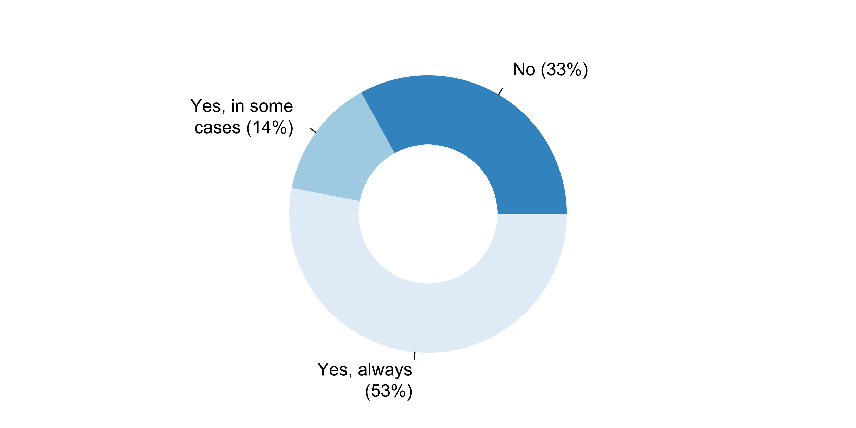

|  |  |  |  |  |  |  |
| --- | --- | --- | --- | --- | --- | --- |
| **Answer** | **Africa** | **Americas** | **Asia** | **Europe** | **Oceania** | **TOTAL** |
| No | 4 | 4 | 6 | 1 | 1 | **16** |
| Yes, in some cases | 3 |  | 3 | 1 |  | **7** |
| Yes, always | 1 | 7 | 3 | 13 | 2 | **26** |

|  |  |  |  |  |  |  |
| --- | --- | --- | --- | --- | --- | --- |
| **Answer** | **Africa** | **Americas** | **Asia** | **Europe** | **Oceania** | **TOTAL** |
| No | 50 | 36 | 50 | 7 | 33 | **33** |
| Yes, in some cases | 38 | 0 | 25 | 7 | 0 | **14** |
| Yes, always | 13 | 64 | 25 | 87 | 67 | **53** |

**Additional details on pre-release**

* A press briefing is provided for major release, 30 min before publication. Information is strictly embargoed until the publication time. A record of attendees is kept and may be published. Pre release access for officials is done by means of a application process. All officials with pre release access are published on our website. Pre release access for officials is in general restricted to 1 hour before publication and only those officials approved can access the data.
* Access to pre-release information is permitted in specific circumstances according to strict rules outlined in our Agency's Official Release Policy.
* According to the IMF regulations
* Certaines statistiques prennent du temps avant d'àªtre publiées. C'est le cas par exemple des rapports thématiques du recensement de la population et de l'habitation.
* Due to the role of some key user groups in the economic and political life, there is a greater interest that they access the information earlier. The pre-release access covers a very narrow scope, is controlled and connected to a target, therefore, the possibility of misusing the information received so is minimized. This is ensured by internal technical and other rules depending on the type of the preliminary access. At 8.30 a. m., prior to the publication at 9 a. m., journalists visiting the press room can read the first releases about the most important indicators, but are allowed to transmit data only at 9 a. m. sharp, after the release by HCSO. All media must adopt the terms of using the pressroom in a written statement which includes the legal consequences applicable in case of the infringement of these conditions. First releases not belonging to the above scope are sent electronically at 8.30 a. m. on the day of publication to news agencies and editorial staffs which requested them, based on a prior agreement. Certain first releases are sent to the members of the government and the president of the Central Bank of Hungary at 5 p. m. on the day prior to the publication, after closing the continuous phase of trading in the Budapest Stock Exchange. All who are concerned receive first releases in the topic the knowledge of which is essential in their work. The responsible use of our data is ensured by strict rules. Data files transmitted to international organizations may also be under embargo at the time of data transmission. During the data transfer to Eurostat, a secure channel excludes the access of unauthorized people to the data.
* Example taken from CPI sheet:Vice-President, Ministers of Finance and Trade, Industry & Tourism, the Governor of Central Bank as well as the Chairperson of the Commission for Statistics get 1-2 hours head start
* Five out of around 40 print publications are given in printed form to only one Minister each 24 hours before publication.The pre-release is stated in the foreword of the publication.
* INEGI made available the economical information twelve hours before its release to the Office of the President of Mexico, the Central Bank and the Ministers of Finance, Economy and Labour.
* Impartiality, objectivity and transparency of the production and dissemination of official statistics are guaranteed by the compliance of the NSO with the principles 6, 8 and 15 of the European statistics code of practice. In particular, pre-release rules are harmonized for the most important statistics of the NSS and are gradually posted on the Internet; timetables of structuring statistics are published on the web.
* NSO and NSS are complaining with Code of Good Practices, African Chart of Statistics and UN principles, specially the principle defending the equal access of statistics for all users that is why we advice all members of NSS to publish all statistical products acording the calendar of publication ensuring the punctuality and equal access for all users.
* Nil
* Only a delivery is made to the secretaries of state who need timely information and presidency of the republic, then a formal launch is made
* Our release practices policy guides how Stats NZ gives access to its data, statistics, and information. Most of Stats NZ's information releases are made public to all New Zealanders at the same time, generally 10.45am. The release calendar shows when releases will be available. Generally, there is no prior access for any stakeholders, including government ministers. However, some â€˜market-sensitive' or â€˜topical releases' may be available for advance briefing under embargoed conditions. Such access is at the discretion of the Government Statistician. It is provided to ensure stakeholders and commentators are well informed and to promote the value of the data and its story.https://www.stats.govt.nz/about-us/legislation-policies-and-guidelines/information-releases-embargoes-and-sanctions/
* Please refer to ABS: Policy on Pre-Release Access to ABS Statistics and Publications.
* Please see: https://statistiques.public.lu/en/actors/statec/policies/prerelease/index.html
* Pre-release access to statistical outputs from the Office for National Statistics (the NSO) ceased in July 2017 at the instruction of the National Statistician, other than for exceptional circumstances. The overarching principle is that an exceptional circumstance is where someone would need to act or make a decision in the public interest on the basis of the statistics. Not granting pre-release in such a case runs the risk of decisions being made on the basis of out of date information. Pre-release access granted exceptionally by the NSO is always fully transparent and documented here: https://www.ons.gov.uk/aboutus/transparencyandgovernance/prereleaseaccess . The only exemptions to date have been given to the Bank of England Monetary Policy Committee and the Office for Budget Responsibility.For other government departments that produce official statistics, pre-release access is regulated through the Statistics and Registration Services Act 2007 and associated Pre-Release Access to Official Statistics Orders for England, Wales, Scotland and Northern Ireland. This feeds through into the Code of Practice for Statistics. Ministers of the Crown and their equivalents in devolved governments may grant pre-release access through these Orders. The length of access allowed by the Orders varies. In England it is 24 hours. In Scotland, it is 5 days.Departments must publish a current list of all those who have pre-release access to each statistical release.
* Pre-releases provided to key parties (Prime Minister's Office, Minister responsible for Statistics, NSO Board of Directors), no earlier than 24 hours prior to release and no later than 2 hours prior to release. This is provided so that these parties may be prepared for queries from the media and the public regarding statistics being published.
* Prelease access is available in metadata on website.It is provided no more than 24 hours
* Prior to the relese, DOSM will present the statistics to the Inter-Agency Planning Group (IAPG) consist of members from specific government agencies.
* Relevant information is provided in the Special Data Dissemination Standards webpage (under Singapore, item 1.2.2 [internal governmental access to statistics prior to release]).
* Since 2015, all the users has access at the same time to the NIS releases.
* Some Ministries receive statistics up to 24 hs in advance in connection with their respective official release date. All these procedures are being carried out in accordance with the SDDS standards and knowledge.
* Some top level government officials or departments.
* Statistical Policy Directive #3:The chairman of the Council of Economic Advisors receives the statistics the day prior to the official release date so that he/she can brief the President.Details:https://www.whitehouse.gov/sites/whitehouse.gov/files/omb/assets/OMB/inforeg/statpolicy/dir_3_fr_09251985.pdf
* The Federal Statistical Office complies with the provisions of the European Code of Practice and gives pre-release information only to specific users and to a limited extent, which is documented on the webside.https://www.destatis.de/EN/PressServices/Press/pr/PreRelease.htmlGenerally, embargoed press releases are made available to the relevant agencies not earlier than the day before release.
* The Minister responsible for Statistics and the Financial Secretary are given the main findings of the statistical releases for information 1 working day before official release.
* The Secretary of Socioeconomic Planning (National Economic and Development Authority), as Chair of the PSA Board and/or as presiding officer in press conferences on the release of some critical statistics, such as the CPI, LFS results, national accounts, etc., is provided advance copies of press releases for review (usually, one day in advance) before they are disseminated to the public.
* The list of recipients is annually approved by the NSI President.
* The reports are submitted to the Ministry of Finance and Economic Development which forwards it to the Cabinet through the Minister for notation prior to release, in accordance with Section 8 of the Statistics Law
* The statistical results delivery policy of the INEC establishes that the results are delivered to government authorities corresponding to the subject (specifically to the minister) 24 hours before its release.
* This are technical working groups and agencies who provide source data
* Up to 2016 news agencies had access to some statistics 20 minutes prior to their public release under embargo. In 2016 this practice ended.
* We publish a pre-release form before we release the data officialy.
* With regard to the Rules for the Preparation and Dissemination of Statistical Information, Statistics Lithuania provides an opportunity for the Prime Minister and the Ministers of Finance, Economy, and Social Security and Labour of the Republic of Lithuania to receive news releases on, half an hour prior to the official release of this statistical information. The persons listed above are obligated not to disseminate statistical information received prior to its official release.
* https://www.csb.gov.lv/en/about-us/overview/policy-on-pre-release-access

**Plot_15_Q01.7a.svg**

**Conditions for online access to aggregates and/or microdata**

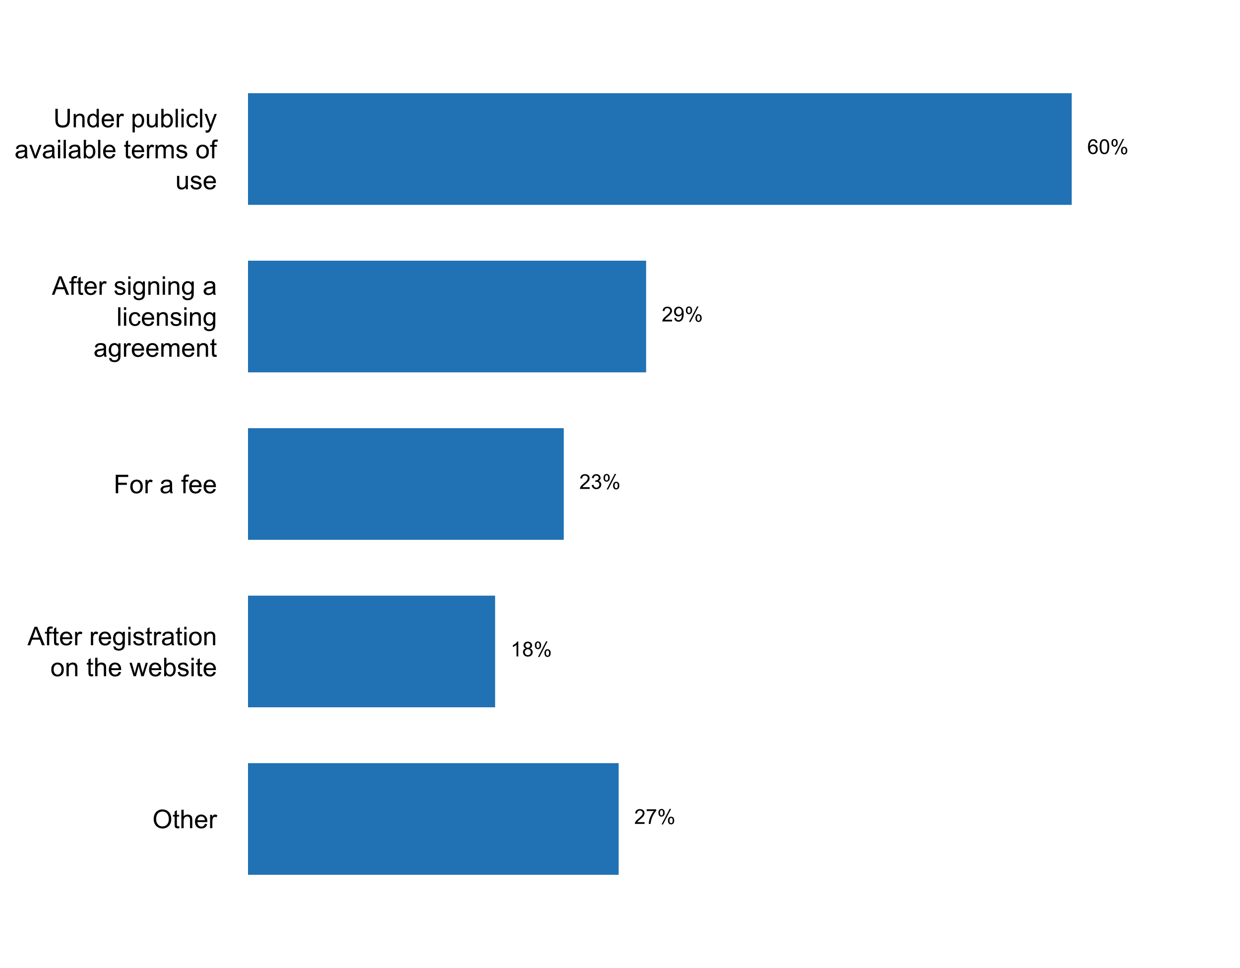

|  |  |  |  |  |  |  |
| --- | --- | --- | --- | --- | --- | --- |
| **Answer** | **Africa** | **Americas** | **Asia** | **Europe** | **Oceania** | **TOTAL** |
| Under publicly available terms of use | 6 | 10 | 14 | 23 | 3 | **56** |
| After signing a licensing agreement | 1 | 4 | 8 | 12 | 2 | **27** |
| For a fee | 2 | 1 | 8 | 8 | 2 | **21** |
| After registration on the website | 3 | 2 | 5 | 6 | 1 | **17** |
| Other | 7 | 6 | 4 | 8 |  | **25** |

|  |  |  |  |  |  |  |
| --- | --- | --- | --- | --- | --- | --- |
| **Answer** | **Africa** | **Americas** | **Asia** | **Europe** | **Oceania** | **TOTAL** |
| Under publicly available terms of use | 35 | 77 | 58 | 66 | 75 | **60** |
| After signing a licensing agreement | 6 | 31 | 33 | 34 | 50 | **29** |
| For a fee | 12 | 8 | 33 | 23 | 50 | **23** |
| After registration on the website | 18 | 15 | 21 | 17 | 25 | **18** |
| Other | 41 | 46 | 17 | 23 |  | **27** |

* According to the data dissemination policy
* Aggregated official statistics and publicly available anonymised microdata are available free of charge and without pre-registration.
* All standard aggregate data is provided online and free of charge. It is governed by an open license: https://www.statcan.gc.ca/eng/reference/licence
* All statistical information produced according to the Official Statistics Work Programme is published and provided for the general public free of charge on the Official Statistics Portal. Statistics Lithuania also provides statistical information on individual request (enquiry). Individual request (enquiry) is a request by a user to provide him/her with a certain piece of statistical information, submitted via the Official Statistics Portal. A response to the request (enquiry) is prepared by the divisions of Statistics Lithuania within the area of their competence. Statistical information collected, processed and published under the Official Statistics Work Programme on the Official Statistics Portal and released according to the Catalogue of Statistical Publications is available free of charge. Responses to statistical enquiries are to be paid for only if additional or more detail statistical information is requested than indicated in the Official Statistics Work Programme. Confidential statistical data can be provided for scientific purposes to the researchers of national and foreign higher education and research institutions as defined in the Law on Higher Education and Research of the Republic of Lithuania; also to researchers of institutions mentioned in 2012/200/EU: Commission Decision of 18 April 2012 amending Decision 2004/452/EC laying down a list of bodies whose researchers may access confidential data for scientific purposes. Confidential statistical data are provided on an electronic medium or a remote desktop, in a manner that does not enable the direct identification of the respondent. Strict protocols apply to external users accessing statistical microdata for research purposes.
* By applying for access through Microdata Access Program
* By negotiation
* Everybode has free and eqaul access to aggregated data. Access to microdata is given only to reasearchers and others that are approved for this.
* For free and we do not have any licensing agreement or terms of use per se.
* For free at the statistical portal, and open data site under condition to mention the data source.
* For free.
* Free
* Free of charge and so far no registration necessary (will change soon)
* L'accès est libre et gratuit
* Les données peuvent àªtre consultées sans coà»t et sans contrat de licence
* Microdata can be accessed for scientific purposes after signing an agreement, which is usually done for a fee. Aggregates can be accessed online without any restrictions.
* Not applicable. Currently working on the development for publishing micro data
* On the online data on free accessible.
* They are published on the web INEC
* accès gratuit et libre pour les statistiques et les microdonnées anonymisées en ligne
* at no cost to user
* data warehouse available online, user can access without registration
* free of charge
* memorandum of understanding (MoU) - Selected Micro Data
* www.microdata.no

**Plot_16_Q01.7b.svg**

**Conditions for re-distribution of anonymized microdata data and aggregates**

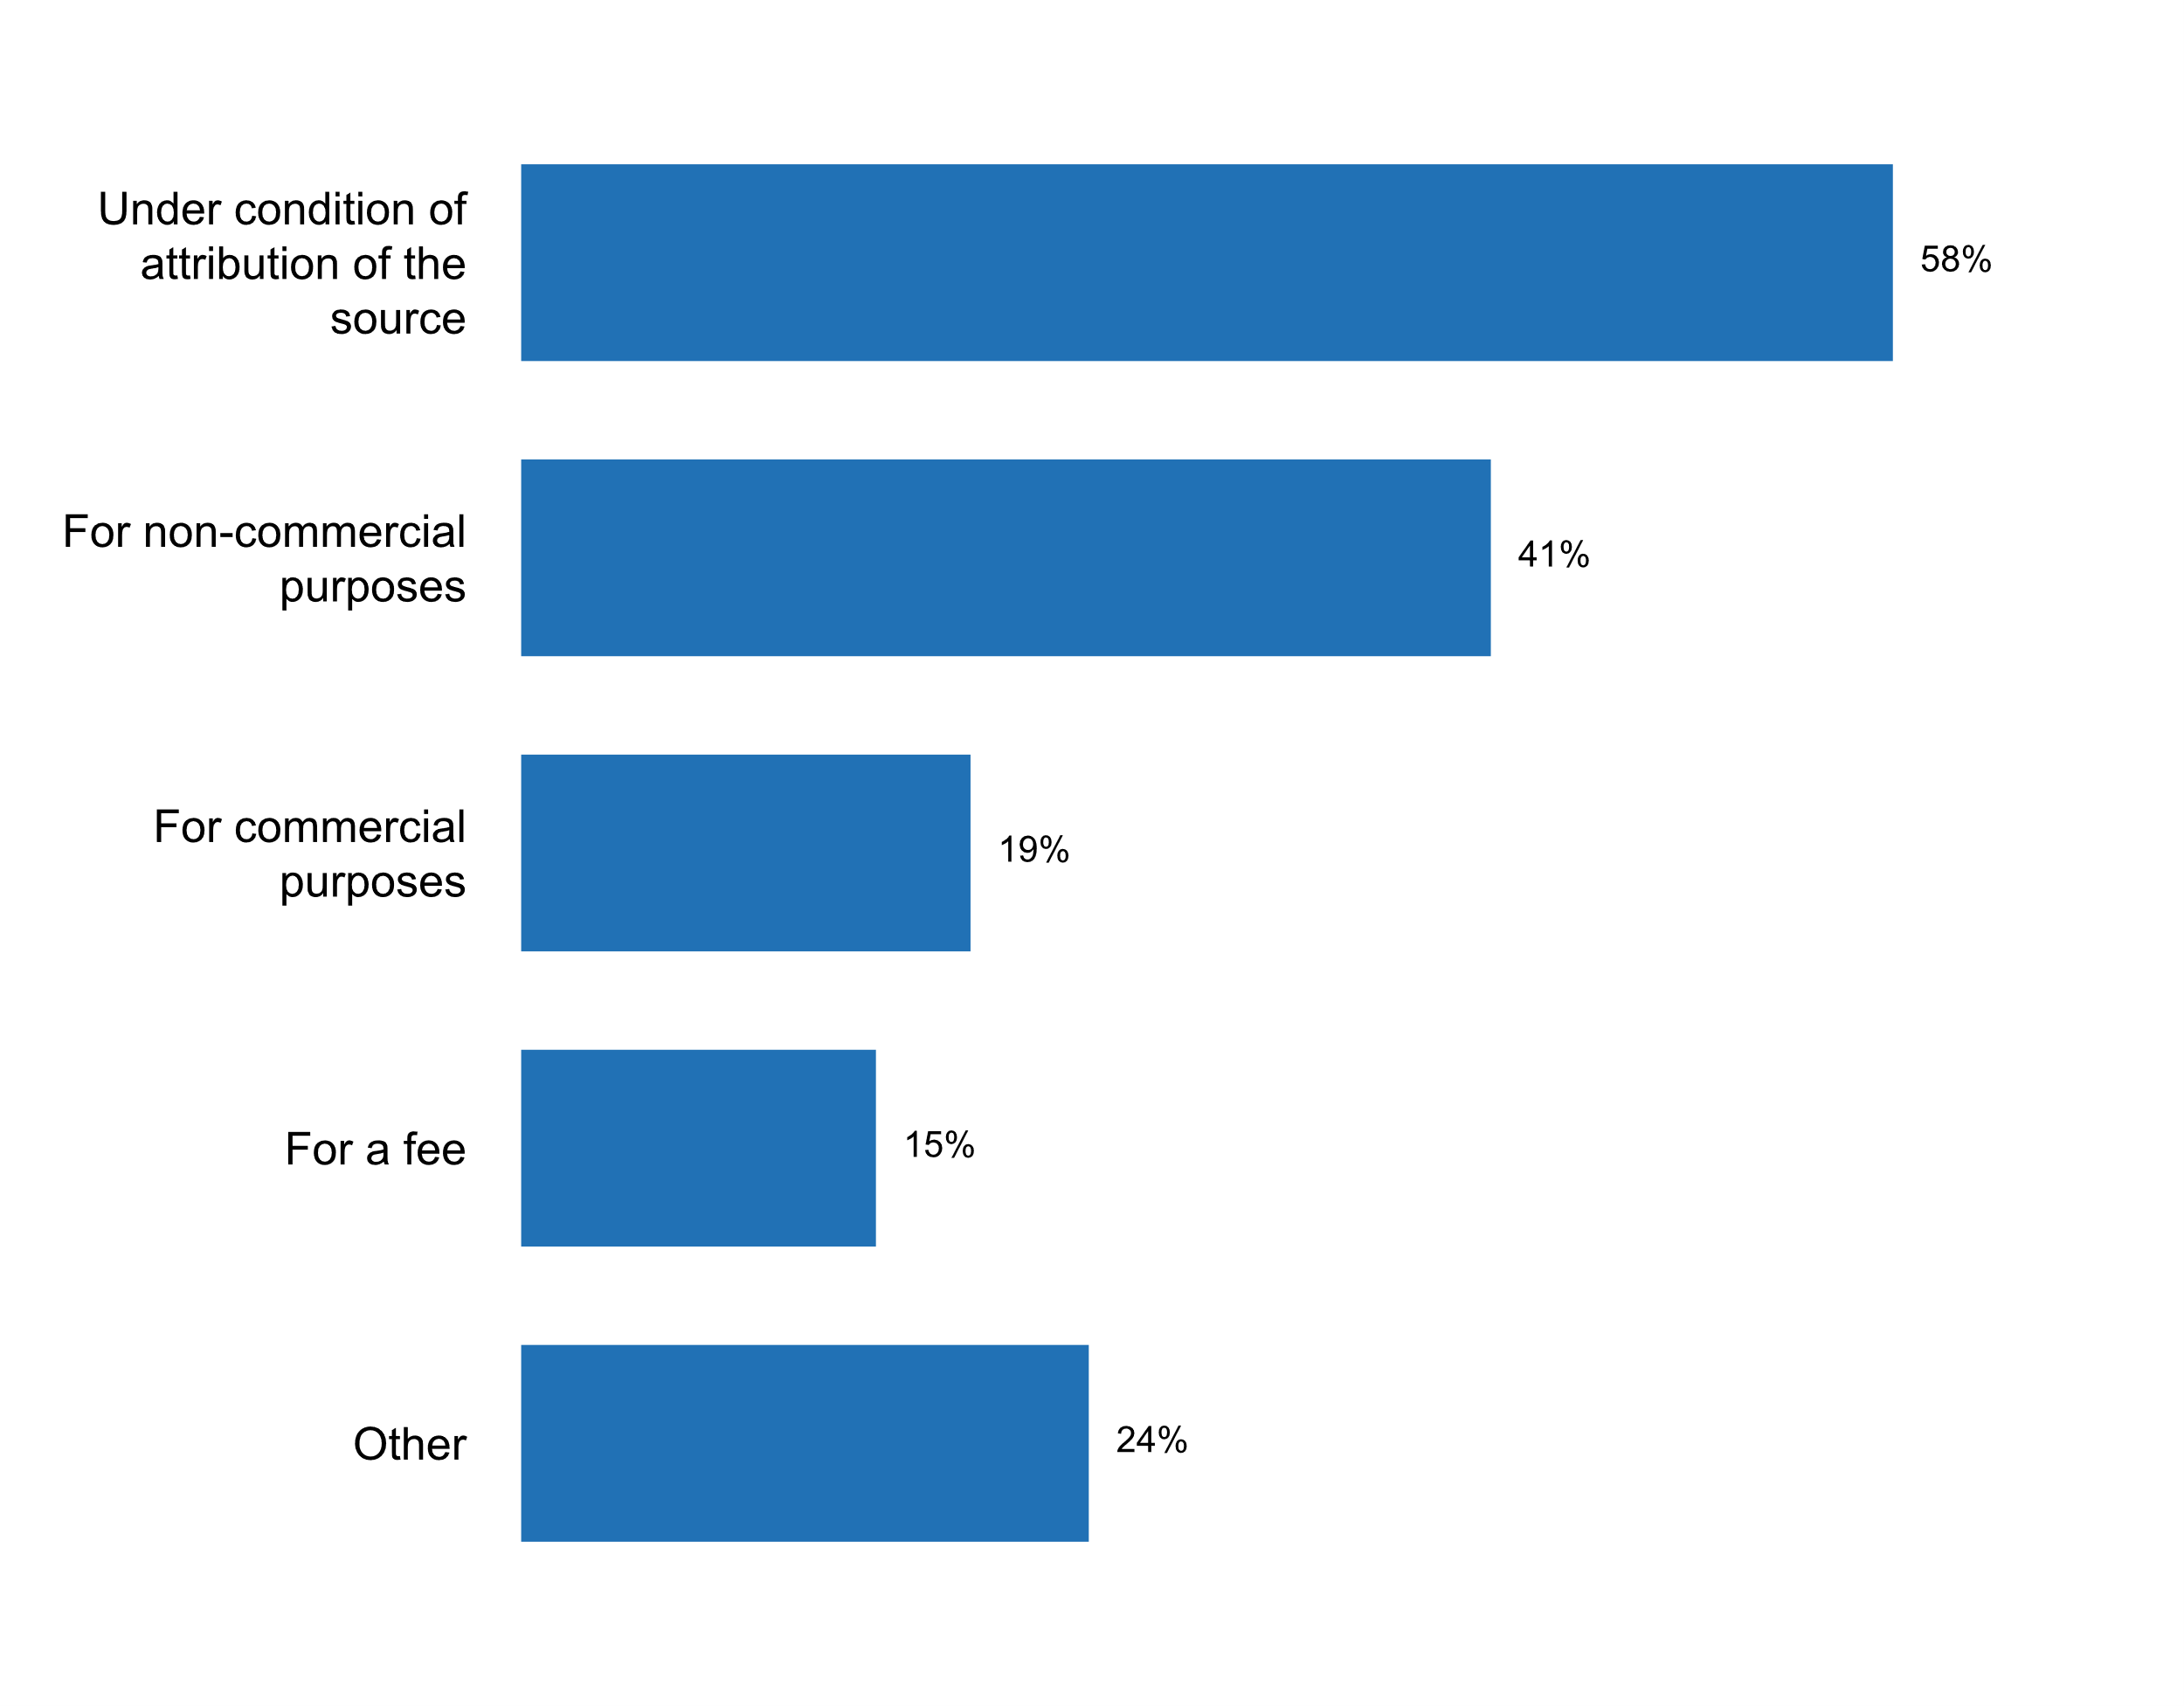

|  |  |  |  |  |  |  |
| --- | --- | --- | --- | --- | --- | --- |
| **Answer** | **Africa** | **Americas** | **Asia** | **Europe** | **Oceania** | **TOTAL** |
| Under condition of attribution of the source | 9 | 7 | 16 | 20 | 2 | **54** |
| For non-commercial purposes | 10 | 6 | 10 | 11 | 1 | **38** |
| For commercial purposes | 4 | 4 | 3 | 7 |  | **18** |
| For a fee | 3 | 1 | 3 | 7 |  | **14** |
| Other | 4 | 6 | 2 | 9 | 1 | **22** |

|  |  |  |  |  |  |  |
| --- | --- | --- | --- | --- | --- | --- |
| **Answer** | **Africa** | **Americas** | **Asia** | **Europe** | **Oceania** | **TOTAL** |
| Under condition of attribution of the source | 53 | 54 | 67 | 57 | 50 | **58** |
| For non-commercial purposes | 59 | 46 | 42 | 31 | 25 | **41** |
| For commercial purposes | 24 | 31 | 13 | 20 |  | **19** |
| For a fee | 18 | 8 | 13 | 20 |  | **15** |
| Other | 24 | 46 | 8 | 26 | 25 | **24** |

* Aggregates - under condition of attribution of the source; Anonymized microdata - any re-distribution is not foreseen.
* Aggregates can be re-distributed for commercial purposes. Anonymized microdata cannot be re-distributed under any circumstances.
* Anonymised microdata cannot be redistributed
* Anonymised microdata cannot be redistributed but others can such as data downloads available in proprietary formats on the website of Statistics Mauritius.
* By negotiation
* For research. Only Danish research environments are granted authorisation. Access is given to anonymised micro data.
* In conformity with Law 226/2009 and Reg. No. 557/2013.
* Microdata canÂ´t be re-distributed
* N/A The conditions in which (post-release) micro data is available may happen, varying amongst agencies. For example, to access certain Census Bureau microdata, you have to be a sworn Census Bureau employee.
* Never, unless express approval from SIB is obtained
* No
* Not applicable
* Not for anonymised microdata
* Only aggregates can be distributed for any purposes (commercial and non-commercial).
* Other: Statistics Canada's open license now applies to public use microdata files.
* Under condition of respecting data protection rules
* free of charge
* if bilateral agreement is made and a minimal fee is paid
* only aggregated datrasets for non-commercial purposes with the indication of the source
* only aggregates can be re-distributed
* quelques microdonnées sont fournies aux bureaux d'étude privés contre paiement marginal

**Plot_17_Q01.7c.svg**

**Conditions for distribution of derivative works based on the aggregates and/or microdata that are available online**

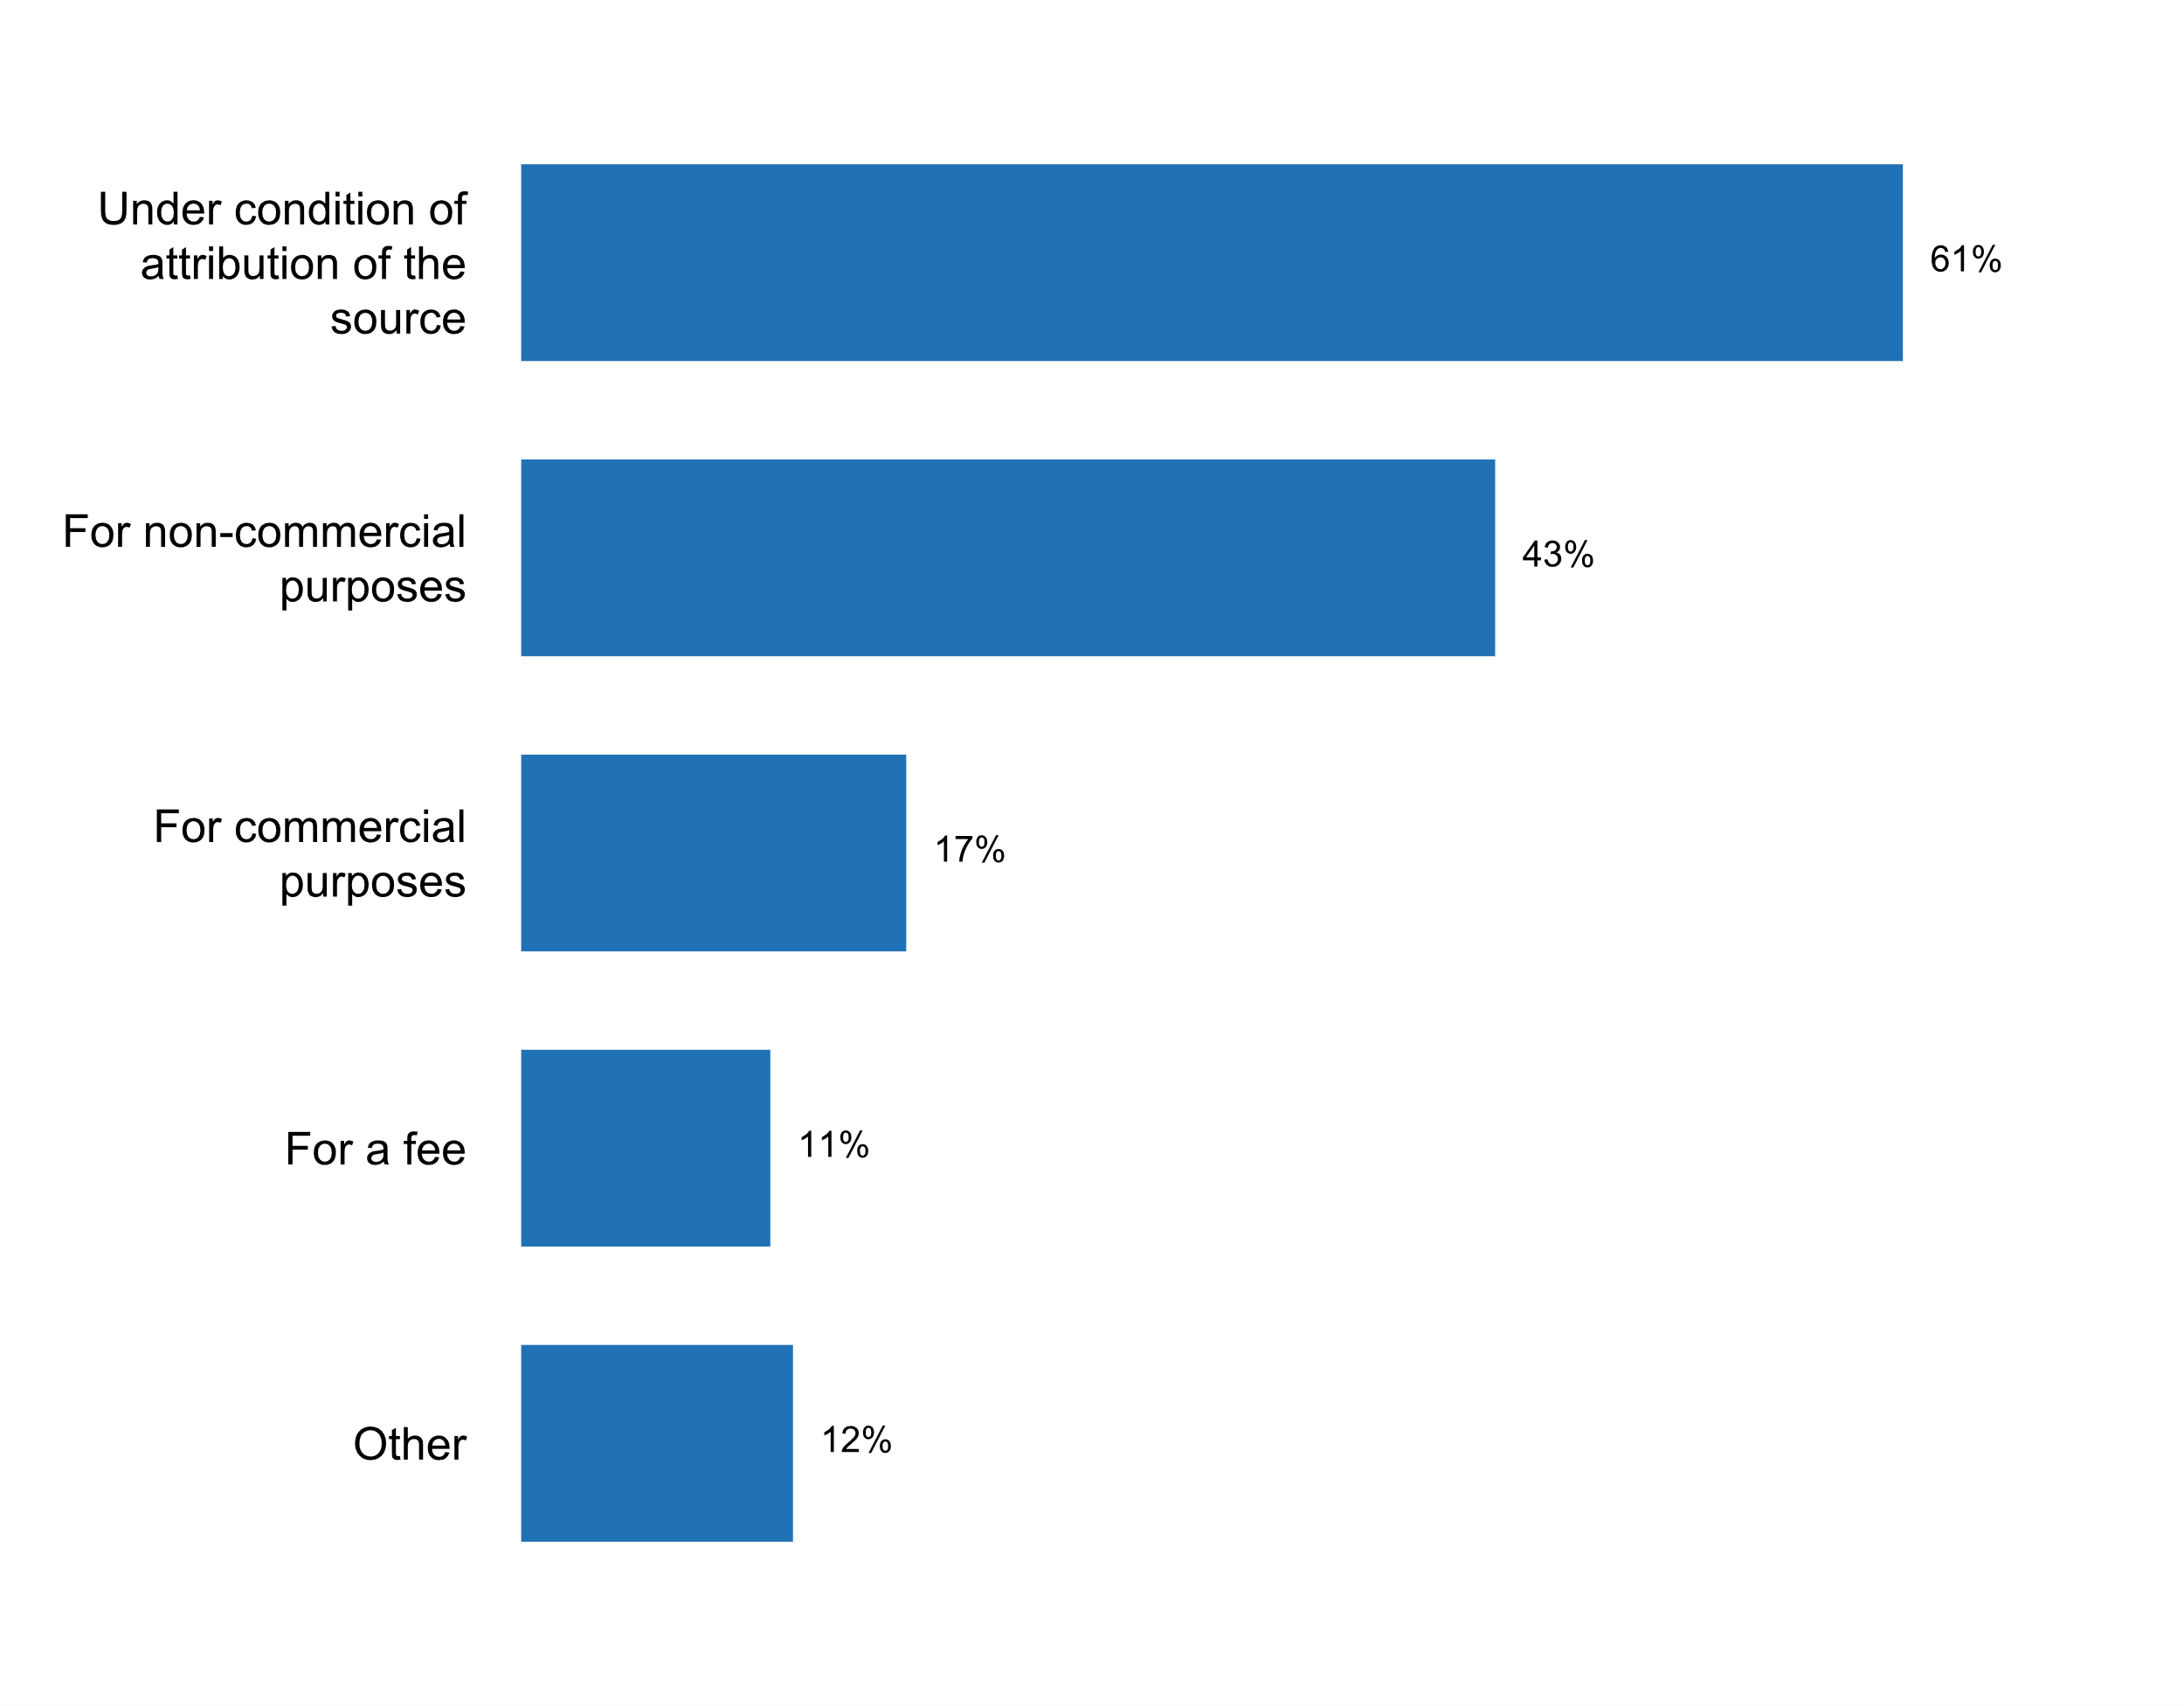

|  |  |  |  |  |  |  |
| --- | --- | --- | --- | --- | --- | --- |
| **Answer** | **Africa** | **Americas** | **Asia** | **Europe** | **Oceania** | **TOTAL** |
| Under condition of attribution of the source | 7 | 8 | 17 | 22 | 3 | **57** |
| For non-commercial purposes | 11 | 6 | 10 | 13 |  | **40** |
| For commercial purposes | 2 | 4 | 2 | 8 |  | **16** |
| For a fee | 3 | 1 | 2 | 4 |  | **10** |
| Other | 2 | 4 | 2 | 3 |  | **11** |

|  |  |  |  |  |  |  |
| --- | --- | --- | --- | --- | --- | --- |
| **Answer** | **Africa** | **Americas** | **Asia** | **Europe** | **Oceania** | **TOTAL** |
| Under condition of attribution of the source | 41 | 62 | 71 | 63 | 75 | **61** |
| For non-commercial purposes | 65 | 46 | 42 | 37 |  | **43** |
| For commercial purposes | 12 | 31 | 8 | 23 |  | **17** |
| For a fee | 18 | 8 | 8 | 11 |  | **11** |
| Other | 12 | 31 | 8 | 9 |  | **12** |

* By negotiation
* Data are provided under the Open Government LIcense: https://www.nationalarchives.gov.uk/doc/open-government-licence/version/3/
* N/A The conditions in which (post-release) derivative work using micro data is available may happen vary amongst agencies.
* No
* Not applicable
* Not distributed
* Open license applies
* When the reuse involves any modification to the data or text, including the translation of text, this is stated clearly to the end user of the information, as well as that ELSTAT bears no responsibility for the result of the modification.
* for statistical purposes only; indicating that the responsibility for analysis and processing is not to be attributed to Istat
* free of charge

**Additional comments on challenges to the implementation of Principle 1**

* 1) User satisfaction surveys suffered from very poor response and have been abolished after 2009.2) First NSDS 2010-2014, never got legal backing from the Government and various efforts to gt Government support produce a second NSDS have all been unsuccessful so far.
* 1.4a, 1.4b
* 1.6 - the process causes significant delay in the release of the report
* 1.7. The answers refer to anonymized microdata. There are other databases of microdata that require signing confidentiality agreements and cannot be used.
* All data are disseminated according to the Principle 1.The challenge concerns the proper and timely implementation of the obligations or recommendations of international organizations regarding data transmission systems.
* All stakeholders are aware of the impartiality and equal access to data.
* Answer to the question 1.7 as there was no possibility to enter it:SURS provides online access to all aggregates in accordance with the National Statistics Act and Annual Work Programme without any conditions. Available on website: https://www.stat.si/StatWeb/enBeside aggregates SURS provides access to public use files for two surveys: the EU Statistics on Income and Living Conditions (EU-SILC) and the Labour Force Survey (LFS). Public use files are statistically protected microdata and prepared according to Principle 5 of the European Statistics Code of Practice and Article 50 of the National Statistics Act. No condition to access Public Use Files is required, only restrictions of the utility.
* As a main government agency to produce statistics and manage the statistical system in Thailand, the TNSO, as much as possible, have attempted to serve the government, the economy and the public with data that matches the most with their informed needs. We are now implementing our second National Statistical System Master Plan in order to improve our works.
* Currently the challenges are limited as all have equal access to statistical information at the same time as per the Statistics Act.The organization has a pricing policy as away of cost recovery to those who access the data and use if for commercial purposes. The country does not have an Open Data Policy at the moment--however the NSO makes efforts in ensuring that data is easily accessible through the Open Data Platforms as well as the Website.
* En général, il n'y a pas d'obstacle à  ce principe.
* Equal access must be treated with cautions. There is a risk involved in granting full access to the full data set especially in small population like the Pacific islands where people or groups of people can easily be identified.There is also a risk of anti-government analysis and this will surely impact on the lives of the employees of the NSOs.We all have good intentions of releasing public information but we need to do a lot of extra work to ensure that data will not raise any political unrest in the country and the that the lives of the employees and their families will not be jeopardized. Most importantly, we do not want the free access interest to ruin the current participation rate of the community in data collections when people and groups of people will be exposed through analysis. This means we might enjoy free access on one hand at losing the trust of people to provide confidential information for anyone to comment on. The latter is the worst option for NSOs.
* If aggregates here means statistics - it is open for all users for full use.
* Les réponses à  1.6 et 1.7 concernent l'ONS i.e. l'ANSD. Les pratiques de diffusion restent à  àªtre bien améliorées dans les autres structures du SSN.
* Limited financial and human resources present the main constraint to more frequent consultation with data users and the establishment of formal groups for this purpose.
* New Zealand has its own framework of principles and protocols for producers of Tier 1 statistics. This framework is based on UN fundamental principles for official statistics, NZ regulatory environment and these recommendations.
* Nil
* No microdata is available online, only aggregates
* Nowadays, the microdata are not available online for users.
* Questions 1.7a, 1.7b, 1.7c are not clear. It is impossible to answer.The situation in Estonia is as follows.1. All the statistics is published free of charge.2. The microdata is accessible for research for a fee according to the rules published https://www.stat.ee/use-of-confidential-data
* Refer to questions 1.2 (a) to 1.2 (c)The previous National Strategy for the Development of Statistics (NSDS) was in place during the period 2007-2012. A new National Strategy for Official Statistics (NSOS) is long overdue. It is finally being developed prepared and will be in place as from 2019.
* Regarding the question number 1.4. the key challenge is to have the strategy of dissemination and communication. Other challenge is the dissemination of data in local language and in timeliness.
* SOME PARTS OF THIS PRINCIPLE DOES NOT GO IN LINE WITH NATIONAL STATISTICAL LAW
* Since the Statistical Centre of Iran(SCI) is affiliated to the Plan and Budget Organization of Islamic Republic of Iran acting as the Vice- Presidency, some people have doubts on impartiality of the SCI, but based on the UNFPOS and the SCI Law, this Centre is independent and impartial organization in producing ,compiling and releasing official statistics.
* Statistical literacy of users should be enhanced. Branding and labeling.
* The Strategy for the development of state statistics of the Republic of Belarus until 2022 makes provisions for wider access of users to microdata for research purposes and analysis. A standard procedure of dissemination of such data is planned to be developed.
* The identification of the users, the needs and the evaluation of their satisfaction in relation to the information and the products to which they have access, is not formalized in the NSS, the mechanisms or methodologies for this subject are little known for the NSS
* The main challenge in the short and medium term is to harmonize the legal frameworks with the statistical framework, in order to promote and support the standardization of statistical and geographical information on a national level; as well as harmonizing administrative records for statistical and geographical purposes, with the aim of increasing the timeliness of dissemination of information and reducing the cost of data capture, the generation of information and lessen the burden of the system's informants.
* There is no Challenges faced in applying principle 1 as we obey the statistical law that guarantee relevance of statistical products.
* There is no specific challenge in France to implement principle 1.
* Turkstat has no available online microdata. TURKSTAT provides access and usage facility for the microdata of survey and researches in accordance with the legal legislation based on the national and international researchers' demand. Turkish Statistical Institute, Instructions for the Access and Use of Microdata came into effect from September 1, 2012 regulating the procedures for microdata access and usage. According to instruction, TURKSTAT allows microdata users in two types of facilities. The first one is on-site access for Group A microdata, comprises of data that are permitted to be accessed only in Data Research Centers (DRC) settled at the Headquarter in Ankara and at some Regional Offices that is not allowed to be taken out of the Institute. The results of the studies are permitted to be taken outside the Institute after the completion of controlling processes by the related experts of Turkstat. The second facility to allow user microdata is distribution on cd-rom or any other device for the Group B microdata, data in which individual data is hidden, and has no restriction for dissemination. In context of relevance, in Turkstat, procedures are in place to consult users about the statistical needs which the tools are User Evaluation Report and User Survey. User Evaluation Report Dissemination policy of the institution is to meet user requests for timely and quality, to improve awareness of using statistics. Aims for the future targets of the institution is to meet national needs for data produced as well as ensuring compliance with international standards and methodologies. Therefore, after the reference year, “User Evaluation Report” is being prepared for determining expectations, needs and the profile of the users and to have decision about production and dissemination policies by analyzing information requests. In the process of replying information requests, all requests are recorded by "Dissemination Management System” in detail. Information requests received by Regional Offices are also obtained and recorded as to provide data integrity. By using these data, helping to guide the activities of production and distribution policies of the institution, to lead managers to plan and program and inform for deciding targets, User Evaluation Report is published for internal use. User Survey TurkStat has a user survey on its website for determining profiles, needs and expectations of users and setting the policies of the Institution in the medium and long term. It is analyzed annually and the report of the survey is shared with the staff via intranet. Structure and questions of the survey were changed in 2013 and questions appear under four main parts which are general information, using status of TurkStat data, perception and trust, and evaluation.
* WE DON'T HAVE ACCESS TO ALL THE INFORMATIONS TO METADATA.SO, THE LAW STATISTICAL IS NOT KNOWN BY EVERYBODY.
* We are strongly following the Principle 1. Official statistics is publicly available for the general public. All users have equal access.
* We do not have further comments about this principle.
* https://www.czso.cz/csu/czso/conditions_for_use_and_further_dissemination)
* the answers to the questions 1.7b and 1.7c only apply to aggregates

**Chief statistician has direct access to policy-making authorities**

|  |  |  |  |  |  |  |
| --- | --- | --- | --- | --- | --- | --- |
| **Answer** | **Africa** | **Americas** | **Asia** | **Europe** | **Oceania** | **TOTAL** |
| No | 1 |  | 2 |  |  | **3** |
| Yes | 16 | 13 | 22 | 33 | 4 | **88** |

|  |  |  |  |  |  |  |
| --- | --- | --- | --- | --- | --- | --- |
| **Answer** | **Africa** | **Americas** | **Asia** | **Europe** | **Oceania** | **TOTAL** |
| No | 6 |  | 8 |  |  | **3** |
| Yes | 94 | 100 | 92 | 94 | 100 | **95** |

**Plot_18_Q02.1a.svg**

**Modalities of communication between chief statistician and policy-making authorities**

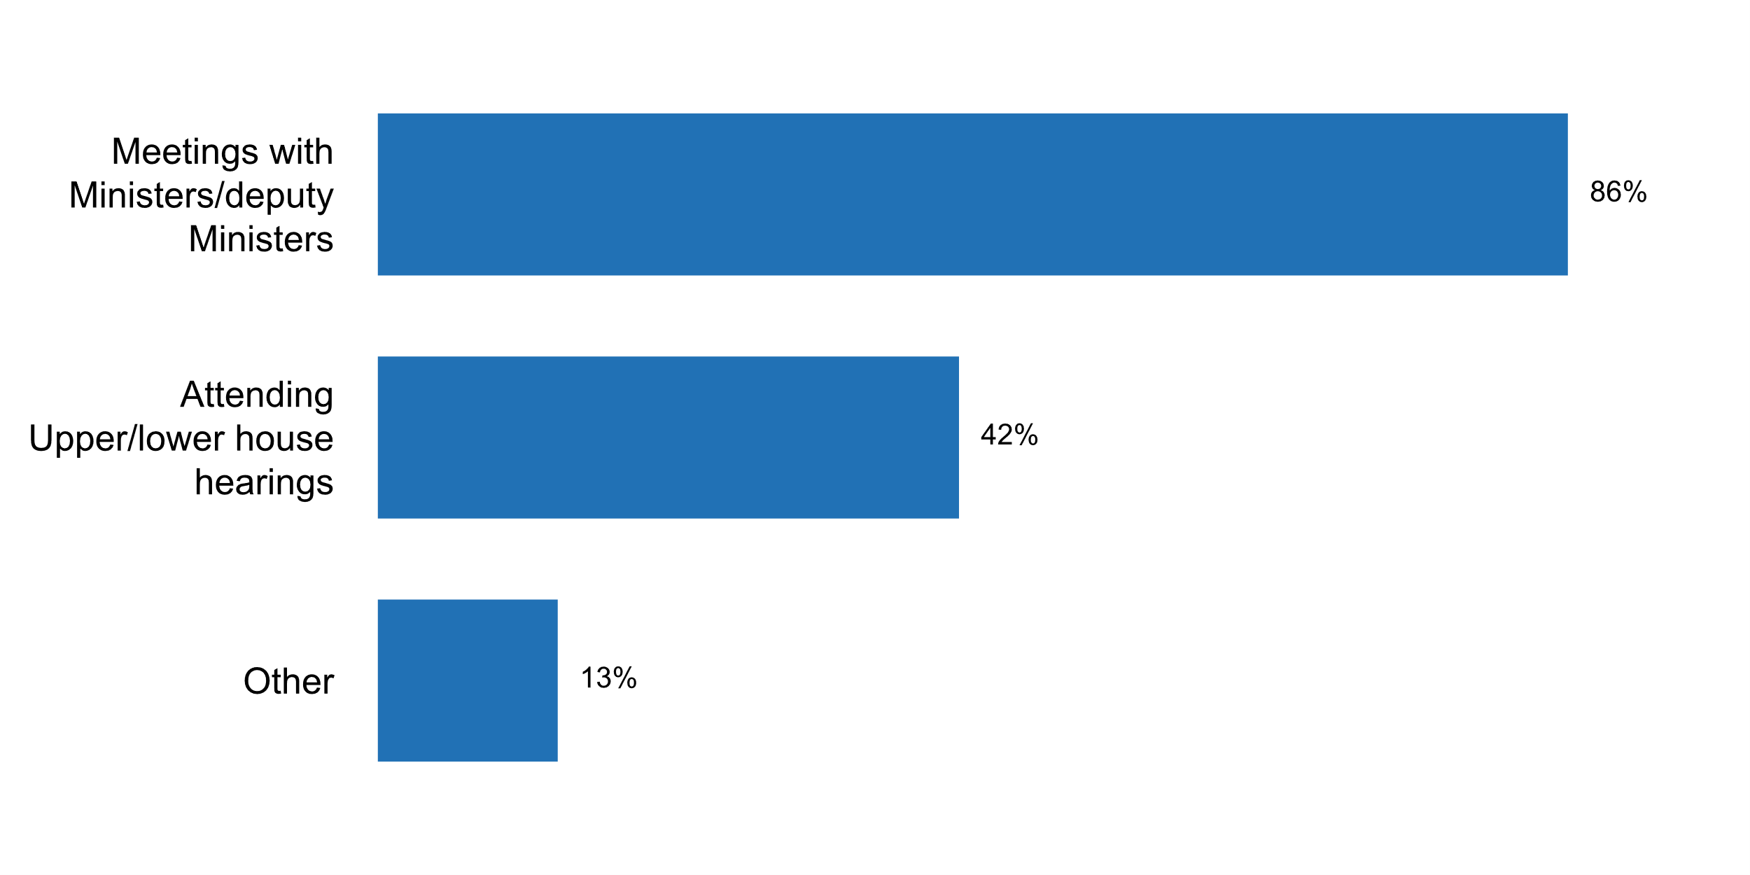

|  |  |  |  |  |  |  |
| --- | --- | --- | --- | --- | --- | --- |
| **Answer** | **Africa** | **Americas** | **Asia** | **Europe** | **Oceania** | **TOTAL** |
| Meetings with Ministers/deputy Ministers | 13 | 13 | 21 | 29 | 4 | **80** |
| Attending Upper/lower house hearings | 6 | 5 | 10 | 16 | 2 | **39** |
| Other | 2 | 2 |  | 7 | 1 | **12** |

|  |  |  |  |  |  |  |
| --- | --- | --- | --- | --- | --- | --- |
| **Answer** | **Africa** | **Americas** | **Asia** | **Europe** | **Oceania** | **TOTAL** |
| Meetings with Ministers/deputy Ministers | 76 | 100 | 88 | 83 | 100 | **86** |
| Attending Upper/lower house hearings | 35 | 38 | 42 | 46 | 50 | **42** |
| Other | 12 | 15 |  | 20 | 25 | **13** |

* Access to key ministerial professional staff
* Any types of communication (letters, e-mails, telephone, face to face meetings etc)
* Chief of Cabinet of Ministers
* Department Head Meetings and regular engagement
* Dialouge meetings through ministries
* Meeting with ministry
* Rèunions avec la tutelle ministérielle
* Réunion du Conseil de Cabinet Ministériel de tutelle
* The Director-General of SURS is a member of the Economic Committee of the Government.
* The President of the HCSO participates as a permanent invitee at the meeting of the forum preparing the meeting of the Government and shall be invited to the item on the agenda of the meeting of the Government that concerns the tasks of the HCSO
* varies, depending on the situation
* weekly attendance at the regular Government meetings

**Main reasons/challenges preventing direct access to policy-making authorities by chief statistician**

* Have to seek appointment
* It is not INE's mission in the country's political decisions but rather to contribute through the provision of data
* to avoid statistic data adjustment

**Plot_19_Q02.2.svg**

**Existence of clear rules for appointment and dismissal of the head of NSO**

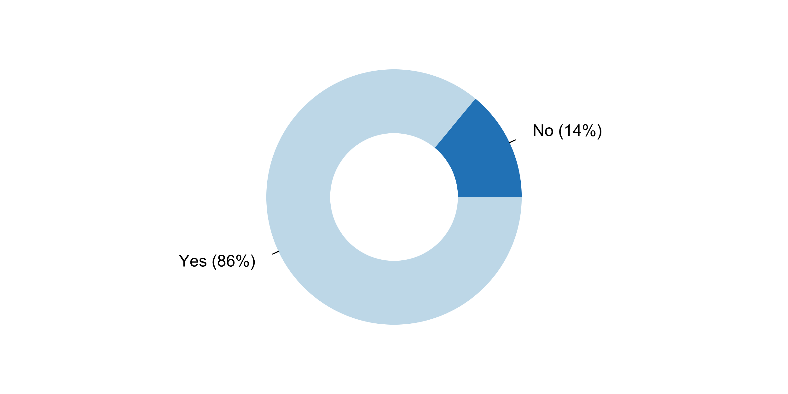

|  |  |  |  |  |  |  |
| --- | --- | --- | --- | --- | --- | --- |
| **Answer** | **Africa** | **Americas** | **Asia** | **Europe** | **Oceania** | **TOTAL** |
| No | 4 | 3 | 4 | 2 |  | **13** |
| Yes | 13 | 10 | 20 | 33 | 4 | **80** |

|  |  |  |  |  |  |  |
| --- | --- | --- | --- | --- | --- | --- |
| **Answer** | **Africa** | **Americas** | **Asia** | **Europe** | **Oceania** | **TOTAL** |
| No | 24 | 23 | 17 | 6 |  | **14** |
| Yes | 76 | 77 | 83 | 94 | 100 | **86** |

**Plot_20_Q02.2a.svg**

**Aspects regulated in rules for appointment and dismissal of the head of NSO**

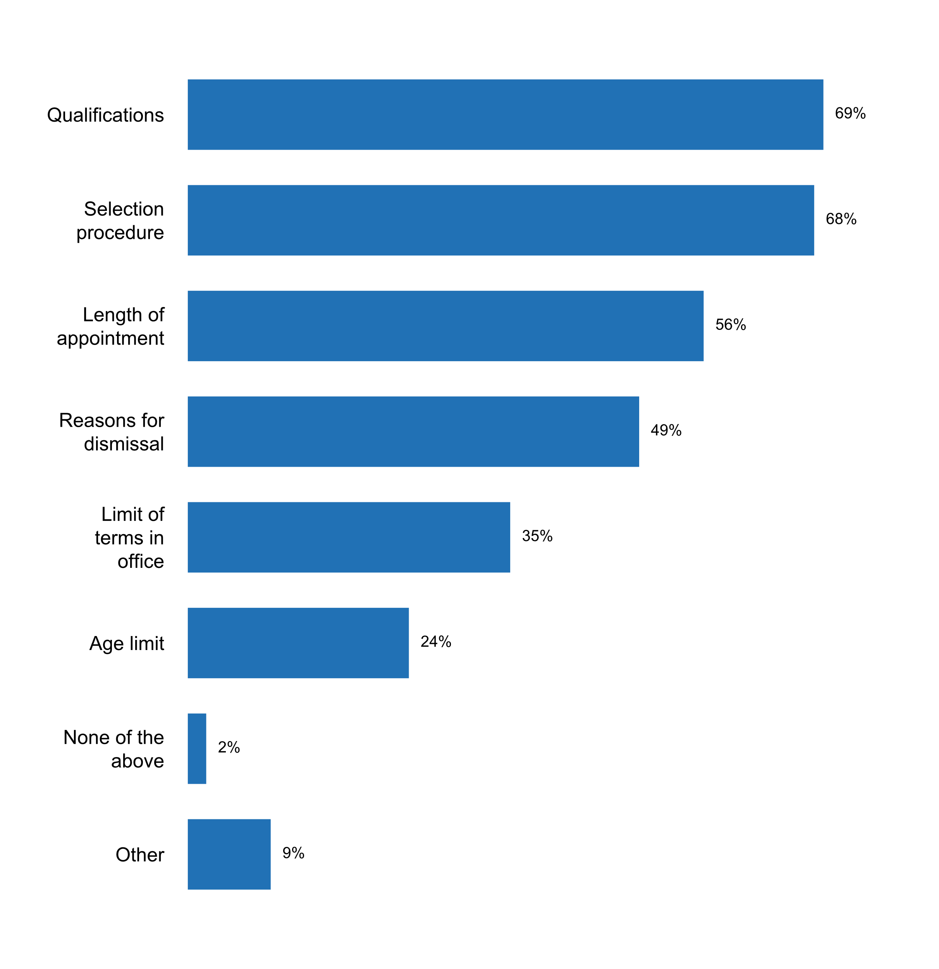

|  |  |  |  |  |  |  |
| --- | --- | --- | --- | --- | --- | --- |
| **Answer** | **Africa** | **Americas** | **Asia** | **Europe** | **Oceania** | **TOTAL** |
| Qualifications | 9 | 8 | 18 | 26 | 3 | **64** |
| Selection procedure | 6 | 8 | 17 | 29 | 3 | **63** |
| Length of appointment | 7 | 6 | 13 | 22 | 4 | **52** |
| Reasons for dismissal | 5 | 6 | 8 | 23 | 4 | **46** |
| Limit of terms in office | 7 | 5 | 8 | 11 | 2 | **33** |
| Age limit | 3 | 3 | 6 | 9 | 1 | **22** |
| None of the above | 1 | 1 |  |  |  | **2** |
| Other | 1 | 2 |  | 5 |  | **8** |

|  |  |  |  |  |  |  |
| --- | --- | --- | --- | --- | --- | --- |
| **Answer** | **Africa** | **Americas** | **Asia** | **Europe** | **Oceania** | **TOTAL** |
| Qualifications | 53 | 62 | 75 | 74 | 75 | **69** |
| Selection procedure | 35 | 62 | 71 | 83 | 75 | **68** |
| Length of appointment | 41 | 46 | 54 | 63 | 100 | **56** |
| Reasons for dismissal | 29 | 46 | 33 | 66 | 100 | **49** |
| Limit of terms in office | 41 | 38 | 33 | 31 | 50 | **35** |
| Age limit | 18 | 23 | 25 | 26 | 25 | **24** |
| None of the above | 6 | 8 |  |  |  | **2** |
| Other | 6 | 15 |  | 14 |  | **9** |

* In US, some executive managers are political appointees, but most senior managers, including many heads of NSOs, are career civil servants (SES). While there may not be explicit legislation for civilian hirees, there are Human Resources guidelines.
* Legislation of the Russian Federation
* Presidential Decree
* Regulations for government employees also holds for the DG of the NSO
* The Governor in Council (GIC) appoints the Chief Statistician to be deputy head. The Chief Statistician will hold office for a term of not more than five (5) years, during good behaviour but may be removed for cause by the GIC. The Chief Statistician is eligible for reappointment for an additional term not exceeding five (5) years. The law provides for interim appointments not exceeding six (6) months in event of absence or incapacity of the Chief Statistician.
* The listed and other aspects of the appointment and release from office of public servants are regulated by the Law on Public Service in the Republic of Belarus, Presidential Decree On certain issues of state statistics bodies No. 445 of 26 August 2008, and Presidential Decree On certain measures to improve personnel management within the system of public bodies No. 557 of 2 November 2011.
* This is partly regulated in STATEC's law and in the laws ruling civil servants careers.
* is a Polish citizen, enjoys full civil rights, has never been penalised for a deliberate criminal offence or a deliberate fiscal offence, has at least 6 years' professional experience, including at least 3 years' professional experience as an executive.

**Plot_21_Q02.3.svg**

**Inquiries (e.g. by the media, the academia, advocacy groups) on procedure for selecting a head of the NSO in the past five years**

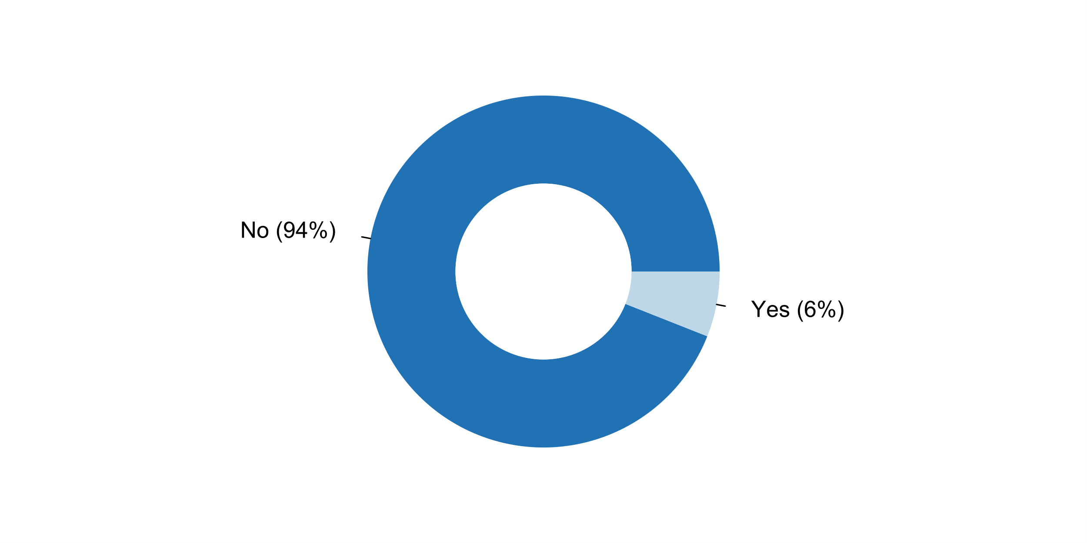

|  |  |  |  |  |  |  |
| --- | --- | --- | --- | --- | --- | --- |
| **Answer** | **Africa** | **Americas** | **Asia** | **Europe** | **Oceania** | **TOTAL** |
| No | 15 | 12 | 22 | 34 | 4 | **87** |
| Yes | 2 | 1 | 2 | 1 |  | **6** |

|  |  |  |  |  |  |  |
| --- | --- | --- | --- | --- | --- | --- |
| **Answer** | **Africa** | **Americas** | **Asia** | **Europe** | **Oceania** | **TOTAL** |
| No | 88 | 92 | 92 | 97 | 100 | **94** |
| Yes | 12 | 8 | 8 | 3 |  | **6** |

*What was questioned in inquiries (e.g. by the media, the academia, advocacy groups) on procedure for selecting a head of the NSO in the past five years*

* *During the political intervention of the NSO (2007-2015), the independence of the Office was questioned.*
* *Experience in applied statistical work*
* *Selection procedures.*
* *Such as professional qualification, work style, self-discipline.*
* *the independence*

**Plot_22_Q02.4.svg**

**How NSS sought external endorsement of its methodologies and survey designs in the past five years**

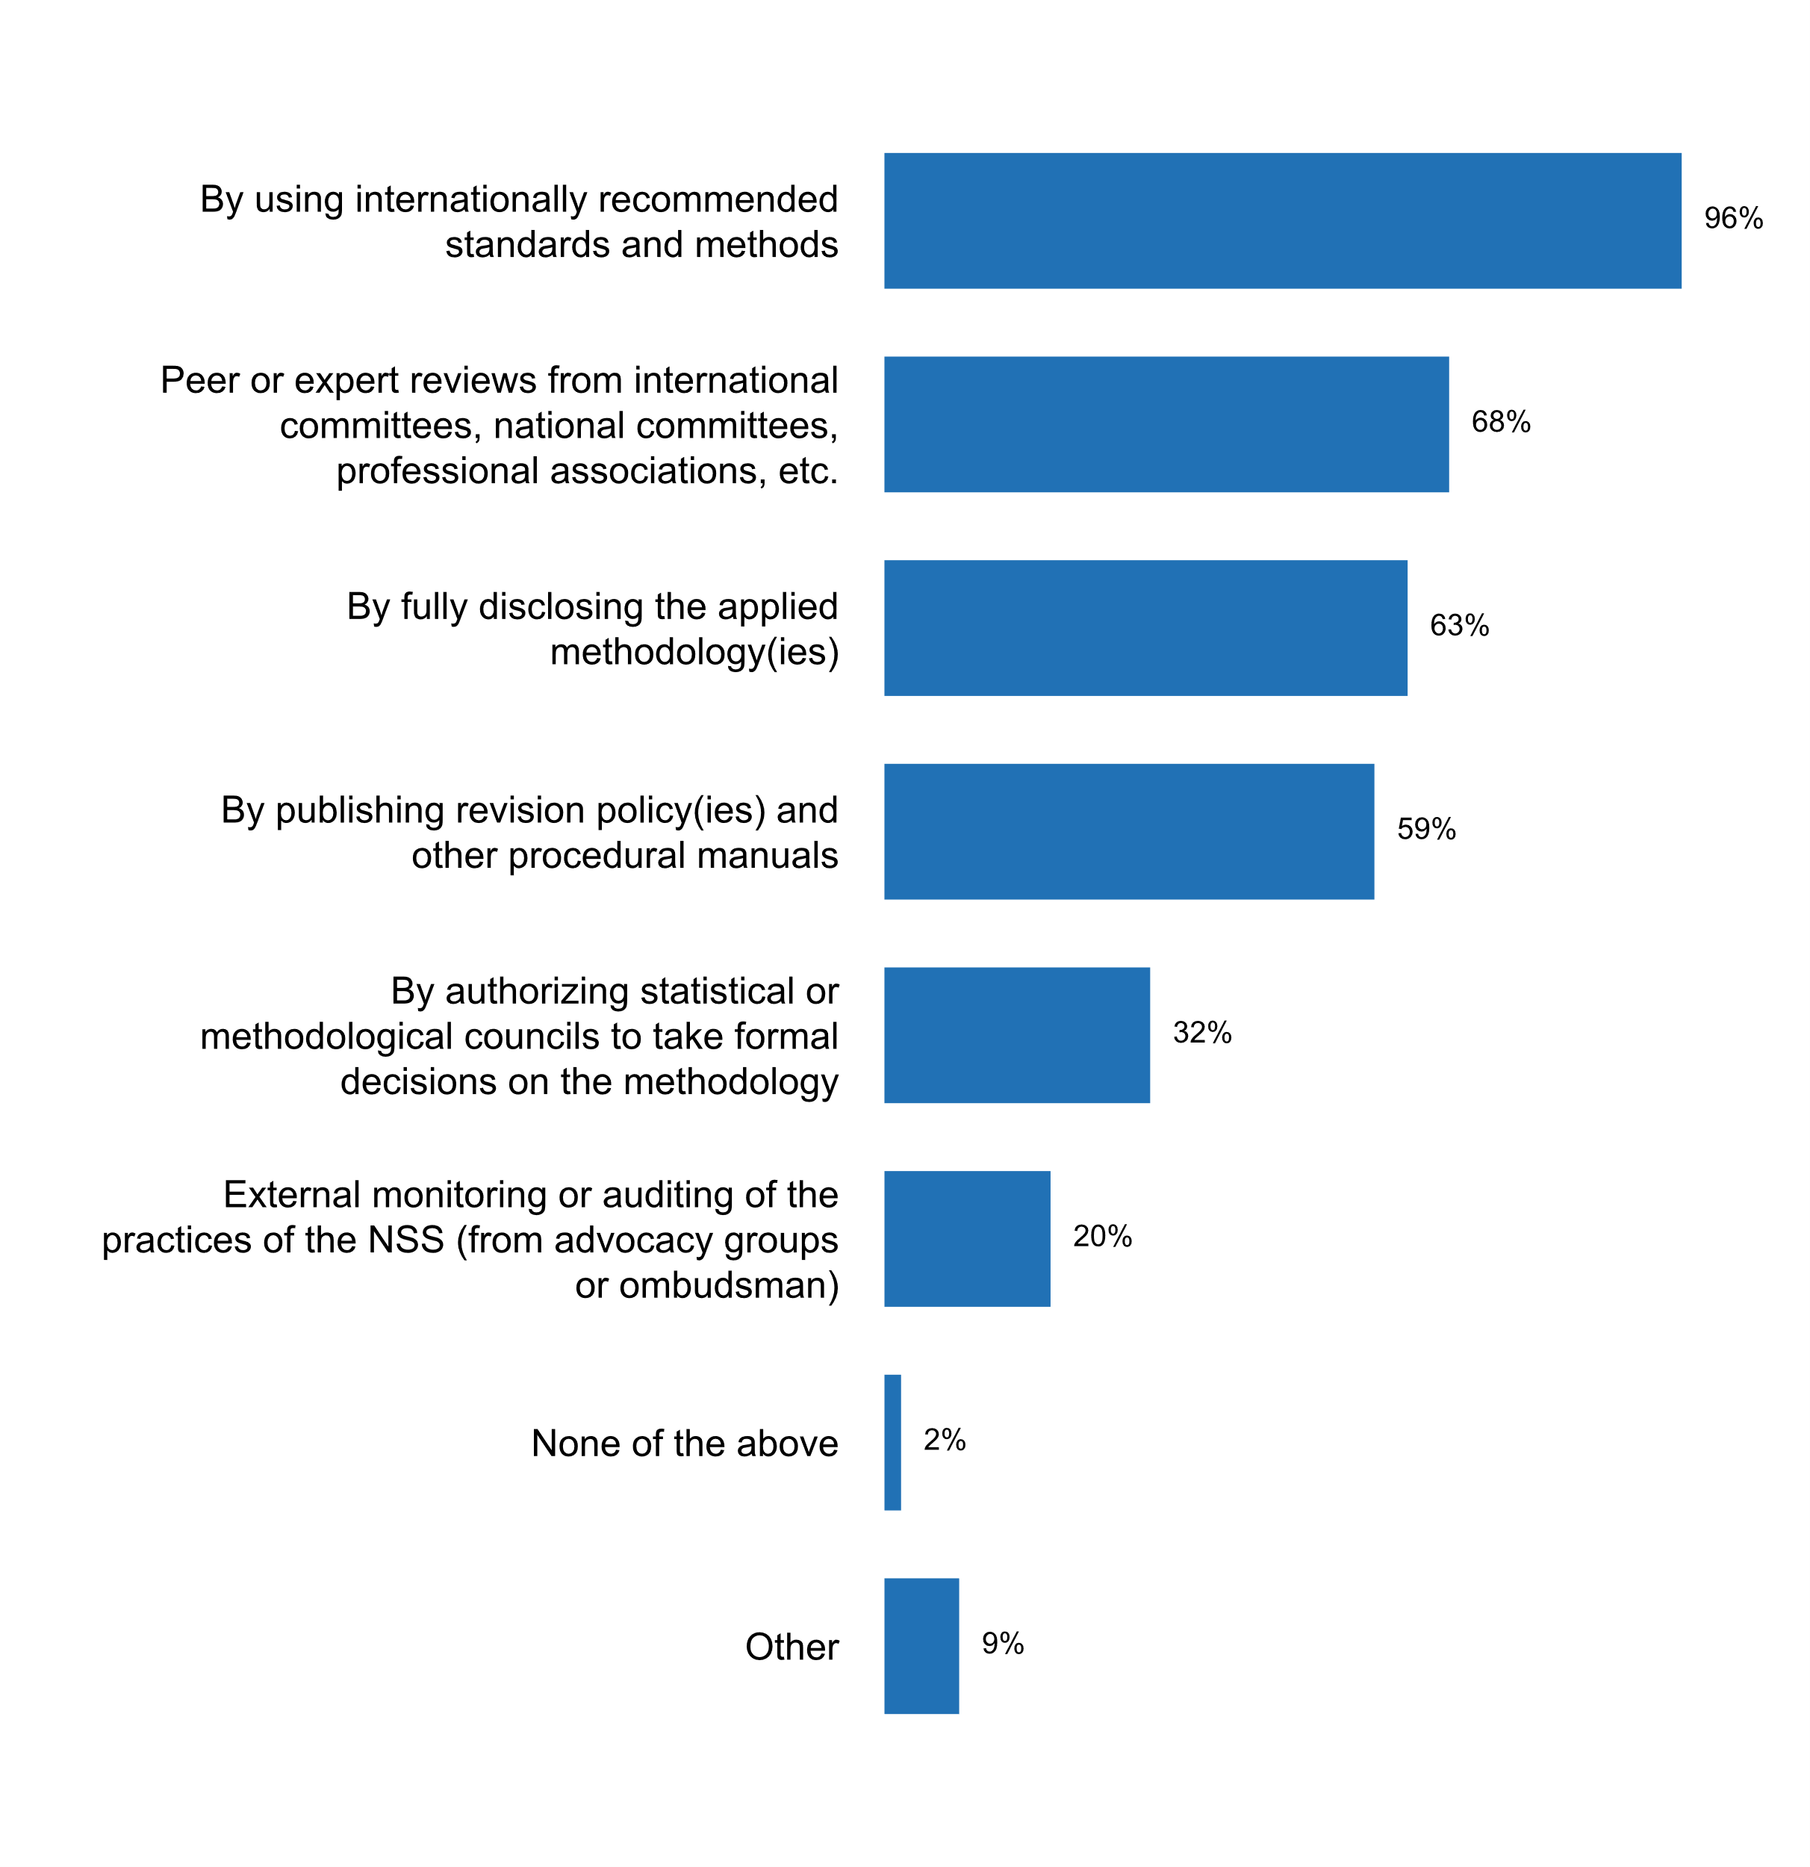

|  |  |  |  |  |  |  |
| --- | --- | --- | --- | --- | --- | --- |
| **Answer** | **Africa** | **Americas** | **Asia** | **Europe** | **Oceania** | **TOTAL** |
| By using internationally recommended standards and methods | 17 | 12 | 24 | 32 | 4 | **89** |
| Peer or expert reviews from international committees, national committees, professional associations, etc. | 10 | 7 | 14 | 30 | 2 | **63** |
| By fully disclosing the applied methodology(ies) | 8 | 10 | 15 | 22 | 4 | **59** |
| By publishing revision policy(ies) and other procedural manuals | 6 | 8 | 12 | 27 | 2 | **55** |
| By authorizing statistical or methodological councils to take formal decisions on the methodology | 3 |  | 11 | 14 | 2 | **30** |
| External monitoring or auditing of the practices of the NSS (from advocacy groups or ombudsman) | 3 | 2 | 6 | 7 | 1 | **19** |
| None of the above |  | 1 |  | 1 |  | **2** |
| Other |  | 3 | 1 | 4 |  | **8** |

|  |  |  |  |  |  |  |
| --- | --- | --- | --- | --- | --- | --- |
| **Answer** | **Africa** | **Americas** | **Asia** | **Europe** | **Oceania** | **TOTAL** |
| By using internationally recommended standards and methods | 100 | 92 | 100 | 91 | 100 | **96** |
| Peer or expert reviews from international committees, national committees, professional associations, etc. | 59 | 54 | 58 | 86 | 50 | **68** |
| By fully disclosing the applied methodology(ies) | 47 | 77 | 63 | 63 | 100 | **63** |
| By publishing revision policy(ies) and other procedural manuals | 35 | 62 | 50 | 77 | 50 | **59** |
| By authorizing statistical or methodological councils to take formal decisions on the methodology | 18 |  | 46 | 40 | 50 | **32** |
| External monitoring or auditing of the practices of the NSS (from advocacy groups or ombudsman) | 18 | 15 | 25 | 20 | 25 | **20** |
| None of the above |  | 8 |  | 3 |  | **2** |
| Other |  | 23 | 4 | 11 |  | **9** |

* Before a new statistical product is released, there is extensive vetting of methodologies, including external consultants (international, academia, etc.)
* By communicating with the NSO members.
* Certification System of Statitistical Quality
* Con un Comité Consultivo
* European Union Statistical regulations
* Eurostat Experts' regular statistical reviews of key statistical areas (e.g. methodological discussion on excessive deficit procedure (EDP) statistics and government finance statistics; information relating to the Lithuanian GNI data and inventory of sources and methods; review of statistical practices used to compile the HICP); OECD experts' review on the compliance with the OECD Council Recommendation on Good Statistical Practice.
* Peer reviews on the European statistics Code of Practice
* The Methodological Council was set up in order to have a review of the used statistical methods from the external experts of the academic community. New statistical surveys or surveys which are subject to a major revision are discussed by the Methodological Council, which issues an opinion about the proposed changes. It is composed of ten members appointed by the SURS's Director-General. Three members are the employees of SURS and seven members are outside members â€“ experts from the field of statistical methodology from different scientific disciplines (in practice they are well known professors of statistics from the Universities). The Council is headed by the head of the Sector for Processes and Communication. The work of the Council is defined by the Instruction on the procedure for verification and approval of statistical surveys' methodology. Authorized producers are invited to participate at the sessions of the Council as observers, as well as to present their own statistical survey and benefit from the view of the experts.

**Plot_23_Q02.5.svg**

**Measures currently being undertaken for coordinating standards and classifications across the NSS**

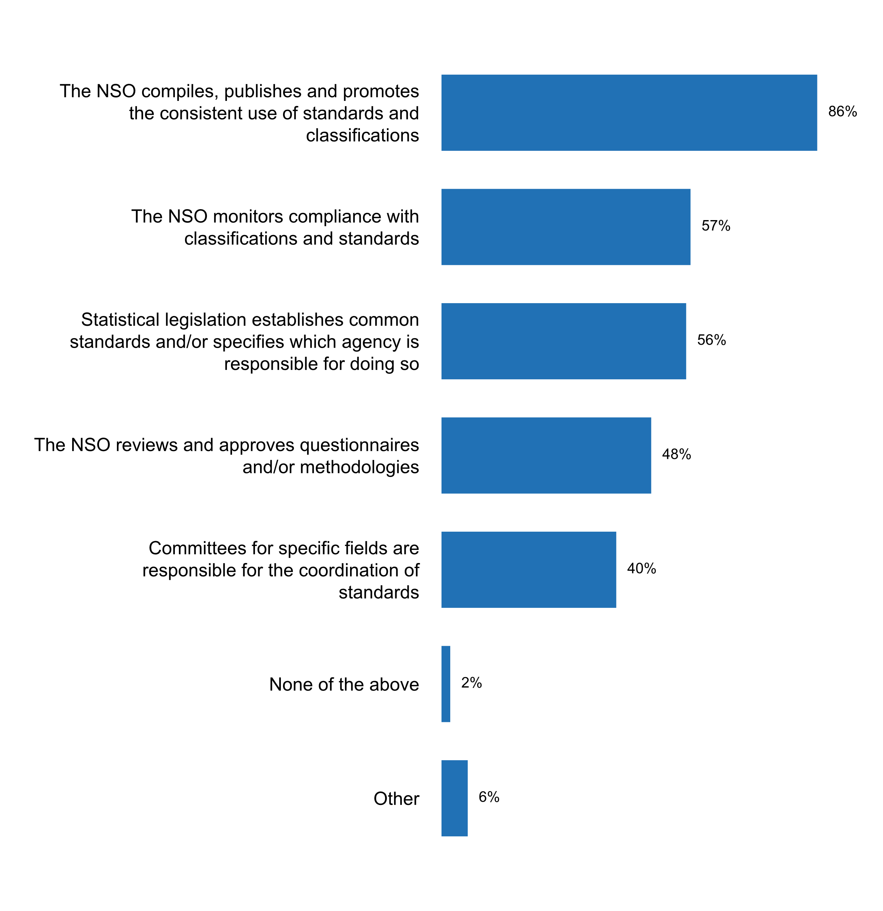

|  |  |  |  |  |  |  |
| --- | --- | --- | --- | --- | --- | --- |
| **Answer** | **Africa** | **Americas** | **Asia** | **Europe** | **Oceania** | **TOTAL** |
| The NSO compiles, publishes and promotes the consistent use of standards and classifications | 13 | 11 | 22 | 30 | 4 | **80** |
| The NSO monitors compliance with classifications and standards | 8 | 7 | 17 | 20 | 1 | **53** |
| Statistical legislation establishes common standards and/or specifies which agency is responsible for doing so | 11 | 5 | 15 | 19 | 2 | **52** |
| The NSO reviews and approves questionnaires and/or methodologies | 9 | 5 | 15 | 14 | 2 | **45** |
| Committees for specific fields are responsible for the coordination of standards | 7 | 4 | 12 | 11 | 3 | **37** |
| None of the above | 1 | 1 |  |  |  | **2** |
| Other |  | 2 | 1 | 3 |  | **6** |

|  |  |  |  |  |  |  |
| --- | --- | --- | --- | --- | --- | --- |
| **Answer** | **Africa** | **Americas** | **Asia** | **Europe** | **Oceania** | **TOTAL** |
| The NSO compiles, publishes and promotes the consistent use of standards and classifications | 76 | 85 | 92 | 86 | 100 | **86** |
| The NSO monitors compliance with classifications and standards | 47 | 54 | 71 | 57 | 25 | **57** |
| Statistical legislation establishes common standards and/or specifies which agency is responsible for doing so | 65 | 38 | 63 | 54 | 50 | **56** |
| The NSO reviews and approves questionnaires and/or methodologies | 53 | 38 | 63 | 40 | 50 | **48** |
| Committees for specific fields are responsible for the coordination of standards | 41 | 31 | 50 | 31 | 75 | **40** |
| None of the above | 6 | 8 |  |  |  | **2** |
| Other |  | 15 | 4 | 9 |  | **6** |

* Provide consultation and training for the adoption of international standard and classification
* Statistics Canada coordinates standards by developing, publishing and promoting the use of harmonized definitional metadata standards including variables, statistical classifications and extensive classification indexes for coding to the major classifications. Definitional metadata standards are developed for social statistics, economic statistics and geographic areas. Directives and policies are in place to ensure that statistical programs are aware of the level of metadata required and the need to use the harmonized definitional metadata including variables and classifications within statistical programs.
* The Committe of official statistics coordinates with STATEC the NSS. This committee owns several sub-groups/task forces to deal, amongst others, with methodological issues. That
* The statistical legislation sets the requirements to the development, approval and use of classifications within the NSS; Belstat collaborates with government bodies and organizations on the development of classifications; Belstat undertakes work on harmonization of national classifications with international classifications.
* in the process of strengthening NSS
* no ONAs in the country

**Plot_24_Q02.6.svg**

**Document(s) providing guidance on professional ethics for staff**

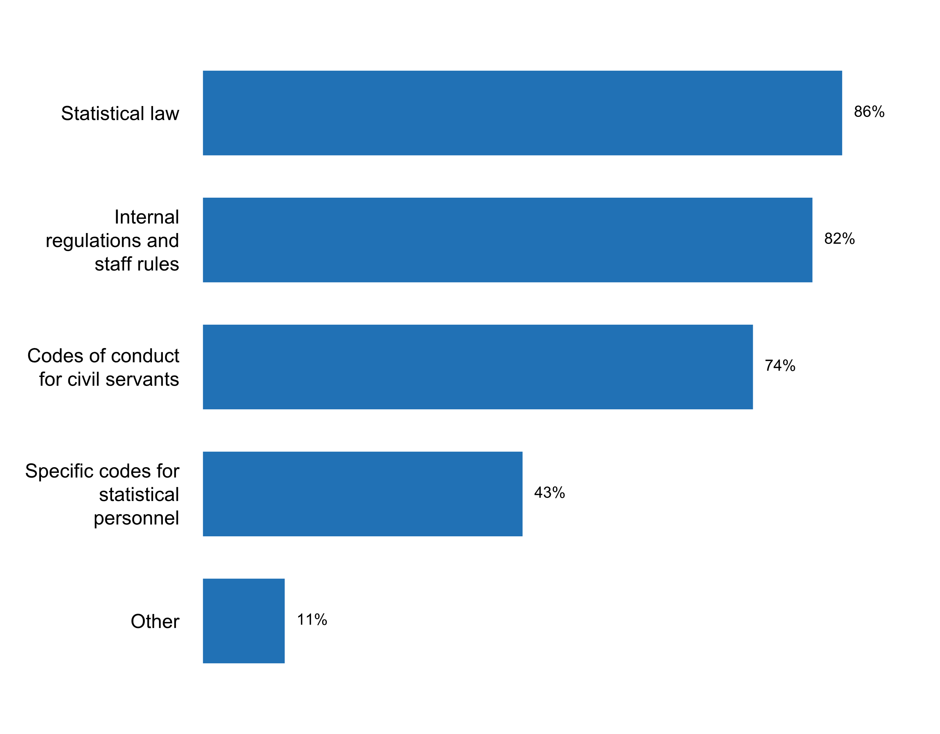

|  |  |  |  |  |  |  |
| --- | --- | --- | --- | --- | --- | --- |
| **Answer** | **Africa** | **Americas** | **Asia** | **Europe** | **Oceania** | **TOTAL** |
| Statistical law | 17 | 11 | 20 | 29 | 3 | **80** |
| Internal regulations and staff rules | 13 | 12 | 22 | 26 | 3 | **76** |
| Codes of conduct for civil servants | 10 | 10 | 17 | 28 | 4 | **69** |
| Specific codes for statistical personnel | 7 | 7 | 6 | 18 | 2 | **40** |
| Other | 1 | 2 | 3 | 4 |  | **10** |

|  |  |  |  |  |  |  |
| --- | --- | --- | --- | --- | --- | --- |
| **Answer** | **Africa** | **Americas** | **Asia** | **Europe** | **Oceania** | **TOTAL** |
| Statistical law | 100 | 85 | 83 | 83 | 75 | **86** |
| Internal regulations and staff rules | 76 | 92 | 92 | 74 | 75 | **82** |
| Codes of conduct for civil servants | 59 | 77 | 71 | 80 | 100 | **74** |
| Specific codes for statistical personnel | 41 | 54 | 25 | 51 | 50 | **43** |
| Other | 6 | 15 | 13 | 11 |  | **11** |

* DOSM Transformation Plan, 2015-2020
* Federal employees are required to take Annual Ethics training. There are also additional ethics training for specific careers, such as contracting and budget officers, etc.
* Fundamental Principles of Official Statistics and ISI Declaration of Professional Ethics
* Law on Civil Service
* ON THE APPLICATION OF THE DECLARATION ON PROFESSIONAL ETHICS has been translated into Armenian and approved by the State Council on Statistics and posted on the website at https://www.armstat.am/file/doc/Ethics.pdf
* Philippine Statistical Association, Inc.'s Code of Ethics for Statisticians
* Statut du personnel, Règlement intérieur
* The Law on Public Service in the Republic of Belarus, the Rules of professional ethics of public servants of state statistics bodies
* engagement of confidentiality
* ethical code for civil servants

**Plot_25_Q02.7.svg**

**Ways in which staff have been informed and reminded of existing codes of conduct, in the past five years**

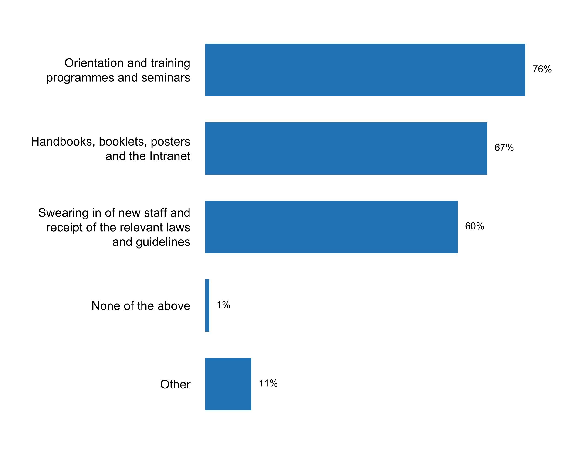

|  |  |  |  |  |  |  |
| --- | --- | --- | --- | --- | --- | --- |
| **Answer** | **Africa** | **Americas** | **Asia** | **Europe** | **Oceania** | **TOTAL** |
| Orientation and training programmes and seminars | 14 | 11 | 17 | 25 | 4 | **71** |
| Handbooks, booklets, posters and the Intranet | 12 | 10 | 17 | 21 | 2 | **62** |
| Swearing in of new staff and receipt of the relevant laws and guidelines | 7 | 8 | 14 | 24 | 3 | **56** |
| None of the above | 1 |  |  |  |  | **1** |
| Other | 2 | 4 | 1 | 3 |  | **10** |

|  |  |  |  |  |  |  |
| --- | --- | --- | --- | --- | --- | --- |
| **Answer** | **Africa** | **Americas** | **Asia** | **Europe** | **Oceania** | **TOTAL** |
| Orientation and training programmes and seminars | 82 | 85 | 71 | 71 | 100 | **76** |
| Handbooks, booklets, posters and the Intranet | 71 | 77 | 71 | 60 | 50 | **67** |
| Swearing in of new staff and receipt of the relevant laws and guidelines | 41 | 62 | 58 | 69 | 75 | **60** |
| None of the above | 6 |  |  |  |  | **1** |
| Other | 12 | 31 | 4 | 9 |  | **11** |

* Attaching the internal regulations by e-mail
* Emails are sent out, as necessary. For example, before an election, an email regarding the Hatch Act is usually sent out.
* In the INE, through the memorandum, all personnel were informed about the Code of Ethics
* Junior Employee Book
* Receipt of the relevant laws and guidelines
* Statistics Canada employees are required to follow confidentiality and privacy awareness training at start of employment and every three (3) years. A framework of policies, directives, guidelines and tools are available to employees. An annual security awareness event is held at Statistics Canada headquarters.
* THERE IS NO CODE OF CONDUCT
* The swearing in is mainly for survey enumerators because permanent staff sign oaths of secrecy.
* annual information on compliance with civil service rules and ethics of the civil service corps; Information plates with the rules of the civil service and the rules of ethics of the civil service corps located in the premisses of Statistics Poland.
* during initial training

**How NSO/NSS develops professional qualifications of staff**

* - international training/study visits;- general national training at the Academy of Public Administration;
* 1) Attending international meetings, workshops, conference and forum organised by the IMF, ADB, etc. 2) Participate in online courses. 3) Study leave
* 1. By providing and facilitating customised training on specific areas. 2. One-hour early release for staffs to attend university course.3. 21 days leave as from second year for revision purposes.
* A travers les ateliers de renforcement des capacités nationales et internationales. Les candidats sont envoyés dans les écoles sous-régionales de formation en démographie et en statistique.
* All staff members undergo training in state management and government service at educational institutions of system for training, specialization and upgrading qualification of the government employees. As for special (statistical) issues, the SSSU Headquarters staff members upgrade the qualification mostly at foreign statistical/economical educational institutions (courses) and at the seminars dealing with statistics issues and funded through international technical assistance. The staff members from the SSSU regional offices are trained according to professional programs at the National Academy for Statistics Accounting and Audit (subordinated to the SSSU) and at the seminars organized by the SSSU sectoral departments (using own forces or with the help of international experts under international technical assistance projects).
* Annual training plans are elaborated. Individual training plans are to be composed in the beginning of every year and by the integration of all individual plans the HCSO institutional plan is composed. The HCSO's institutional training plan includes: professional training of staff (internally compiled and organised courses, speakers are own experts) management trainings (provided by National University of Public Service) obligatory training of public administration (basic and specialised exams of public administration)
* BY PARTICIPATING IN THE NATIONAL AND INTERNATIONAL WORKSHOPS , MEETINGS , CONFERENCES, ETC RELATED TO STATISTICS.
* BY TRAINING ON WORKSHOPS, SEMINARS
* Belstat's personnel regularly attend thematic seminars at the national and international levels, undertake training and skills upgrade courses in national higher education institutions according to the annually developed plan for skills upgrade of managerial staff and specialists. Professional staff training within the central office and individual units as well as seminars with managerial staff and specialists of subordinated organizations are carried out in Belstat on a monthly basis.
* By attending seminars, sensing staff for professional qualifications (depending on availability of resources)
* By designing and implementing a Career Development Plan.
* By hold training about open data every year.
* By internal and external training courses, personal training, business trips, knowledge sharing, good practice seminars, etc.
* By providing training on a wide range of statistical matters
* DANE during the last year has offered technical advice, trainings, and workshops to NSS members in the preparation and dissemination of methodological documents and methodological fact sheets for statistical operations; construction and interpretation of indicators, baseline indicators and formulation of a statistical plan; and in the implementation of the DDI, Dublin Core and SDMX diffusion standards to entities such as the Ministry of Environment and Sustainable Development, the Ministry of Agriculture and Rural Development, the Ministry of Culture, SENA, the Superintendence of Ports and Transport, National Superintendence of Health, the Attorney General of the Nation, the National Army of Colombia, the National Police of Colombia, the District Planning Secretariat of Bogota and the Colombian Chamber of Books.
* During annual "Employee Evaluation and Performance Appraisal" employees together with their peers agree on development of the professional qualification (if needed). The annual training plan is prepared by HR based on results of annual evaluation and taking into account HR development goals.
* Each professional post in NSO has set qualifications which are outlined in the Job Description
* Each staff member has a passport with description of professional qualifications and requirements for each position.
* Every year it is drafted the Annual Plan for Personnel Training by the Director of each department.
* Exchange of the experience with other countries; Participation in national and international workshops; Staff training.
* Formal training (mandatory and elective courses); participation in relevant conferences, workshops and seminars; on the job training; machine learning working groups, Data science courses (in house and at post-secondary institutions), site visits to various locations using new techniques and tools
* Hiring well qualified people External Training On job training
* Human Resources: The Australian Government has recognised the critical importance of developing capability for statistical purposes, outlined in the Data Skills and Capability in the Australian Public Service publication. This publication outlines a Data Skills and Capability Framework to improve overall data skills and capability across the Australian Public Service. The Learning Hub on the ABS website provided access to a range of statistical capability resources. The ABS publication Statistical Skills for Official Statisticians is a resource that provides guidance on the skills, knowledge, and expertise required for statistical production. The ABS recognises that its people are essential to successfully realising its transformation goals and achieving its vision and objectives. The ABS has identified that in order to deliver its transformation agenda, it needs to change its culture, drive high performance and build capability. To deliver on this, an ABS Strategic Workforce Plan is implemented through annual People and Culture Action Plans. Workforce strategies focus on: reshaping workforce capability; aligning staff profiles and structure to support a rationalised and responsive work program; building a high-performance culture and improving diversity, leadership and collaboration. The ABS Strategic Workforce Plan links to a series of well-established people related plans and strategies. These include the Statistical Capability Plan, and a suite of diversity plans (Workplace Diversity Action Plan, Reconciliation Action Plan and the Gender Diversity Action Plan) which aim to attract and retain a diverse and capable workforce. To equip and enable an agile workforce, the ABS is currently implementing a flexible working environment. This offers ABS staff more flexible working conditions and provides cost savings through more efficient use of property. ABS staff can efficiently work from home, or remotely, through smarter use of technology, with all staff working from mobile computing devices on an enhanced computing network. The ABS's learning management system, CapabilityPlus, provides a contemporary blended learning environment â€“ providing easy online access to capability development options for field and office staff (as well as for external clients). To support efficient and effective work practices, staff can search a vast store of corporate knowledge online, covering corporate services, statistical services, policy and legislation and technological support though the ABS knowledge management system, Services@ABS. Develop staff qualifications. The ABS has developed a statistical capability framework to guide building statistical capability internally, domestically and internationally. The framework has three dimensions: statistical use, statistical production, and statistical leadership. Associated with each of these dimensions are a range of statistical activities and statistical skills. The ABS also makes available to its staff a capability building resource known as Statistical Skills for Official Statisticians. The ABS graduate program is run annually and is a key part of how the ABS maintains capability. Many ABS graduates have backgrounds in relevant fields such as: economics, econometrics, statistics, information and communication technology, demography, business, mathematics, computer science and software engineering. ABS graduates are generally employed within one of four streams: statistical analysis and research, methodology, information and communication technology, and corporate. The ABS methodology division runs regular, comprehensive training courses in subjects such as survey methods, and a seminar and workshop series which regularly features external and international speakers aimed at building staff capability. The ABS's learning management system, CapabilityPlus, provides a contemporary blended learning environment â€“ providing easy online access to capability development options for field and office staff (as well as for external clients). To support efficient and effective work practices, staff can search a vast store of corporate knowledge online, covering corporate services, statistical services, policy and legislation and technological support though the ABS's knowledge management system
* Individual training courses, training and educational Annual Plan, Governmental organized training programmes
* Internal and external training
* Internal training programmes with a selection of training courses
* Internal training ESTP (European Statsitocs Training Programme)
* L' INS a élaboré un plan de formation de son personnell'INS assure le renforcement des capacités de son personnel à  travers, des séminaires et ateliers de formations ainsi que des voyages d'études...
* Mainly through external trainings in the region, and specialized training provided on-line.
* Malaysia Statistical Training Institute (ILSM) was established for the development of human capital of DOSM's Officers by organising multiple statistical training courses at the national and international level in collaboration with International Statistical Institution/ Organisation such as SIAP and ASEAN. Statistician Competencies Development Programme (SCDP) is conducted for the new appointed statistician in producing competent and highly skilled human capital. Actively participate and contribute in international training programmes conducted by International Statistical Organisastion/Institute/bodies such as UNSIAP, UNESCAP, ASEANStats, JICA, CATI and so on. DOSM's has emerged as the world's first government agency to have certified data scientists statistician in collaboration with analytics expert SAS Institute Sdn Bhd.
* Mediante evaluaciones de sus logros académicos y de experiencia; Asà­ como las entrevistas.
* NSO:Training in the form of courses, on the job training, conferences, international meetings, in the EU-cooperation etc.
* On the job training is provided for permanent staff, while continuous training is available for field personnel. Within the cooperation project with Statistics Sweden (2011-2018) several STAC (Statistics in Action) courses have been conducted. Participation in such training courses, software courses, etc. is encouraged. Geostat staff can attend those during working hours. Training is valued and taken into consideration by Geostat management when deciding on promotions, bonuses, etc. However, formal mechanisms are not in place.
* Only via scholarships and sponsored courses because the NSA does not have capacity to train its staff and/or the NSS staff.
* Par la formation continue; cependant, elle n'est pas mise en oeuvre ces 2 dernières années faute de budget.
* Participating in International and internal meetings, workshops and training courses
* Participation in European Statistical Training Programme and IT trainings
* Preparation of an annual training plan that takes into account the training needs of the staff of the National Statistical System Preparation of a training plan for new staff in PCBS to increase their capacity on frameworks and methodologies of statistical work and general topics (statistical analysis, report writing, etc.) Implementation of training courses on awareness-raising activities for the National Statistical System on all topics related to statistical work, administrative records and sustainable development goals SDG's. Hosting trainees from universities and academic institutions to participate in internal workshops and lectures and look closely at the mechanism of work in various statistical fields Build the capacity of the PCBS staff by providing them with scholarships to obtain higher degrees (Masters and Bachelor Degrees) Participation in many training activities , workshops and meetings in addition to international, regional and local conferences that will raise the staff's capacity and help to exchange experiences with participants from other countries and sister organizations. Sending statisticians to participate in study visits and learn about achievements of regional and international statistical offices in different topics, especially new topics. Preparation of an annual training plan that takes into account the training needs of the staff of the National Statistical System Preparation of a training plan for new staff in PCBS to increase their capacity on frameworks and methodologies of statistical work and general topics (statistical analysis, report writing, etc.) Implementation of training courses on awareness-raising activities for the National Statistical System on all topics related to statistical work, administrative records and sustainable development goals SDG's. Hosting trainees from universities and academic institutions to participate in internal workshops and lectures and look closely at the mechanism of work in various statistical fields Build the capacity of the PCBS staff by providing them with scholarships to obtain higher degrees (Masters and Bachelor Degrees) Participation in many training activities , workshops and meetings in addition to international, regional and local conferences that will raise the staff's capacity and help to exchange experiences with participants from other countries and sister organizations. Sending statisticians to participate in study visits and learn about achievements of regional and international statistical offices in different topics, especially new topics.
* Seminars and training programmes are used for that purposes. Staff members take part in internal and external (including foreign) trainings, as well as in internships. Co-financing of education costs is also provided.
* Specifications for qualifications vary across the US decentralized Federal Statistical System. However, for most civilian career positions in the senior executive service, there are two phases:1) Executive Core Qualifications (ECQs) which asks essays showing experience in the last 10 years of: leading people, leading change, results driven, business acumen and building coalitions2) Technical essays to demonstrate qualifications applicable to specific position. For example, SES applicants for the Bureau of Economic Analysis, generally should who extensive technical experience in economic statistics.
* Staff members participate regularily in training courses organised by national, european and international statistical and non-statistical organisations.
* Statistical Centre of Iran has developed an official document on meritocracy for appointment of different managerial levels.
* Stats NZ has a continuous process of learning and development for staff, which is embedded into our people management and policies and practices as well as everyday systems and processes that managers use. Managers in all areas have a local training and development budget for use for staff training. An online system is used to manage learning and development although we also have a Leadership Coaching programme for Senior Leaders which provides people with access to external coaching to support them with specific development goals. Staff are encouraged to drive their own development by taking an active role in identifying and prioritising their needs. We use Coaching with a performance approach to help staff create a positive, directed in change their working lives and develop their potential.Stats NZ is also reviewing our workforce capabilities and job descriptions to be clear on about which capabilities and skills we will need to deliver our core services, both now and in the future. This is a multi-year programme of work to guide our capability development over the next several years.
* THE NSO/NSS IMPROVE THE PROFESSIONAL QUALIFICATION OF STAFF MEMBERS BY ORGANISING THE WORKSHOPS TO REFORCE THE KNOWLEDGE IN THE NATIONAL AND INTERNATIONAL WAY AND BY TRAINUNG WORKSHOPS RELEASE THE ORGAISATION DATA COLLECT.
* THROUGH PUBLIC COMPETITIONS AND DEGREE OF GRADING
* The Department of Statistics provides on-the-job training for staff. In addition, staff are sent for the following training to develop their statistical skills: (i) Classroom training and workshops at the Civil Service College and other educational institutions; (ii) E-learning via online courses; and (iii) Statistical conferences in Singapore and other countries.
* The Government Statistician Group (GSG) is the civil service profession for statisticians, and is headed by the National Statistician. The group has its own specialised competency framework, and statisticians have access to centralised training and development including formal academic qualifications. There are centralised, compulsory induction and in-career training courses for all GSG members.Entry to the GSG and promotion to higher grades requires an appropriate set of formal academic qualifications and demonstration of appropriate levels of competency by interview.Professional accreditation is also available through the Royal Statistical Society's Chartered Statistician route.
* The NSO is a semi-autonomous organization, which has its own Human Resource policies and regulations as guided by the Board of Directors. Development of the professional qualifications is guided by the terms and conditions, inline with the guidance from the handbook of Statistical Organizations as well as the Statistics Act.
* The National statistical institute's has the particularity of offering its future managers an initial training of a very high level whose excellence is recognised.
* The PSA continually develops the professional qualifications of its staff through formulation/enhancement of competency criteria and qualification standards, by position type/level. These qualification standards are reviewed/approved by the Civil Service Commission prior to recruitment and selection. Once staff are hired, they undergo capacity building programs such as training (both local and international), workshops, scholarships, and participation in various relevant fora.
* The action plan for professional development, additional professional education programs, an electronic library with teaching materials, equipped classrooms; - interaction with universities, training centers, schools, professional community (Russian Association of Statisticians), etc. - internal and external training with the use of foreign and domestic experts for various categories of employees; system of knowledge management and training: training programs, individual plans, testing, questionnaires, appraisals and competitions; the use of e-learning, teaching materials, electronic libraries; Experience in the implementation of master's and academic programs such as "European Master of Statistics"; methods for analyzing the effectiveness of staff training and development (double questioning, oral surveys).
* The article 20.1 j of the NSO internal regulation collects the fomation's permission. Moreover, interntational institutions sometimes provides free courses for the NSO staff. This courses are announce by e-mail and all interested can participate in them.
* There are four main training programmes for the staff:1. Internal FSO training program2. Common training programm with the Statistical Offices of the Laender3. Training at the Federal Academy of Public Administration4. European Statistical training ProgrammeThe Training programmes focusing the following subjects:- Management Training courses, -health and management, Communication, -Press and public relations, -Personal work organisation, -Statistics / Methodology / Quality, -Information technology, -Legislation, Data Protection and Information Security, -Languages.
* Through in house and external training.
* Through internal and external training.
* Through participation in courses at both national level and international level. Istat develops an annual training plan for its personnel with courses in different fields: statistics, methodology, management and organization, legal issues and IT. Istat personnel has also access to the European statistics training programme, a programme coordinated by Eurostat , with courses, workshops and seminars at postgraduate level. Ad hoc training initiatives are designed for members of the NSS to update their knowledge on specific surveys or more recently training has been provided on institutional setup, statistical processes, quality and governance and communication issues.
* Through participation in workshops and training programs; through attachments to other NSOs; through on-the-job training; through supporting the pursuit of higher academic studies in the form of scholarships, study leave, and time off from work. The national university recently launched a Bachelor Degree in Statistics, developed through technical assistance from the IDB, which is tailored to meet the training needs of the NSS.
* Through retraining and short-term training
* Through specialized training courses and guidance
* Through the conduct of training programmes and seminars on statistical issues.
* Through training
* Through training programs and participation in international workshops.
* Through training programs and seminars, as well as the Professional Service Career.
* Through training, workshops, national and international congresses.
* Training
* Training Courses and WorkshopsFunding (by NSO) or seeking funds for advanced studies of staff
* Training and development concept of TurkStat is the continuous training at every level, taking into consideration that the rapid changes in science and socio-economic life have direct impacts on statistics and its applications. In this context, main means used for development of professional skills of staff at TurkStat are the courses, training programs, study visits, internship programs and consultancy activities mostly funded by EU. All training activities in TurkStat are planned and implemented through the Training Strategy with the aims to increase technical knowledge and working efficiency of the staff, as well as make them able to produce data/information in accordance with the international standards. Also, TurkStat provide special career path to the assistant experts. Expertise Area Training Program (EATP) is developed in order to increase technical knowledge and working efficiency of the assistant experts, as well as make them able to produce data/information in accordance with the international standards on the subjects of their expertise.
* Training and mentoring
* Training and skills development at SURS comprises a broad range of activities, including formal and informal learning, job rotation, in-house and external training (course topics ranged from methodology and processes, statistical fields, dissemination and data visualisation, specific IT topics and the ESS system, to leadership and inter-personal skills), traineeships, integration of new employees (mentoring as a part of 'on the job' training), our EMOS involvement as well as international collaboration - our staff members participate in numerous ESTP training courses, conferences, seminars and workshops..Forming long-term partnerships and innovative ways of cooperation with external academic parties. With that in mind, SURS has successfully established mutual agreements on cooperation in education, research and consulting activities with various faculties in Slovenia, including the Faculty of Social Science, the Faculty of Economics, the Faculty of Organisational Sciences, and the Faculty of Computer and Information Science.It is particularly beneficial for a small statistical office like SURS to be involved in different international activities, such as working groups, initiatives, projects and task forces to obtain hands-on experience and exchange knowledge. This also provides colleagues possessing different expertise profiles with diverse learning experiences and opportunities for professional growth, which turns out to be a strong motivational factor. We actively encourage our staff members to participate in international consultations, working groups, task force meetings and committees.
* Training, both internal and external.
* Training, international cooperation projects, professional conferences, support of publishing, support of academic activities, etc.
* Trainings, domestics and international scholarships
* Undertaking Functional Reviews every three years and development of job specifications
* by training and meetings
* on the job training, external courses
* trainings â€“Eurostat, working groups Eurostat,ESTP courses, study visits
* we have a pilot program of statistical education, and plan to extend it further as of next year

**Plot_26_Q02.9_Q2.10.svg**

**Training concerning open data, data privacy or access to information policies and principles**

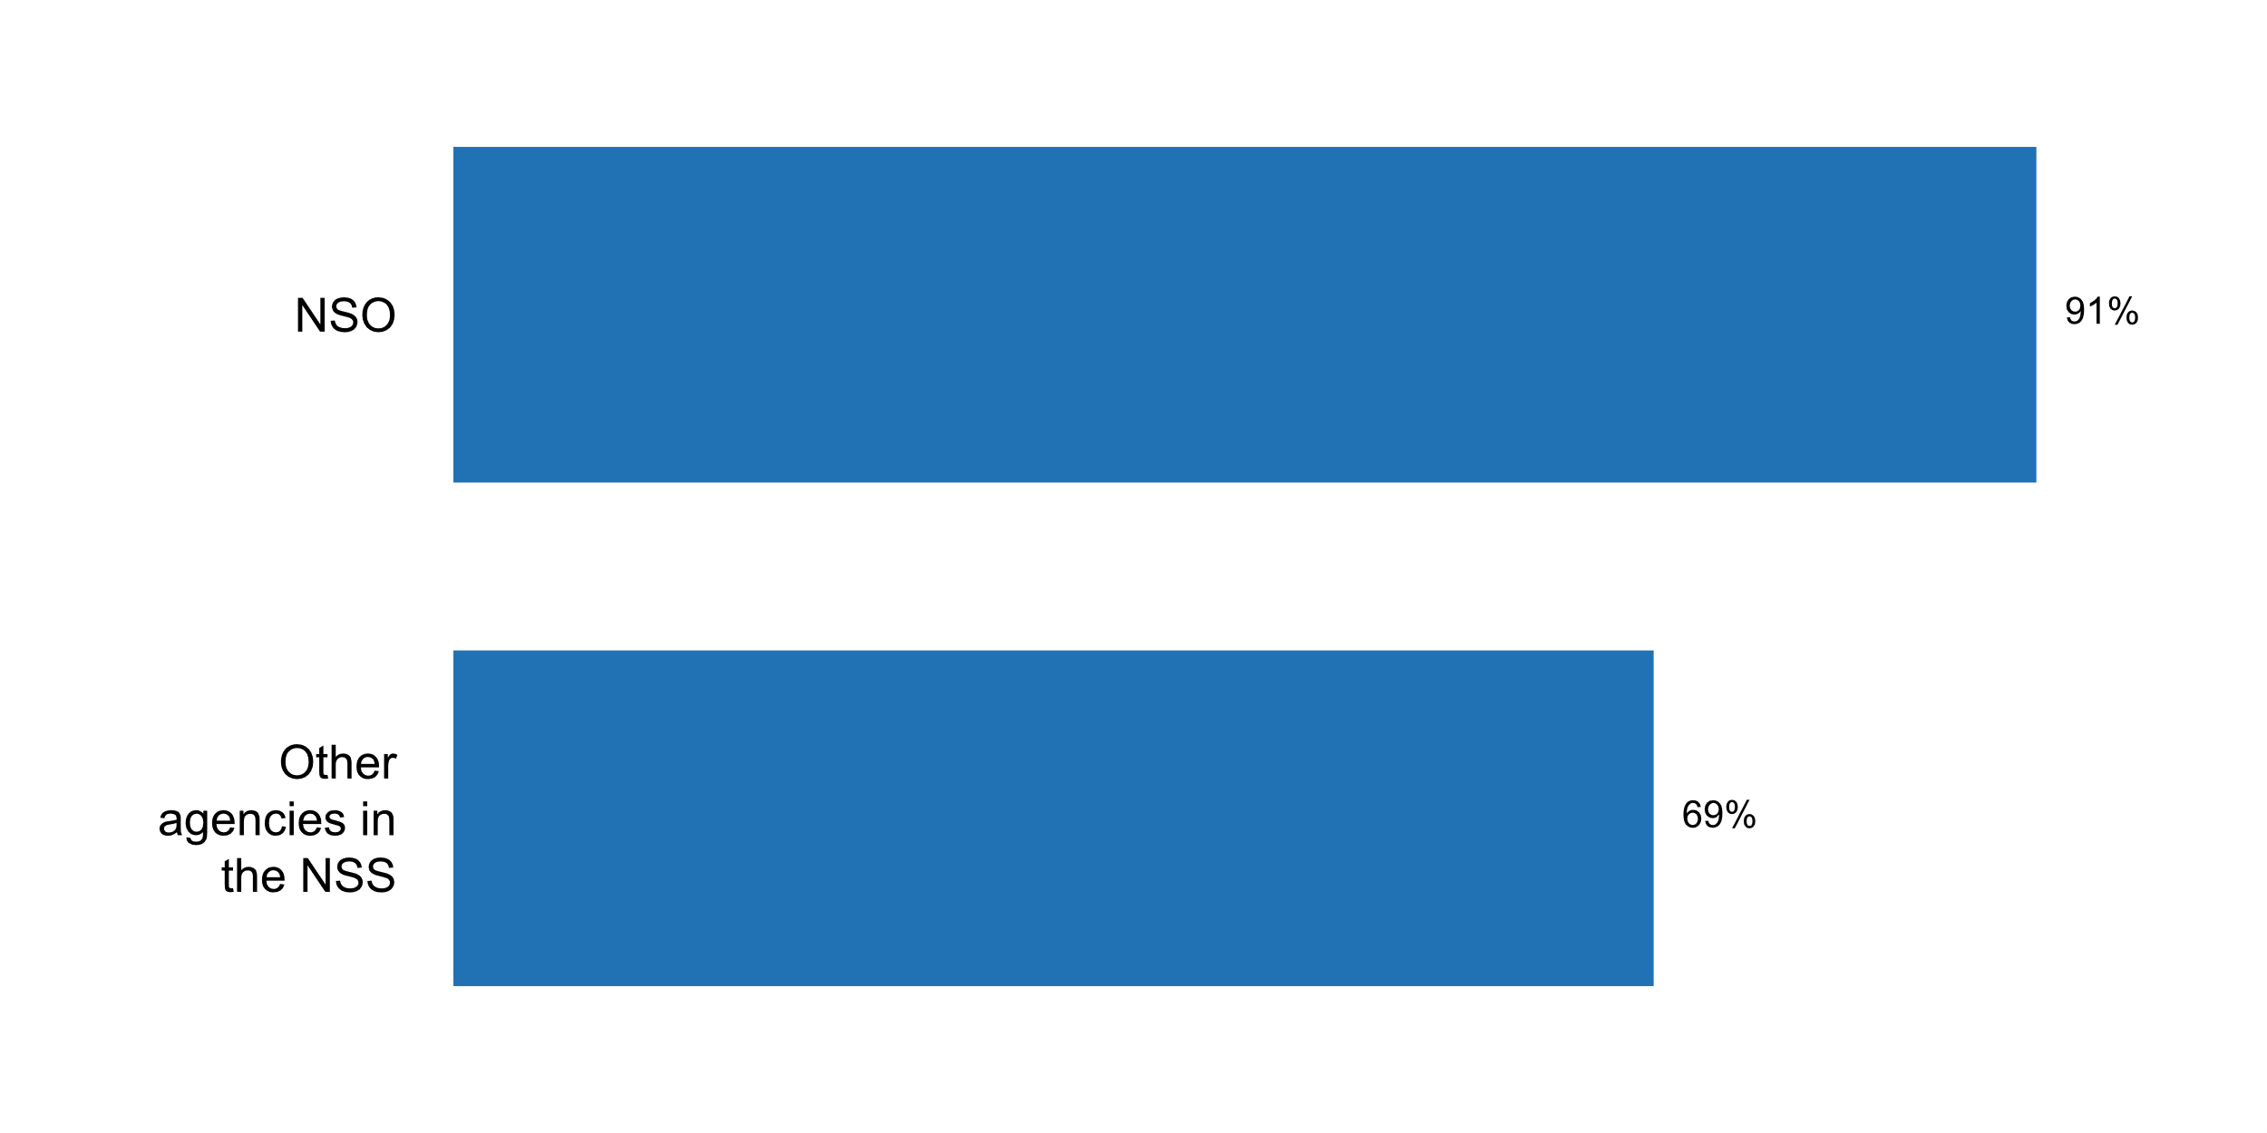

|  |  |  |  |  |  |  |  |
| --- | --- | --- | --- | --- | --- | --- | --- |
|  | **Answer** | **Africa** | **Americas** | **Asia** | **Europe** | **Oceania** | **TOTAL** |
| NSO staff has received training concerning open data, data privacy or access to information policies and principles | No | 3 | 2 | 2 |  |  | **7** |
|  | Yes | 14 | 11 | 21 | 35 | 4 | **85** |
|  | **Answer** | **Africa** | **Americas** | **Asia** | **Europe** | **Oceania** | **TOTAL** |
| Other agencies in the NSS have received training concerning open data, data privacy or access to information policies and principles | No | 7 | 4 | 8 | 2 | 2 | **23** |
|  | Yes | 10 | 9 | 16 | 27 | 2 | **64** |

|  |  |  |  |  |  |  |  |
| --- | --- | --- | --- | --- | --- | --- | --- |
|  | **Answer** | **Africa** | **Americas** | **Asia** | **Europe** | **Oceania** | **TOTAL** |
| NSO staff has received training concerning open data, data privacy or access to information policies and principles | No | 18 | 15 | 8 |  |  | **8** |
|  | Yes | 82 | 85 | 88 | 100 | 100 | **91** |
|  | **Answer** | **Africa** | **Americas** | **Asia** | **Europe** | **Oceania** | **TOTAL** |
| Other agencies in the NSS have received training concerning open data, data privacy or access to information policies and principles | No | 41 | 31 | 33 | 6 | 50 | **25** |
|  | Yes | 59 | 69 | 67 | 77 | 50 | **69** |

*Type of training received by NSO staff concerning open data, data privacy or access to information policies and principles*

* - staff signs a confidentiality declaration when assigned corresponding commitments in the NSO; - specialized staff of NBS was trained on above issues in the framework of NBS connection to Government Interoperability Platform M-Connect;- training on confi
* A staff of the Division of Project Management and Statistical Coordination received training on the Data Revolution initiated by the Right to Access Information Commission (RAIC)
* All staff are schooled in data privacy as is required by the ISO 27001 standard
* All staff have been trained to be in compliance with the GDPR regulation.
* Almost the 40% of the NSO staff
* Annual briefings and on-the-job training for staff handling data collection, compilation and dissemination.
* BY TRAINING ON WORKSHOPS, SEMINARS
* Belstat's IT staff regularly attend seminars and undertake training and skills upgrade courses on information security and data protection according to the annually developed plan for skills upgrade of managerial staff and specialists
* Confidentiality, Data security, and IT-security are important training courses for all staff members. Since 2017 we also offer courses on the use of big data by official statistics.
* Courses on data confidentiality algorithms as well as on GDPR-rules are offered.
* DOSM has participated in the trainings, workshops and conferences on the open data internally and internationally to enhance the knowledge and expertise in Open Data.
* Data Anonymisation is critical for Open data
* Data security officer and his staff has received training on data privacy; IT-staff has received training on open data, etc.
* ESTP courses, study visits in other NSI
* El gobierno tiene como objetivo la interoperatividad, por lo que se dan las capacidades orientadas a los datos abiertos.
* European Statistical Training Programme Internal Trainings for data protection and on the new European General Data Protection Regulation Law.
* Every year, training regarding data privacy matters is organized at the CSB.
* Examples of trainings:- Open data - access, standard, education- Introduction to linked open data- Basic legal and technical aspects of opening and using public data- Opening public data- Training on the protection of personal data. In respect of the process of increasing the scope of statistics published in an open data format,Statistics Poland has organized internal meetings and trainings concerning the open statistics idea. Statistics Poland staff is also participant of external courses on public open data organized by the Ministry of Digital Affairs related to the national Programme for Opening Public Data.
* Freedom of Information and Data Protection Law seminars/training provided by government
* Generally, each Office of the Chief Information Officer, is responsible for leading the agency in training for Open Data, Data Privacy, etc.Here is an example from GSA, including information on US Open Data Policy:https://open.gsa.gov/data/
* Geostat staff members have participated in international trainings on these topics.
* Government conduct the assessment regarding to open data
* INEGI's officials have participated in international seminars, congresses and online courses related to open data.
* In 2017 -1 person, in 2018 -5 persons (were trained).
* In house training and seminars
* In the sphere of the Open data, two persons in 2017 (The programe for the training and exchange of ideas for representatives from central executive bodies Open Data Leaders Network)
* Information security training with data privacy aspects is carried out through regular education for all employees and through compulsory education of new employees and e-mail messages with warnings about the threats of using information technology.
* Internal courses on confidentiality principles etc.
* International training programs organized by UNESCAP and SIAP
* Mandatory training on data confidentiality and privacy by all employees at time of hire and every three (3) years. Participation in privacy conferences by privacy staff.
* Many staff of NSS have been trained in concerning open data, data privacy or access to information policies and principles.
* Mission d'étude à  l'Insee (France)exposé-débat avec La Commission nationale de protection des données personnelles
* NSO ORGANIZED NATIONAL OPEN DATA FORUM AND ATTENDING EXTERNAL CONFERENCES
* NSO received training concerning open data/data privacy/data governance framework by Digital Development Government Agency (Public Organization) (DGA).
* NSO staff has participated in training courses on data privacy either organised by the NSO or by national universities or by the National School for Civil servants.
* National Statistics Office of Mongolia organizes training courses to its staff, staffs in National Statistical System and other government organization.
* Nso is interested in participating in the external training regarding open data, data privacy in addition to the internal activities in this regard in order to enhance the capacities of its' staff and to raise their awareness in the statistical standards.
* One of my staff attended a SPC recent workshop in Tonga November 5-7, 2018 - IMPROVING ACCESS AND USE OF PACIFIC MICRODATA
* Open Data Portal TrainingSeminars on the Data Privacy Act Fourth International Open Data Conference and Pre-Conference
* Open Data from Open Data Watch and World Bank
* Open data
* Open data has been a government guidance established by ICT Ministry. On the other hand, Colombia has a Law related to Habeas Data, which establishes the personal data protection regulations.
* Open data is among statistical products provided to the users. Staff involved in providing open data was respectively trained. Data privacy is stipulated by the law and specific internal bylaws. Respective training is also performed.
* Open data, data privacy and access to information are built into cross-government statistical development. There are dedicated training modules around legal aspects of the use of statistics, while the Code of Practice for Statistics sets out the professional responsibilities of statisticians in assuring the trustworthiness of official statistics.
* PR Officer had training for open data. In addition the legal staff had a training on the data privacy and the data protection.
* Participation in the International Seminar on Open Data for the Sustainable Development Goals, Seoul, Republic of Korea, 25-27 September 2017 There is a focus on the topics of data privacy and confidentiality, and how to obtain data through training courses that target staff of the National Statistical System
* Public Information Access Agency & Undersecretary of Public Innovation and Open Government (Modernisation Government Secretary)
* Seminars on data privacy and access to information
* Staff of ELSTAT participated in seminars on the General Data Protection Regulation organized by external agencies.
* Staff receive training in order to implement the General Data Protection Regulation 2016/679 of the European Parliament and of the Council.
* Statistical Centre of Iran has hold several training courses on protecting confidentiality of statistical data, anonymizing statistical data and protecting privacy and personal data of respondents . All staff members of this Centre have signed a written undertaking to observe confidentiality principles specified by the SCI.
* Stats NZ has a training module on data privacy as part of its essential training. Training has also been provided on access to information policies and principles as part of our training on document management tools. Stats NZ has the government lead for open data so we have a team of experts who can provide guidance and advice about open data for staff. Specific measures are also in place to ensure the full protection of individual data from any potential disclosure without consent. These are publicly available on our website under our Privacy and Confidentially page and cover requirements from the Statistics Act 1975, Official Information Act 1982, Privacy Act 1993, and Public Records Act 2005. All employees of Stats NZ must make a declaration of secrecy before entering into his or her duties as set out in the Statistics Act 1975. The requirement to make a declaration
* TECNCOS OF THE INFORMATION TECHNOLOGY MANAGEMENT
* The ABS fosters a strong privacy culture by requiring all staff to undertake privacy training at regularly intervals, providing regular privacy communication and messaging, and uses privacy-by-design principles to ensure privacy is considered at all stages of project development and implementation. This approach was successfully used in the recent Australian Marriage Law Postal Survey and is being used in the 2021 Census program.
* The head of information security of INEC attended the International Open Data Conference, as well as conferences given by the entity in charge of telecommunications in Ecuador (MINTEL).
* The objective one of the training courses organised internally is the legal environment which HCSO exists in and data protection. All new commers have to attend this course. E-learning training material on GDPR has been compiled and made online available for the staff.
* The organization has participated in various forums, workshops and meetings organized by the various development partners on Open Data.
* The technical staff in charge of data privacy and access to information policies and principles have been trained on the following subjects in 2018. ISO 9001 Quality Management System Basic Training (1) ISO 9001 Quality Management System Basic Training (2) ISO 19011 Internal Auditor Basic Training ISO 27001 Information Security Management System Basic Training ISO 9001 Lead Auditor Training ISO 27001 ISMS Lead Auditor Training Fundamentals of Information Safety Awareness
* There are regular Training courses for incoming staff on this issues
* There are some courses that some of the NSO staff have attended on open data and data privacy.
* Through workshops and seminars organized by international organizations such as the World Bank, the Banco Interamericano de Desarrollo (BID), the Organizacià³n para la Cooperacià³n y el Desarrollo Econà³mico (OECD), GPSDD and other national organizations.
* Training conducted by the department on confidentiality/ data privacy.
* Training on legislation etc.
* Trainings at SIAP for UNFPOS relating courses
* Trainings concerning implementation of EU General Data Protection Regulation; proper management, protection and security of personal data; cyber security: safe data transmission.
* Two Open Data Forums in Cape Town, South Africa in 2017 and in Dubai, United Arab Emirates in 2018.
* Two staff of Statistics Mauritius attended training sessions on Open Data in 2018, organised by the Ministry of Technology, Communication and Innovation in collaboration with the National Computer Board, to form part of Open Data Teams and contribute to the National Open Data portal.
* Via PARIS21
* We have special group for Future Data dealing with open data, big data and other sources of data.They meet expert people and conferences in this regard
* Yearly courses in the Statistical Public School (inetgrted in the INE)
* specific training on data privacy
* Sporadic education through the ESS.
* We have a new law of access to information in Tunisia and the staff must have training about access to information
* BECAUSE THOSE KIND OF INFORMATIONS ARE NOT AVAILABLE TO ANYONE.
* Faiblesse des ressources financières
* Open data so far has been a matter for senior management of the NSO
* The main challenge is to list this necessity as one of the priority. Is plan to be done in 2019.
* We do not the specific training with open data. We have only guideline for dissemination
* lack of fund

*Type of training received by agencies in the NSS concerning open data, data privacy or access to information policies and principles*

* - specialized staff from other authorities was trained on above issues in the framework of NBS connection to Government Interoperability Platform M-Connect;
* All government departments are required to attend FOI seminars
* All members of NSS as been invited to participate in seminars and workshops concerning open data, data privacy or access to information policies and principles. obviously more action and training program on this meter is needed.
* Annual briefings are part of training for all staff in public service.
* BY TRAINING ON WORKSHOPS, SEMINARS
* Confidentiality, Data security, and IT-security are important training courses also in our common training program with our regional Offices (Corporate Training of the statistical Offices of the Federation and the Laender). Since 2017 we also offer courses on the use of big data by official statistics for all staff members. Since 2017 we also offer courses on the use of big data by official statistics.
* Czech Statistical Office organizes regular meetings (twice a year) with partners inside the State Statistical System. Issues regarding data privacy or access to information policies and principles are always presented and discussed there. Open data activities are coordinated on governmental level.
* Do not know exactly,
* GDPR har meant that several institutions have revisited this part of their production
* Government has a policy on information access
* INFORMATION TECHNOLOGY AUTHORITY ORGANISED WORKSHOPS SPECIALIZED SUBJECTS RELATED TO OPEN DATA
* In conformity with Annual Plan for Personnel Training.
* Internal trainings organised by the HCSO are available for staff members of the NSS.
* Ministry of Digital Affairs responsible for coordination of the national Programme for Opening Public Data is an organizer of this kind of training for ministries, central and regional public authorities
* NCB through the ECB statistical system
* NSO has a national Statistical Training Centre at its' headquarters which has an annual plan for statistical training provided to its' staff and other statistical partners.
* NSS member can access courses held by the NSO and some have attended courses or seminars dealing with these issues.
* Open Data Watch
* Open data has been a government guidance established by ICT Ministry. On the other hand, Colombia has a Law related to Habeas Data, which establishes the personal data protection regulations.
* Orientation on the Data Privacy Act
* Other lead Australian Government statistical authorities have a similar focus on ensuring privacy and follow similar privacy practices. In addition, the AIHW is guided by the AIHW Ethics Committee, established under Section 16 of the Australian Institute of Health and Welfare Act 1987, which, among a range of issues, considers compliance with the Privacy Act. The ABS offers ABS DataLab training on our website: http://www.abs.gov.au/websitedbs/D3310114.nsf/home/DataLab+Training+ScheduleThe Office of the Australian Information Commissioner also offers materials and resources to help Australian organisations and agencies develop or improve their privacy training programs.
* Professional statisticians are required to attend training on legal aspects of the use of statistical information, including statutory frameworks such as data protection legislation and ethical considerations. Individual government departments also run internal programmes that are specific to their operational environments, especially where those involve the use of sensitive personal information.
* Public Information Access Agency & Undersecretary of Public Innovation and Open Government (Modernisation Government Secretary)
* SURS does not have detailed information about trainings in other agencies in the NSS.
* Se convocaron a reuniones para dar a conocer sobre los datos abiertos y privacidad de datos.
* Seconded staff in other agencies have attended the same training.
* Some of the Departments that deal with administrative data have received trainin gon open data.
* Staff members of other NSS agencies attended trainings on personal data, data confidentiality etc.
* Staff receive training in order to implement the General Data Protection Regulation 2016/679 of the European Parliament and of the Council.
* The Central Bank in ape Town, South Africa in 2017
* The IT staff of authorized producers of official statistics regularly attend seminars and undertake training and skills upgrade courses on information security and data protection.
* The NZ government has programmes of work that support the opening up of government data, improving privacy practice and good information and records management.www.data.govt.nzhttps://www.ict.govt.nz/governance-and-leadership/the-gcio-team/government-chief-privacy-officer/https://www.digital.govt.nz/
* The Office of the President through technical assistance from the world bank were in collaboration to develop an open Data Policy for the country.Through the TA trainings were held. Also there is an Open Data Forum coordinated by the University of Botswana
* The Sierra Leone Police and the Environment Protection Agency (EPA)
* The above-mentioned Open Data training involved participants from line ministries and departments. However, some agencies were not invited such as the Central Bank.
* The knowledge is limited to the activities and events carried out by the PCBS, in which the employees of the National Statistical System join, and in general the subject of data privacy and confidentiality, publishing policies and access to data are topics that are addressed when implementing training courses by PCBS, which are usually implemented annually.
* The ministry responsible for the Latvian Open Data Portal has organised training on open data. The CSB has ensured training on the EU Code of Practice.
* The open data initiative has not been sufficiently disseminated, it is a relatively new topic for the NSS, however, MINTEL is the entity that has the most knowledge on this subject and who is under its coordination.
* The seminar entitled "European Statistics Code of Practice and other documents regulating the set-up of the national statistical system" (September 28, 2018) for the staff from the Ministry of Finance and the National Bank of Ukraine who together with the State Statistics Service compose the national statistical system in line with Ukraine's law on the state statistics
* There are two producers of official statistics in Estonia - the Statistics Estonia and the National Bank. Trainings have been similar in both of them.
* There is a Specialized Technical Committee on Open Data, integrated by members of INEGI and different State Units of the NSS. The Office of the Coordination of the National Digital Strategy, gave a series of training courses for the implementation of the federal open data initiative to the offices of the executive branch.
* Training from the Open Data Institute by Malaysian Administrative Modernization and Management Planning Unit (MAMPU) sponsored by World Bank.
* Trainings concerning implementation of EU General Data Protection Regulation; protection and security of personal data; electronic information and cyber security; implementation of the EU Network and Information Security Directive; State information resources protection; open data principles; etc.
* TurkStat provides tailor-made training programs to the stakeholder institutions in the Official Statistics Program (OSP) based on demands of these institutions. In this context, a training program including data privacy for one of these institutions (General Directorate of State Railways) was organized in 2018. Also, an annual training program is being arranged for all institutions and organizations included in the OSP for the purpose of improving capabilities of the participants through providing necessary information on data collection methods, statistical methodologies and techniques and data analysis. In future, subjects concerning open data, data privacy or access to information policies and principles may considered to be included in this training program.
* We created a pilot for quality assurance training for other federal departments who produce and prepare data. Additionally, all Canadian government departments have access to information offices in support of legislation on this.
* We hold the training in the whole WSS about open data.
* With in force coming of the Regulation (EU) 2016/679 of the European Parliament and of the Council of 27 April 2016 on the protection of natural persons with regard to the processing of personal data and on the free movement of such data... all civil servants had to be briefed in this field. GDPR courses are offered to all civil servants.
* Within the framework of an hoc course on governance and quality issues, NSS received training on data privacy and anonymisation techniques.
* https://digital.gov/open-data-policy-m-13-13/
* some employees have attended workshops on open data, smart data, big data...etc.
* special courses in the NSS
* staff of other government agencies such as Ministry of Education.

**Additional comments on challenges to the implementation of Principle 2**

* 1. There is a lack of training offered by international organisations in this area and also NSO and this contributed to the lack of knowledge in this area by line ministries.
* 2.2 "Article 10: Le Directeur général est choisi parmi les ingénieurs de la statistique et de la démographie ou de niveau équivalent." http://www.ansd.sn/index.php?option=com_docman&task=doc_download&gid=20&Itemid=259
* Additional comment for 2.2 - Based on the rules and regulation of Public Service of Government Malaysia.
* Areas of data governance, indigenous rights and sovereignty of data are emerging as more significant issue in the supply of and access to data. The role of the NSO in New Zealand is evolving to look at setting the direction of the data system and the need to set mandatory data standards to ensure more standardisation and increase the value from data and statistics. We recognize that some work is proceeding in these areas and support this.
* CONSTATNTE TRAINING AND INCLUSION OF THE PROMOTION OF A STATISTICAL CULTURE
* Challenges:- Approval of the project to reform the current law.- Strengthen capacities to establish standards for the SEN and implement them.- Establish disclosure and confidentiality policies for the SEN.
* FOR THIS PRINCIPLE THERE IS A LOT OF EFFORTS TO DO IN THAT WAY THE NSO AND THER OTHER AGENCIES DON'T HAVE THE SAME COLLECTS METHODOLOGICAL.
* Further improvements are in the process of implementation, as the new law on Official Statistics is in the process of implementation (delayed unfortunately due to low priority of statistics in the Government). The new law should clarify the procedure of appointment of the DG, improve the coordination role of the NSI and provide additional sources of funding which should be used for education of staff.
* Inadequate human and financial resources are the main constraint in this area.
* It is important to strengthen the professional and Technical Independence in the Statistical activities carry out for the State Units other than INEGI.
* It is necessary to update the statistical law, considering a principle that guarantees the professional and technical independence of the INEC and the NSS entities. It is necessary to take into account the mechanisms for the designation and dismissal of the chief of statistics, as well as the code of ethics of all statistical personnel of the NSS.
* Knowledge, capacity and capability are required in the NSS in order for one to understand the need and importance of data. This is lacking in many developing countries.
* Low level of Awareness on data users and data providersWorkload of staff from statistics unitsNo dedicated staff for statistics at line ministries
* NO CHALLENGES
* None
* Questions 2.1 and 2.5 are not clear. Difficult to answer.
* Reg. Q2.3. - it is the Ministry of Finance who is responsible for the recruitement process and hence would be the right insitution to direct the question to. There was some dicussions in the media when the previous DG was employed in 2015.
* Statistical units in ministriesNSO training to be strengthenedClassifications and codes are not used consistently across NSS
* Statistics Poland applies international classifications and nomenclatures in statistical research, which makes comparing statistical data possible. Classifications and nomenclatures are applied directly (e.g. CN) or national detailed versions are elabrated based on the European Union standards (the Polish Classification of Activity based on NACE and the Polish Classification of Goods and Services based on CPA). Statistics Poland President is legally authorised to elaborate the national classification standards, as well as to change and interpret them. The legal means to introduce them is however a regulation of the Prime Minister. The basic classification standards are applied not only for statistical purposes, but they have also broad usage outside statistics. They are available along with auxiliary materials on the Statistics Poalnd information portal for users other than statisticians. Examples of interpretation decisions are also available on the website
* Strenghthen the cooperation with the universities and scientific centres to impact the scientific knowledge; Improving the dissemination of ethics procedures to the staff; Promoting the Capacity Building in the staff.
* The Strategy for the development of state statistics of the Republic of Belarus until 2022 provides for raising professional competence and qualification of the staff, creating conditions for the development and interest in achieving high performance results through: improvement of HR planning and long-term plans for HR development taking into account the needs of state statistics bodies; application of new forms and methods of HR management, implementation of modern HR technologies. Due to the budget limitations, it is not always possible to implement planned activities on professional staff development.
* The big challenge on this principle is to establish National Quality Framework to measure the quality of NSS statistical products.
* There is need for more transparency and accountability by statistical agencies
* To ensure full implementation of EU General Data Protection Regulation;To strengthen technical and organizational measures to prevent, detect, analyze and respond to cyber incidents.
* We do not have further comments about this principle
* We have no challenges for principle 2
* We strongly follow the Principle 2

**Plot_27_Q03.1.svg**

**Dissemination channels through which the NSS/NSO makes its data available to the public?**

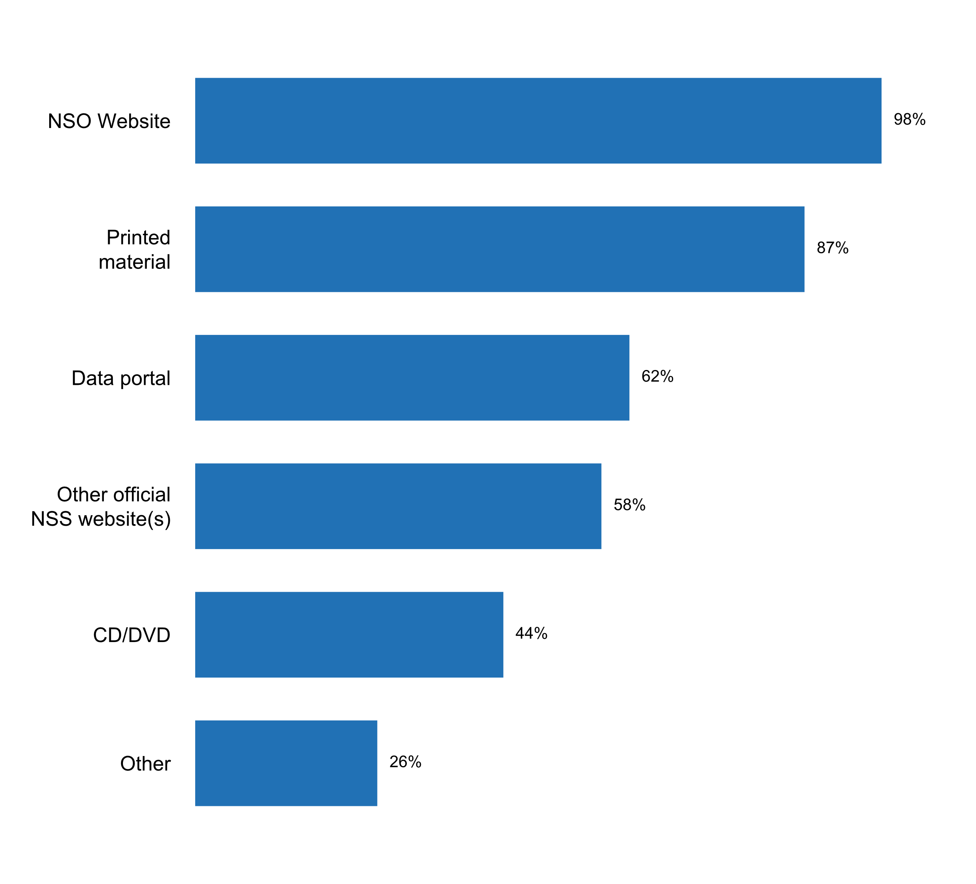

|  |  |  |  |  |  |  |
| --- | --- | --- | --- | --- | --- | --- |
| **Answer** | **Africa** | **Americas** | **Asia** | **Europe** | **Oceania** | **TOTAL** |
| NSO Website | 17 | 13 | 23 | 34 | 4 | **91** |
| Printed material | 16 | 10 | 21 | 30 | 4 | **81** |
| Data portal | 13 | 4 | 16 | 22 | 3 | **58** |
| Other official NSS website(s) | 10 | 8 | 15 | 20 | 1 | **54** |
| CD/DVD | 6 | 4 | 16 | 13 | 2 | **41** |
| Other | 3 | 5 | 7 | 9 |  | **24** |

|  |  |  |  |  |  |  |
| --- | --- | --- | --- | --- | --- | --- |
| **Answer** | **Africa** | **Americas** | **Asia** | **Europe** | **Oceania** | **TOTAL** |
| NSO Website | 100 | 100 | 96 | 97 | 100 | **98** |
| Printed material | 94 | 77 | 88 | 86 | 100 | **87** |
| Data portal | 76 | 31 | 67 | 63 | 75 | **62** |
| Other official NSS website(s) | 59 | 62 | 63 | 57 | 25 | **58** |
| CD/DVD | 35 | 31 | 67 | 37 | 50 | **44** |
| Other | 18 | 38 | 29 | 26 |  | **26** |

* Dedicated dissemination staff for responding to requests; press conferences and media appearances; social media
* Electronic services and mobile services
* L'ANSD dispose d'une bibliothèque ouvert au public.
* Mobile App developed by the SCI for statistical data dissemination.
* Notas de Prensa
* Open data registered at the National Catalogue of Open Data
* Press Conferences
* Press conferences, seminars, national conferences
* Published on the website
* Research Data Centres, Public Use Microdata Files
* SIGNAGE SYSTEM, SOCIAL MEDIA
* Safe Centre (research room)
* Social Media such as Facebook, twitter, press releases, whasapp group and so on.
* Social media (Facebook, Twitter), RSS, access in SURS's secure room
* Social media platforms including Twitter
* Social media, such as Twitter, Facebook and the WordPress blog, mobile application.
* Social networks
* UBOSAPP
* Via media releases
* press conferences, news briefings, dissemination forum
* press releases
* social media, networks, mass media
* social media, user support solutions; Local Data Bank, National Official Business Register (REGON) and National Official Register of the Territorial Division of the Country (TERYT) are equipped with API. Statistics' Poland objective is to provide API to all statistical databases as well as to disseminate all data sets published on our website in open formats

**Plot_28_Q03.2.svg**

**How users are informed of the quality of published data**

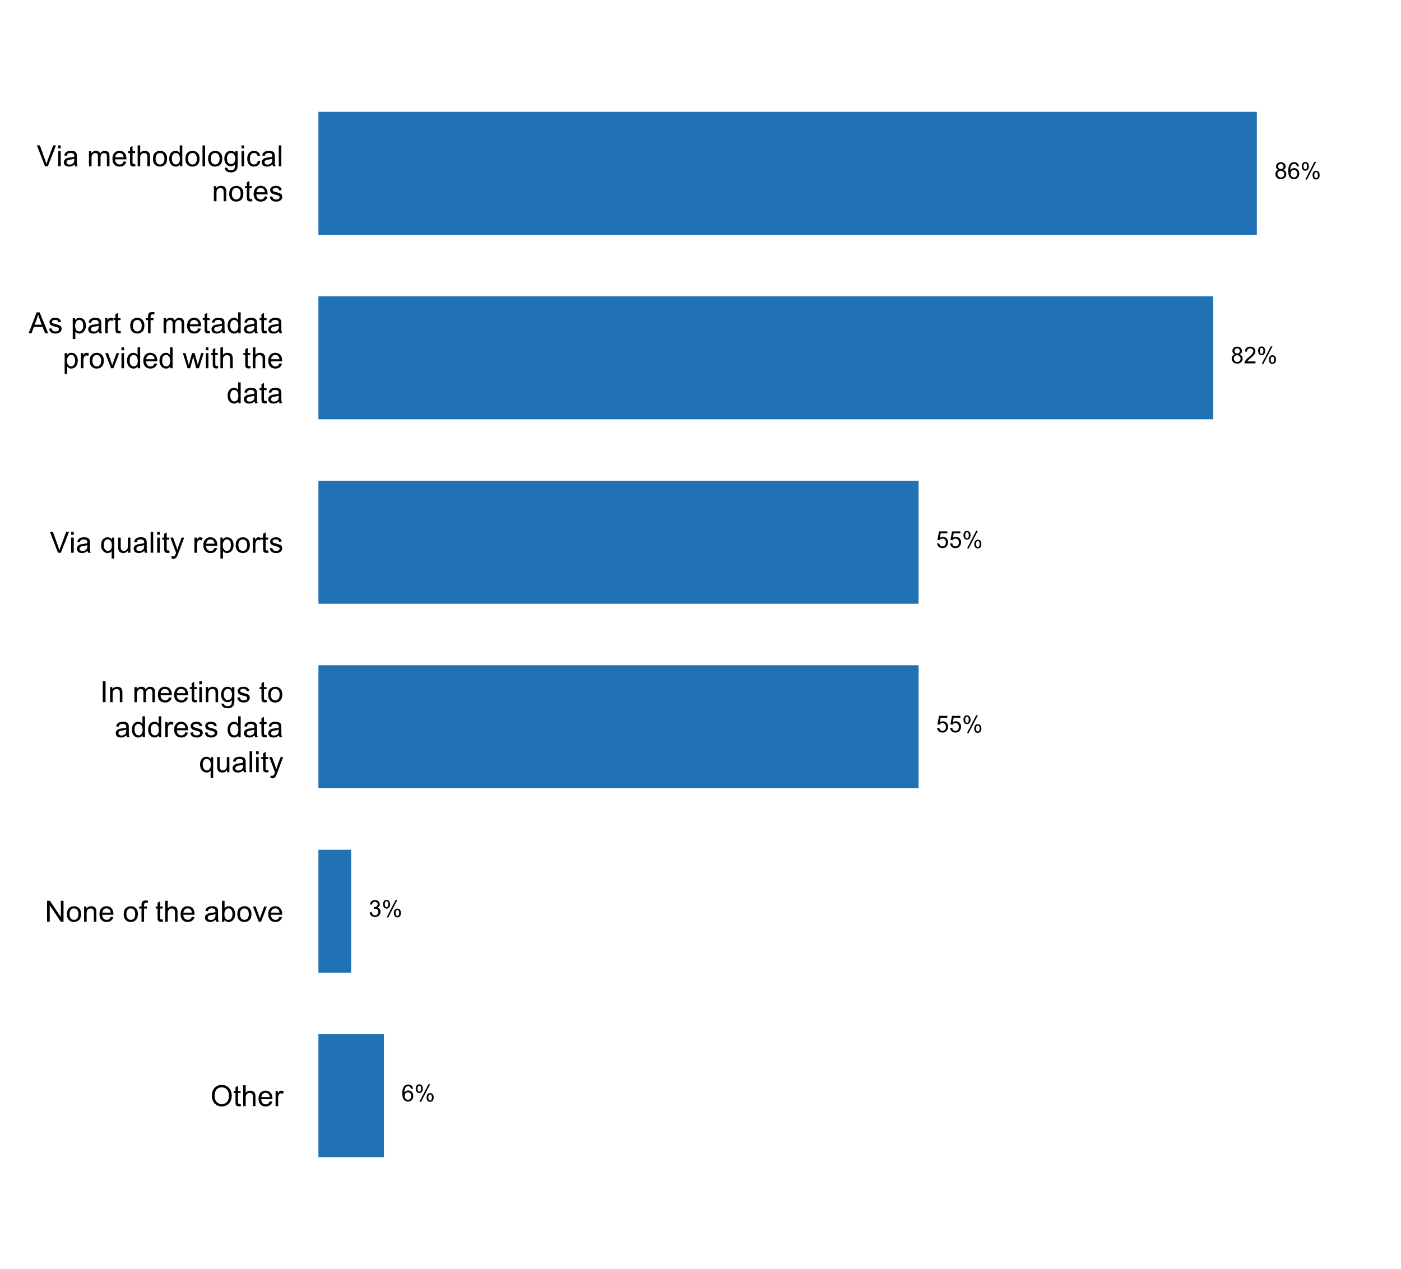

|  |  |  |  |  |  |  |
| --- | --- | --- | --- | --- | --- | --- |
| **Answer** | **Africa** | **Americas** | **Asia** | **Europe** | **Oceania** | **TOTAL** |
| Via methodological notes | 13 | 12 | 20 | 31 | 4 | **80** |
| As part of metadata provided with the data | 12 | 10 | 21 | 30 | 3 | **76** |
| Via quality reports | 4 | 5 | 8 | 31 | 3 | **51** |
| In meetings to address data quality | 11 | 6 | 15 | 15 | 4 | **51** |
| None of the above | 1 | 1 | 1 |  |  | **3** |
| Other |  | 2 | 1 | 2 | 1 | **6** |

|  |  |  |  |  |  |  |
| --- | --- | --- | --- | --- | --- | --- |
| **Answer** | **Africa** | **Americas** | **Asia** | **Europe** | **Oceania** | **TOTAL** |
| Via methodological notes | 76 | 92 | 83 | 89 | 100 | **86** |
| As part of metadata provided with the data | 71 | 77 | 88 | 86 | 75 | **82** |
| Via quality reports | 24 | 38 | 33 | 89 | 75 | **55** |
| In meetings to address data quality | 65 | 46 | 63 | 43 | 100 | **55** |
| None of the above | 6 | 8 | 4 |  |  | **3** |
| Other |  | 15 | 4 | 6 | 25 | **6** |

* All ABS Publications have a data quality declaration based on the ABS Data Quality Framework
* CBS' Database of Quality Information (metadata repository)
* No information on quality of published data is provided to the users, but in the weighing method non- response rate is implicitly mentioned.
* Statistics Canada uses a variety of methods to ensure our users are well informed about quality.
* via metadata descriptions.
* websites generally include extensive methodology documents; including documents on key assumptions for missing data. For example, for "advance" GDP, many key assumptions are made for the missing key source data for the third month of the quarter.

**Plot_29_Q03.3.svg**

**Types of explanatory texts that accompany published data**

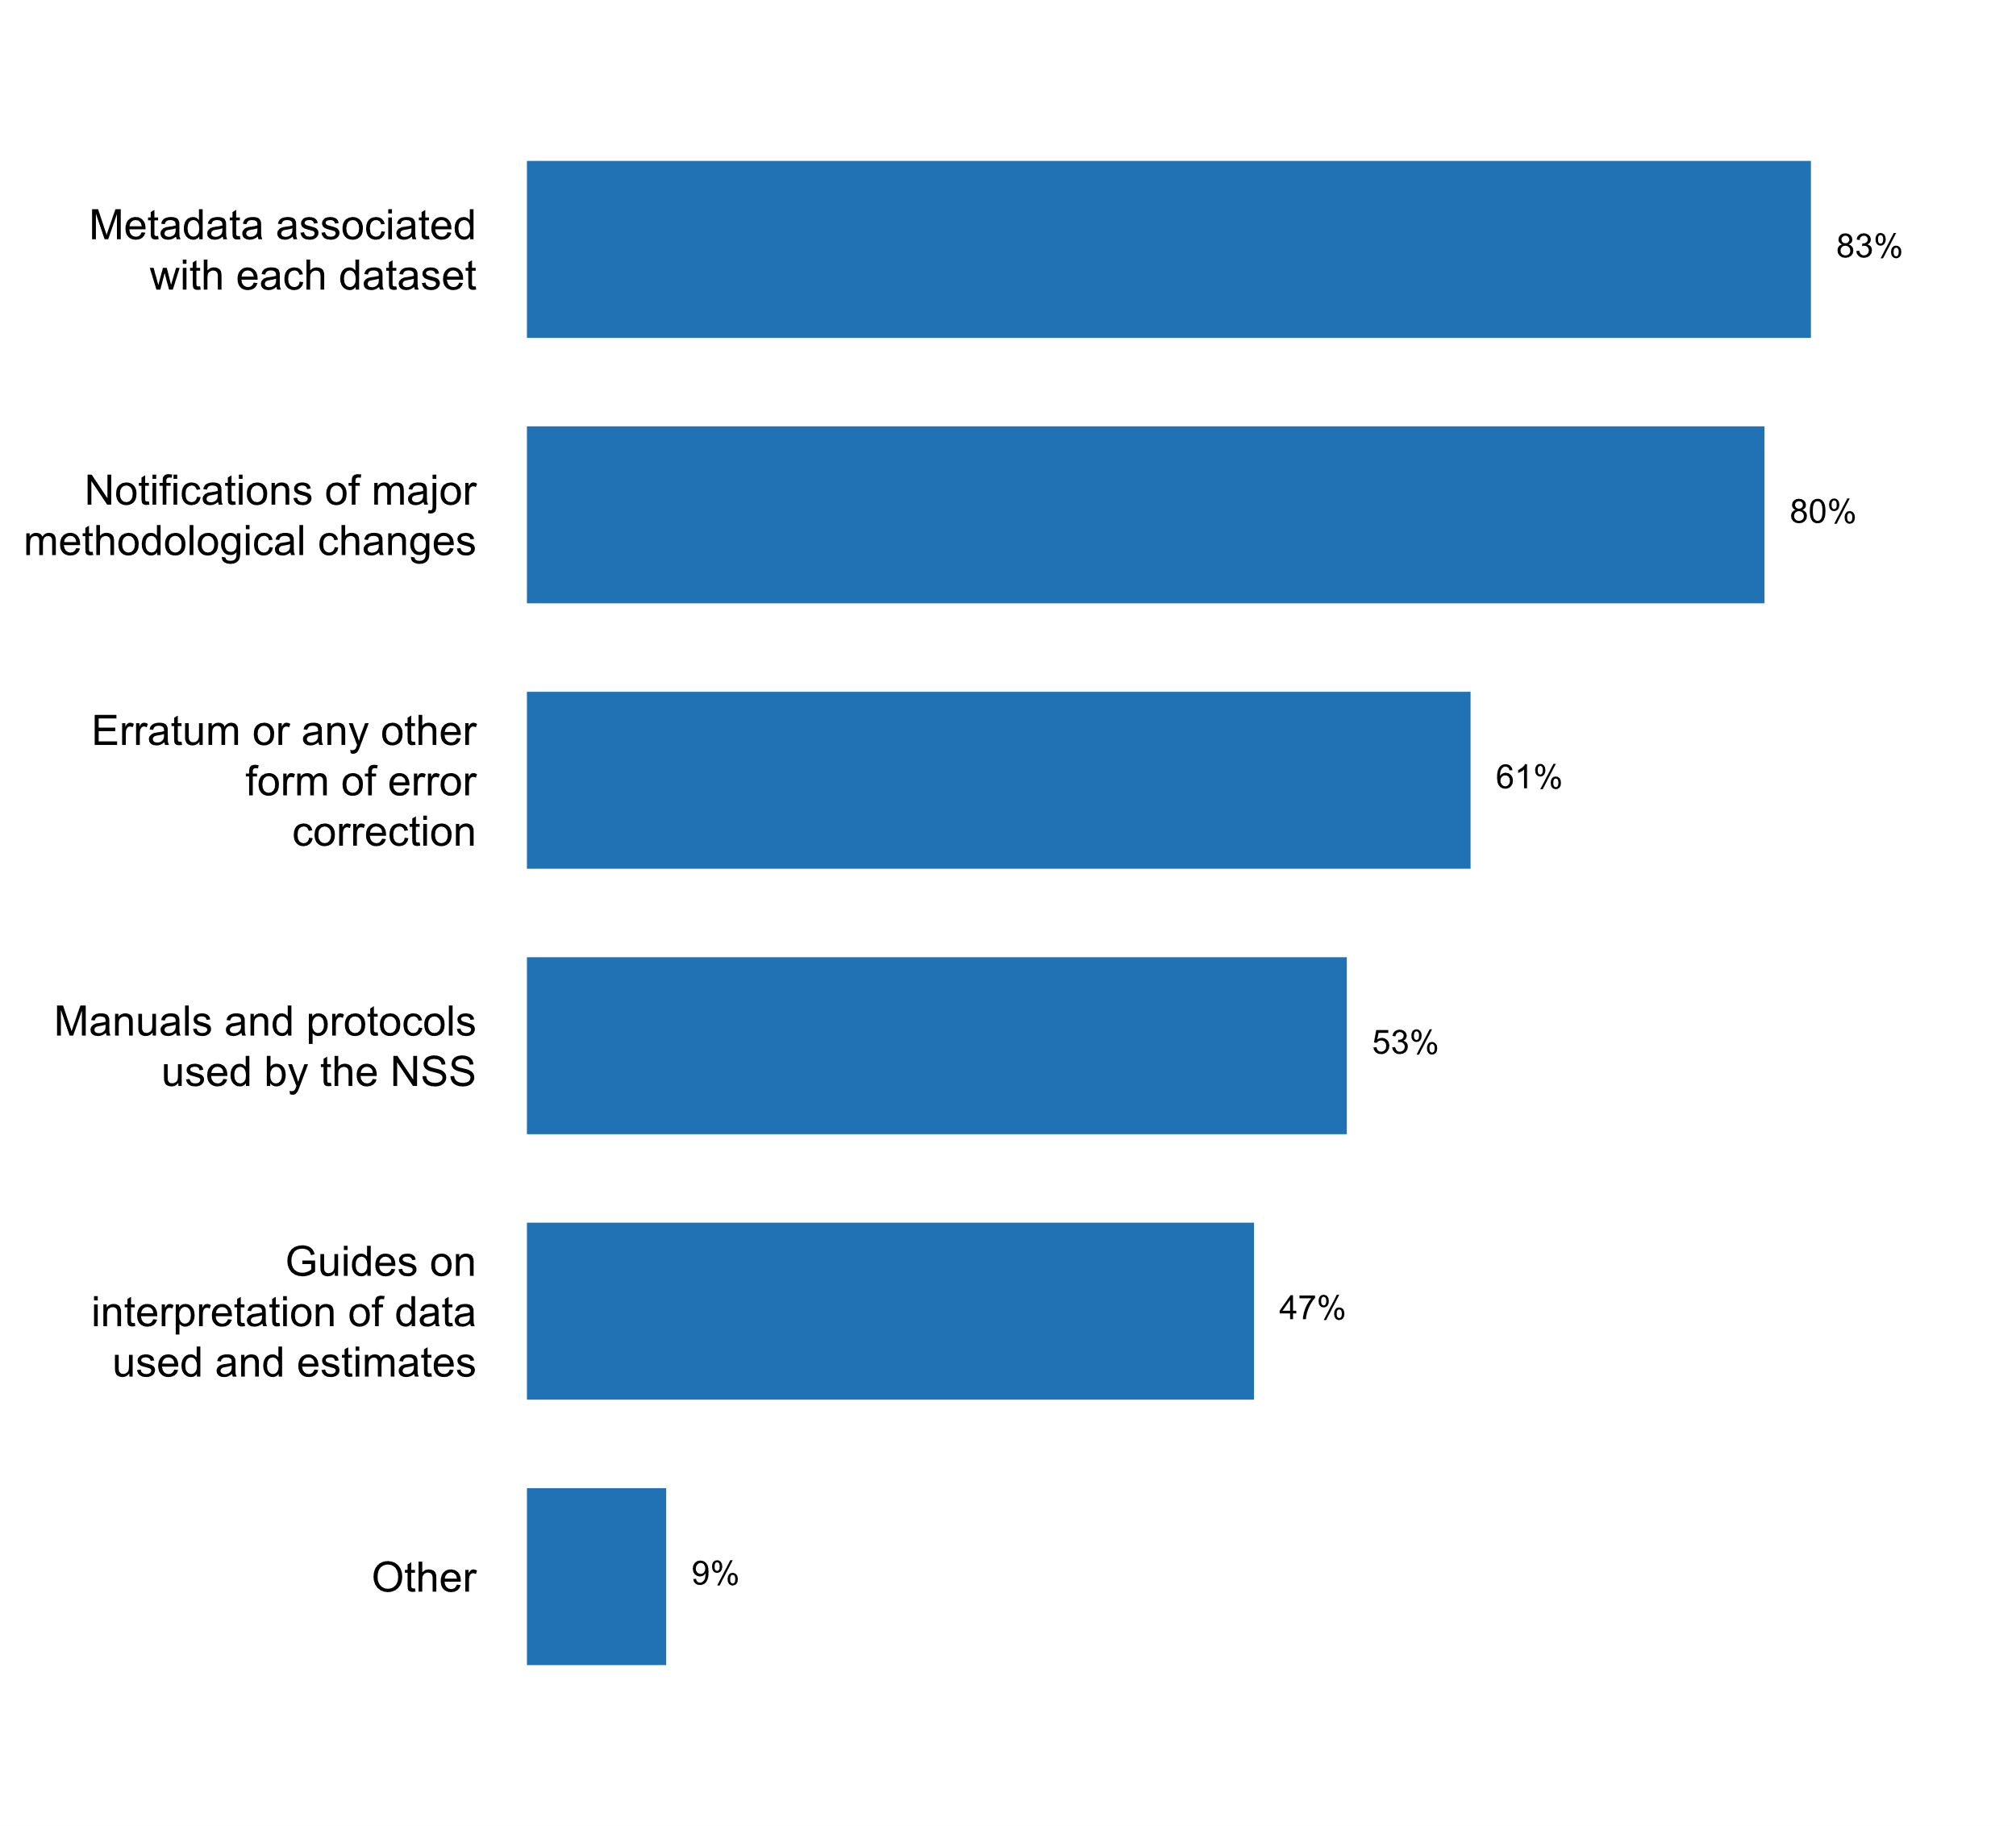

|  |  |  |  |  |  |  |
| --- | --- | --- | --- | --- | --- | --- |
| **Answer** | **Africa** | **Americas** | **Asia** | **Europe** | **Oceania** | **TOTAL** |
| Metadata associated with each dataset | 11 | 10 | 22 | 31 | 3 | **77** |
| Notifications of major methodological changes | 11 | 11 | 17 | 31 | 4 | **74** |
| Erratum or any other form of error correction | 11 | 8 | 9 | 26 | 3 | **57** |
| Manuals and protocols used by the NSS | 8 | 7 | 11 | 20 | 3 | **49** |
| Guides on interpretation of data used and estimates | 5 | 8 | 14 | 14 | 3 | **44** |
| Other | 1 | 1 | 3 | 3 |  | **8** |

|  |  |  |  |  |  |  |
| --- | --- | --- | --- | --- | --- | --- |
| **Answer** | **Africa** | **Americas** | **Asia** | **Europe** | **Oceania** | **TOTAL** |
| Metadata associated with each dataset | 65 | 77 | 92 | 89 | 75 | **83** |
| Notifications of major methodological changes | 65 | 85 | 71 | 89 | 100 | **80** |
| Erratum or any other form of error correction | 65 | 62 | 38 | 74 | 75 | **61** |
| Manuals and protocols used by the NSS | 47 | 54 | 46 | 57 | 75 | **53** |
| Guides on interpretation of data used and estimates | 29 | 62 | 58 | 40 | 75 | **47** |
| Other | 6 | 8 | 13 | 9 |  | **9** |

* Analysis of data
* Concepts and Definitions, Scope & Data Sources are provided in historical series and data published in reports and social and economic indicators.
* Data users receive no information on quality of data. Only in weighing method, non-response issue is implicitly explained.
* INE publish ESMS (SDMX) metadata with each statistics
* SingStat Website has videos and infographics to explain statistical concepts and data, and the statistical tables on SingStat Table Builder contains explanatory footnotes.
* Statistical Analyses
* each section of the yearbook has methodological notes
* press releases

**Plot_30_Q03.3b.svg**

**Information included in explanatory texts that accompany published data**

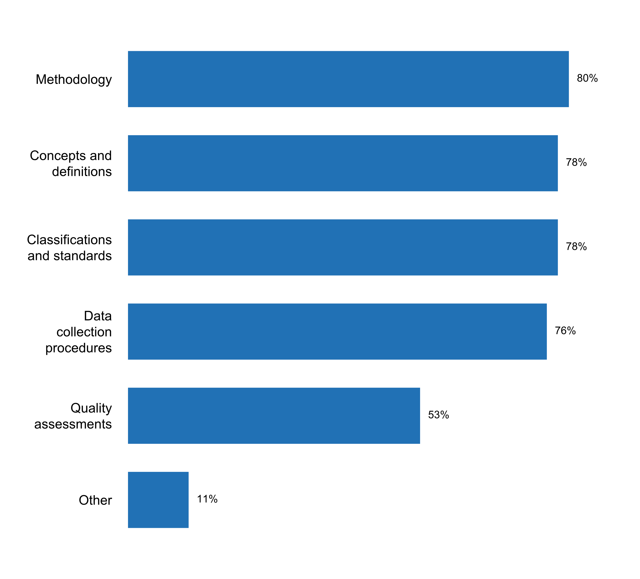

|  |  |  |  |  |  |  |
| --- | --- | --- | --- | --- | --- | --- |
| **Answer** | **Africa** | **Americas** | **Asia** | **Europe** | **Oceania** | **TOTAL** |
| Methodology | 10 | 10 | 20 | 31 | 3 | **74** |
| Concepts and definitions | 11 | 10 | 19 | 30 | 3 | **73** |
| Classifications and standards | 10 | 10 | 19 | 31 | 3 | **73** |
| Data collection procedures | 10 | 10 | 18 | 30 | 3 | **71** |
| Quality assessments | 6 | 7 | 10 | 25 | 1 | **49** |
| Other | 1 | 3 | 3 | 3 |  | **10** |

|  |  |  |  |  |  |  |
| --- | --- | --- | --- | --- | --- | --- |
| **Answer** | **Africa** | **Americas** | **Asia** | **Europe** | **Oceania** | **TOTAL** |
| Methodology | 59 | 77 | 83 | 89 | 75 | **80** |
| Concepts and definitions | 65 | 77 | 79 | 86 | 75 | **78** |
| Classifications and standards | 59 | 77 | 79 | 89 | 75 | **78** |
| Data collection procedures | 59 | 77 | 75 | 86 | 75 | **76** |
| Quality assessments | 35 | 54 | 42 | 71 | 25 | **53** |
| Other | 6 | 23 | 13 | 9 |  | **11** |

* All information defined by the ESS Single Integrated Metadata Structure (SIMS) are published to the users.
* Applied international codes such as COICOP and survey questionnaire
* ESMS (SDMX) structure
* Points of Contacts for the media and other data users are usually provided
* Statistics Canada uses a variety of methods to ensure our users are well informed about quality. Each statistical program must initially complete and keep up-to-date an accompanying metadata page prior to the release of data. Included on this page are all the options noted above.
* Table title, frequency, start period, end period, footnote, unit, data source, URL, formats for download, condition of use.
* data sources, accounting conventions
* everything requested within ESS standard metadata structures: ESMS and ESQRS
* surveys Questionnaires
* variable dictionary, forms

**Proportion of the datasets released in the last two years by the NSO which included metadata**

|  |  |  |  |  |  |  |
| --- | --- | --- | --- | --- | --- | --- |
| **Answer** | **Africa** | **Americas** | **Asia** | **Europe** | **Oceania** | **TOTAL** |
| 50% or more | 9 | 10 | 18 | 30 | 2 | **69** |
| Less than 50% | 2 |  | 4 | 1 | 1 | **8** |

|  |  |  |  |  |  |  |
| --- | --- | --- | --- | --- | --- | --- |
| **Answer** | **Africa** | **Americas** | **Asia** | **Europe** | **Oceania** | **TOTAL** |
| 50% or more | 53 | 77 | 75 | 86 | 50 | **74** |
| Less than 50% | 12 |  | 17 | 3 | 25 | **9** |

**Plot_31_Q03.3d.svg**

**Types of manuals and protocols made available with published data**

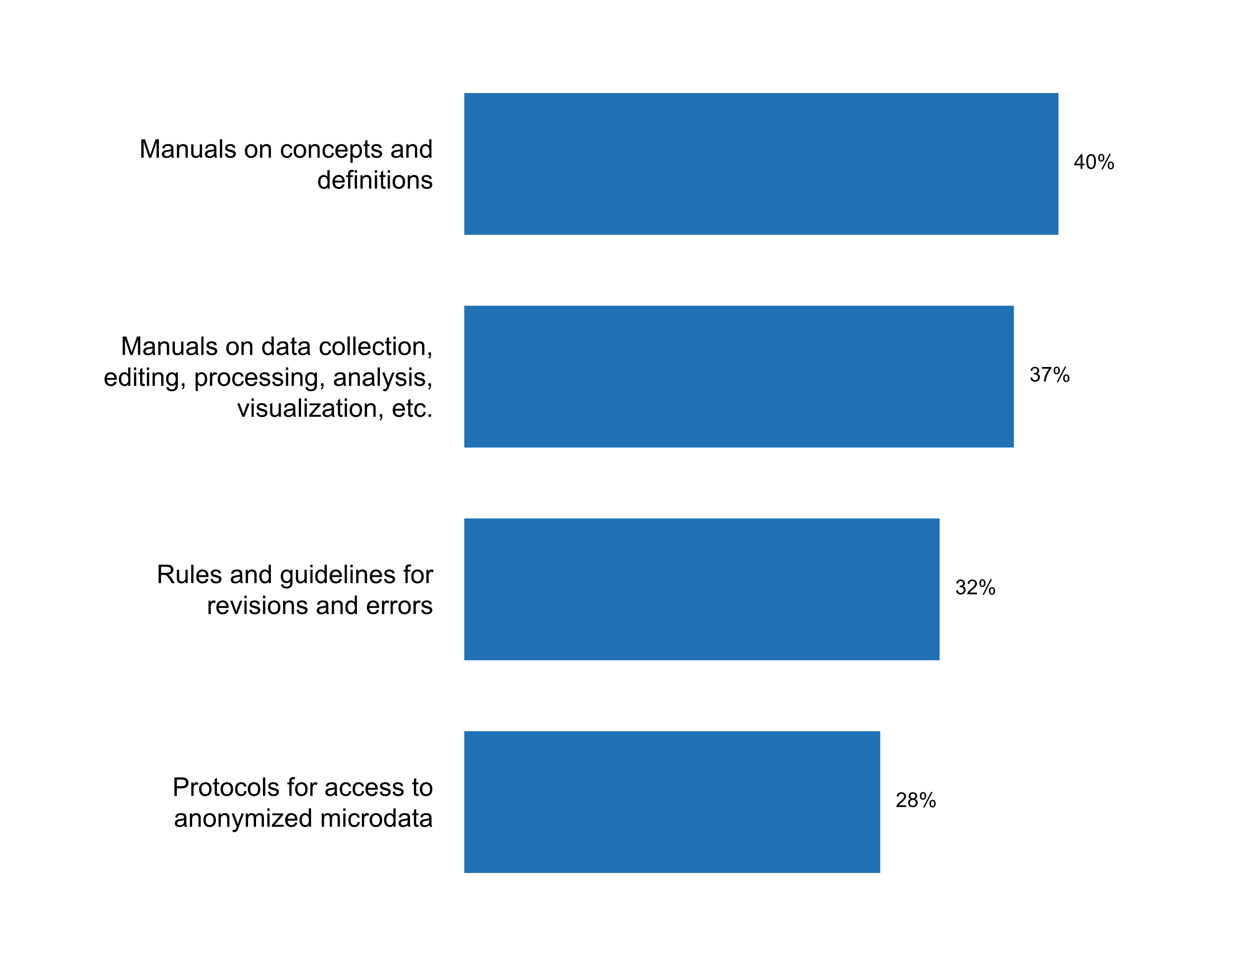

|  |  |  |  |  |  |  |
| --- | --- | --- | --- | --- | --- | --- |
| **Answer** | **Africa** | **Americas** | **Asia** | **Europe** | **Oceania** | **TOTAL** |
| Manuals on concepts and definitions | 7 | 6 | 10 | 12 | 2 | **37** |
| Manuals on data collection, editing, processing, analysis, visualization, etc. | 6 | 6 | 8 | 13 | 1 | **34** |
| Rules and guidelines for revisions and errors | 3 | 4 | 4 | 17 | 2 | **30** |
| Protocols for access to anonymized microdata | 3 | 5 | 4 | 12 | 2 | **26** |

|  |  |  |  |  |  |  |
| --- | --- | --- | --- | --- | --- | --- |
| **Answer** | **Africa** | **Americas** | **Asia** | **Europe** | **Oceania** | **TOTAL** |
| Manuals on concepts and definitions | 41 | 46 | 42 | 34 | 50 | **40** |
| Manuals on data collection, editing, processing, analysis, visualization, etc. | 35 | 46 | 33 | 37 | 25 | **37** |
| Rules and guidelines for revisions and errors | 18 | 31 | 17 | 49 | 50 | **32** |
| Protocols for access to anonymized microdata | 18 | 38 | 17 | 34 | 50 | **28** |

**Plot_32_Q03.4.svg**

**Data platforms(s) currently used by NSS/NSO to disseminate statistical data**

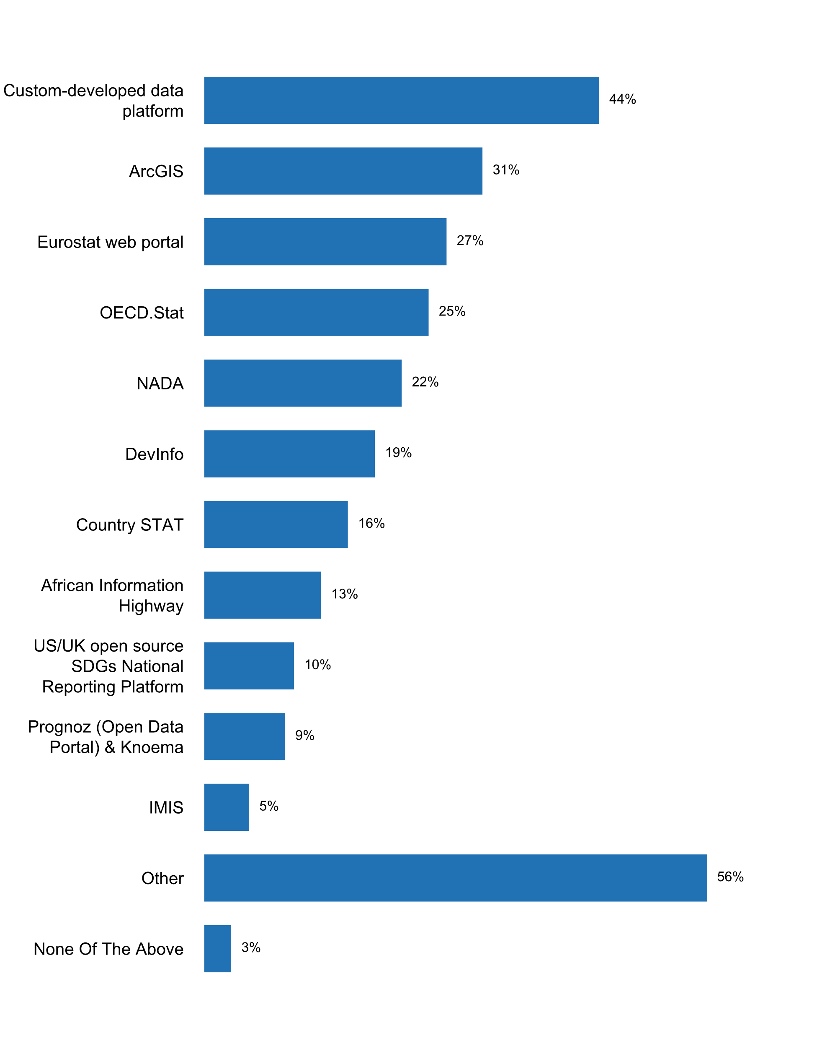

|  |  |  |  |  |  |  |
| --- | --- | --- | --- | --- | --- | --- |
| **Answer** | **Africa** | **Americas** | **Asia** | **Europe** | **Oceania** | **TOTAL** |
| Custom-developed data platform | 8 | 7 | 13 | 11 | 2 | **41** |
| ArcGIS | 6 | 3 | 10 | 10 |  | **29** |
| Eurostat web portal |  |  | 3 | 22 |  | **25** |
| OECD.Stat | 2 | 2 | 3 | 14 | 2 | **23** |
| NADA | 8 | 4 | 7 |  | 1 | **20** |
| DevInfo | 6 | 2 | 6 | 3 | 1 | **18** |
| Country STAT | 6 |  | 5 | 4 |  | **15** |
| African Information Highway | 12 |  |  |  |  | **12** |
| US/UK open source SDGs National Reporting Platform | 1 | 2 | 2 | 4 |  | **9** |
| Prognoz (Open Data Portal) & Knoema | 6 |  | 2 |  |  | **8** |
| IMIS | 5 |  |  |  |  | **5** |
| Other | 8 | 6 | 14 | 21 | 3 | **52** |
| None Of The Above |  |  | 3 |  |  | **3** |

|  |  |  |  |  |  |  |
| --- | --- | --- | --- | --- | --- | --- |
| **Answer** | **Africa** | **Americas** | **Asia** | **Europe** | **Oceania** | **TOTAL** |
| Custom-developed data platform | 47 | 54 | 54 | 31 | 50 | **44** |
| ArcGIS | 35 | 23 | 42 | 29 |  | **31** |
| Eurostat web portal |  |  | 13 | 63 |  | **27** |
| OECD.Stat | 12 | 15 | 13 | 40 | 50 | **25** |
| NADA | 47 | 31 | 29 |  | 25 | **22** |
| DevInfo | 35 | 15 | 25 | 9 | 25 | **19** |
| Country STAT | 35 |  | 21 | 11 |  | **16** |
| African Information Highway | 71 |  |  |  |  | **13** |
| US/UK open source SDGs National Reporting Platform | 6 | 15 | 8 | 11 |  | **10** |
| Prognoz (Open Data Portal) & Knoema | 35 |  | 8 |  |  | **9** |
| IMIS | 29 |  |  |  |  | **5** |
| Other | 47 | 46 | 58 | 60 | 75 | **56** |
| None Of The Above |  |  | 13 |  |  | **3** |

* ArmStatBank at https://www.armstat.am/en/?nid=13, Armenia SDGs indicators at https://www.armstat.am/en/?nid=655
* CZSO provides special applications (Public Database, External Trade, National Accounts) to use by users
* IMF Open Data Platform
* LankaSis
* Mexico open data portal (datos.gob.mx)
* NATIONAL SUMMERY PAGE
* National Data Portal
* National Open Data portal accessible at: https://data.govmu.org/dkan/
* National web page (NSDP) on eGDDS
* Open Data Portal
* Open data - data.public.lu (La plate-forme de données luxembourgeoise); www.grande-region.lu
* Oracle databases in-house developed
* PC-Axis
* PX-Web
* PX-web
* PxWeb for statistical database
* REDATAM for census
* ReDATAM
* Redatam
* STATcube - Statistics Austrias Database
* SingStat Mobile Application
* StatBank (http://www.statistica.md/pageview.php?l=ro&idc=407) GenderPulse (http://genderpulse.md/?utm_source=Statistica&utm_medium=banner&utm_campaign=main_page), Census platform (http://recensamant.statistica.md/)
* The NSA App as the custom-developed data platform
* agency websites
* data.gov.my (Malaysia Open Data portal) and IMF (Subscribe with SDDS)
* gov. data (German Data Platform)
* https://www.data.gouv.fr/, https://www.insee.fr/
* own website
* the following systems are used to share the data with international organizations: Integrated Correspondence System (ICS) for IMF, FTP for UN.

**Additional comments on challenges to the implementation of Principle 3**

* 3.3a (If none of the above was selected) Please explain briefly why no accompanying text is provided. (If "metadata" was selected) Please provide more details on the metadata. More information on "metadata" are provided below - Please refer to the metadata section of the SingStat Table Builder http://www.tablebuilder.singstat.gov.sg/publicfacing/viewGlossary.action
* 3.4 - Data platform: px-web
* At least SDDS standards are provided. MEDAS (Merkezi DaÄŸÄ±tÄ±m VeritabanÄ±/Central Dissemination Database) supports metadata at cell level (3.4)
* Database Genesis and Regional Databank together with the Laender
* INSTAT in order to optimize statistical processes have implement the GSBPM version 5.0. GSBPM in INSTAT is used for monitoring the statistical business processes (timetable) and for processes documentation. Monitoring the quality in statistical production is the main priority aspect in INSTAT and in the framework of 2018-2030 Strategy of INSTAT, one of the sub objectives is the Statistical Audit. INSTAT have defined the activities for the statistical auditing: Procedure of statistical internal audit; Documentation process for the statistical product and Recommendations for quality improvements of statistical process audited.
* Increase the number of statistical operations documented in the NADA site.
* La page web de chaque publication comprend un document sur "Méthodes et définitions". Exemple : http://www.ansd.sn/ressources/methodes/Mise%20en%20oeuvre%20du%20changement%20annee%20de%20base_vf_bis.pdf
* Nil
* Poor structure and weak institutional regulations and controls
* Regarding topic Dissemination, metadata and services CBS has established database of quality information (DBQI). DBQI became a key tool for quality assessment, quality documentation and quality reporting for CBS' surveys. Database content is based on an exhaustive list of quality information, which is further based on two widely accepted ESS structures, ESMS and ESQRS, divided in two parts: numerical information (meaning quality indicators which represent the most demanding part of the list of quality information which are gathered through the survey process) and descriptive (textual) information which refers directly to the survey quality assessment. All the information in the database can roughly be divided in two parts: 1) Numerical information, also called quality indicators. The whole list of quality indicators is divided in two parts: key indicators, which should be mandatory and calculated in all the surveys for which the quality assessment will be performed, and supportive indicators, which will be calculated if the survey manager considers them important for the quality assessment of a particular survey. 2) Descriptive (textual) information. This list can also be divided in two parts: information not directly connected to the quality assessment but aimed at describing the important characteristics of the survey, and information which refers directly to the survey quality assessment. To achieve the usefulness of this tool, the database itself had to be upgraded with a user-friendly application that enables easy inserting of information and management of inserted information. The first phase of development was devoted to the physical creation of the database and development of this user-friendly tool. The second phase is then devoted to the development of the management tool. At the beginning of the second phase we defined requirements for the output functionalities. These functionalities can be summarized as follows: â€¢ Survey manager authorization. Each survey manager should have the right to edit only specific surveys and view data from any survey. Survey manager must be checked before they start working with the application. This functionality is implemented by using Croatian metadata repository - CROMETA - web service. â€¢ Formatting of quality indicators into a readable (formatted) form. Application should enable creation of formatted tables from indicator values. This functionality is especially important for the sub-annual surveys. In these cases the table should summarize the values for the whole year. â€¢ Filling out the template for standard quality report. A quality report provides information on the main quality characteristics of a product for its users. Quality reports are normally based on quality indicators describing these characteristics and are important for both the producers and the management. The requirements of users and producers are different but a standard structure is preferable, so the application enables automatic transfer from the DBQI into the template for Standard Quality Report. Textual information from the database of quality information should be transferred unchanged, while the indicators should first be formatted into tables. One of the functionalities of the database of quality information is also easy and user-friendly creation of CBS's quality reports, which should be publicly available on our website. â€¢ Development of the basic analytical tool for comparative analyses of quality indicators. This tool should enable comparison for a selected reference period and for a selected indicator between all surveys. The comparison should be performed only on the level of the whole survey (no domains included). The tool should provide a list of indicator values for all the surveys for which the certain indicator is available on demand. Creating XML for the ESS Metadata Handler (ESS MDH) export from one system to another. This application should enable automatic transfer from the DBQI into ESS MDH as well as vice versa, from ESS MDH into DBQI. Textual information from the database of quality information should be transferred unchanged, while the indicators should first be formatted and then transferred into the ESS MDH. â€¢ Supplementation of the information in the database (Documentation). The first part of the database, which contains textual information, should be supplemented with the information derived from documenting the statistical process. The list of items for this part is already prepared and consists of 36 sub-processes while each sub-process is further divided into 4 standard elements. â€¢ Integration with metadata repository CROMETA. Static lists added from CROMETA should be replaced with dynamic lists retrieved from CROMETA via web services. If any change appears in CROMETA it is automatically updated in the DBQI. â€¢ Development of the advanced analytical tool for comparative analyses of quality indicators. The application should enable two types of comparative analyses for a particular quality indicator: 1. Analyses through time. When a user selects a starting and ending date as a reference period, the application provides a time series of a selected quality indicator. The series are presented in the form of tables and line charts. 2. Analyses between domains. The application should enable two different domain comparisons. The first one takes into consideration the specific indicator values and specific reference period between the indicator values for a chosen domain in a specific survey (e.g. response rate for different regions in LFS in 1st quarter 2017). The second one enables a comparison between the different (selected) surveys. The values are presented in tabular and bar chart form.
* Statistics Canada has strict protocols and control mechanisms around who has access to anonymize data and for what reasons. Rules and guidelines for revisions and errors are included in the policy suite and within the quality framework. Much of the data collection, editing, processing is now done centrally. These areas have documented their processes and work closely with their clients to ensure high quality end result. All harmonized concepts and definitions, including variables and classifications, are documents and available for use.
* THE AVAILABILITY OF MATADATA IN OTHER AGENCIES WITHIN NSS
* THERE IS NO COMMENTS ON CHALLENGES TO THE IMPLEMENTATIONS OF PRINCIPLE 3.
* The NSO web page is the main site where people can find statistical information of our country. Nowadays, we are working to be integrated on the e-GDDS.
* The Strategy for the development of state statistics of the Republic of Belarus until 2022 provides for the development of methodological approaches for the quality management of administrative data and publication of quality reports.
* The adoption of the GSBPM.
* The implementation in the NSS of dissemination strategies that contemplate a greater disaggregation of information, metadata and other means of dissemination, is necessary for users to have greater access and understanding of the information that is generated.
* The main constraint remains inadequate resources to produce the recommended quality reports and metadata, or to utilize other data platforms for data dissemination.
* The majority of Namibians live in the rural areas and literacy is also a challenge. Hence, hard copy publications are needed and they are costly.
* The way metadata is produced should be standardised across all subject areas and made more visible on our website. There are not enough resources to do so.
* We do not have further comments about this principle.
* We have the plan to develop a new project that includes the module of Web Portal to Disseminate Official Statistics data of our Country by our Custom developed, and we have educate more from International platform such as NADA, Eurostat web portal, Country STAT etc.
* We strongly follow the Principle 3
* we are working to implement OCDEStat

**Plot_33_Q04.1.svg**

**The NSO/NSS has reacted to erroneous interpretation and misuse of statistics during the past five years**

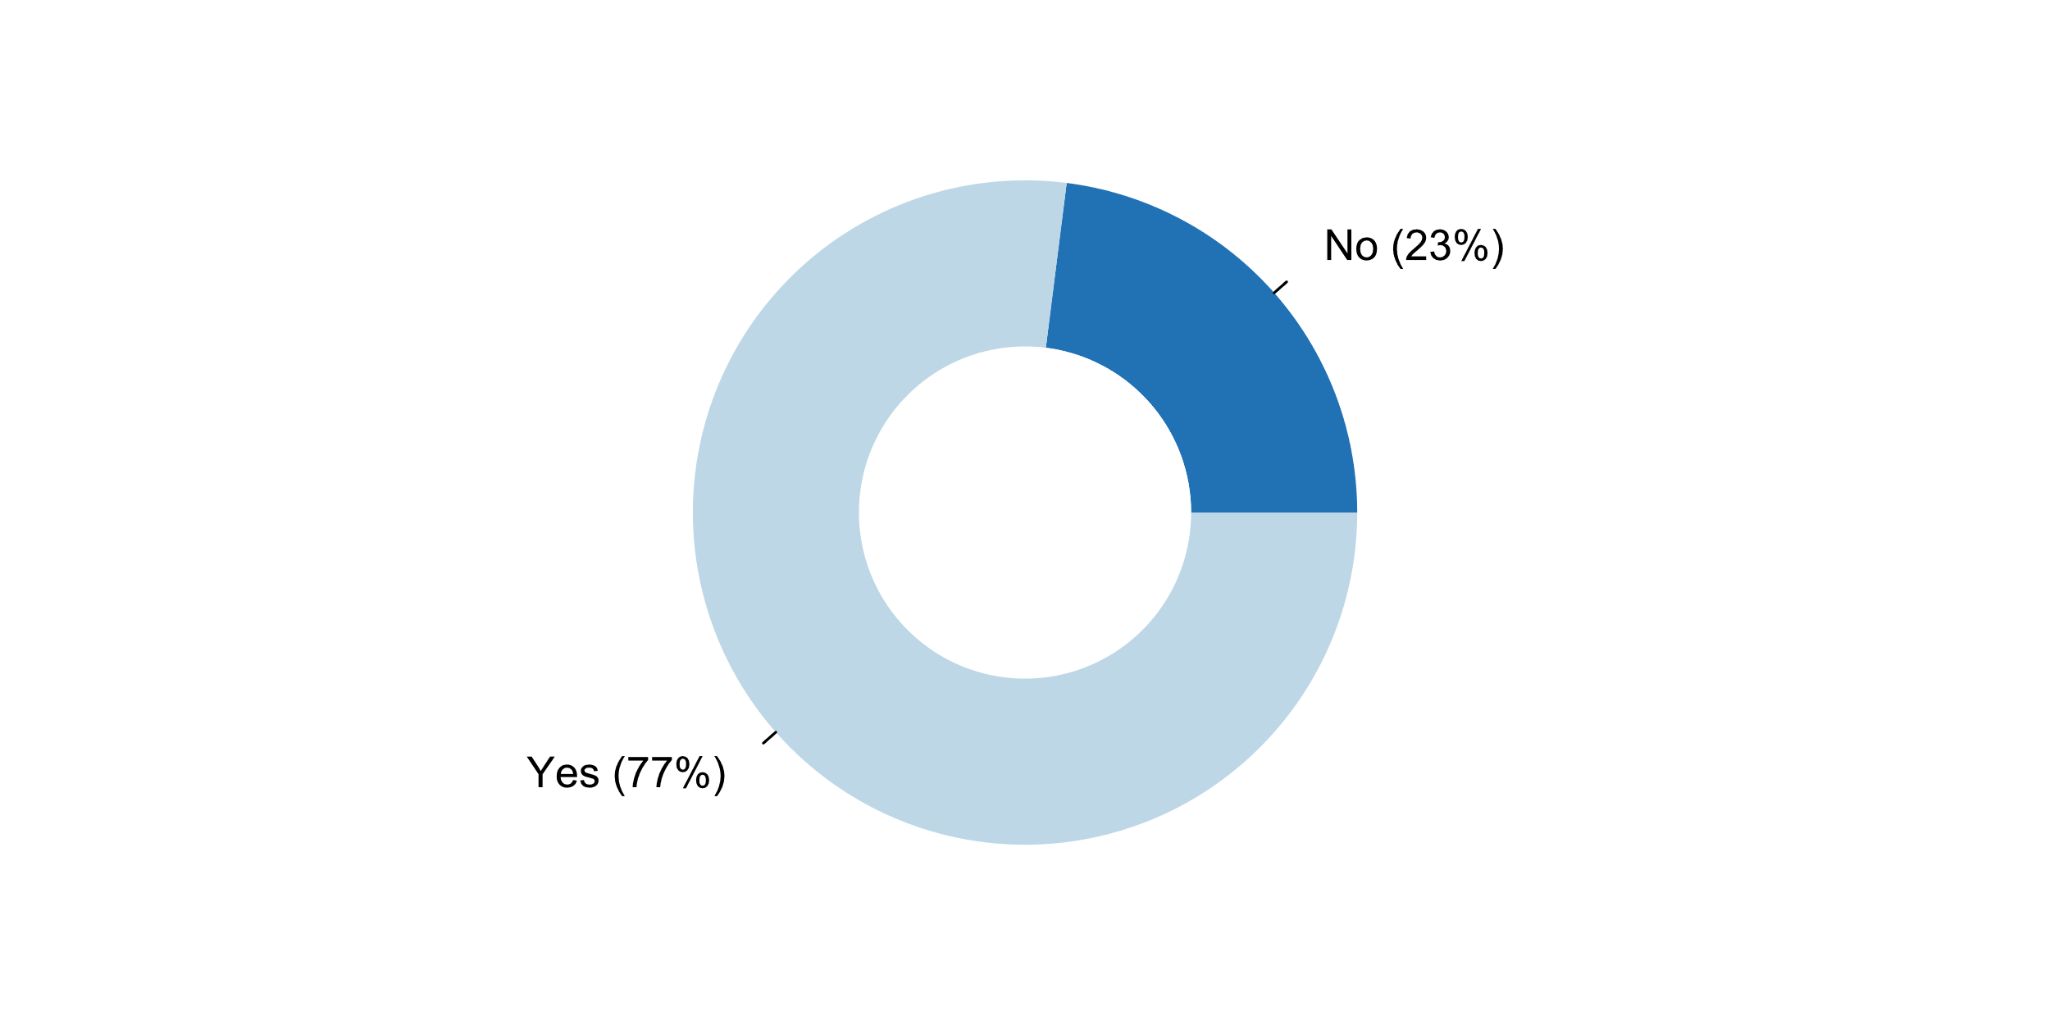

|  |  |  |  |  |  |  |
| --- | --- | --- | --- | --- | --- | --- |
| **Answer** | **Africa** | **Americas** | **Asia** | **Europe** | **Oceania** | **TOTAL** |
| No | 8 |  | 8 | 3 | 2 | **21** |
| Yes | 9 | 13 | 16 | 32 | 2 | **72** |

|  |  |  |  |  |  |  |
| --- | --- | --- | --- | --- | --- | --- |
| **Answer** | **Africa** | **Americas** | **Asia** | **Europe** | **Oceania** | **TOTAL** |
| No | 47 |  | 33 | 9 | 50 | **23** |
| Yes | 53 | 100 | 67 | 91 | 50 | **77** |

**Plot_34_Q04.2.svg**

**How NSO/NSS reacted to erroneous interpretations and misuse of statistics during the past five years**

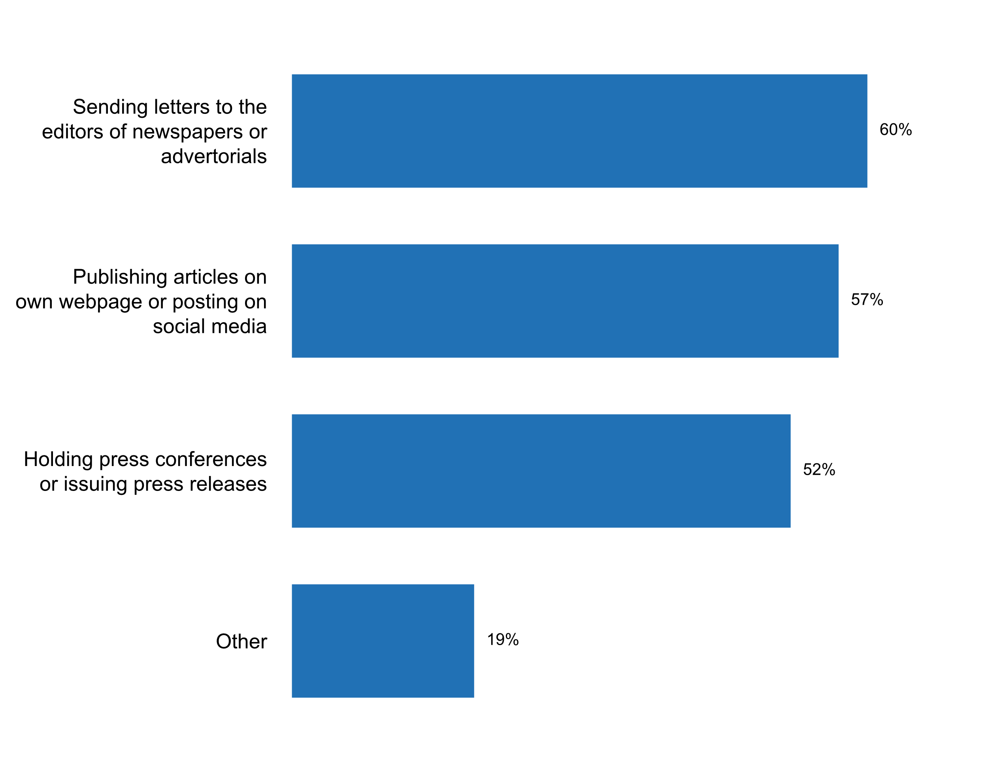

|  |  |  |  |  |  |  |
| --- | --- | --- | --- | --- | --- | --- |
| **Answer** | **Africa** | **Americas** | **Asia** | **Europe** | **Oceania** | **TOTAL** |
| Sending letters to the editors of newspapers or advertorials | 6 | 10 | 14 | 25 | 1 | **56** |
| Publishing articles on own webpage or posting on social media | 7 | 9 | 10 | 26 | 1 | **53** |
| Holding press conferences or issuing press releases | 8 | 9 | 10 | 19 | 2 | **48** |
| Other | 2 | 4 | 3 | 9 |  | **18** |

|  |  |  |  |  |  |  |
| --- | --- | --- | --- | --- | --- | --- |
| **Answer** | **Africa** | **Americas** | **Asia** | **Europe** | **Oceania** | **TOTAL** |
| Sending letters to the editors of newspapers or advertorials | 35 | 77 | 58 | 71 | 25 | **60** |
| Publishing articles on own webpage or posting on social media | 41 | 69 | 42 | 74 | 25 | **57** |
| Holding press conferences or issuing press releases | 47 | 69 | 42 | 54 | 50 | **52** |
| Other | 12 | 31 | 13 | 26 |  | **19** |

* A press communique was sent by the Statistics Board
* Belstat regularly monitors media publications (websites, newspapers, magazines) for the use of official statistical information. Such publications are checked by employees of the NSO, and when errors or misinterpretation of official statistical information are detected, the spokesperson or Belstat employees conduct explanatory work with the media. In case of systematic errors, an official letter is sent to the editor-in-chief of the media with explanations and a requirement to prevent errors or misinterpretation of statistical data, and an information letter is sent to the Ministry of Information of the Republic of Belarus (the body responsible for implementing state policy in the field of mass information). In addition, the official website of Belstat, the official pages of Belstat on social media contain information explaining the main methodological approaches to the compilation of official statistical information on which errors were made, and also underlines the possibility to get the necessary consultation on these issues from Belstat specialists. Belstat also holds regular press conferences on the results of various observations and surveys, at which the leadership of Belstat and its employees tell journalists about the results obtained, as well as explain the main methodological approaches used in compiling official statistical information.
* If the source is mentioned but the data are not correctly reported we are going into a dialog
* Issued statement and emails to data users
* Newspaper articles/commentaries, TV-debates
* Sending an official letter for concerned party.
* Sending statements to the editors of newspapers for publication
* TV appearance
* Television show appearances; preparation and publication of informative material, videos, etc.
* The UK Statistics Authority considers all potential misuse cases raised with it and responds publicly to all cases that are deemed to require a full response. All correspondence on issues of potential misuse is publicly available on the Authority's website.
* VIA SOCIAL MEDIA
* We have also invited those involved to a meeting to explain. We have appeared on TV to also explain to the nation.
* Working with authors of that information to provide additional information and/or training about the data. Engagement, increasing awareness of sources and methods.
* contacting rlevant persons
* e-mails
* focusing on the development of documentation and appropriate means of communication
* phone call
* varies across agencies, depending on scope of error

**Plot_35_Q04.2a.svg**

**Types of misuse identified in the past two years?**

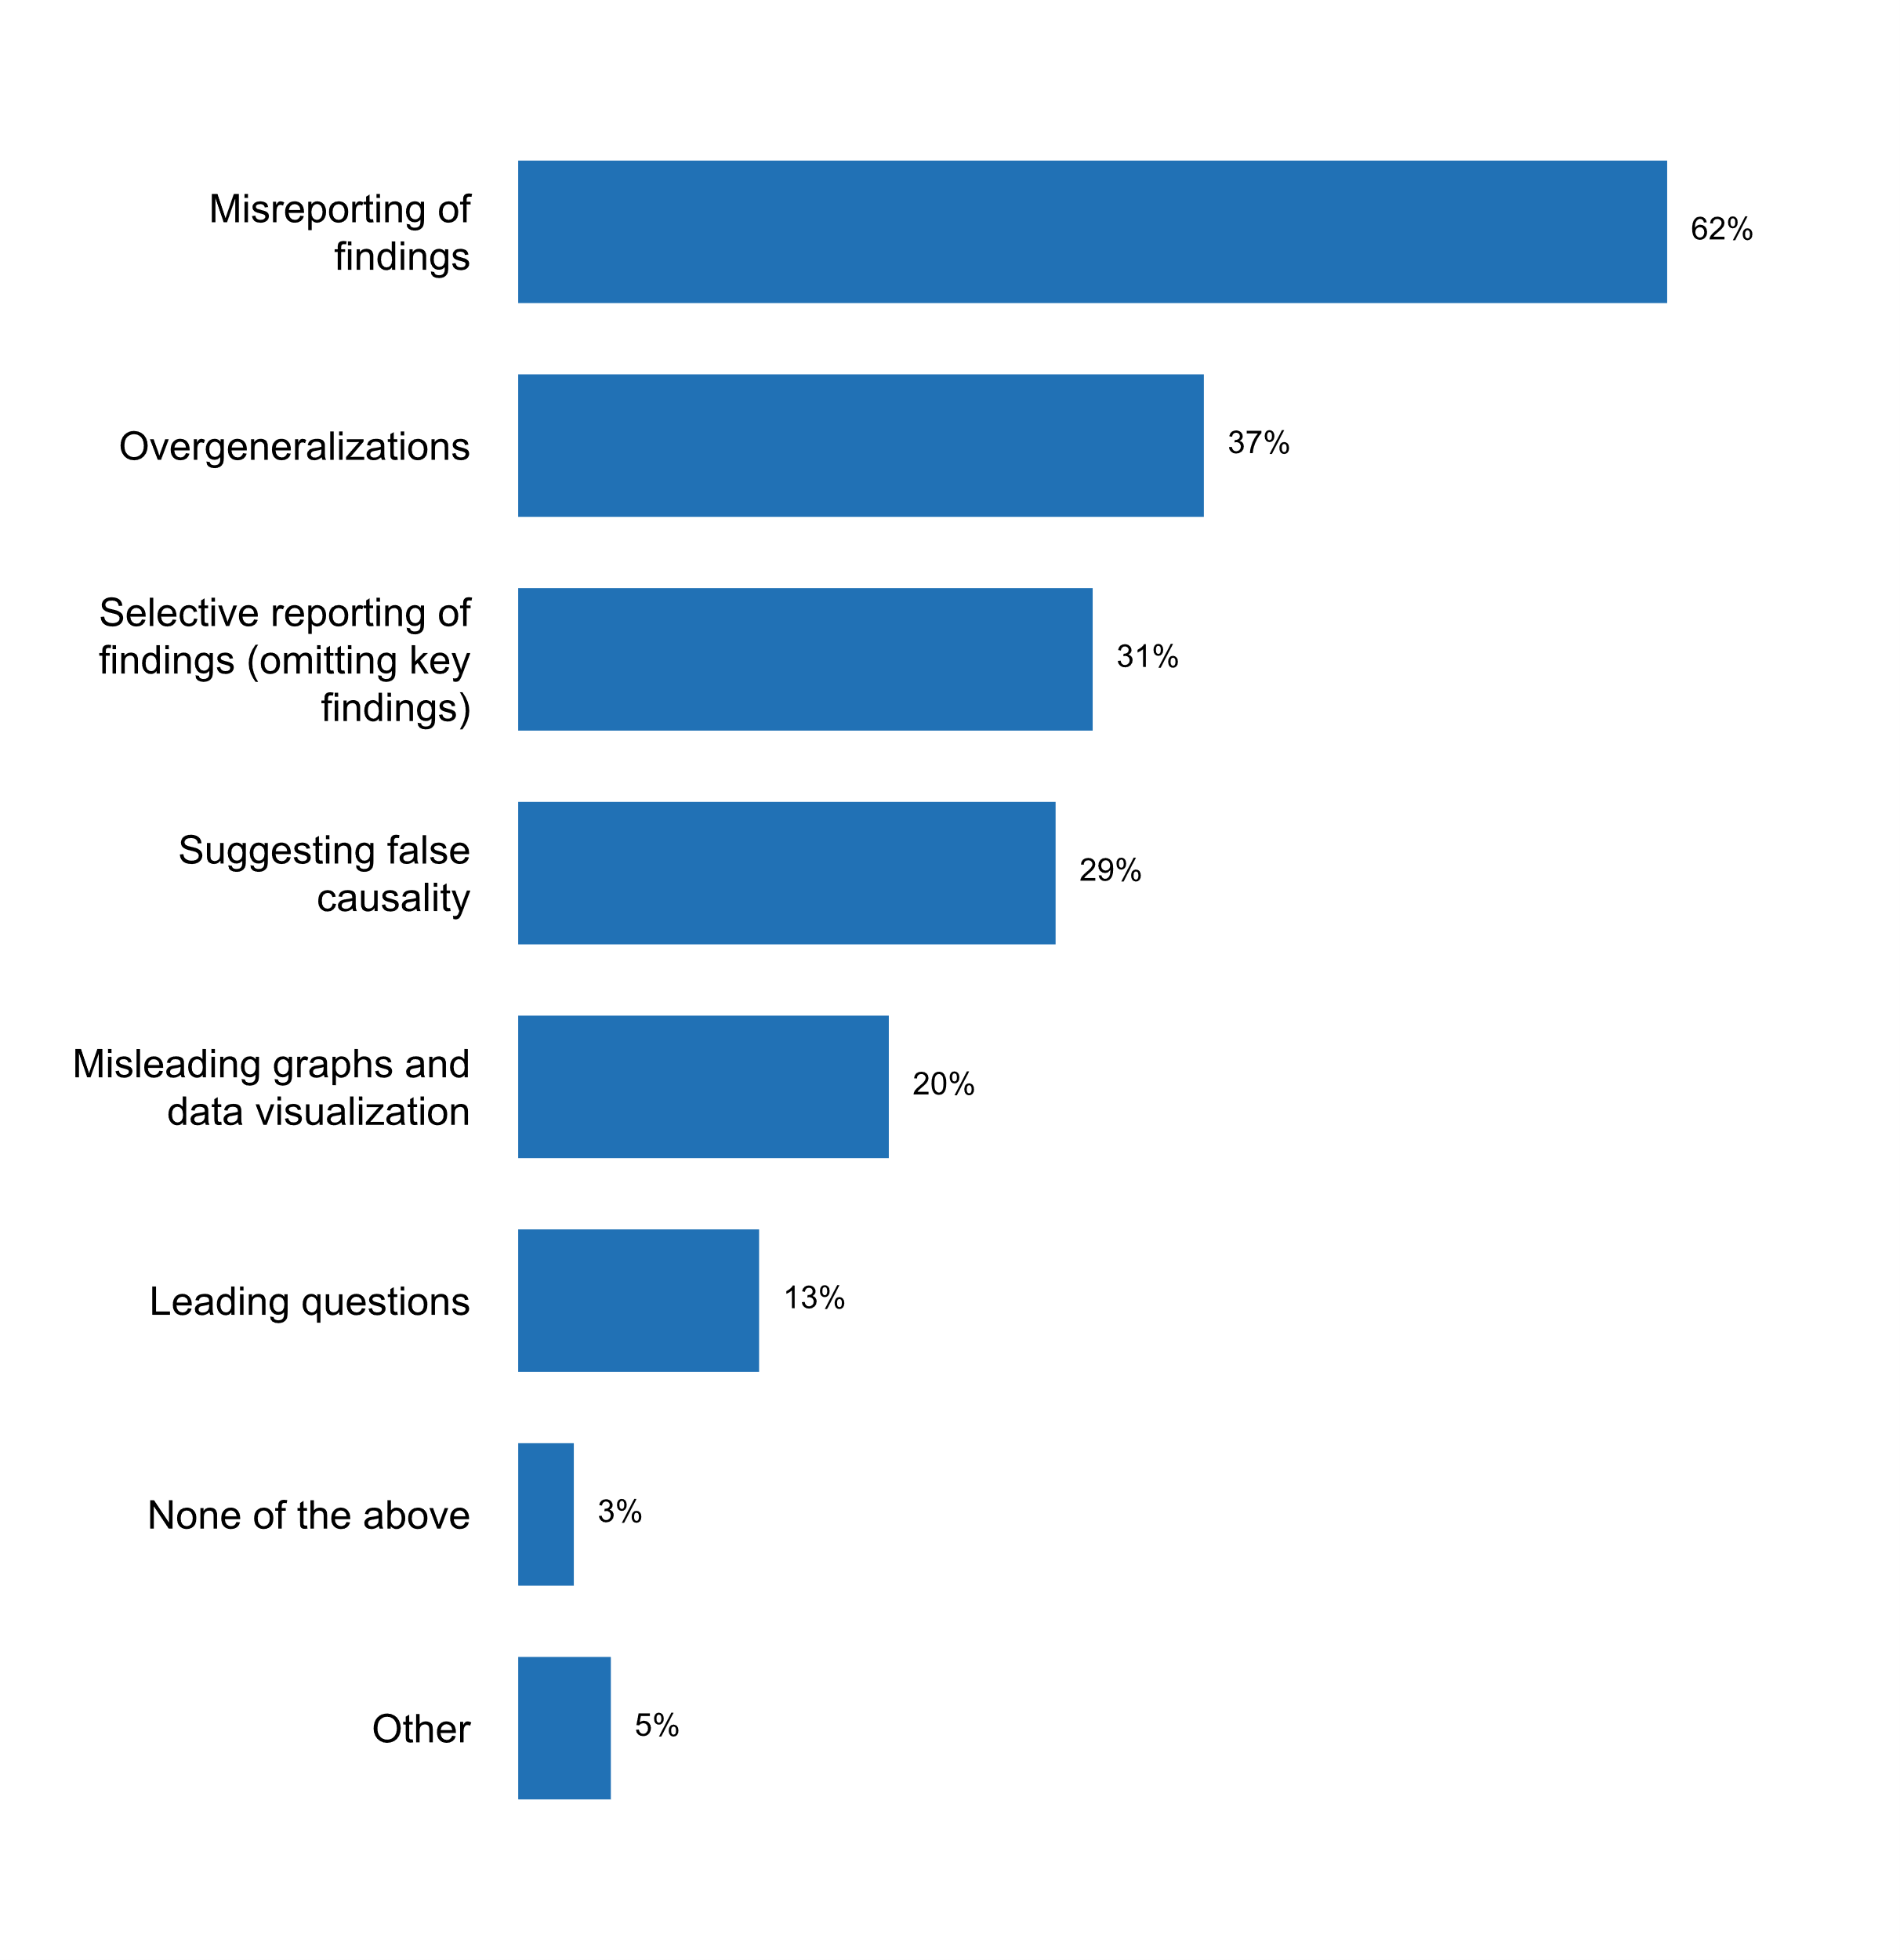

|  |  |  |  |  |  |  |
| --- | --- | --- | --- | --- | --- | --- |
| **Answer** | **Africa** | **Americas** | **Asia** | **Europe** | **Oceania** | **TOTAL** |
| Misreporting of findings | 6 | 12 | 13 | 25 | 2 | **58** |
| Overgeneralizations | 4 | 5 | 8 | 17 |  | **34** |
| Selective reporting of findings (omitting key findings) | 2 | 5 | 7 | 15 |  | **29** |
| Suggesting false causality | 1 | 3 | 3 | 20 |  | **27** |
| Misleading graphs and data visualization | 2 | 2 | 3 | 12 |  | **19** |
| Leading questions | 2 | 1 | 3 | 5 | 1 | **12** |
| None of the above |  | 1 | 2 |  |  | **3** |
| Other |  | 4 | 1 |  |  | **5** |

|  |  |  |  |  |  |  |
| --- | --- | --- | --- | --- | --- | --- |
| **Answer** | **Africa** | **Americas** | **Asia** | **Europe** | **Oceania** | **TOTAL** |
| Misreporting of findings | 35 | 92 | 54 | 71 | 50 | **62** |
| Overgeneralizations | 24 | 38 | 33 | 49 |  | **37** |
| Selective reporting of findings (omitting key findings) | 12 | 38 | 29 | 43 |  | **31** |
| Suggesting false causality | 6 | 23 | 13 | 57 |  | **29** |
| Misleading graphs and data visualization | 12 | 15 | 13 | 34 |  | **20** |
| Leading questions | 12 | 8 | 13 | 14 | 25 | **13** |
| None of the above |  | 8 | 8 |  |  | **3** |
| Other |  | 31 | 4 |  |  | **5** |

* Misinterpretation of key concepts and data
* Misinterpretation of methodologies
* Misuse because of serious incompetence
* SCI prevents misuse through timely information dissemination.
* US Statistical agencies cooperate with media to make every effort to get the reporting correct. For example, there is 1/2 hour prior to the GDP and Unemployment news releases. This is done to give them time to write their stories correctly before the 8:30 a.m. release.

**Plot_36_Q04.2b.svg**

**Number of times the NSO/NSS commented on erroneous interpretation and misuse of statistics in the past five years**

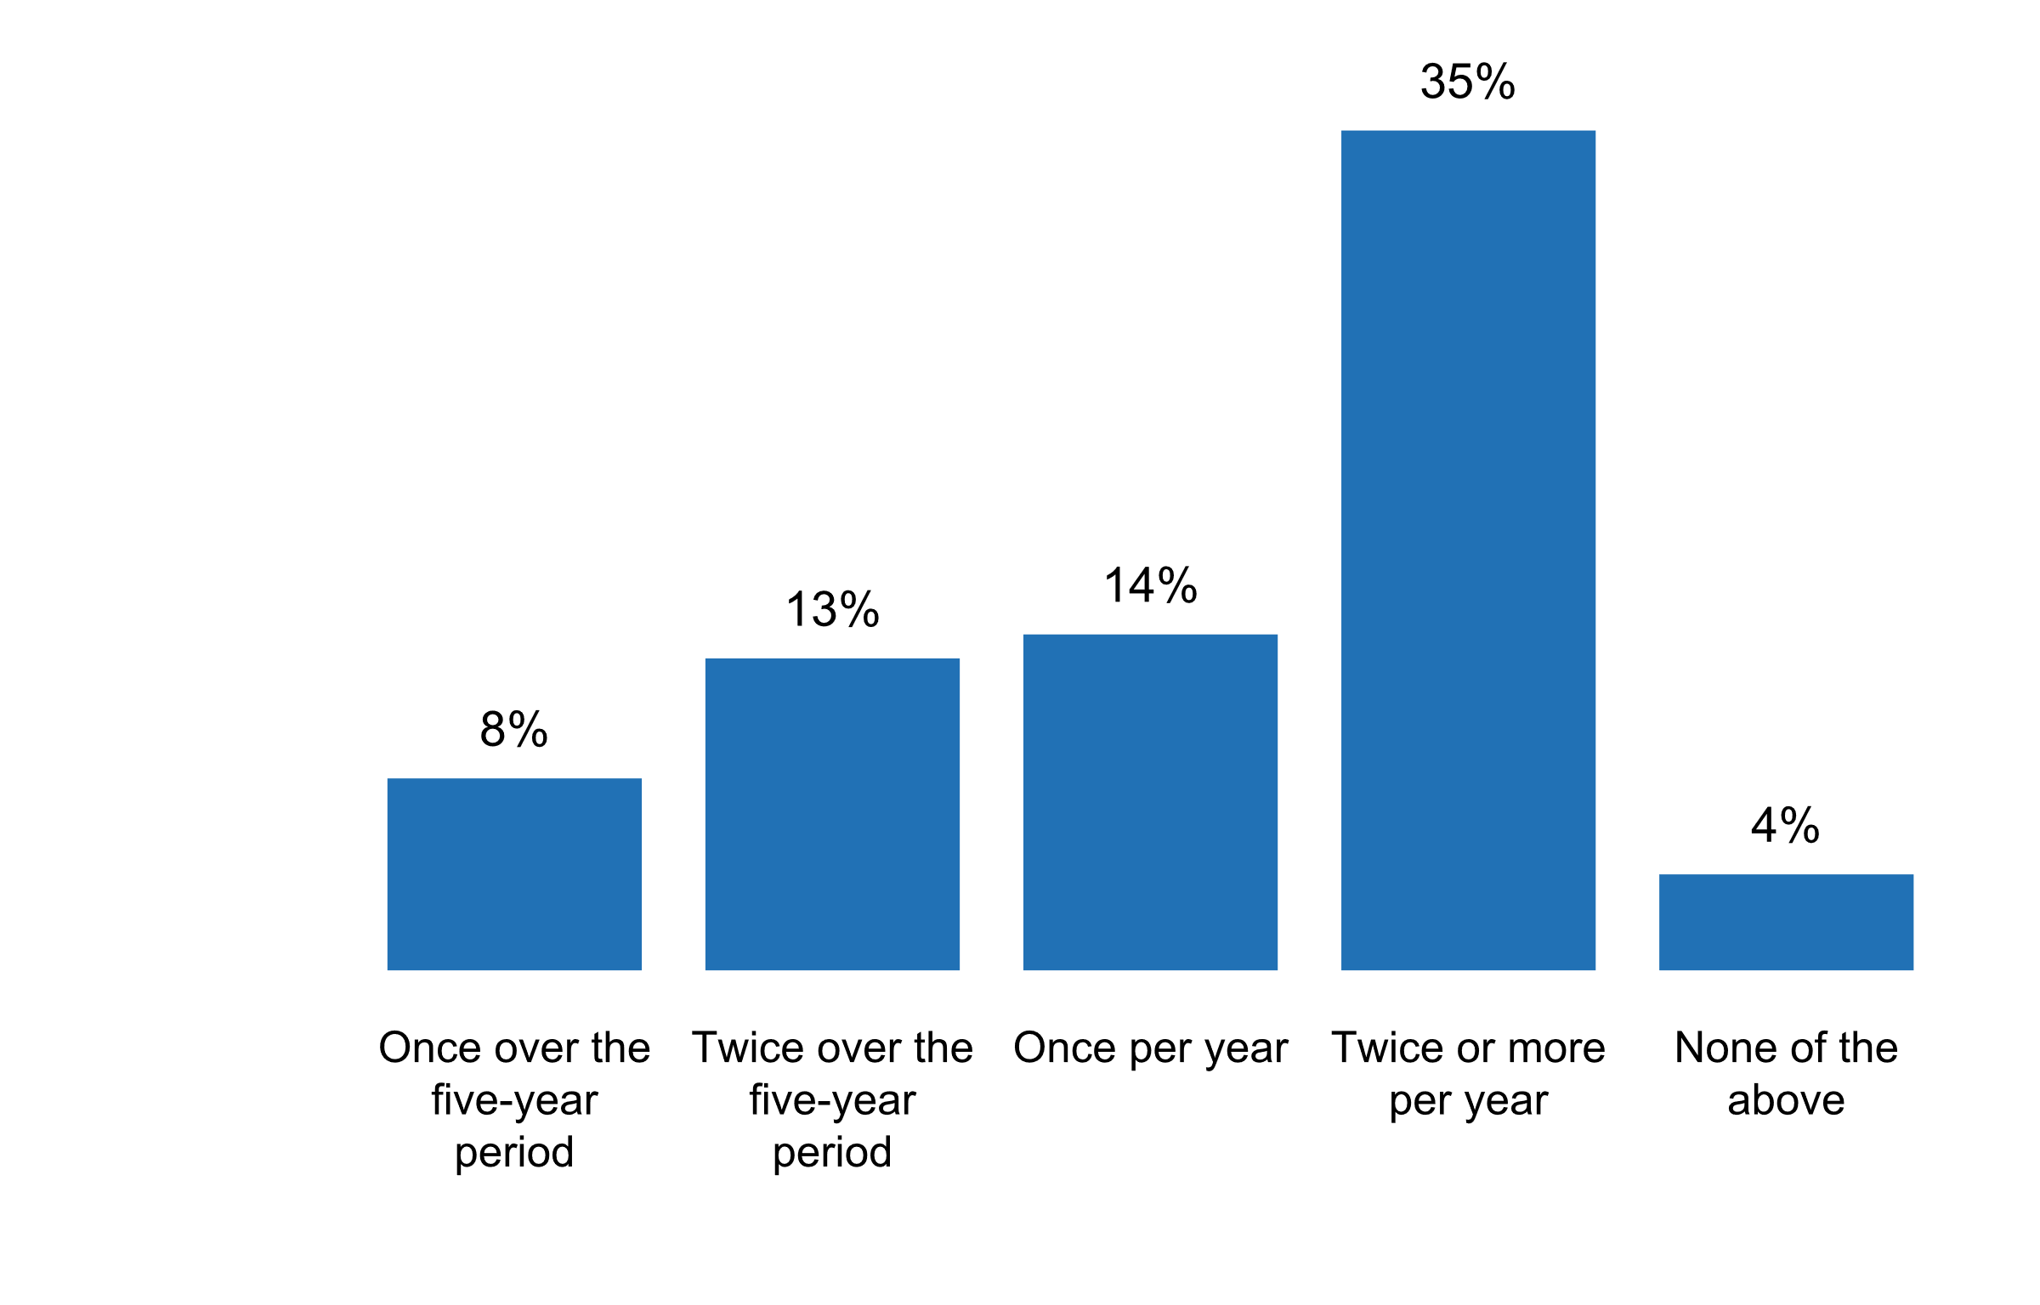

|  |  |  |  |  |  |  |
| --- | --- | --- | --- | --- | --- | --- |
| **Answer** | **Africa** | **Americas** | **Asia** | **Europe** | **Oceania** | **TOTAL** |
| Once over the five-year period | 2 | 1 | 2 | 2 |  | **7** |
| Twice over the five-year period |  | 3 | 2 | 6 | 1 | **12** |
| Once per year | 2 | 3 | 4 | 4 |  | **13** |
| Twice or more per year | 4 | 4 | 6 | 18 | 1 | **33** |
| None of the above |  | 2 | 1 | 1 |  | **4** |

|  |  |  |  |  |  |  |
| --- | --- | --- | --- | --- | --- | --- |
| **Answer** | **Africa** | **Americas** | **Asia** | **Europe** | **Oceania** | **TOTAL** |
| Once over the five-year period | 12 | 8 | 8 | 6 |  | **8** |
| Twice over the five-year period |  | 23 | 8 | 17 | 25 | **13** |
| Once per year | 12 | 23 | 17 | 11 |  | **14** |
| Twice or more per year | 24 | 31 | 25 | 51 | 25 | **35** |
| None of the above |  | 15 | 4 | 3 |  | **4** |

**Plot_37_Q04.3.svg**

**Activities carried out by the NSO/NSS to educate data users in the past five years, including the media**

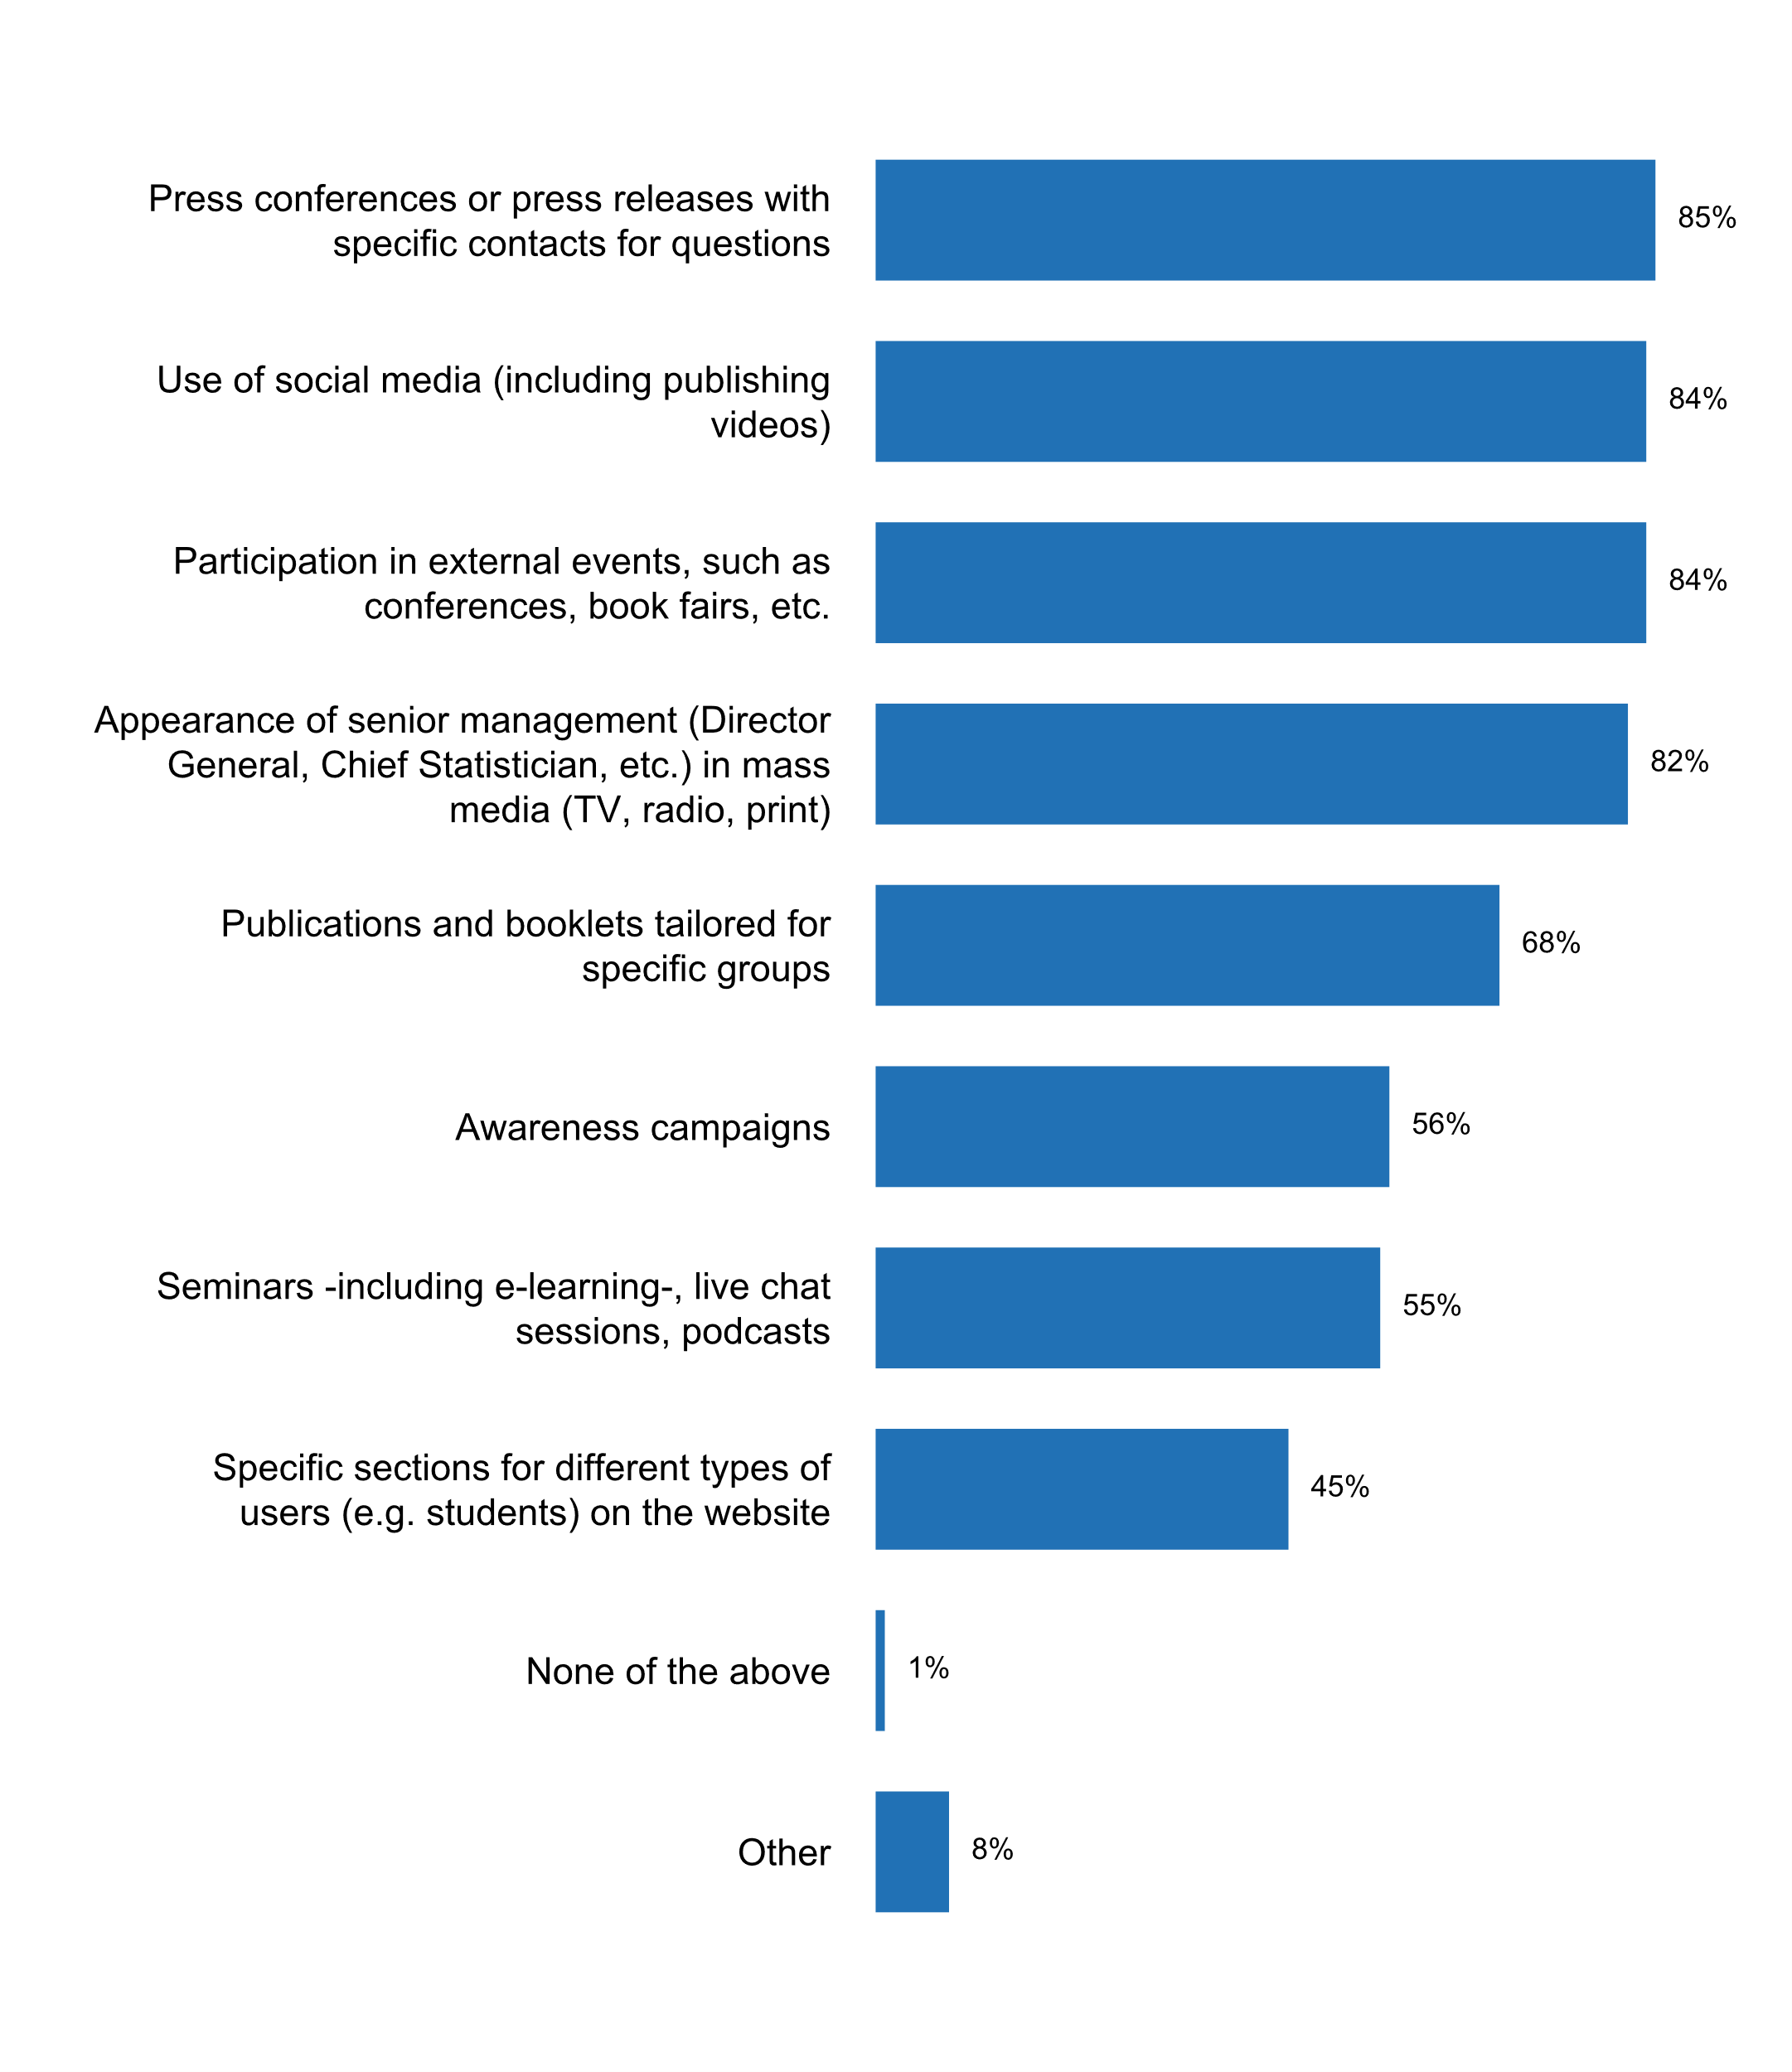

|  |  |  |  |  |  |  |
| --- | --- | --- | --- | --- | --- | --- |
| **Answer** | **Africa** | **Americas** | **Asia** | **Europe** | **Oceania** | **TOTAL** |
| Press conferences or press releases with specific contacts for questions | 10 | 12 | 21 | 32 | 4 | **79** |
| Use of social media (including publishing videos) | 13 | 12 | 19 | 31 | 3 | **78** |
| Participation in external events, such as conferences, book fairs, etc. | 16 | 10 | 18 | 30 | 4 | **78** |
| Appearance of senior management (Director General, Chief Statistician, etc.) in mass media (TV, radio, print) | 15 | 12 | 18 | 28 | 3 | **76** |
| Publications and booklets tailored for specific groups | 11 | 10 | 16 | 24 | 2 | **63** |
| Awareness campaigns | 10 | 8 | 14 | 18 | 2 | **52** |
| Seminars -including e-learning-, live chat sessions, podcasts | 9 | 5 | 10 | 24 | 3 | **51** |
| Specific sections for different types of users (e.g. students) on the website | 5 | 7 | 11 | 17 | 2 | **42** |
| None of the above |  |  |  | 1 |  | **1** |
| Other |  | 1 | 3 | 3 |  | **7** |

|  |  |  |  |  |  |  |
| --- | --- | --- | --- | --- | --- | --- |
| **Answer** | **Africa** | **Americas** | **Asia** | **Europe** | **Oceania** | **TOTAL** |
| Press conferences or press releases with specific contacts for questions | 59 | 92 | 88 | 91 | 100 | **85** |
| Use of social media (including publishing videos) | 76 | 92 | 79 | 89 | 75 | **84** |
| Participation in external events, such as conferences, book fairs, etc. | 94 | 77 | 75 | 86 | 100 | **84** |
| Appearance of senior management (Director General, Chief Statistician, etc.) in mass media (TV, radio, print) | 88 | 92 | 75 | 80 | 75 | **82** |
| Publications and booklets tailored for specific groups | 65 | 77 | 67 | 69 | 50 | **68** |
| Awareness campaigns | 59 | 62 | 58 | 51 | 50 | **56** |
| Seminars -including e-learning-, live chat sessions, podcasts | 53 | 38 | 42 | 69 | 75 | **55** |
| Specific sections for different types of users (e.g. students) on the website | 29 | 54 | 46 | 49 | 50 | **45** |
| None of the above |  |  |  | 3 |  | **1** |
| Other |  | 8 | 13 | 9 |  | **8** |

* (a) Quizzes for users on SingStat Website https://www.singstat.gov.sg/find-data/quizzes; (b) infographics and videographics on SingStat Website, e.g. https://www.singstat.gov.sg/find-data/search-by-theme/households/household-income/visualising-data, https://www.singstat.gov.sg/find-data/search-by-theme/industry/services/visualising-data
* Hackatons
* Producers and users Dialogue
* Statistics for schools, 2017(Armenian) at https://www.armstat.am/am/?nid=82&id=1883, Frequently Asked Questions are posted on the website at https://www.armstat.am/en/?nid=107
* Themed content on our website to cover particular statistical stories and make them accessible.
* self-learning videos
* statistical olympics for high school students

**Plot_38_Q04.3a.svg**

**Number of times "seminars, participation in external events, and/or appearance in mass media" took place to educate users in the past five years**

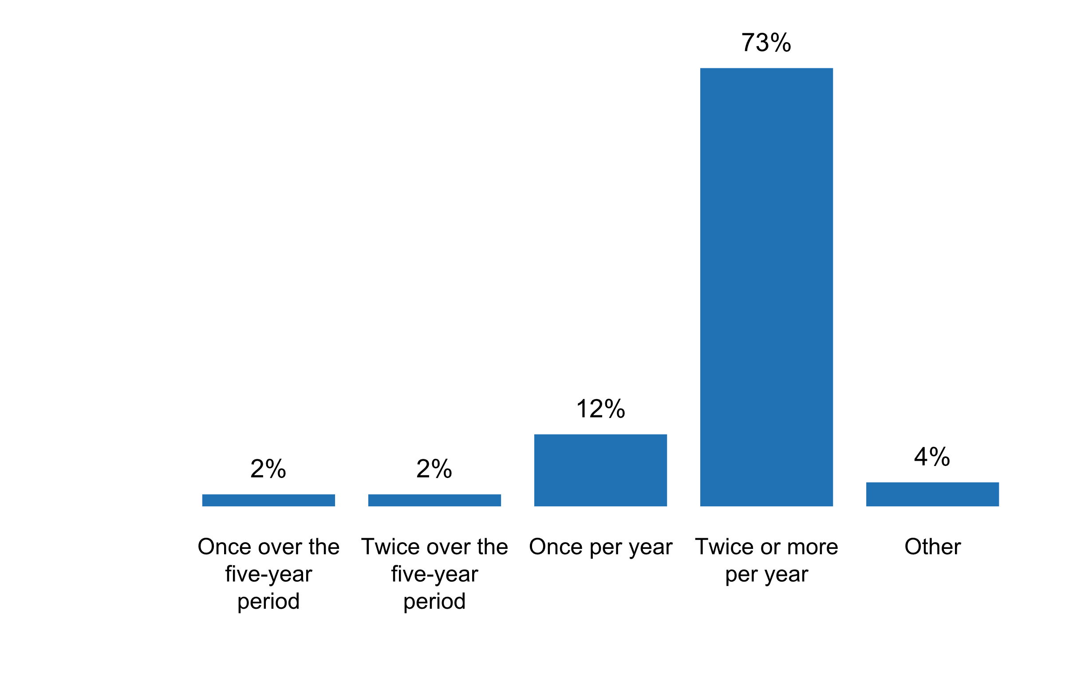

|  |  |  |  |  |  |  |
| --- | --- | --- | --- | --- | --- | --- |
| **Answer** | **Africa** | **Americas** | **Asia** | **Europe** | **Oceania** | **TOTAL** |
| Once over the five-year period | 1 |  | 1 |  |  | **2** |
| Twice over the five-year period |  | 1 |  | 1 |  | **2** |
| Once per year | 2 | 3 | 2 | 3 | 1 | **11** |
| Twice or more per year | 13 | 7 | 18 | 27 | 3 | **68** |
| Other |  | 2 |  | 2 |  | **4** |

|  |  |  |  |  |  |  |
| --- | --- | --- | --- | --- | --- | --- |
| **Answer** | **Africa** | **Americas** | **Asia** | **Europe** | **Oceania** | **TOTAL** |
| Once over the five-year period | 6 |  | 4 |  |  | **2** |
| Twice over the five-year period |  | 8 |  | 3 |  | **2** |
| Once per year | 12 | 23 | 8 | 9 | 25 | **12** |
| Twice or more per year | 76 | 54 | 75 | 77 | 75 | **73** |
| Other |  | 15 |  | 6 |  | **4** |

* 150+
* As appropriate, it varies. If there is a launch of a new statistical product or prior to a major release, there will be more events.
* More than 100
* Seminars are regularly held

**The NSO/NSS carries out user-engagement activities to better understand users' needs**

|  |  |  |  |  |  |  |
| --- | --- | --- | --- | --- | --- | --- |
| **Answer** | **Africa** | **Americas** | **Asia** | **Europe** | **Oceania** | **TOTAL** |
| No | 3 | 1 | 2 | 5 |  | **11** |
| Yes | 14 | 11 | 22 | 29 | 4 | **80** |

|  |  |  |  |  |  |  |
| --- | --- | --- | --- | --- | --- | --- |
| **Answer** | **Africa** | **Americas** | **Asia** | **Europe** | **Oceania** | **TOTAL** |
| No | 18 | 8 | 8 | 14 |  | **12** |
| Yes | 82 | 85 | 92 | 83 | 100 | **86** |

**Details on user-engagement activities carried out by NSO/NSS to better understand users' needs**

* Electronic questionnaire to a sample of users.- Workshops with representatives of the SEN and users.- Review of reports prepared in the INEC.- Consultations with the Consejo Nacional Consultivo de Estadà­stica (CONACE).
* User consultation is required by the NSA [A]. Article 7 defines that one of the professional tasks performed by SURS within the framework of its basic functions shall be also establishing public need for data in co-operation with the Statistical Council
* Via National Statistics Committee (NSC) focal persons 2)Bilateral meetings
* The National Statistical Council - composed of users of official statistics, is consulted regularly about users' needs.2. We organize hackathons and focus-groups about current development issues, e.g. data visualisation.
* User consultation workshops before every census and survey like Population Census, DHS, HIES, LFS, Agriculture census, National Accounts, etc
* Users Advocacy, beneficiaries and the media through workshops 2. Sending all press releases on all subjects to media and users 3. Distributing publications (hard copy) in all topics to users 4. Distributing monthly e-newsletter to users and the media 5. Sending a brief monthly statistical summary to the President of State Palestine, Prime Minister, and Ministers
* Users satisfaction2. Hotline3. Data lab4. Social network
* A questionnaire for the user of official statistical information is available on the official websites of state statistics bodies of the Republic of Belarus The questionnaire was developed to improve the dissemination of statistical information by providing feedback from users, determining their needs for statistical information, improving the quality of statistical data and increasing user confidence in official statistics. Received replies from the user questionnaire are analyzed quarterly, the confidence index and the user satisfaction index are calculated. Comments and suggestions of users are passed for consideration to the leadership of Belstat and to structural units.
* A survey of key user was conducted two years ago.
* A user producer workshop is conducted after evet 5 years with the last one conducted in 2015. In addition users are engaged during planning stages of the surveys and dissemination
* Apart from the participation of users represented in National Statistical Council we have also been organizing workshops whenever a survey or other statistical activity is launched to discuss what will be done and the outcome.
* Armstat makes analysis of user satisfaction surveys and has an annual program for the work with all users groups.
* Atelier de validation des questionnaires d'enquàªte
* Awareness raising workshops
* By organising stakeholders workshops
* Conducting meeting with different users to understand their needs in addition to conduct user needs survey
* Conducting statistical needs assessment among government agencies, organs of NSS and private sector of the country.
* Convene users for meeting in the context or the launch of new surveys/censuses to assess their needs.
* DANE has some instruments such as user's surveys and the website monitoring report. On the other hand, in the Quality Statistical Assessment process, DANE leads a survey oriented to the user related to the statistical operation which is assessed.
* Durant la phase de préparation des recensements et enquàªtes.
* ELSTAT organizes user conferences on annual basis.
* Example:For statistical agencies like Census, BEA and BLS, they participate via agency booths at major conferences, events, etc. This provides an opportunity to interact with data users as well as provide information on new statistical products.
* For example we work together with data journalists, scientists, ministries an the media to improve statistical literacy.
* Formal and informal meeting with user groups
* Geostat use social media for this purpose.
* Holding seminars in universities to promote activities and the nature of data produced by the Central Bureau of Statistics
* IN CASE OF THE CENSUS WE TAKE THE MOST IMPORTANT NEEDS OF THE USERS BEFORE THE END OF THE QUESTIONNAIRE
* Improving and reviewing quality There are several mechanisms in the Australian statistical system for data users to provide feedback about the accuracy, relevance, timeliness and accessibility of official statistical collections. This includes: regular review of the ABS forward work program; user consultation and engagement (which is also regularly reviewed) (see figure 1 and 2); the biennial ABS stakeholder relationship health assessment; Essential Statistical Assets initiative to identify priority statistics and assess quality; National Agricultural Statistics Review; and external and independent reviews as needed (e.g. APSC Capability Review, 2016 Census independent assurance panel quality assessment, independent technical review into the Labour Force Survey). Figure 1 â€“ ABS engagement pathways Figure 2 â€“ Key stakeholder fora
* Inquire with users to listen to their needs
* Many activities are carried out, mainly through social media, various user group, Statistical Council and user satisfaction survey.
* NSO conducts annual training course for all users and media.
* Numbers of downloads, website consultation statistics, numbers of followers on Twitter, etc.
* Once per year the main users are involved in defining the content of the Statistical Programme. Additionally, there are meetings with domain-specific users.
* Outreach on an ongoing basis with stakeholders, partners, etc., to ensure programs and products are designed to meet user needs. National Engagement Week in October, where 150 consultations were held in 20 locations across the country. Focus groups, online consultations, etc.
* Parties and stakeholders have their input and opinion considered in the elaboration process of annual programme of statistical surveys. We carry out user engagement activities â€“ meetings with data analytics and media
* Public consultations and satisfaction surveys are applied for different projects, in order to know the opinions and needs of the users. Specialized Technical Committes, through special working groups which are attended by producers and users of information.
* Public relations events are also used to collect user's needs. Media a monitored to detect user's needs.
* Realiza reuniones de coordinacià³n con usuarios.
* SEND OFFICIAL LETTERS TO IDENTIFY THEIR NEEDS
* Seminars for journalists and visitor groups e.g. students
* Statistical workshop for users and media on an annual basis.
* Stats NZ runs a range of seminars, meet ups, hackathons, conferences to engage with users. As part of our Population Census we take the opportunity to understand user needs in an in-depth way and this round had a dedicated user engagement team. This team came up with innovative ways to engage with a range of communities and groups who weren't so familiar with data and statistics and their value. Stats NZ also has a strategic engagement function which supports strategic relationship management and is critical to understanding user needs and working with key partners and producers in the Official Statistics System.
* Surveys of users are conducted
* Targeted workshops usually focusing on one product. These include media practitioners, private sector political directorate policy makers
* The NSS entities carry out activities to identify needs focuses mainly on their internal users through meetings or surveys. However, it is important to work more in user-engagement activities to understand user needs.
* The PSA conducts user-producer's/stakeholders' forums, consultative/dissemination forums, and press conferences/news briefings, among others.
* The Statistics Estonia carries out user surveys, focus groups, recommendation index, etc.
* The User Council meets once a year in a plenary meeting or in advisory subgroups (quality groups) where users are consulted on continuing or emerging information needs .Another important forum is the National Conference of statistics which takes place every two years.
* The user requirements and highly prioritised statistics in Malaysia are tabled and approved at the Main User Committee meeting.
* There is a Website Satisfaction Survey currently in working process.
* Through workshop of dialogue between users and producers.
* User Satisfaction SurveyPress conferencesExternal User Survey Meetings with academics
* User Satisfaction Surveys
* User engagements are held with different users to better understand their needs and determine if some of the needs can be accommodated in our statistical collections.
* User groups, user survey
* User satisfaction survey
* User satisfaction survey, user groups meetings and discussions, collecting users feedback from information services department.
* Users are provided a possibility to put forward suggestions and comments by e-mail and via the Internet, attend meetings and trainings, which are regularly organized by SL. In order to ensure the quality of statistical information and provided services, SL, starting from 2005, has been regularly carrying out user satisfaction surveys. The results of these surveys are analyzed and improvement actions are planned. From 2007, it has been started to estimate the customer satisfaction level. In addition users' behavior in data portal is analyzed regularly.
* Using two channels:- Participation of users at the High Council of Statistics.- User Surveys:
* We conducted a qualitative user satisfaction survey .
* We engage often and widely with users of statistics from specialist communities through to the public. Engagement activities include: a) User testing of websites and web content, including focus groups. b) Consultations on the use, coverage and value of statistical outputs. c) Online user communities, for example on Census, Health Statistics and Economic Statistics. d) Questionnaires and feedback requests on statistical publications. e) Dedicated events for particular user communities to gain feedback and built links. f) Analysis of the use of digital platforms to assess value and accessibility.
* We engage the users every time when we carry out a survey for the users to be aware of the survey (for a good response rate) as well as to have input in the questionnaire questions.
* We gathered views from the general public via website analytics and focus group discussions were conducted prior to the SingStat Website revamp.
* We have conduct some questionnaires for the user needs through our FB platform, but the answers were very poor.
* We have several user groubs for different statistics and services
* We hold Statistical Open Day every year.
* We hold consultation meetings with main data users, e.g. Ministries, government departments
* We need to make friendly with user to understand and use a lots of data
* Works shop with different tipes of users (students, NGO media).
* arranged data dissemination workshops for users
* arranging the meeting with the major users for some particular subject.
* information needs survey
* regular meetings with users
* yes, through the NSDS workshops, user engagements workshops are held; before the conduction of the Annual Surveys and Censuses, users are engaged and consulted before questionnaire development ; Customer Satisfaction engagement surveys are held

**Reasons why user-engagement activities are not carried out by NSO/NSS to better understand users' needs**

* Disappointment with the very low response rates of user satisfaction surveys
* Lack of human and financial resources
* Lacking resources
* The NSO still working in the best way to realice this type of activities.
* We have intention to conduct such activities in the future
* le budget alloué à  l'INS n'est pas suffisants pour réaliser ces activités.
* poor attention of users

**Additional comments on challenges to the implementation of Principle 4**

* Line ministries also have their own statistical activities for administrative purposes. We do not interfere with their own data analysis and their own interpretation. The users will make their own decision based on the quality of the data they trusted.
* A mechanisms must be implemented to guarantee or reduce the percentage of cases of misinterpretation of information, wich could be through the elaboration of a technical norm or the identification of statistical products as methodological notes that give greater explanation to the information that is disseminated.
* Explanation to the question 4.2:According to the National Statistical Act, article 6, SURS responds in the events of unintentional or deliberate wrongful use of statistics, as well as the Mass Media Act (2006) gives in articles 26-44 to any person the right to demand that the editor publish free of charge a correction or reply to any report that infringed upon the person's right or interest.To prevent misuse and erroneous interpretation of statistics SURS conducts training courses for the use of statistical data and information and for the interpretation of statistics for different users' groups including also media. All statistical results are disseminated together with respective metadata on SURS's website to give users comprehensive information. Meaningful comparisons and storytelling principles are clearly included and used in releases, when appropriate to increase right understanding of the data.
* In the past five, the country has not had any erroneous interpretation, hence they was no response to that effect.
* It is necessary to enhance statistical education of users
* NO CHALLENGES
* Nil
* None
* Questions 4.2.a./4.2.b.: All misuses were related to the political intervention (2007-2015).
* Stats NZ looks to prevent misuse through good relationships with the media, government officials and others to engage ahead of their publications and statements to ensure accuracy. Cases of deliberate misuse are rare.
* The Strategy for the development of state statistics of the Republic of Belarus until 2022 provides for the development and implementation of tools for statistical literacy development among users (conducting training workshops for users, conferences, presentations, posting useful information on Belstat's website (instructions, videos) to train various user groups to work databases/ databanks.
* The general level of statistical education and awareness is very low
* The lack of statistical literacy
* User Engagement takes place, preparatory to all Population and Establishment Censuses
* WE HAVE JUST MADE THE LAW STATISTICAL REVIEW. SO WE ARE AT THE BEGINIG OF THE CREATION OF NSO AND WE ARE ALSO AT THE BEGINING OF THE IMPLEMENTATION OF THIS LAW.
* We aare in the process of implementation of CRM system in CBS (ongoing project).
* We do not have further comments about this principle.
* While the ABS priorities remain essentially unchanged for the medium term we are very conscious of the need to adjust to the evolving expectations of the community and our customers in industry and government. It is important that we remain a trusted and reliable provider of official statistics and it is equally important that we continuously re-examine our information products and services to remain relevant. We will continue to consult widely with our stakeholders to ensure our choices reflect a sound balance between continuity and change, but change itself is necessary. The ABS is required to manage within the resources provided by Government and the Parliament, with user funding enabling us to deliver critical social statistics. The environment in which we are operating is challenging. There are increasing demands for new statistics and improved access to data. Our stakeholders expect quality statistics, first time every time, and we are confronting new business risks that are amplified while we transform our statistical business systems. When considering our corporate direction for 2018â€“19 and beyond, a number of key themes have been prominent: collaboration and partnering to build effectiveness and relevance; capital renewal to build systems resilience and stakeholder confidence; technical innovation to increase efficiency and enhance our capability to deliver in a more challenging environment; and workplace flexibility to maintain capacity. Underneath all of this change, the purpose and role of the ABS remains constant.

**Plot_39_Q05.1.svg**

**Sources of data currently used by the NSO**

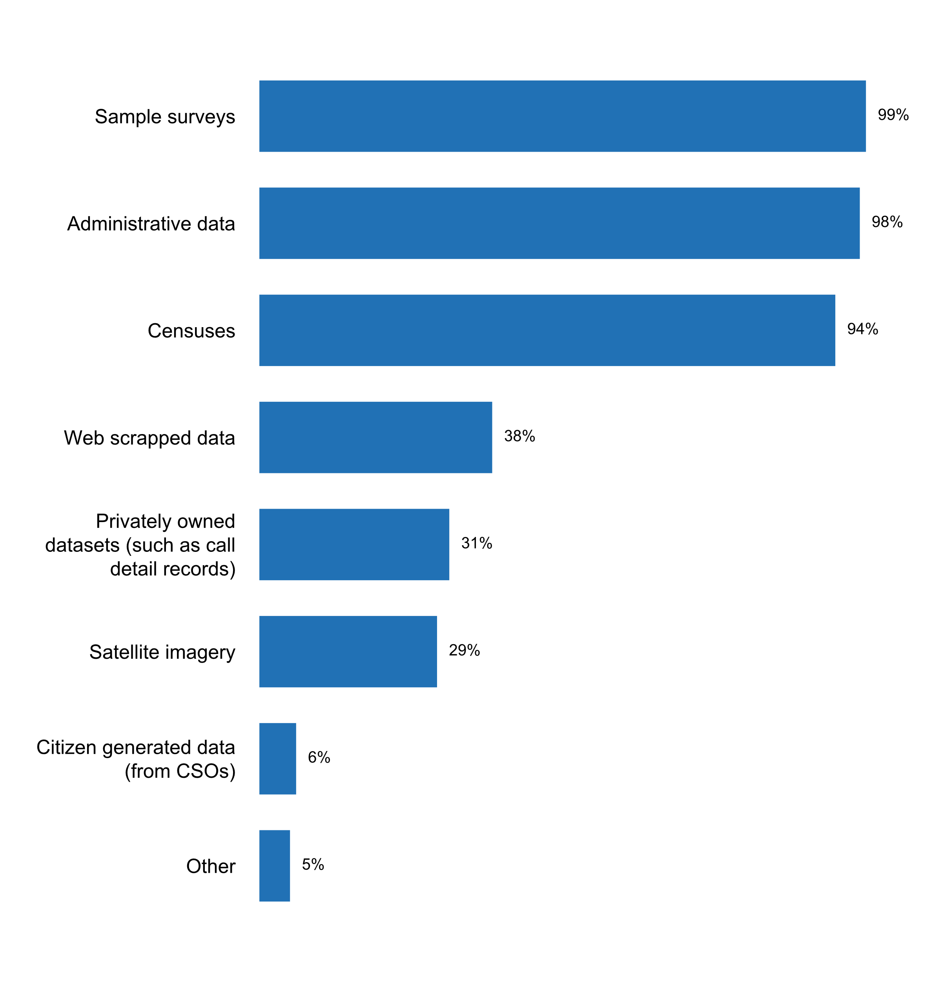

|  |  |  |  |  |  |  |
| --- | --- | --- | --- | --- | --- | --- |
| **Answer** | **Africa** | **Americas** | **Asia** | **Europe** | **Oceania** | **TOTAL** |
| Sample surveys | 17 | 13 | 24 | 34 | 4 | **92** |
| Administrative data | 16 | 12 | 24 | 35 | 4 | **91** |
| Censuses | 16 | 13 | 22 | 32 | 4 | **87** |
| Web scrapped data | 1 | 5 | 3 | 24 | 2 | **35** |
| Privately owned datasets (such as call detail records) | 2 | 3 | 4 | 17 | 3 | **29** |
| Satellite imagery | 5 | 7 | 5 | 8 | 2 | **27** |
| Citizen generated data (from CSOs) | 1 |  | 1 | 3 | 1 | **6** |
| Other |  | 3 |  | 2 |  | **5** |

|  |  |  |  |  |  |  |
| --- | --- | --- | --- | --- | --- | --- |
| **Answer** | **Africa** | **Americas** | **Asia** | **Europe** | **Oceania** | **TOTAL** |
| Sample surveys | 100 | 100 | 100 | 97 | 100 | **99** |
| Administrative data | 94 | 92 | 100 | 100 | 100 | **98** |
| Censuses | 94 | 100 | 92 | 91 | 100 | **94** |
| Web scrapped data | 6 | 38 | 13 | 69 | 50 | **38** |
| Privately owned datasets (such as call detail records) | 12 | 23 | 17 | 49 | 75 | **31** |
| Satellite imagery | 29 | 54 | 21 | 23 | 50 | **29** |
| Citizen generated data (from CSOs) | 6 |  | 4 | 9 | 25 | **6** |
| Other |  | 23 |  | 6 |  | **5** |

* GPS data collected during listing operations
* Private sector financial records and production data
* We make extensive use of geospatial data, primarily from the UK's national mapping agency.
* data of exhaustive surveys
* state and local government data, etc.

**Plot_40_Q05.1a.svg**

**How administrative records are currently used**

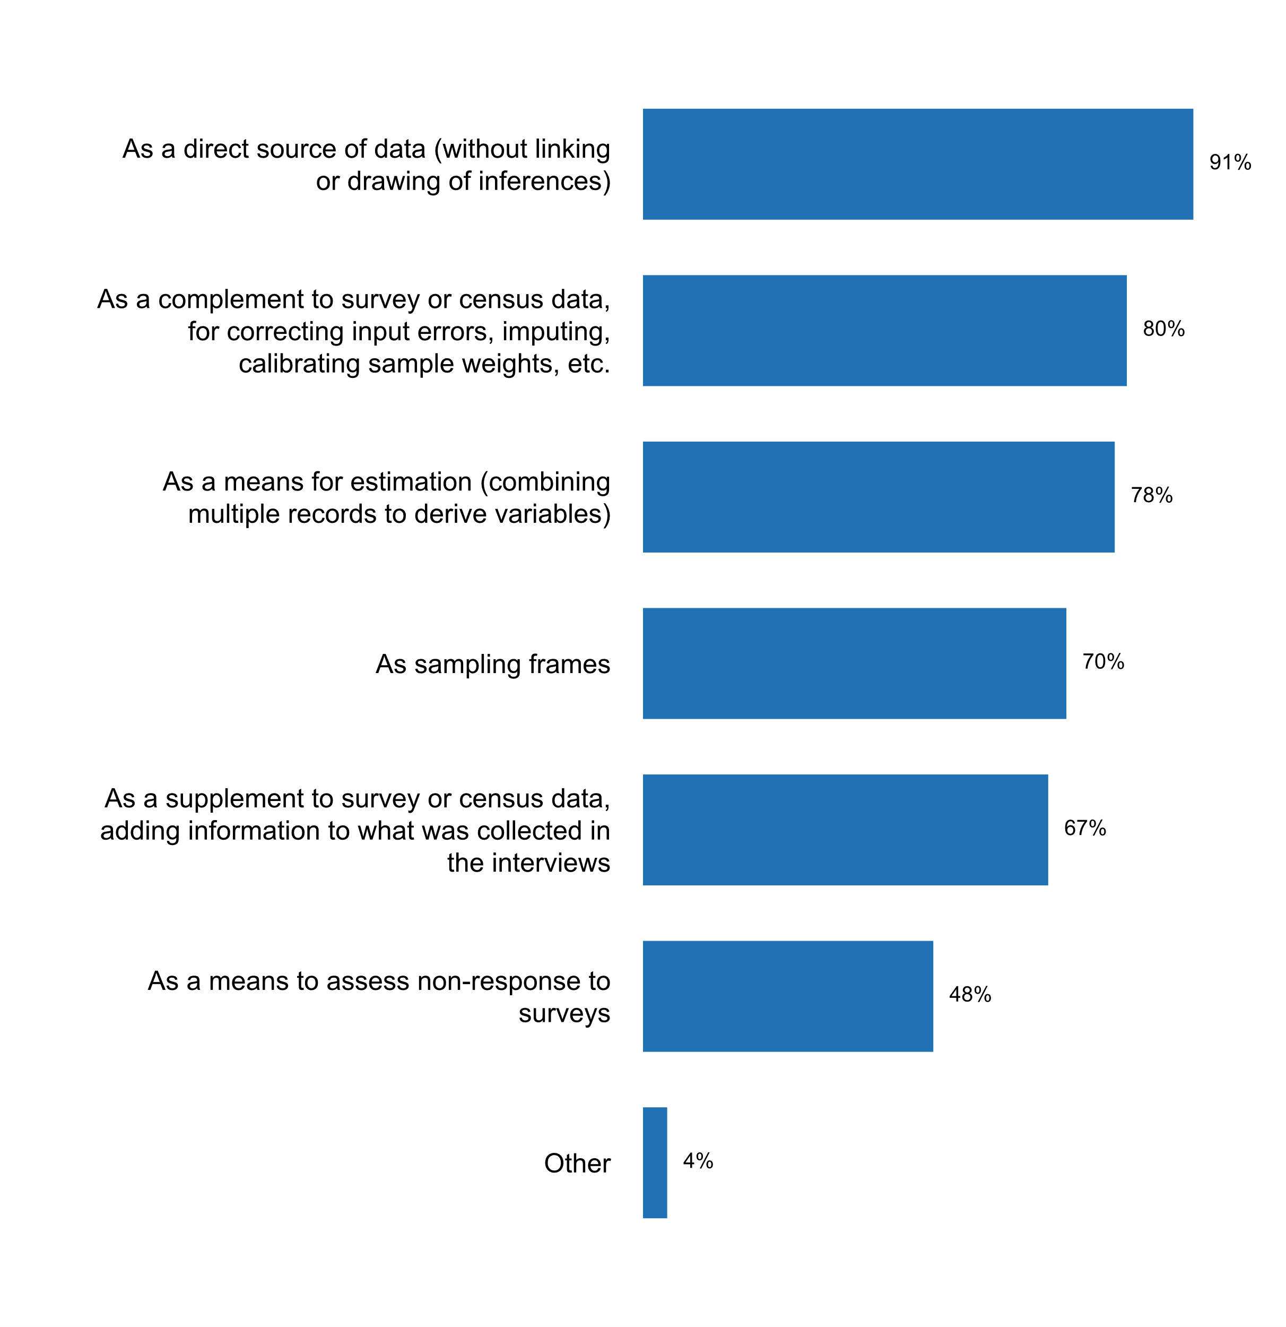

|  |  |  |  |  |  |  |
| --- | --- | --- | --- | --- | --- | --- |
| **Answer** | **Africa** | **Americas** | **Asia** | **Europe** | **Oceania** | **TOTAL** |
| As a direct source of data (without linking or drawing of inferences) | 14 | 11 | 22 | 34 | 4 | **85** |
| As a complement to survey or census data, for correcting input errors, imputing, calibrating sample weights, etc. | 12 | 10 | 16 | 33 | 3 | **74** |
| As a means for estimation (combining multiple records to derive variables) | 9 | 9 | 18 | 33 | 4 | **73** |
| As sampling frames | 10 | 6 | 15 | 31 | 3 | **65** |
| As a supplement to survey or census data, adding information to what was collected in the interviews | 8 | 7 | 13 | 31 | 3 | **62** |
| As a means to assess non-response to surveys | 5 | 4 | 11 | 23 | 2 | **45** |
| Other |  | 2 |  | 1 | 1 | **4** |

|  |  |  |  |  |  |  |
| --- | --- | --- | --- | --- | --- | --- |
| **Answer** | **Africa** | **Americas** | **Asia** | **Europe** | **Oceania** | **TOTAL** |
| As a direct source of data (without linking or drawing of inferences) | 82 | 85 | 92 | 97 | 100 | **91** |
| As a complement to survey or census data, for correcting input errors, imputing, calibrating sample weights, etc. | 71 | 77 | 67 | 94 | 75 | **80** |
| As a means for estimation (combining multiple records to derive variables) | 53 | 69 | 75 | 94 | 100 | **78** |
| As sampling frames | 59 | 46 | 63 | 89 | 75 | **70** |
| As a supplement to survey or census data, adding information to what was collected in the interviews | 47 | 54 | 54 | 89 | 75 | **67** |
| As a means to assess non-response to surveys | 29 | 31 | 46 | 66 | 50 | **48** |
| Other |  | 15 |  | 3 | 25 | **4** |

* Data Integration
* Linking to census and survey sources to add information content.
* Quality Assurance Purposes
* Research

**Plot_41_Q05.1b.svg**

**Actions are being taken for adapting administrative records to statistical purposes**

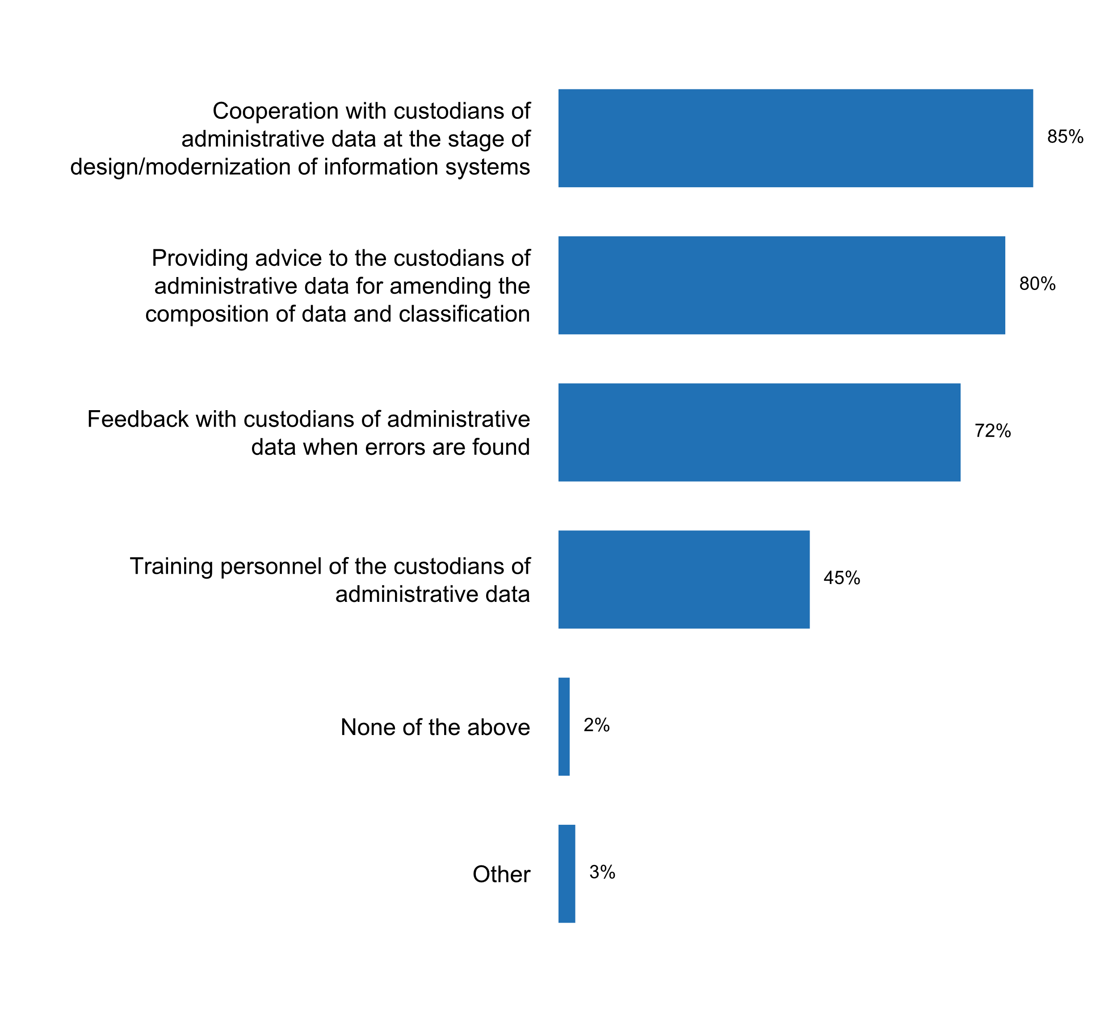

|  |  |  |  |  |  |  |
| --- | --- | --- | --- | --- | --- | --- |
| **Answer** | **Africa** | **Americas** | **Asia** | **Europe** | **Oceania** | **TOTAL** |
| Cooperation with custodians of administrative data at the stage of design/modernization of information systems | 13 | 9 | 22 | 31 | 4 | **79** |
| Providing advice to the custodians of administrative data for amending the composition of data and classification | 11 | 10 | 22 | 28 | 3 | **74** |
| Feedback with custodians of administrative data when errors are found | 13 | 10 | 14 | 26 | 4 | **67** |
| Training personnel of the custodians of administrative data | 9 | 7 | 15 | 7 | 4 | **42** |
| None of the above |  | 1 | 1 |  |  | **2** |
| Other |  | 1 | 1 | 1 |  | **3** |

|  |  |  |  |  |  |  |
| --- | --- | --- | --- | --- | --- | --- |
| **Answer** | **Africa** | **Americas** | **Asia** | **Europe** | **Oceania** | **TOTAL** |
| Cooperation with custodians of administrative data at the stage of design/modernization of information systems | 76 | 69 | 92 | 89 | 100 | **85** |
| Providing advice to the custodians of administrative data for amending the composition of data and classification | 65 | 77 | 92 | 80 | 75 | **80** |
| Feedback with custodians of administrative data when errors are found | 76 | 77 | 58 | 74 | 100 | **72** |
| Training personnel of the custodians of administrative data | 53 | 54 | 63 | 20 | 100 | **45** |
| None of the above |  | 8 | 4 |  |  | **2** |
| Other |  | 8 | 4 | 3 |  | **3** |

* In project: methodology of evaluation of administrative records
* Checking and processing administrative data for statistical purposes
* Unfortunately the actions are not very effective

**Plot_42_Q05.1c.svg**

**How the NSS accesses and uses big data or citizen-generated data**

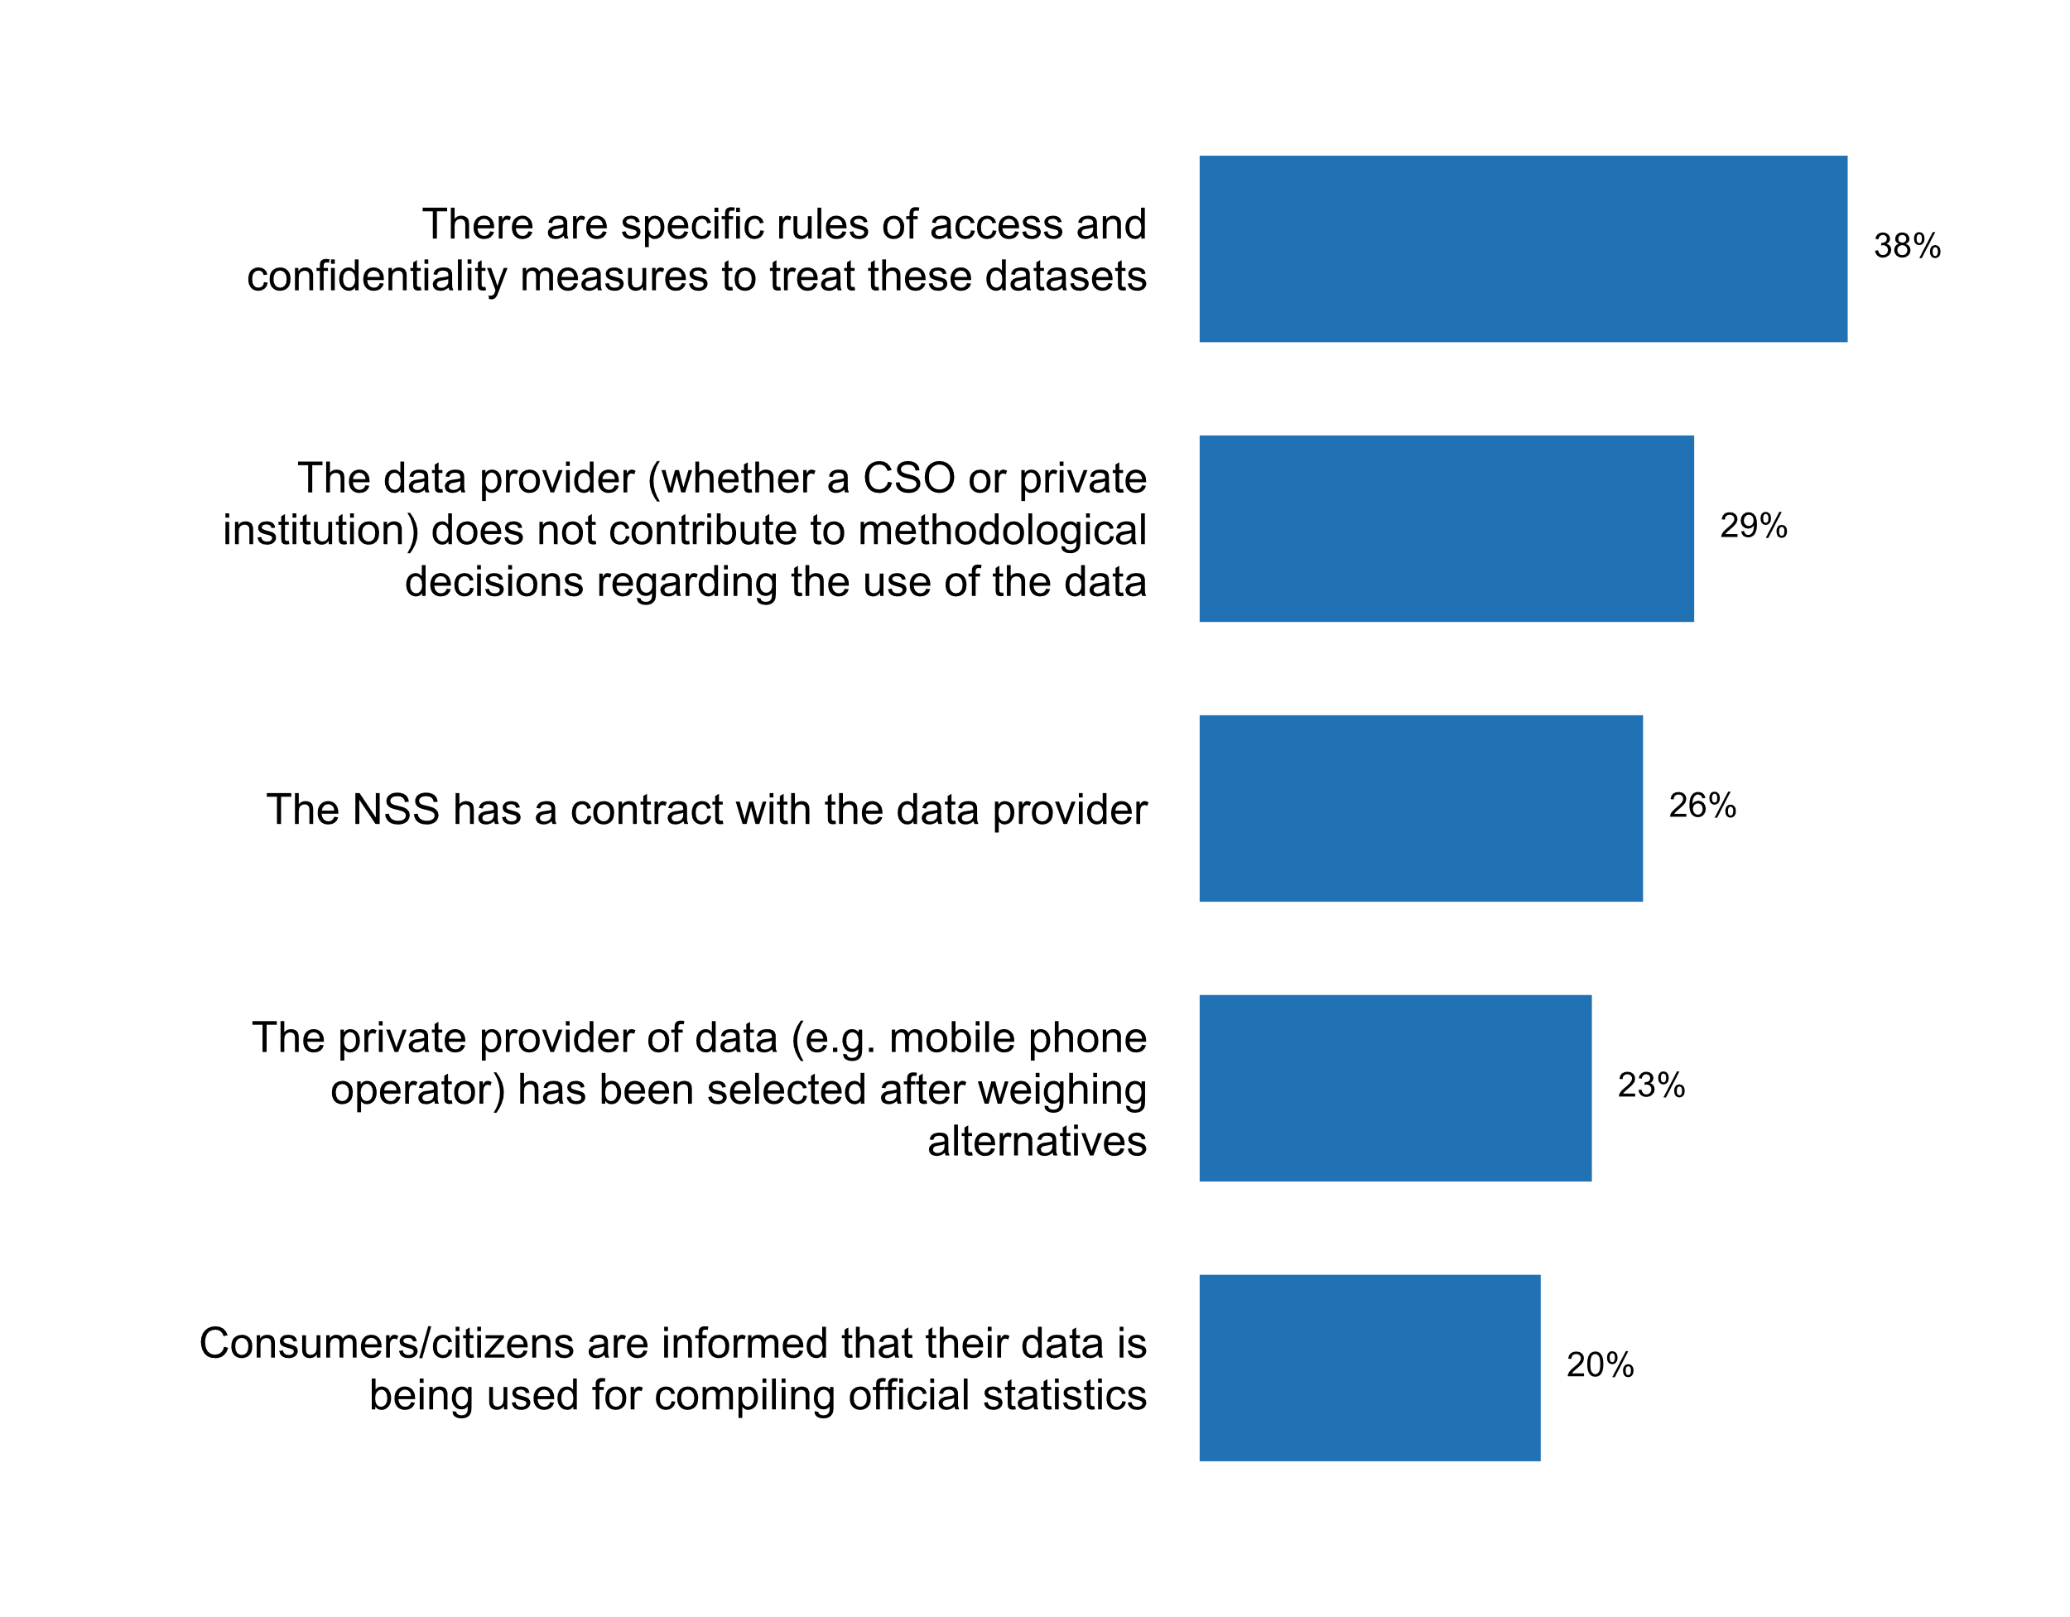

|  |  |  |  |  |  |  |
| --- | --- | --- | --- | --- | --- | --- |
| **Answer** | **Africa** | **Americas** | **Asia** | **Europe** | **Oceania** | **TOTAL** |
| There are specific rules of access and confidentiality measures to treat these datasets | 3 | 7 | 7 | 15 | 3 | **35** |
| The data provider (whether a CSO or private institution) does not contribute to methodological decisions regarding the use of the data | 1 | 5 | 3 | 16 | 2 | **27** |
| The NSS has a contract with the data provider | 1 | 2 | 5 | 14 | 2 | **24** |
| The private provider of data (e.g. mobile phone operator) has been selected after weighing alternatives |  | 4 | 5 | 10 | 2 | **21** |
| Consumers/citizens are informed that their data is being used for compiling official statistics | 3 | 2 | 4 | 8 | 2 | **19** |

|  |  |  |  |  |  |  |
| --- | --- | --- | --- | --- | --- | --- |
| **Answer** | **Africa** | **Americas** | **Asia** | **Europe** | **Oceania** | **TOTAL** |
| There are specific rules of access and confidentiality measures to treat these datasets | 18 | 54 | 29 | 43 | 75 | **38** |
| The data provider (whether a CSO or private institution) does not contribute to methodological decisions regarding the use of the data | 6 | 38 | 13 | 46 | 50 | **29** |
| The NSS has a contract with the data provider | 6 | 15 | 21 | 40 | 50 | **26** |
| The private provider of data (e.g. mobile phone operator) has been selected after weighing alternatives |  | 31 | 21 | 29 | 50 | **23** |
| Consumers/citizens are informed that their data is being used for compiling official statistics | 18 | 15 | 17 | 23 | 50 | **20** |

**Plot_43_Q05.2.svg**

**Measures taken to ensure timely release of survey results and/or statistical publications/bulletins**

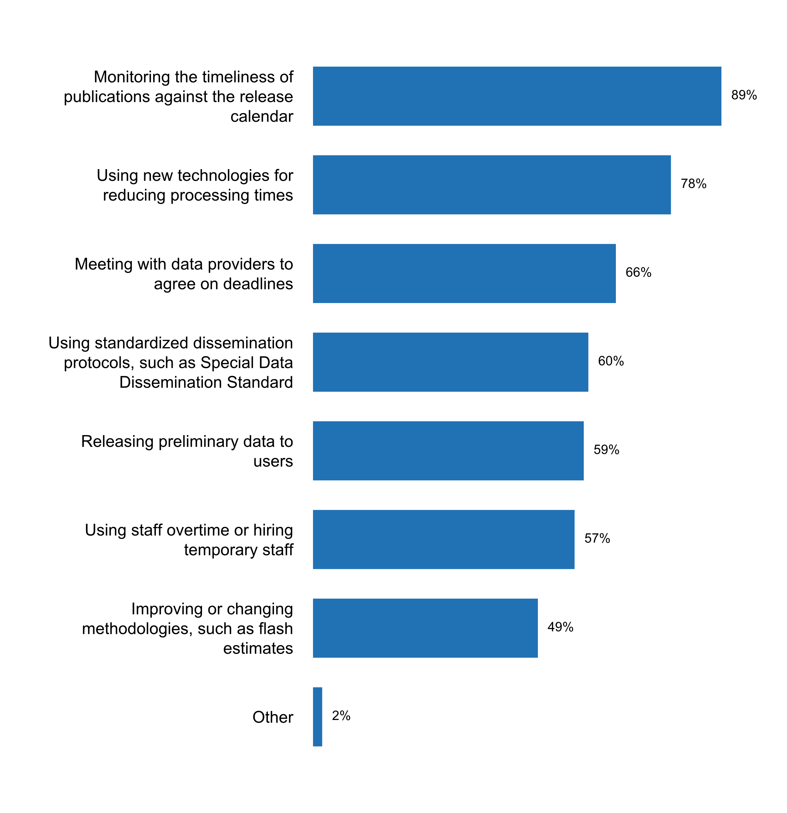

|  |  |  |  |  |  |  |
| --- | --- | --- | --- | --- | --- | --- |
| **Answer** | **Africa** | **Americas** | **Asia** | **Europe** | **Oceania** | **TOTAL** |
| Monitoring the timeliness of publications against the release calendar | 13 | 13 | 20 | 34 | 3 | **83** |
| Using new technologies for reducing processing times | 16 | 12 | 18 | 23 | 4 | **73** |
| Meeting with data providers to agree on deadlines | 8 | 8 | 18 | 23 | 4 | **61** |
| Using standardized dissemination protocols, such as Special Data Dissemination Standard | 10 | 8 | 14 | 23 | 1 | **56** |
| Releasing preliminary data to users | 9 | 8 | 14 | 22 | 2 | **55** |
| Using staff overtime or hiring temporary staff | 9 | 10 | 18 | 12 | 4 | **53** |
| Improving or changing methodologies, such as flash estimates | 7 | 4 | 12 | 22 | 1 | **46** |
| Other | 1 |  |  | 1 |  | **2** |

|  |  |  |  |  |  |  |
| --- | --- | --- | --- | --- | --- | --- |
| **Answer** | **Africa** | **Americas** | **Asia** | **Europe** | **Oceania** | **TOTAL** |
| Monitoring the timeliness of publications against the release calendar | 76 | 100 | 83 | 97 | 75 | **89** |
| Using new technologies for reducing processing times | 94 | 92 | 75 | 66 | 100 | **78** |
| Meeting with data providers to agree on deadlines | 47 | 62 | 75 | 66 | 100 | **66** |
| Using standardized dissemination protocols, such as Special Data Dissemination Standard | 59 | 62 | 58 | 66 | 25 | **60** |
| Releasing preliminary data to users | 53 | 62 | 58 | 63 | 50 | **59** |
| Using staff overtime or hiring temporary staff | 53 | 77 | 75 | 34 | 100 | **57** |
| Improving or changing methodologies, such as flash estimates | 41 | 31 | 50 | 63 | 25 | **49** |
| Other | 6 |  |  | 3 |  | **2** |

* Also the release of the key highlights before the entire report
* Official statistics dissemination policy is defined (https://www.stat.gov.lt/en/oficialiosios-statistikos-sklaidos-politika). GSBPM is being implemented to improve the efficiency of organization and implementation of the processes; time used for different statistical processes is regularly monitored to find the potential to increase the efficiency of the processes; all statistical data editing rules/algorithms used in data entry programs have been revised. Other measures, such as rearrangement of statistical surveys and sooner provision of the statistical results to the users; modernisation of business processes and organisational structure and increasing the effectiveness of statistical information production and dissemination are laid down in the new Strategy 2018-2022 of Statistics Lithuania (https://osp.stat.gov.lt/documents/29256/1366419/STRATEGY_2018_2022.pdf/d602dffa-d8ba-4100-be7a-d32c454cbc6a)

**Details on new technologies or methodologies used to ensure timely release of survey results and/or statistical publications/bulletins**

* 1. Computer-assisted personal interviewing (CAPI) 2. Online surveys
* Application of web-scrapping techniques; Tablets are used in data computing phase. Online data collection, control and data verification via information system “STS” based on new technologies;Information system “Foreign trade” is used to automate all the activities related to the production and dissemination of data on foreign trade in goods statistics of Bulgaria. â€¢ “Micro-data” subsystem covers the entire statistical production process - entering of individual data from different sources (SAD, Intrastat declarations, VAT declarations and other administrative data), processing, validation and credibility control, automated and manual corrections, estimation of non-response and trade bellow the thresholds for Intrastat, analysis of data and creation of output files for different users. â€¢ “Macro-data” subsystem stores processed and ready for dissemination data and provides access (in Bulgarian and in English) -for internal users - employees of the NSI from different departments use foreign trade data to produce various output tables according to their needs- for external users - on-line access (http://ftrade.nsi.bg/)
* As of 2015 and starting from the creation of an internal working group on innovation, DANE has implemented a Smart Data strategy with the objective of strengthening the process of production, generation and dissemination of official statistics by incorporating alternative sources of information and non-traditional methods, such as administrative records and Big Data in the framework of the National Statistical System. The strategy is based on the implementation of pilot projects that in their majority integrate or complement traditional information from administrative records, censuses and surveys with non-traditional sources such as Earth observation data, detailed mobile phone records, social networks, and information from web pages of enterprises, among others. Once the piloting or exploration phase has been completed, and, according to the viability of the results, the incorporation process begins, which involves reviewing the aspects related to the technological infrastructure required for the incorporation, the verification of compliance with quality standards and attributes as well as the generation of necessary skills in human resources. Also, as a result of this strategy, DANE has made progress in incorporating innovations in the information collection process by making use of new technologies. A specific case is the first electronic census (eCensus) conducted in Colombia, which in addition to providing an easy, fast and secure questionnaire, also had mechanisms for verifying the identity of the persons, for the purpose of ensuring the quality and truthfulness of the information reported, through the consultation in real time of the National Registry web service. In order to ensure the georeferencing of these units, DANE integrated information from administrative records and geocoding services; as a result, the georeferencing of 97% of the registered units was achieved. DANE has also explored the use of mobile telephony data and its applications in statistical production, in such a way that within the framework of the project "Measuring the information society" -that had the participation of DANE, the Ministry of Information and Communication Technology and the International Telecommunications Union-, in 2017, it was possible to have access to information of detailed records of mobile phones, guarded by private companies. The access to this type of source continues however to be one of the main challenges to overcome. Finally, DANE, based on the work that it has carried out in recent years as a member of the working group of Satellite Images and Geospatial Data of the UN Big Data for Official Statistics, recognizes the importance of both the use of data and technological platforms, as well as of the interinstitutional coordination that is necessary for the fulfillment of the goals and for the formulation of public policies that pursue this integral and multi-sectorial agenda in terms of the use and exploitation of new sources of Smart Data.
* By using alternative data sources NSOs are able to reduce the burden on data providers, improve data quality and ensure more timely release of survey results. In Hungary one of these sources is the online cash register, while the other new source is based on the use of traffic monitoring camera data of the National Toll Payment Services PLC and the Hungarian National Police Headquarters.
* CAI
* Centralized IT and methodological units ensure the effective performance of statistical processes. Usually, IT Development and Methodology and Quality divisions (as coordinators) within their competence and all statistical divisions are involved in the implementation of projects or introduction of IT systems or other systems for modernization of statistical production processes. The examples of such projects can be the development of the Official Statistics Portal allowing to access official statistics produced by different institutions on a single contact point principle; IT system (e.statistics) enabling electronic preparation and transmission of statistical data from enterprises and population; Metadata management system, allowing effective preparation and dissemination, as well as archiving of metadata; a modern 2011 Population and Housing Census data collection and processing technology â€“ a computerized system based on cloud computing. With regard to improving statistical data processing methods, methodologies are regularly deliberated and improved by the Methodology Commission of Statistics Lithuania according to the annual plans on deliberation of draft statistical survey methodologies. The commission also deliberates the draft statistical survey (work) methodologies or other methodological documents prepared by the other national authorities. Statistics Lithuania implements the projects, considering the web scraping in such areas as price and job vacancies statistics. Moreover, the EU-recommended statistical data editing and missing value imputation methods using standard IT tools have been implemented; the proportion of statistical indicators for the calculation of whose estimates additional information or administrative data are used have been increased; centralized management of data obtained from administrative sources has been introduced, etc.
* Collecte numérique (PDA, tablettes, ...) et remontée des données via InternetCollecte par call center
* DCS using Computer-assisted personal interviewing (CAPI) ,
* DOSM has initiated the Statistics Big Data Analytics (STATSBDA).The key objectives are modernisation of data collection, producing new statistical products, supplements for existing data in production of certain statistics, allow high accuracy of data and reduce respondents' burden. Six initiatives is developed in line with Malaysia Plan, strategic trusts and SDGs Indicators.There are:The 3 main projects are: i. Trade by Enterprise Characteristics (TEC) ii. Price Intelligent (PI) iii. Public Maturity Assessment on Official StatisticsThe 3 support projects are: i. Real Time Business Status ii. Real Time News on Official Statistics (RTOS) iii. Bizcode@Stats
* Data capture is automated in all statistical operations of INEC and automated coding processes are in development.
* Data collection by CAPI to reduce processing time.Data collection by teams for sample surveys, for improved supervision and monitoring of progress.
* Data collection using CAPI (Computer Aided Personal Interviewers) are used to collect data and the data is normally sent to the server whilst the enumerators are still in the field.
* Data portal is introduced for table builder
* E.g. standardisation of production processes
* Estimation techniques also using administrative records and other more timely surveys (for example first estimates of quarterly data are based also on surveys and administrative data with monthly periodicity).
* FOR SAME TIME NOW, WE ARE USING CAPI SYSTEM IN CASE OF THE CENSUS AND SURVEY AT THE NSO
* For example : Flash estimates on poverty rateEvery year in September N+2, INSEE publishes the poverty rate and the main indicators of inequalities in standard of living for year N. This delay is unsatisfactory for meeting the social requirements of users of these indicators. Of the 21 months between the end of the year under consideration and the publication of the poverty rate, about three-quarters of this time is taken up collecting tax and social data, and about one quarter with statistically matching Labour Force Survey (LFS) data, from which the Tax and Social Incomes Survey (ERFS) is produced. Nowcasting consists of producing an earlier indicator (in autumn N+1) of the poverty rate for the target year N based on the ERFS N-1. The method to be used here is microsimulation, which simulates individuals' standard of living by imputing benefits and contributions on scales, and allows to take account of any legal changes in the social and tax legislation. The exercise is based on the INES model, which simulates the majority of French social security and tax legislation, based on any year of the ERFS. To implement nowcasting, one important step is ageing population by uprating incomes (using surveys about wages, aggregated tax data, inflation...) and calibration weighting (using margins from LFS and census). Reverse ageing is also used so that evaluations for year N and N-1 (and thus annual evolutions) are only based on the ERFS N-1 (that is minimising the sample bias). In this paper, we present the methodology and assess the quality of the early indicators thus produced. Indeed, we compare the results that would have been produced by microsimulation with those that were in fact disseminated from the ERFS. When applied to the target years 2010 to 2015, this method produced estimations similar to the actual figures published the following year for the poverty rate and the main indicators of inequalities.
* General modernisation of the NSO's informatics and telecommunications resources and services.
* Improved methodology on SMEs statistics according to Eurostat and OECD methodologies
* Increasing use of tablets for data collectionUsing direct access to administrative data such as File Transfer Protocols
* Integrated data collection and processing systems are used. Use of R allows to process data in a shorter time.
* Moving from paper and Excel to SAS-Projects
* Online data collection and CAPI data collection method allow to shorten data capturing, coding validation and validation.
* SURS is exploring and introducing new technologies (e.g. web questionnaires, standardized metadata driven solution for data processing, â€¦), improving methodologies and exploring potential of new data sources (e.g. big data).
* Se usan formularios en là­nea con controles de depuracià³n y consistencia.
* Since July 2018, the Office for National Statistics has published "nowcast" rolling monthly and three-monthly estimates of GDP estimates: https://www.ons.gov.uk/releases/gdpmonthlyestimateukseptember2018ONS is also transforming its data processing and deployment platforms to streamline our ability to bring data into the organisation and store and process it as efficiently as possible. More details of improved methods and technologies are available here: https://www.ons.gov.uk/aboutus/whatwedo/programmesandprojectsAcross government, statisticians are making greater use of automation, including use of open source tools, to streamline the process of producing and disseminating statistical outputs.The Code of Practice for Statistics provisions for the release of experimental statistics based on new methods or datasets so that users can comment early on them.
* Some of the technologies used are: (1) Using commercial RPA tools to web-scrape data from â€˜dynamic' websites (e.g. airfares websites) to be used in statistical compilation and analyses; (2) virtual assistant on our SingStat Website to provide first line of support to users.
* Stats NZ has used an orchestration tool to speed up processing of survey and administrative data processing. We have also used technology to improve the receipt of administrative data through automation.
* Stats SA is in the process of implementing digital collection of data, thi sis being implemented in a phased in approach.
* Switch from Pen and Paper Interviewing to CAPI.
* Tablets use.
* The ABS is currently implementing a wide reaching transformation agenda to enable the ABS to achieve its purpose and ensure that its systems, process and methods remain relevant and functional. The ABS's ambitious transformation agenda is arguably the most significant and comprehensive change in its history. The transformation is essential for the continued production of timely, relevant and quality statistical information required to inform decisions in a rapidly changing world. Beginning in 2014-15, the ABS transformation is underpinned by an investment of $257 (AUD) million to modernise infrastructure over five years through the Statistical Business Transformation Program (see recommendation 3 for more information). The Statistical Business Transformation Program is responsible for designing and developing the next generation of statistical business processes and supporting information infrastructure to provide a platform to reduce costs and burden on providers, bring together various datasets to develop new statistical products more rapidly, and make data available in a form which can be more easily used. The transformation program is focused on building capacity on six key areas: environment, strategy, governance, people, culture and infrastructure.
* The INEC has automated the processing of information so that the tabulated variables and indicators that are published ar obtained easily and quickly.
* The Integrated State Statistics Information System (ISSIS) has been created in the country, the main purpose of which is to create an integrated statistical information resource and software, technological and technical means with the aim of pursuing a uniform information policy in the field of state statistics. ISSIS allowed not only to automate the main processes of statistical production, but also to collect reports from respondents in electronic format. Currently, about 96% of all respondents use electronic format for submitting reports. An automated electronic document management system, as well as a corporate e-mail system; information protection system, computing and network infrastructure that ensures the functioning of the information system of state statistics bodies at all levels - from the district to the national level, have also been created within the framework of ISSIS
* The adoption of multimodal approaches for data collection in the recent Labour Force Survey 2018 was implemented such as the adoption of using Computer Assisted Personal Interviews (CAPI) which significantly reduced processing time
* The organization has taken a deliberate decision to move from PAPI to CAPI as a way of improving technology in undertaking its statistical processes.
* The publishing process is conducted and monitored electronically by software.
* The use of CAPI
* Through the use of new information technologies in the data collection process
* US agencies continually investigate new technologies for improving efficiencies and improving estimation techniques (via new methodologies).For example, when the Input-Output tables are released every five years, there is a comprehensive revision of the National Income and Product Accounts (including GDP). This is an opportunity to not only incorporate I-O and update the base year (for real GDP), but, also to implement major methodologies, particularly SNA concepts. Examples are capitalization of software, R&D and other intangibles.
* USE HANDHELD DEVICES IN ALL DATA COLLECTION. USING CALL CENTER FOR FOLLOWUP AND IMPROVING QUALITY OF DATA. USING WEB-ENABLED FORM FOR SELF COUNTING.FOLLOW PROJECT MANAGEMENT METHODOLOGIES.DIRECT LINK WITH DATA PROVIDERS.
* Use available software to compile and analyse data. Especially Microsoft Office software.
* Use of CATI (Computer Assisted Telephone Interview) and CAPI (Computer-assisted personal interviewing).
* Use of Computer Assisted Personal Interview (CAPI) for data collection
* Use of electronic questionnaires and web applications for data collection.
* Use of tablet with installed software applications on data collection and processing (Computer Assisted Personal Interview), Online collection/submission of questionnaires
* Use of tablets and scanning
* Using CAPI for data collection
* Using electronic questionnaires.
* Using tablets For census data collection in 2017 in addition to applying this new technologies in other surveys conducted by NSO such as the economic census 2018/2019
* Using tablets during data collection stage, and putting all checks to be sure that the data are consistent to reduce the time needed for data processing.
* Using tablets for LFS and CPI surveys to shorten data capture and processing time
* Utilisation de la tablette dans les enquàªtes
* We are abondoning PAPI data collection technique and almost always carry out the survey data collection process by computer-assisted questionnaires; use of administrative data where possible; producing flash estimates for GDP, employment, poverty, unemployment,etc.; use of small area estimation methods for more timely and reliable estimates, etc.
* We are exploring to use Cloud computing and Big date.
* We are updating our generalized systems and have developed multipurpose questionnaire platforms and processing to enhance timeliness. Click or tap here to enter text.

**Plot_44_Q05.3.svg**

**Quality management framework(s) currently applied by the NSO**

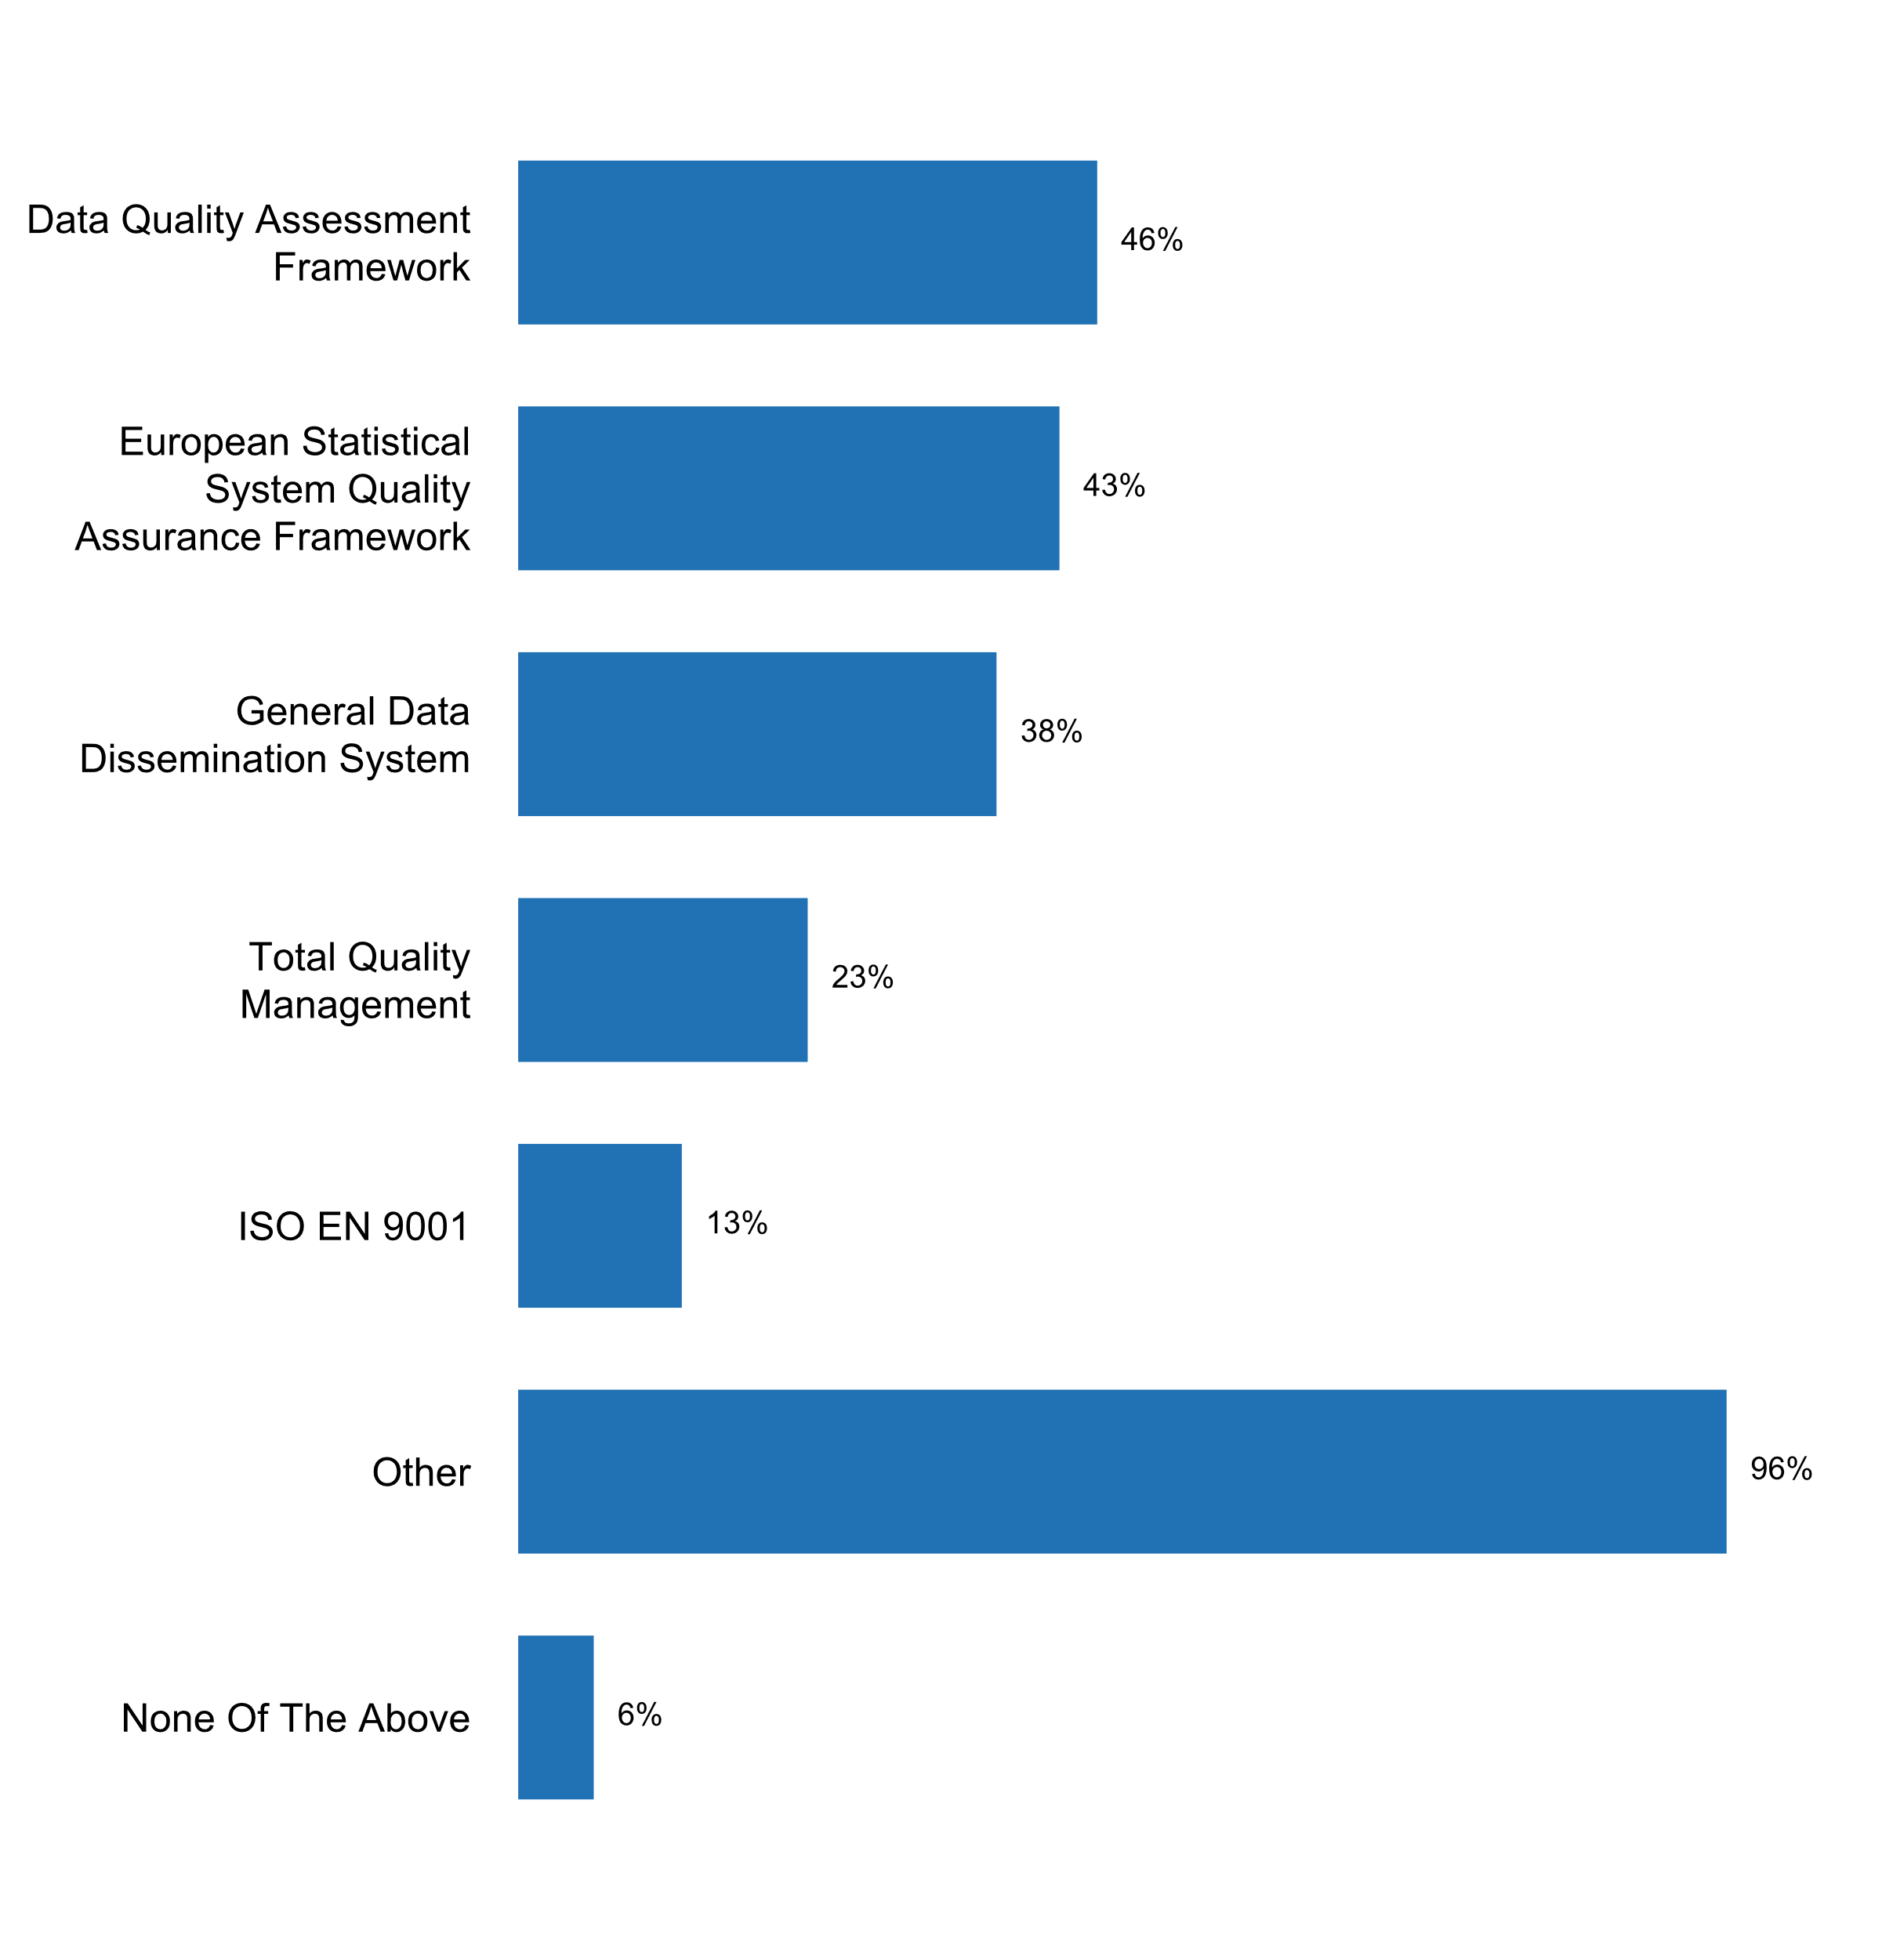

|  |  |  |  |  |  |  |
| --- | --- | --- | --- | --- | --- | --- |
| **Answer** | **Africa** | **Americas** | **Asia** | **Europe** | **Oceania** | **TOTAL** |
| Data Quality Assessment Framework | 11 | 9 | 15 | 7 | 1 | **43** |
| European Statistical System Quality Assurance Framework | 1 | 2 | 7 | 30 |  | **40** |
| General Data Dissemination System | 11 | 6 | 12 | 6 |  | **35** |
| Total Quality Management | 1 | 2 | 5 | 13 |  | **21** |
| ISO EN 9001 |  | 2 | 5 | 5 |  | **12** |
| Other | 15 | 13 | 23 | 34 | 4 | **89** |
| None Of The Above | 2 | 1 | 1 |  | 2 | **6** |

|  |  |  |  |  |  |  |
| --- | --- | --- | --- | --- | --- | --- |
| **Answer** | **Africa** | **Americas** | **Asia** | **Europe** | **Oceania** | **TOTAL** |
| Data Quality Assessment Framework | 65 | 69 | 63 | 20 | 25 | **46** |
| European Statistical System Quality Assurance Framework | 6 | 15 | 29 | 86 |  | **43** |
| General Data Dissemination System | 65 | 46 | 50 | 17 |  | **38** |
| Total Quality Management | 6 | 15 | 21 | 37 |  | **23** |
| ISO EN 9001 |  | 15 | 21 | 14 |  | **13** |
| Other | 88 | 100 | 96 | 97 | 100 | **96** |
| None Of The Above | 12 | 8 | 4 |  | 50 | **6** |

* ABS Data Quality Framework, IMF SDDS Framework
* ASEAN Community Statistical System Code of Practice
* ASPIRE (Stats Sweden adaptation)
* CARICOM Good Statistical Practices and CARICOM RSDS
* EFQM, SDDS, GSBPM
* European Statistics Code of Practice; National Statistics Code of Practice
* Generally, referred to as
* ISO 20252:2012
* ISO 27001
* ISO 27001 ongoing
* ISO EN 27 001
* Lean. But first and foremost European Code of Practice.
* National Quality Assurance Framework (NQAF)
* Quality Assurance Framework for the NSO
* Quality framework based on NQAF.
* Quality guidelines of the office
* SDDS
* SGDD-a
* Special Data Dissemination Standards (SDDS)
* StatCan Quality Assurance Framework Guidelines
* Statistical quality assurance framework
* The NSO is planning a National Integral Statistical Quality Framework
* There is no international quality framework implemented at NBS, yet, there are elements of quality management system in place.
* TurkStat Quality Assurance Framework
* UN-National Quality Assurance Framework, EFQM-excellence model, ENP-COP.
* US943 and US942

**Plot_45_Q05.3a.svg**

**Aspects considered in the quality management framework**

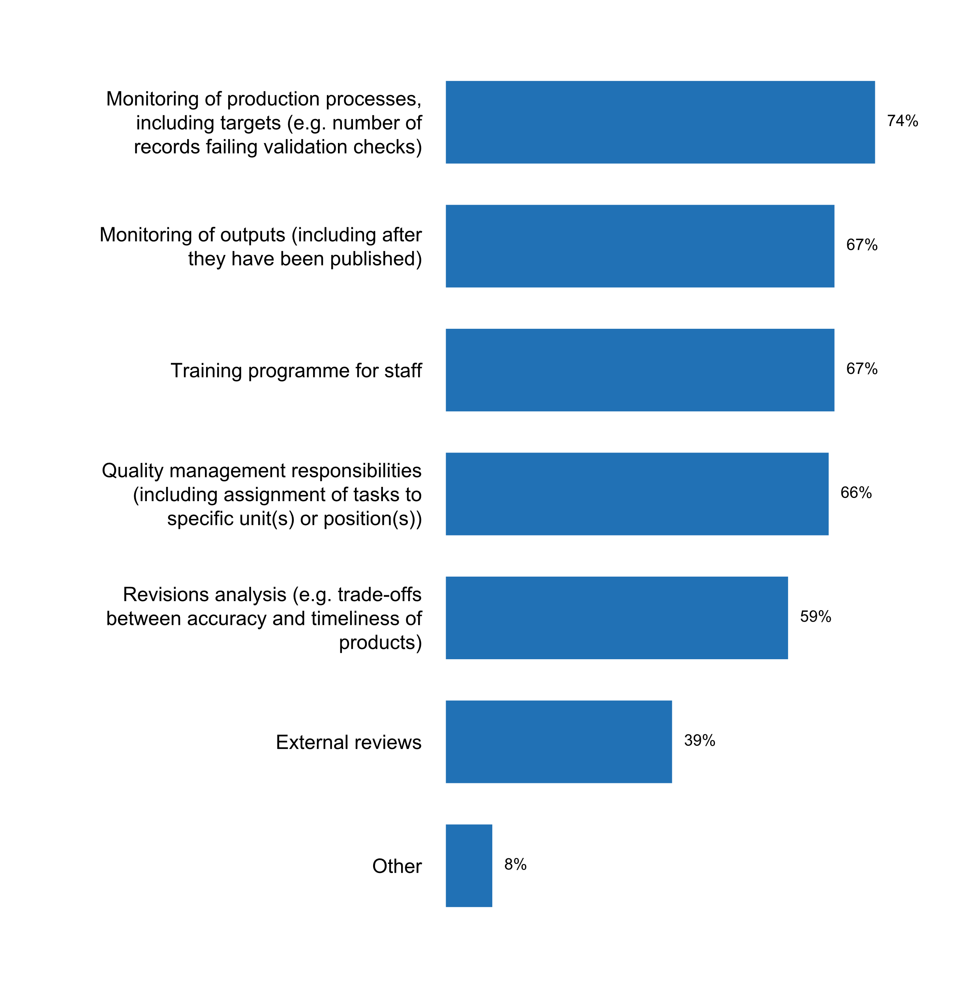

|  |  |  |  |  |  |  |
| --- | --- | --- | --- | --- | --- | --- |
| **Answer** | **Africa** | **Americas** | **Asia** | **Europe** | **Oceania** | **TOTAL** |
| Monitoring of production processes, including targets (e.g. number of records failing validation checks) | 9 | 12 | 17 | 29 | 2 | **69** |
| Monitoring of outputs (including after they have been published) | 6 | 10 | 18 | 26 | 2 | **62** |
| Training programme for staff | 8 | 10 | 17 | 25 | 2 | **62** |
| Quality management responsibilities (including assignment of tasks to specific unit(s) or position(s)) | 7 | 9 | 15 | 28 | 2 | **61** |
| Revisions analysis (e.g. trade-offs between accuracy and timeliness of products) | 7 | 10 | 13 | 23 | 2 | **55** |
| External reviews | 5 | 6 | 6 | 17 | 2 | **36** |
| Other |  | 2 |  | 4 | 1 | **7** |

|  |  |  |  |  |  |  |
| --- | --- | --- | --- | --- | --- | --- |
| **Answer** | **Africa** | **Americas** | **Asia** | **Europe** | **Oceania** | **TOTAL** |
| Monitoring of production processes, including targets (e.g. number of records failing validation checks) | 53 | 92 | 71 | 83 | 50 | **74** |
| Monitoring of outputs (including after they have been published) | 35 | 77 | 75 | 74 | 50 | **67** |
| Training programme for staff | 47 | 77 | 71 | 71 | 50 | **67** |
| Quality management responsibilities (including assignment of tasks to specific unit(s) or position(s)) | 41 | 69 | 63 | 80 | 50 | **66** |
| Revisions analysis (e.g. trade-offs between accuracy and timeliness of products) | 41 | 77 | 54 | 66 | 50 | **59** |
| External reviews | 29 | 46 | 25 | 49 | 50 | **39** |
| Other |  | 15 |  | 11 | 25 | **8** |

* Internal reviews using external experts
* Peer Reviews; Sector Reviews; Quality Audit; internal auditing
* Risk management
* The ABS uses data quality gates and has invested in risk management frameworks and strategies
* The Statistical Certification System considers external specialists who analyze official statistics
* extensive internal (across agency) reviews, to ensure consistency
* risk management

**Plot_46_Q05.4.svg**

**Measure(s) being applied to reduce respondent burden**

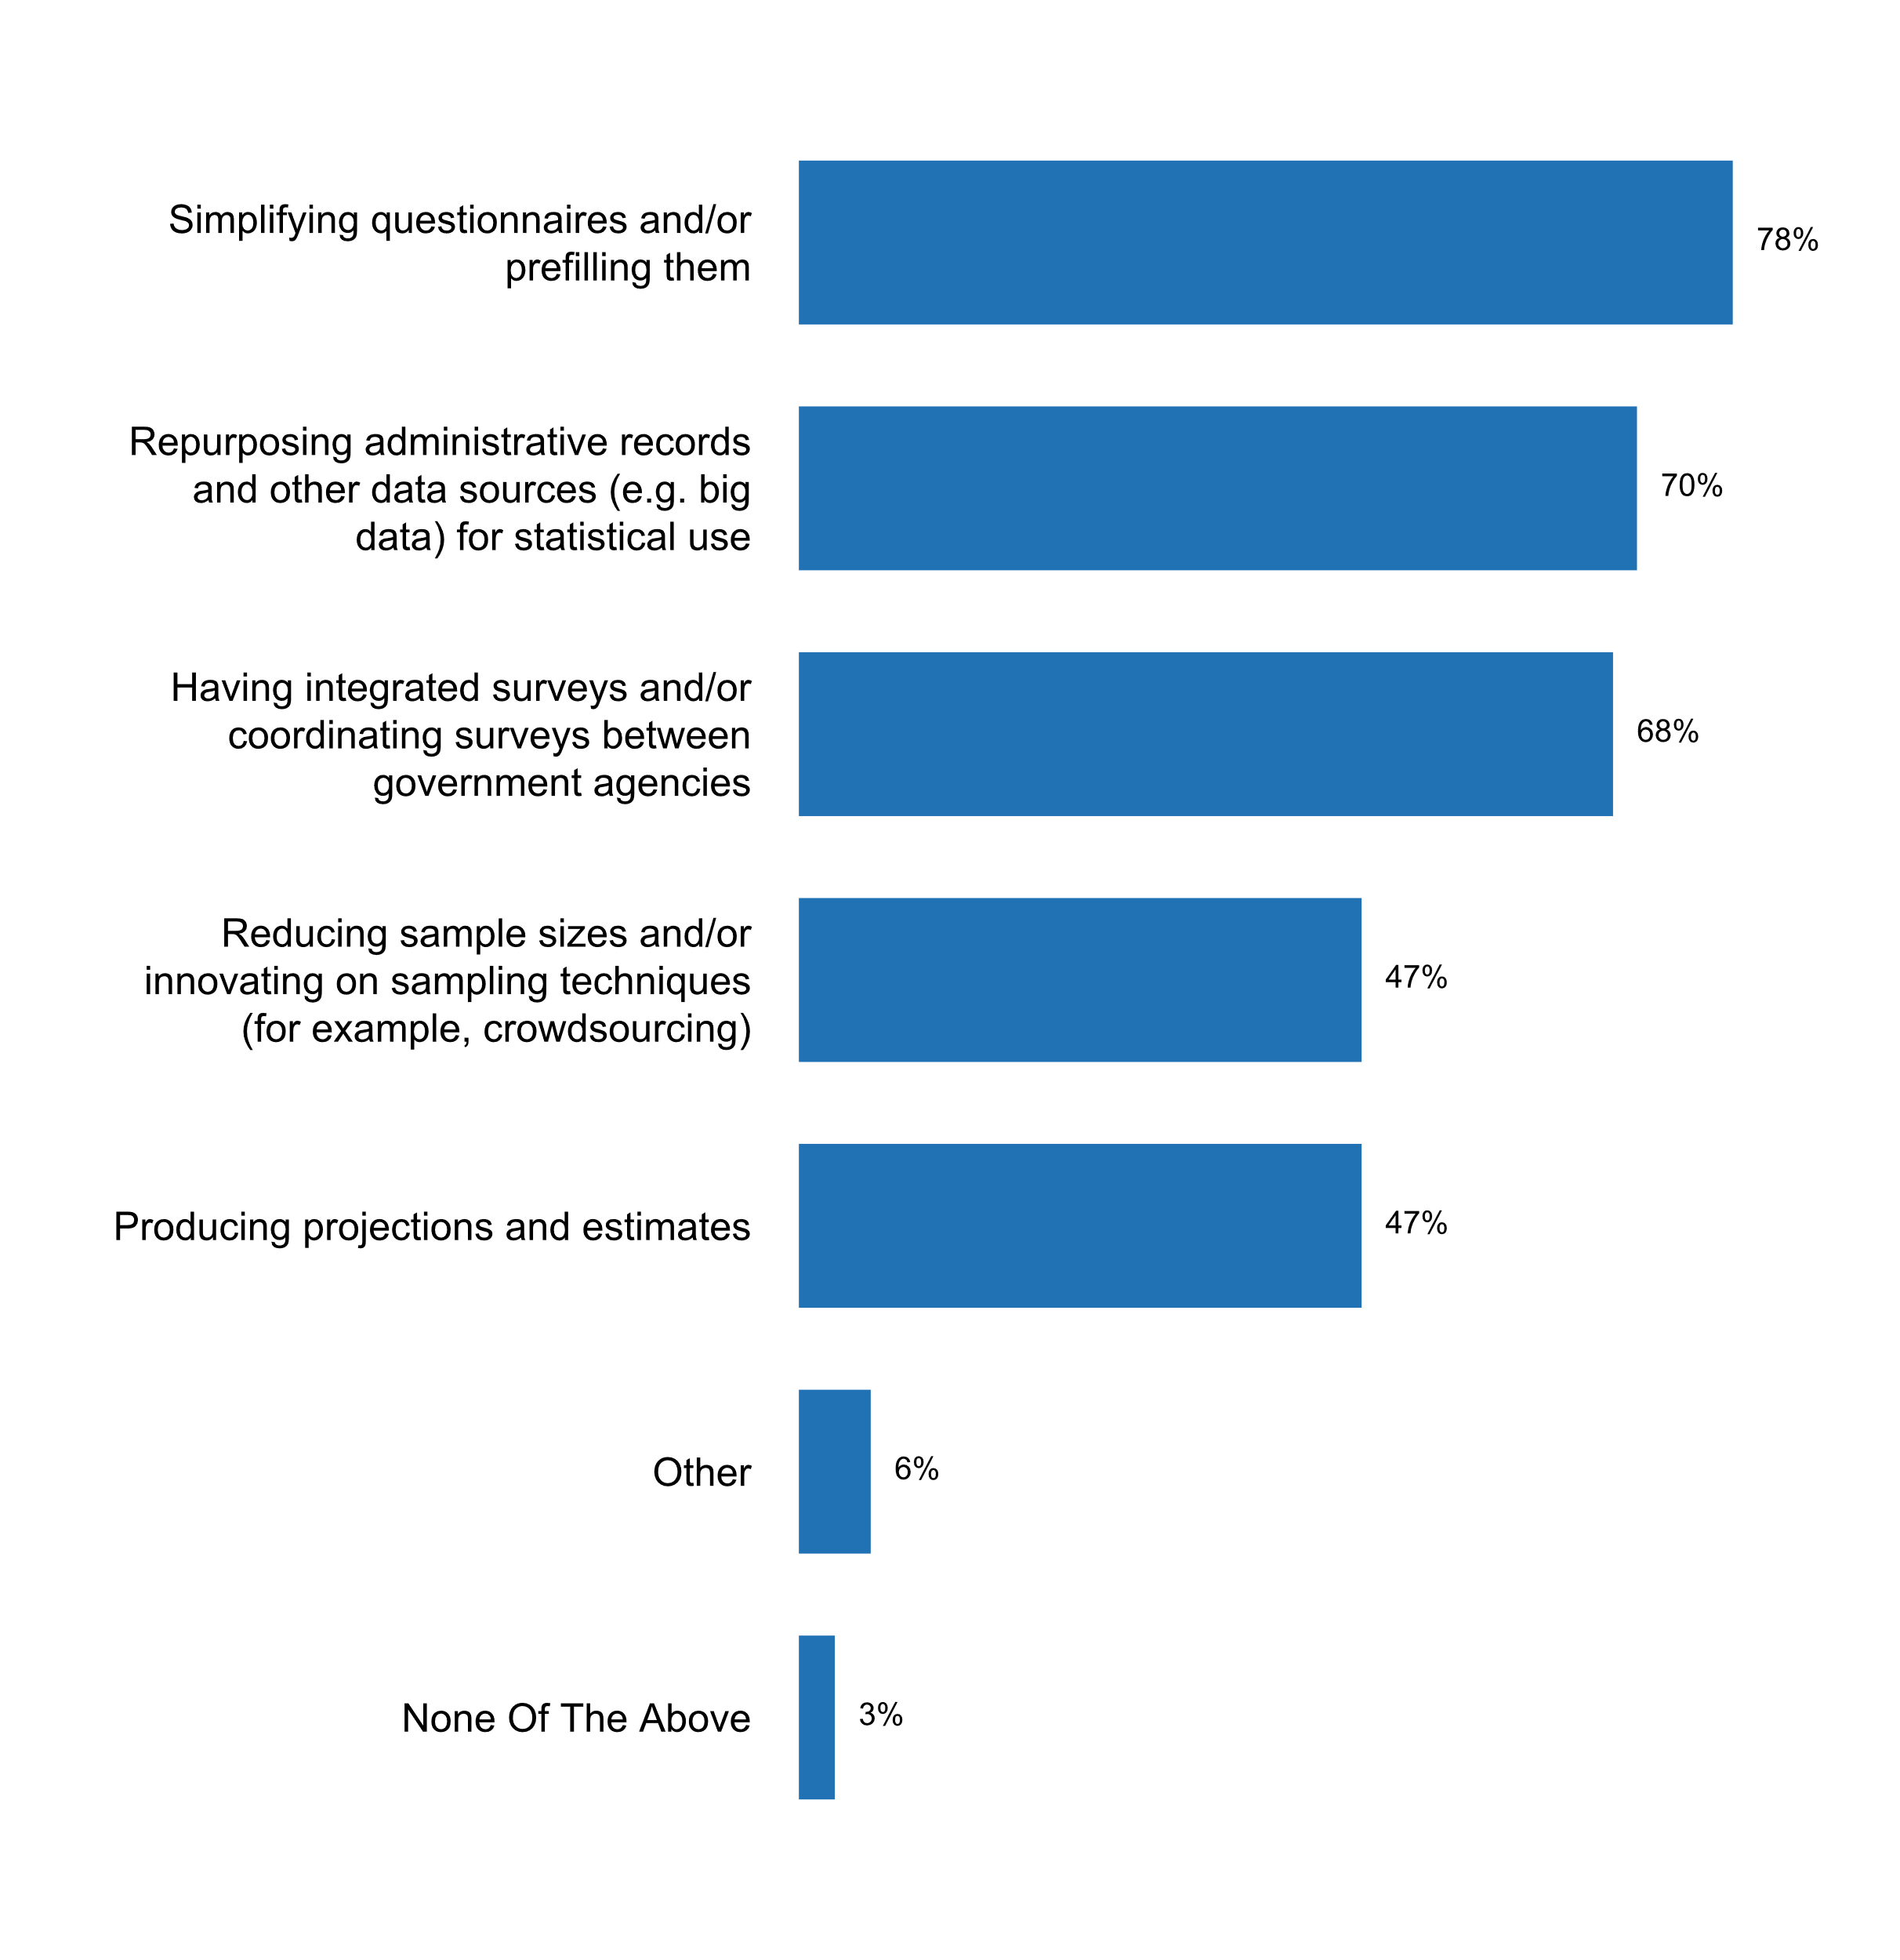

|  |  |  |  |  |  |  |
| --- | --- | --- | --- | --- | --- | --- |
| **Answer** | **Africa** | **Americas** | **Asia** | **Europe** | **Oceania** | **TOTAL** |
| Simplifying questionnaires and/or prefilling them | 11 | 10 | 17 | 32 | 3 | **73** |
| Repurposing administrative records and other data sources (e.g. big data) for statistical use | 4 | 7 | 17 | 34 | 3 | **65** |
| Having integrated surveys and/or coordinating surveys between government agencies | 14 | 8 | 16 | 22 | 3 | **63** |
| Reducing sample sizes and/or innovating on sampling techniques (for example, crowdsourcing) | 4 | 3 | 12 | 22 | 3 | **44** |
| Producing projections and estimates | 7 | 5 | 12 | 18 | 2 | **44** |
| Other |  | 1 | 1 | 4 |  | **6** |
| None Of The Above |  | 2 |  |  | 1 | **3** |

|  |  |  |  |  |  |  |
| --- | --- | --- | --- | --- | --- | --- |
| **Answer** | **Africa** | **Americas** | **Asia** | **Europe** | **Oceania** | **TOTAL** |
| Simplifying questionnaires and/or prefilling them | 65 | 77 | 71 | 91 | 75 | **78** |
| Repurposing administrative records and other data sources (e.g. big data) for statistical use | 24 | 54 | 71 | 97 | 75 | **70** |
| Having integrated surveys and/or coordinating surveys between government agencies | 82 | 62 | 67 | 63 | 75 | **68** |
| Reducing sample sizes and/or innovating on sampling techniques (for example, crowdsourcing) | 24 | 23 | 50 | 63 | 75 | **47** |
| Producing projections and estimates | 41 | 38 | 50 | 51 | 50 | **47** |
| Other |  | 8 | 4 | 11 |  | **6** |
| None Of The Above |  | 15 |  |  | 25 | **3** |

* Digitalisation of questionnaires
* Every new additional data collection has to go through a review by OMB.
* Sharing data between different statistics within NSO and NSS. Yearly assessment of respondent burden of every survey in the Decree of the CZSO on the Programme of Statistical Surveys.
* The respondent's calendar is posted on Belstat's official website, as well as a schedule of primary data collection in electronic form that contains information on the start date and the deadline for statistical reports collection for each statistical survey for each reporting period; The online report collection provides the possibility for respondent to receive an individual list of required forms
* coordinated (Poisson) sampling; implementation of electronic questionnaires with drop down menus for answers
* use of different replicates per survey round

**Additional comments on challenges to the implementation of Principle 5**

* - NBS needs to develop capabilities for using administrative and other data for statistical purposes/integrating administrative and statistical sources; - legislative framework is essential for ensuring access to administrative data for statistical purpose
* 5.1 Difficulties regarding access to Big data sources and privately-owned datasets; Wider use of administrative data
* 5.3.a. At present, there is a proposal for the Quality Management System of the SEN, which is being tested.
* 5.4 Administrative data requires a lot of improvements. Big data not yet embraced.
* Belstat, by means of a questionnaire, makes a selective assessment of the reporting burden on respondents, about the time they spent filling out selected state statistical survey forms. In order to reduce the reporting burden on respondents, it is planned to simplify statistical tools for small businesses and to further develop the method of sample state statistical surveys of the main indicators of micro-enterprises, as well as to expand the use of administrative data from various sources in conducting statistical assessments and calculations, using the mechanism of the quality assessment of such data.
* DANE, as the leading and coordinating body of the National Statistical System (NSS) of Colombia, is responsible, among other things, for the assurance of the quality with respect to the statistical information produced by the members of the NSS. In order to ensure statistical quality, DANE has been carrying out certification processes since 2006 by means of evaluating the statistical operations of the System. In total, 255 quality evaluations have been carried out, where 81% of the operations under assessment have obtained a certification (PEN, 2017: 7). This process was formalized in 2016, by establishing the quality assessment as a mandatory condition of official statistics in Colombia. The statistical quality evaluation process is carried out based on the Statistical Process Quality Technical Standard (NTC-PE 1000), deemed to be the first technical quality standard worldwide in which requirements are established with respect to the statistical process. The entities producing statistics are subject to quality evaluation according to the Annual Statistical Evaluation Program, which it is published one year in advance. The fulfillment of the Technical Standard is evaluated by a Commission of Independent Experts (CEI), consisting of three independent evaluators (experts in the thematic area, statistics and statistical process respectively). Once the Commission presents its recommendation, a Certification Committee that has not participated in the evaluation, issues its decision pertaining to the certification in statistical quality of the evaluated entity, based on the CEI report. The certification is a guarantee of quality with respect to the statistical information produced and provides trust in the use of information. The certification is valid for five years; however, in order to ensure continuous improvement, based on the findings of the assessment, the entity responsible for the statistical operation must present an improvement plan and conduct a self-evaluation with respect to the progress made in such plan and other improvement actions that it may have identified, annually, and subsequently present the report to DANE. This experience has allowed both DANE and the NSS to generate new developments, facilitating the institutional coordination with the entities of the System and promoting the standardization of processes. Furthermore, it is a pioneering process that can be replicated in other statistical systems in the region. By the end of 2018, approximately 30 statistical operations of the SEN will have been evaluated. [1] Spanish acronym
* Database of quality information (DBQI) became a key tool for quality assessment, quality documentation and quality reporting for CBS' surveys.
* Difficult to assess the quality of the administrative data
* Due to lack of resources, we are not presently able to apply a proper Quality Assessment Framework.
* In addition to the Tier 1 Statistics, principles and protocols, Stats NZ also has an internal policy for Data Quality management which requires that quality should be considered in each stage of the statistical production business process. This approach has been embedded into our project management procedures (Prince2) to ensure that a project will create and verify products that are fit for purpose. This includes the methods used to accept the products, and who is responsible (quality planning); then ensuring that the quality methods are implemented and tracked (quality control and assurance). There are three stages in the Stats NZ quality management system: 1. Assessing quality and risk in the end to end process 2. Establishing routine management tasks 3. Review and evaluate for the system continuous improvement. Much of the statistical quality assurance work is undertaken by Stats NZ statistical methodology unit and they have recently adopted â€˜ASPIRE' to assess quality of official statistics especially when new and alternative data sources are used as input. ASPIRE is an evaluation process that gives rise to a set of numerical indicators that over time signify a changing level of quality risk for a statistical product. Assessment of key outputs using ASPIRE is undertaken annually.
* In recent years, significant improvements in administrative registers have been observed and it is preferred in statistics production. The analysis of the administrative registry data requires a different quality of expertise than the survey data. The current staff is trained in this regard.
* Insufficient human and financial resources are the main constraint to better implementation of this principle in practice.
* It would be extremely helpful if UN requests address "respondent burden" as well. Though lengthy, at least this survey provides multiple choice questions. Another self-assessment OECD "survey" is basically 12 "evidence-based" essays, with multiple parts for every question. It was initially sent to the wrong recipient (former US Chief Statistician), so, by the time it got to the correct mailbox, it was many months later. The respondent burden for numerous UN requests is very significant. Can we reduce redundancies? Not all surveys need to be annual, perhaps every other year or every five years?
* Lack of use of administrative registers and their quality.
* Legal framework access to administrative data
* Nil
* None
* QUALITY OF ADMINISTRATIVE RECORDS
* Question 5.1a -- administrative records are not used as sampling frames directly, but via statistical registers. In other words, statistical register of persons is gets input from the national population register and statistical business register gets input from the national business register. All samples are taken from the statistical registers.
* Small size of the country makes it difficult to reduce the burden on large firms
* Support the restructuring of the administrative records from data sources; Increase the awareness on timely data supply.
* THE CHALLENGES ARE MOSTLY RELEASE TO THE ARCHIVING DATA SOURCE
* The ABS does not have a certification process which guarantees the official nature of statistics produced in various parts of the NSS. However, the national statistical authorities have institutional environments that guarantee quality statistical outputs.
* The strengthening and od administrative records to reduce the response burden of the respondents is a good practice that should be improved in the NSS, in the sense that it is an exchange of statistical information.
* There is need for an improved coordination between MDAs
* To reconcile the timeliness of administrative data with statistical needs.

**There is a confidentiality provision in the laws that regulate the NSO/NSS**

|  |  |  |  |  |  |  |
| --- | --- | --- | --- | --- | --- | --- |
| **Answer** | **Africa** | **Americas** | **Asia** | **Europe** | **Oceania** | **TOTAL** |
| Yes | 17 | 13 | 24 | 35 | 4 | **93** |

**Plot_47_Q06.1a.svg**

**Confidentiality provision in the laws applies to…**

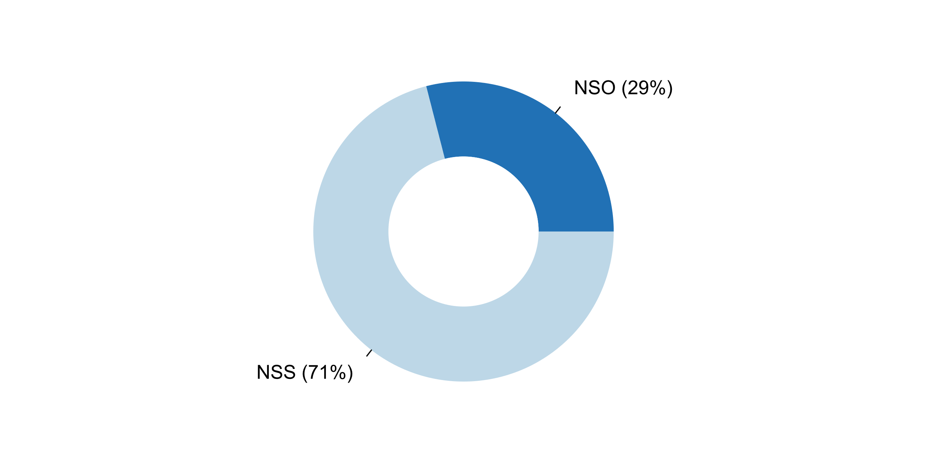

|  |  |  |  |  |  |  |
| --- | --- | --- | --- | --- | --- | --- |
| **Answer** | **Africa** | **Americas** | **Asia** | **Europe** | **Oceania** | **TOTAL** |
| NSO | 2 | 6 | 7 | 10 | 2 | **27** |
| NSS | 15 | 7 | 17 | 25 | 2 | **66** |

|  |  |  |  |  |  |  |
| --- | --- | --- | --- | --- | --- | --- |
| **Answer** | **Africa** | **Americas** | **Asia** | **Europe** | **Oceania** | **TOTAL** |
| NSO | 12 | 46 | 29 | 29 | 50 | **29** |
| NSS | 88 | 54 | 71 | 71 | 50 | **71** |

**Plot_48_Q06.2.svg**

**Aspects considered in the confidentiality policy of the NSO**

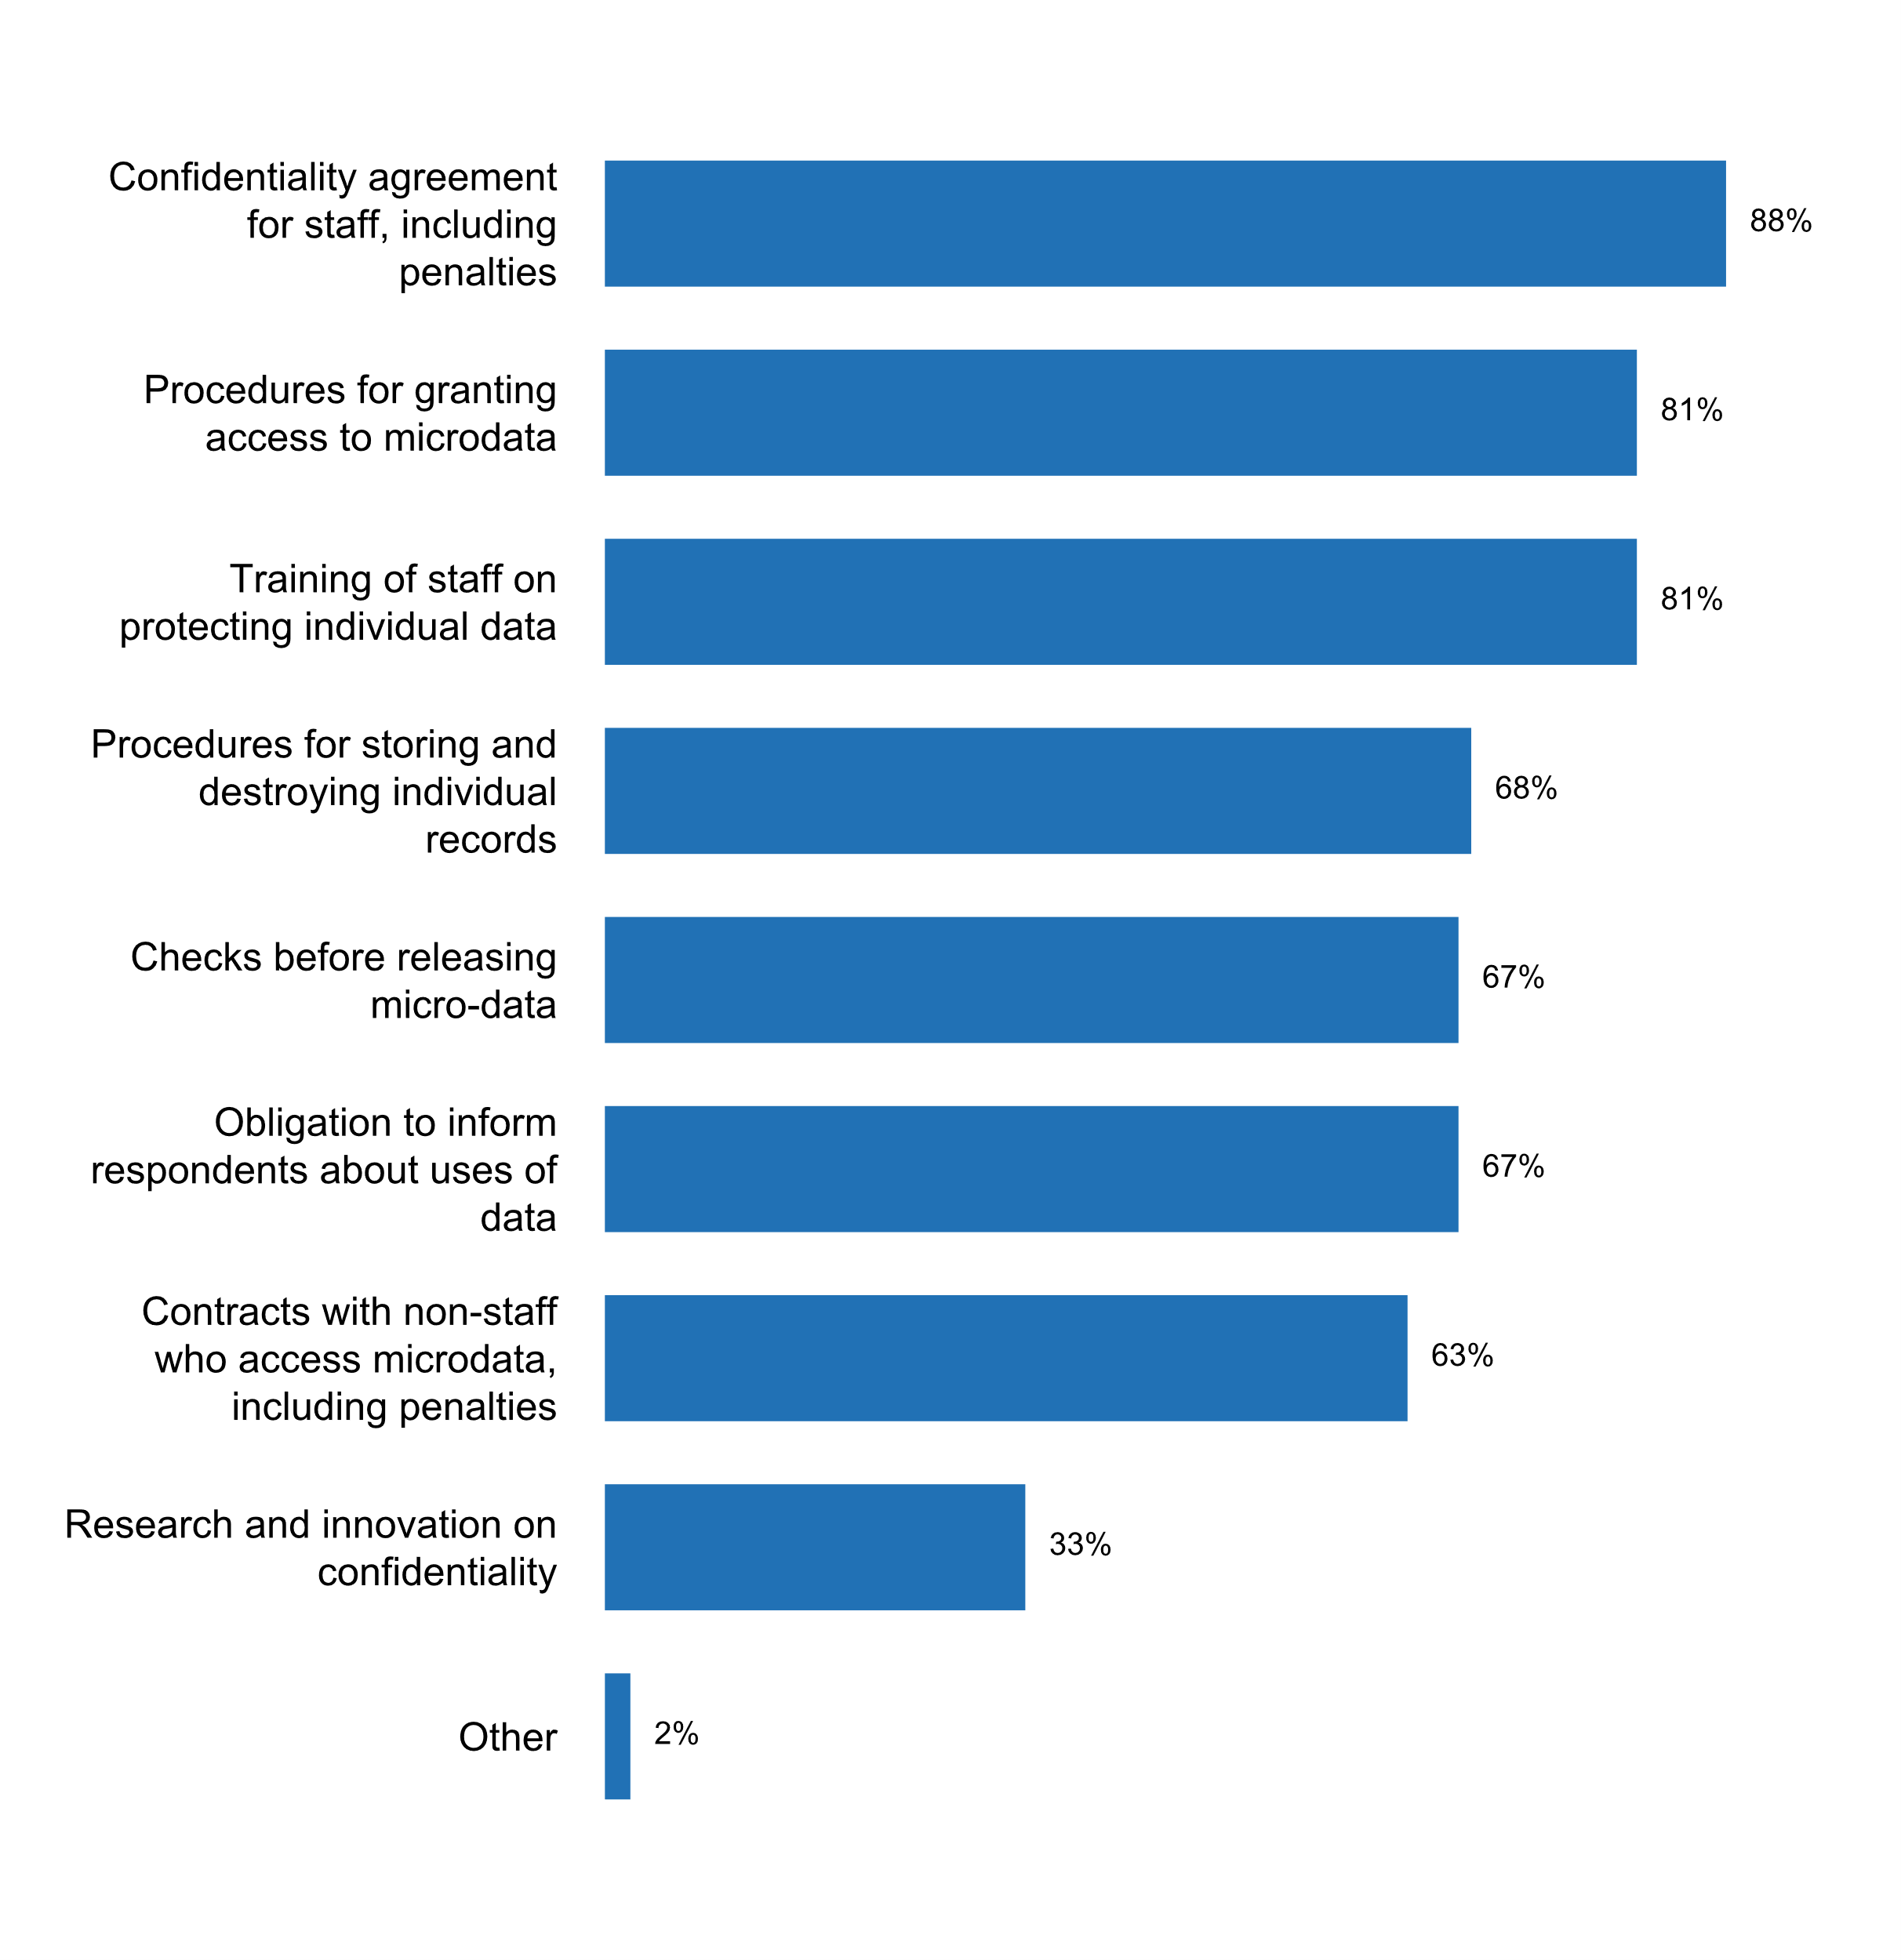

|  |  |  |  |  |  |  |
| --- | --- | --- | --- | --- | --- | --- |
| **Answer** | **Africa** | **Americas** | **Asia** | **Europe** | **Oceania** | **TOTAL** |
| Confidentiality agreement for staff, including penalties | 15 | 13 | 19 | 32 | 3 | **82** |
| Procedures for granting access to microdata | 10 | 11 | 20 | 31 | 3 | **75** |
| Training of staff on protecting individual data | 12 | 9 | 21 | 30 | 3 | **75** |
| Procedures for storing and destroying individual records | 6 | 8 | 16 | 30 | 3 | **63** |
| Checks before releasing micro-data | 6 | 8 | 18 | 27 | 3 | **62** |
| Obligation to inform respondents about uses of data | 11 | 9 | 13 | 26 | 3 | **62** |
| Contracts with non-staff who access microdata, including penalties | 6 | 8 | 13 | 29 | 3 | **59** |
| Research and innovation on confidentiality | 3 | 6 | 5 | 14 | 3 | **31** |
| Other |  | 1 |  |  | 1 | **2** |

|  |  |  |  |  |  |  |
| --- | --- | --- | --- | --- | --- | --- |
| **Answer** | **Africa** | **Americas** | **Asia** | **Europe** | **Oceania** | **TOTAL** |
| Confidentiality agreement for staff, including penalties | 88 | 100 | 79 | 91 | 75 | **88** |
| Procedures for granting access to microdata | 59 | 85 | 83 | 89 | 75 | **81** |
| Training of staff on protecting individual data | 71 | 69 | 88 | 86 | 75 | **81** |
| Procedures for storing and destroying individual records | 35 | 62 | 67 | 86 | 75 | **68** |
| Checks before releasing micro-data | 35 | 62 | 75 | 77 | 75 | **67** |
| Obligation to inform respondents about uses of data | 65 | 69 | 54 | 74 | 75 | **67** |
| Contracts with non-staff who access microdata, including penalties | 35 | 62 | 54 | 83 | 75 | **63** |
| Research and innovation on confidentiality | 18 | 46 | 21 | 40 | 75 | **33** |
| Other |  | 8 |  |  | 25 | **2** |

* Procedures for transmission of protected information, breach protocol
* We do not have a Confidentiality Policy but we have a Statistical Act 2015 that has the confidentiality clause

**Examples of cases in which the confidentiality policy was violated in the past five years, and the sanctions that were applied**

* According to Statistical law
* Especially on NSO staff members who did not keep records on business respondents in appropriate storage areas.
* In case the confidentiality policy was violated the warning for employee/user was issued (who violated the procedures); the procedures were updated, improved, additional provisions for preventing such acts, were added.
* Many times during the political intervention of the NSO (2007-2015). In fact, there is a lawsuit related to this issue, currently pending of its final resolution within the country's Justice.
* One enumerator divulged information about a respondent and he was fired from his job.
* One incident in 2015 where data was handed to a resarch institution for use in a specific research project and the data was distributed to other resarch institutions for other resarch projects. Registered as a deviation and handled accordingly and internal routines was also improved in order to have clearer rules and communication with customers. A division for exchange of microdata has since then been established with both tecnhical and legal expertise, as a measure to secure these agreements also in the future. The handling of micro data exchange was more decentralized before.
* Publication of identifiable data by mistake by one researcher, sanctioned by a ban to use the data
* Staff breach. Direct IDs hacked with additional information. Staff member dismissed and cased handed over to the police authorities.
* Statistics Denmark was ordered by a law to disclose statistical data on educational attainment for administrative and control purposes in 2017 in conflict with FPOS. Statistics Denmark consider it as a serious breach if researchers send home data containing deidentified microdata from Statistics Denmark's research computers. Since 2014 there has been close to 90 breaches, where researchers have sent home microdata. The normal sanction for a breach is one month exclusion from access to microdata for the research environment, that has committed the breach. If the research environment reports a breach to Statistics Denmark, then it is considered a mitigating circumstance, and the exclusion will be shorter than one month. Of the 90 breaches 45 percent have been self-reported. Statistics Denmark's confidentiality policy regarding researcher's access to microdata is more restrictive than required by the European General Data Protection Regulation (GDPR). E.g. confidentiality breach under the research arrangement is normally not considered a breach on GDPR.
* There was a case that was older than ten years, in which the organization violated terms of gaining access to embargoed data. That organization was exempted from access for two years. That seemed to have been effective.To my knowledge, the incident has not happened since.
* There was one situation during a recent Economic Census where an interviewer allowed her husband (who was not contracted by the NSO) to conduct interviews.The interviewer was dismissed, but after legal advice was sought and obtained no further measures were taken against her.
* We have an exemple in which a senior technician of the NSO supplied information to another entity without authorization and the penalty was the dismissal.

**Plot_49_Q06.3.svg**

**Practices being implemented to anonymize statistical data**

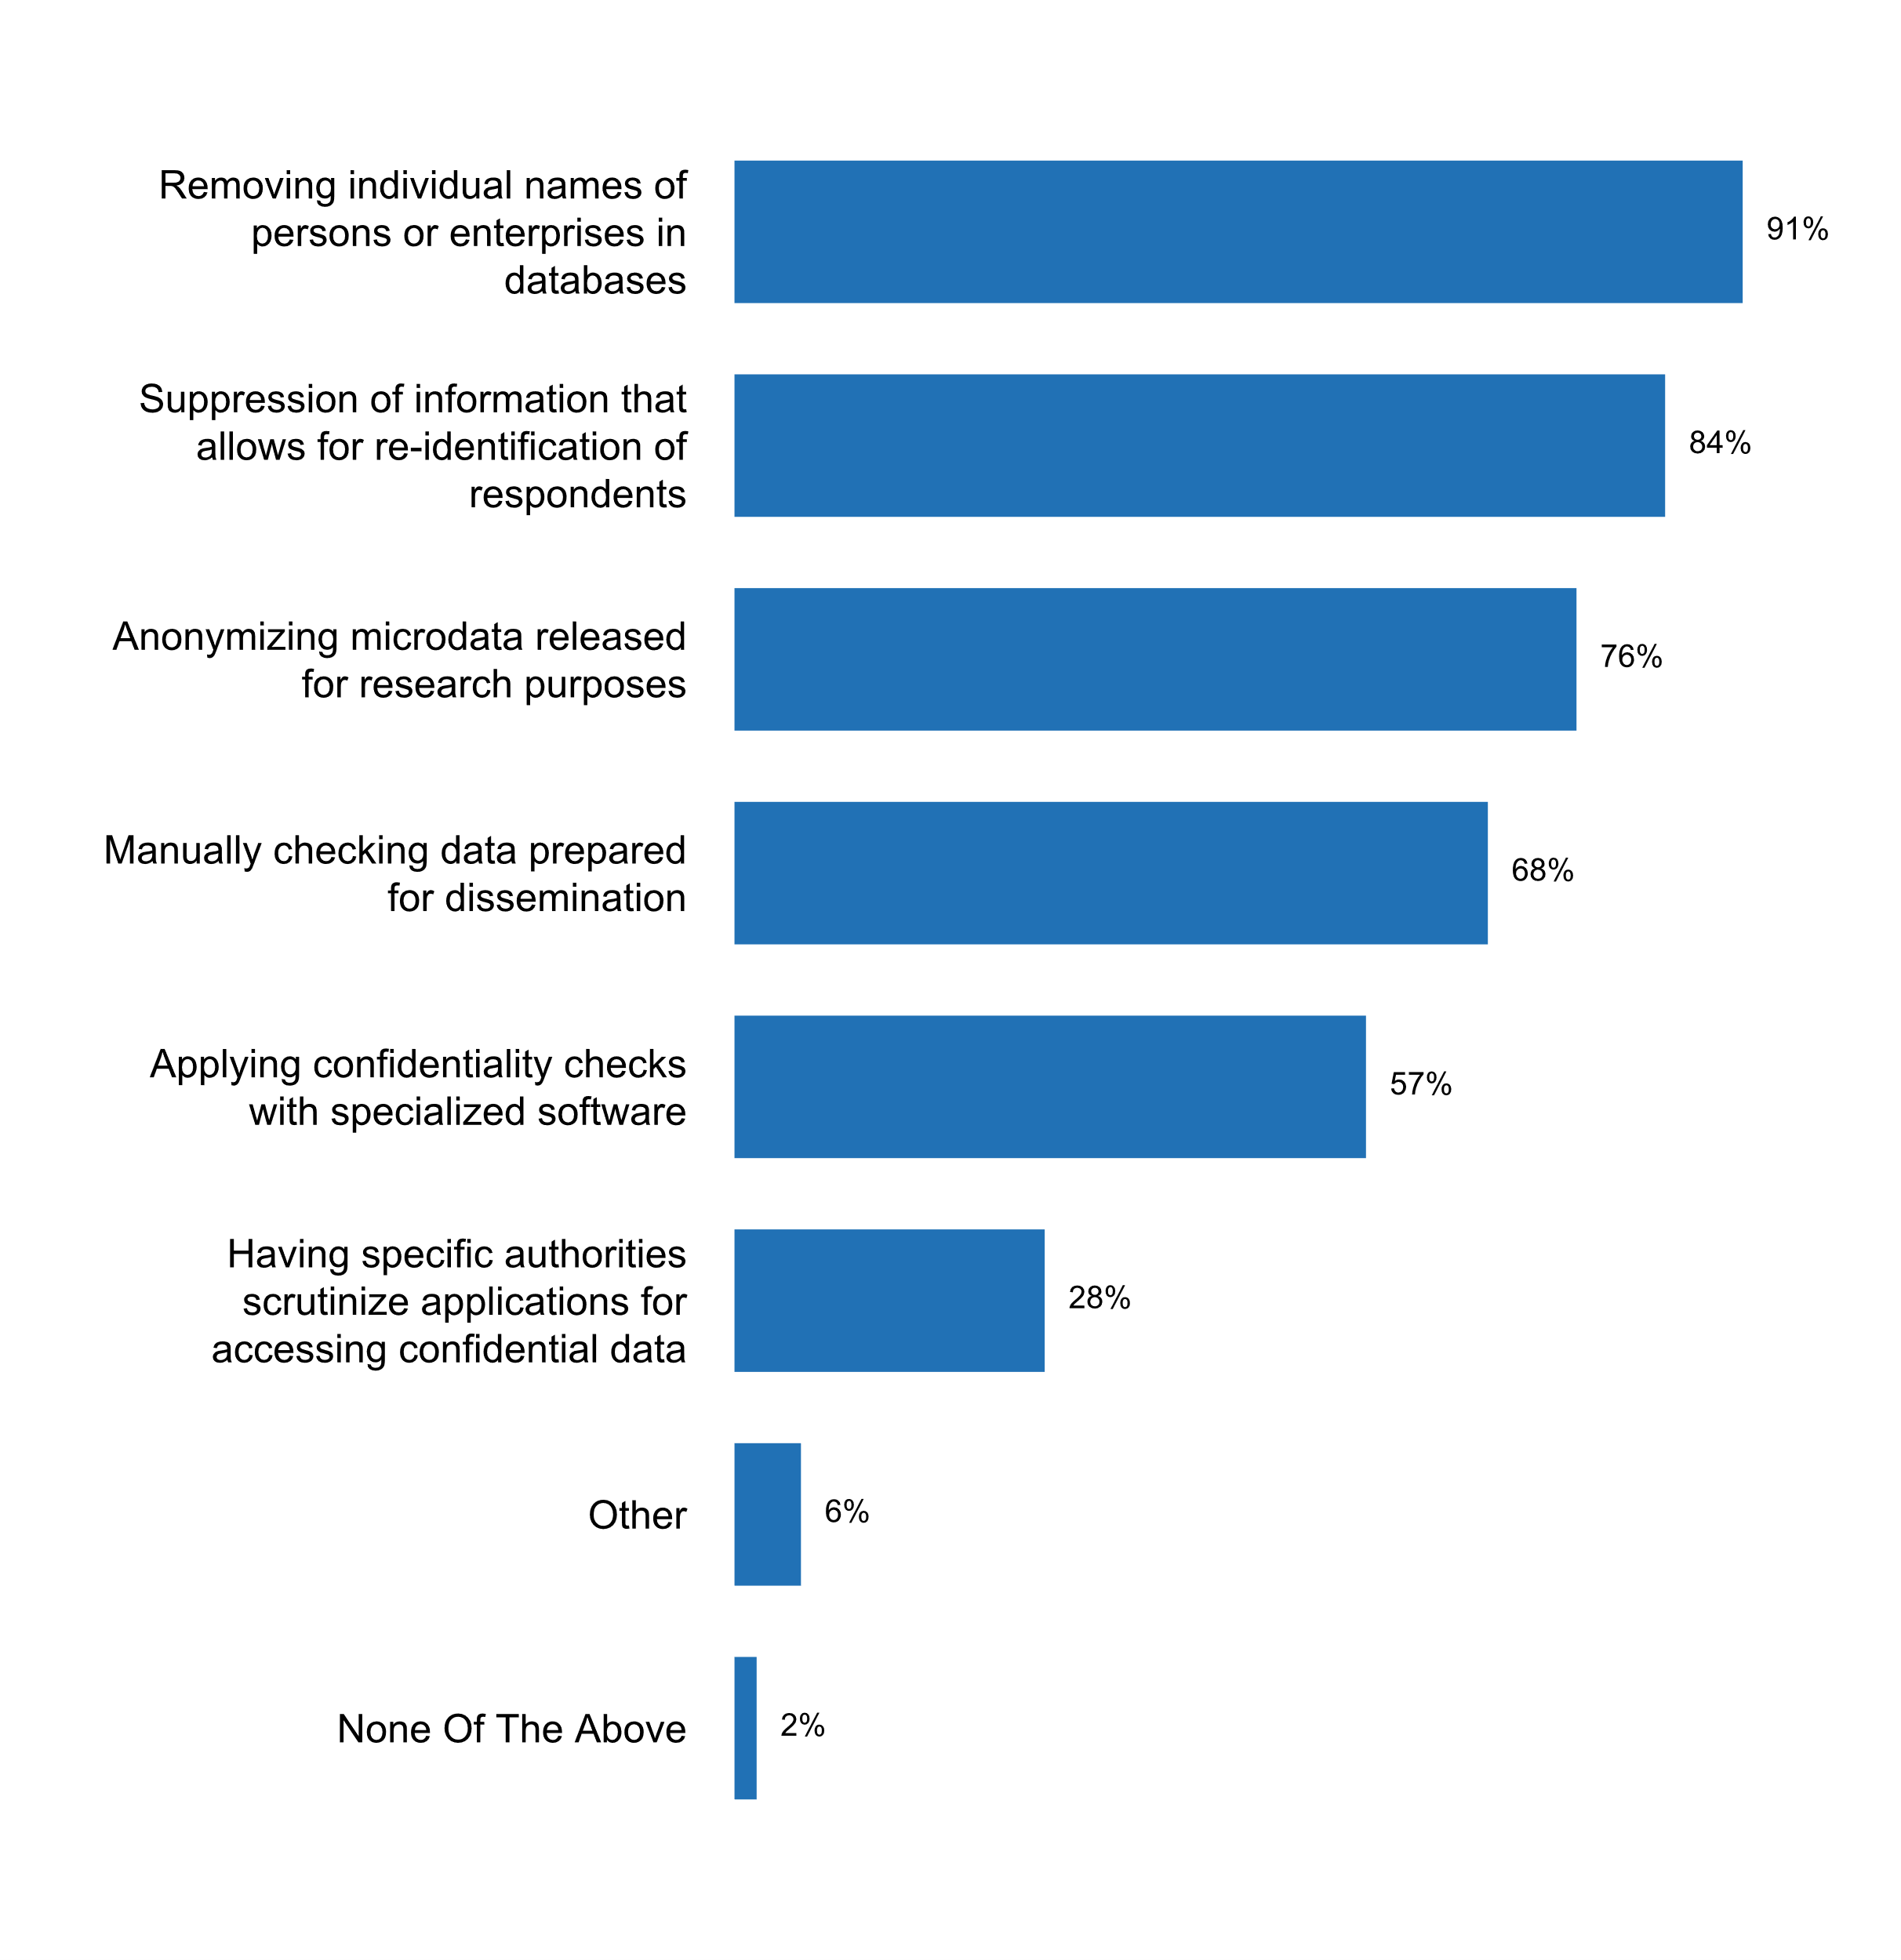

|  |  |  |  |  |  |  |
| --- | --- | --- | --- | --- | --- | --- |
| **Answer** | **Africa** | **Americas** | **Asia** | **Europe** | **Oceania** | **TOTAL** |
| Removing individual names of persons or enterprises in databases | 15 | 12 | 22 | 32 | 4 | **85** |
| Suppression of information that allows for re-identification of respondents | 15 | 12 | 18 | 31 | 2 | **78** |
| Anonymizing microdata released for research purposes | 10 | 12 | 15 | 32 | 2 | **71** |
| Manually checking data prepared for dissemination | 9 | 8 | 16 | 27 | 3 | **63** |
| Applying confidentiality checks with specialized software | 6 | 8 | 13 | 24 | 2 | **53** |
| Having specific authorities scrutinize applications for accessing confidential data |  | 2 | 8 | 15 | 1 | **26** |
| Other |  | 2 |  | 4 |  | **6** |
| None Of The Above |  |  | 1 | 1 |  | **2** |

|  |  |  |  |  |  |  |
| --- | --- | --- | --- | --- | --- | --- |
| **Answer** | **Africa** | **Americas** | **Asia** | **Europe** | **Oceania** | **TOTAL** |
| Removing individual names of persons or enterprises in databases | 88 | 92 | 92 | 91 | 100 | **91** |
| Suppression of information that allows for re-identification of respondents | 88 | 92 | 75 | 89 | 50 | **84** |
| Anonymizing microdata released for research purposes | 59 | 92 | 63 | 91 | 50 | **76** |
| Manually checking data prepared for dissemination | 53 | 62 | 67 | 77 | 75 | **68** |
| Applying confidentiality checks with specialized software | 35 | 62 | 54 | 69 | 50 | **57** |
| Having specific authorities scrutinize applications for accessing confidential data |  | 15 | 33 | 43 | 25 | **28** |
| Other |  | 15 |  | 11 |  | **6** |
| None Of The Above |  |  | 4 | 3 |  | **2** |

* Anonymizing microdata released for public use
* Each agency has specific legislation regarding safeguarding the confidentially of their data. For example, for Census Bureau it is Title 13.
* Establishment of a Statistical Confidentiality Committee in ELSTAT.
* Masking methods
* Procedures implemented for creation of scientific and public use files (survey databases).
* The confidentiality provision of the federal statistical legislation governing the NSO includes restricting access to identifying information to persons employed or deemed to be employed, and who have sworn the oath of office, and prohibits disclosure by these persons of information in a manner that it is possible to relate the information to any identifiable person, business or organization.

**Plot_50_Q06.4.svg**

**Circumstances under which identifiable individual data can be disclosed to third parties**

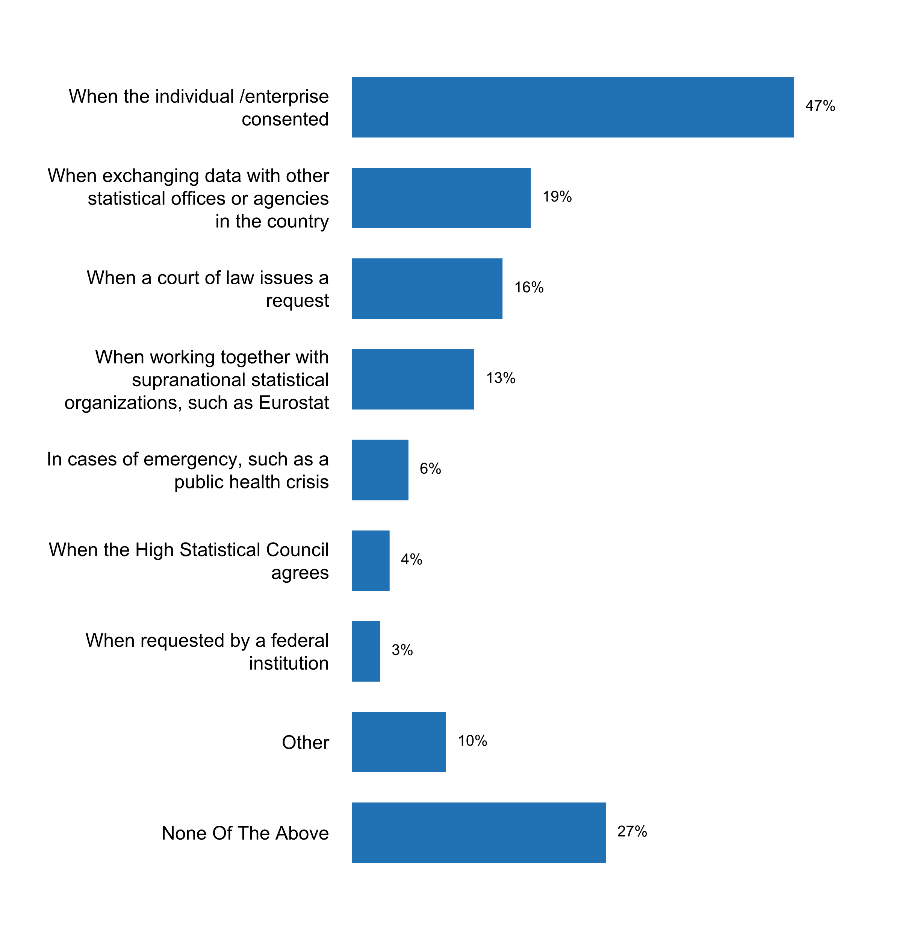

|  |  |  |  |  |  |  |
| --- | --- | --- | --- | --- | --- | --- |
| **Answer** | **Africa** | **Americas** | **Asia** | **Europe** | **Oceania** | **TOTAL** |
| When the individual /enterprise consented | 7 | 6 | 6 | 21 | 4 | **44** |
| When exchanging data with other statistical offices or agencies in the country | 2 |  | 2 | 14 |  | **18** |
| When a court of law issues a request | 4 | 1 | 4 | 4 | 2 | **15** |
| When working together with supranational statistical organizations, such as Eurostat | 2 |  | 1 | 9 |  | **12** |
| In cases of emergency, such as a public health crisis | 2 |  | 2 | 1 | 1 | **6** |
| When the High Statistical Council agrees | 3 | 1 |  |  |  | **4** |
| When requested by a federal institution | 1 |  | 1 |  | 1 | **3** |
| Other |  | 1 | 1 | 7 |  | **9** |
| None Of The Above | 5 | 5 | 9 | 6 |  | **25** |

|  |  |  |  |  |  |  |
| --- | --- | --- | --- | --- | --- | --- |
| **Answer** | **Africa** | **Americas** | **Asia** | **Europe** | **Oceania** | **TOTAL** |
| When the individual /enterprise consented | 41 | 46 | 25 | 60 | 100 | **47** |
| When exchanging data with other statistical offices or agencies in the country | 12 |  | 8 | 40 |  | **19** |
| When a court of law issues a request | 24 | 8 | 17 | 11 | 50 | **16** |
| When working together with supranational statistical organizations, such as Eurostat | 12 |  | 4 | 26 |  | **13** |
| In cases of emergency, such as a public health crisis | 12 |  | 8 | 3 | 25 | **6** |
| When the High Statistical Council agrees | 18 | 8 |  |  |  | **4** |
| When requested by a federal institution | 6 |  | 4 |  | 25 | **3** |
| Other |  | 8 | 4 | 20 |  | **10** |
| None Of The Above | 29 | 38 | 38 | 17 |  | **27** |

* If so required for statistical purposes by an international legal act with direct national effect or by federal law or unless the data subject has expressly and unequivocally agreed to such transmission.
* In compliance with the legislation, without the written consent of the respondent, primary statistical data may be provided in relation to subordinated (affiliated) state organizations, as well as organizations whose shares (shares in the statutory capital) are state-owned and transferred to them for management.
* In general not, but some data exchange on identifiable level to other Nordic NSOs given that the countries legal provisions are as strong as in Norway
* Individual data must not be made public, only with the exceptions provided by the Act No CLV of 2016 on official statistics, Art. 20 39(3)
* Statistics Canada may disclose individual information with permission from the authority responsible for original collection of the information from individuals and businesses. In addition to consent, the Chief Statistician must also have authorized the disclosure.
* These answers are all related to enterprises but do not refer to individuals/individual households. The relations with supra national organisations (Eurostat) only based on European legal act.
* We never provide information to third parties.
* When exchanging data for statistical purposes with other national statistical authorities of the Member States in the EU under multilateral agreement where this is necessary for development and production of European statistical information; When exchanging data with the Bulgarian National Bank in developing, producing and disseminating official national or European statistical information or the statistical information of the European Central Bank
* specific rules are provided for in European Union Law

**Additional comments on challenges to the implementation of Principle 6**

* 1) International Development Partners (IDPs) misbehaving, sometimes with support of Policymakers2) Statistics Act Article 8 (5) doesn't only refer to the situation that an individual respondent may give permission in writing to release its individual data, but also to the situation where the NSO takes a respondent to court if the NSO seriously suspects misreporting
* 6.2 The NSO in hiring consultant, staff and non-staff workers requests them the signature of confidentiality agreements.
* All employees working in the Geostat system are obliged to follow confidentiality of statistical data. The employee is prohibited to disclose, use or disseminate confidential statistical data, for personal, academic, research and other activity purposes. Confidentiality commitment is signed by all staff members. In case of modification agreement will be updated and signed again. The confidentiality policy is in place and it is publicly available.
* Although individual data is not shared, requests are still being sent by the courts.
* As a challenging issue we consider developing comprehensive methodological and organizational solutions to maintain a unified and effective statistical disclosure control system for microdata from surveys conducted by Statistics Poland.IT systems used for data transmission must ensure full security of confidential data
* Before the new law on official statistics was adopted it was rather difficult to access individual records for statistical purposes. It is much easier now, yet, some minor legislative amendments are to be made.
* Currently there are no clear rules for the transfer of administrative records, so it is necessary to strengthen the mechanisms for the exchange of confidential information, under the premise of exclusive use for statistical purposes.
* It is difficult to assess what constitutes a statistical purpose because the data is used mostly to support a project with a different purpose like a health activity but not for a statistics activity
* Lack of law/legal framework
* More guidance in the recommendation about handling micro data and open data accessibility would be helpful. Consideration of the risks relating to equitable access when data is released by multiple sources.
* Releasing microdata
* Statistical confidentiality may be lifted in the event of legal proceedings or in the context of the application of the law on successions, but the case has never occurred in France.
* THER IS NOT CHALLENGES, IF NOT THE RESPECT OF THE CONFIDENTIALITY IS RESPECT.
* The Census and Statistics Act 1905 (CSA): requires the Australian Statistician to conduct the Census of Population and Housing every five years; requires the Australian Statistician to publish a quarterly population estimate for each Australian state and territory; empowers the Australian Statistician to collect statistical information on a broad range of demographic, economic, environmental and social topics; enables the Australian Statistician to legally direct a person to provide statistical information, and provides penalties for non-compliance with such a direction; requires the ABS to publish the results of all statistical collections; contains secrecy provisions that ensures any information relating to a person will not be released in a manner that is likely to enable the identification of that person, unless it is permitted by law; and places a life-long obligation on all ABS officers to maintain the secrecy of information collected under the CSA, and provides harsh penalties for those who fail to do so. Section 13 of the CSA provides for the Minister to make determinations allowing for the disclosure, with the approval in writing of the Australian Statistician, of information included in a specified class of information furnished in pursuance of the CSA. The Statistics Determination 1983 (the Determination) is such a determination which authorises the release of a restricted range of information under certain circumstances. The Determination is due to sunset on 1 October, 2018 and a new determination will be in force before that date. The Determination will provide a more flexible scheme under which business information can be released in sufficient detail to meet the analysis and decision making needs of governments, businesses and other stakeholders, whilst managing business expectations around the confidentiality of their commercial information. Section 19 of the CSA contains strong secrecy provisions which ensure information collected under the CSA is only disclosed where explicitly enabled by the CSA. All ABS officers are bound for life to maintain the secrecy of information collected under the CSA, and sign an undertaking of fidelity and secrecy upon commencement and at regular intervals throughout their employment. The CSA provides for harsh personal penalties should secrecy not be maintained. The CSA also provides for Regulations to be made to assist the Australian Statistician in performing their functions. These are contained within the Census and Statistics Regulation 2016.
* The confidentiality of primary statistical data is ensured at all stages of statistical production (collection, processing, storage and protection of primary statistical data, generation, accumulation, dissemination and presentation of official statistical information). To ensure the technical and cryptographic protection of primary statistical data, information security systems are created, which pass the relevant certification procedures for compliance with the established security requirements.
* The local population is too small, hence there is high probability of response fatigue among households for household surveys. Anonymizing data is also a challenge as it is easy to identify persons at the EA level (an EA is comprised of 100 households). Hence, the lowest level that data can be shared is at district level.
* There is a lot of areas to discuss.
* We strongly follow the Principle 6.
* cf. Loi statistique (http://www.ansd.sn/index.php?option=com_docman&task=doc_download&gid=29&Itemid=259), articles 6 à  8-ter.
* there are some contradiction between other laws and the STAT law

**Plot_51_Q07.1.svg**

**Existence of a general statistics law in the country**

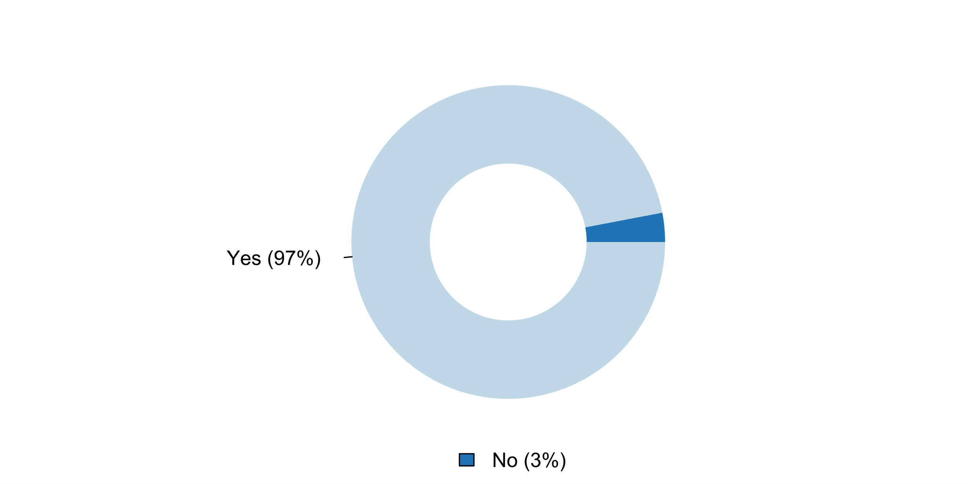

|  |  |  |  |  |  |  |
| --- | --- | --- | --- | --- | --- | --- |
| **Answer** | **Africa** | **Americas** | **Asia** | **Europe** | **Oceania** | **TOTAL** |
| No |  | 1 | 2 |  |  | **3** |
| Yes | 17 | 12 | 22 | 35 | 4 | **90** |

|  |  |  |  |  |  |  |
| --- | --- | --- | --- | --- | --- | --- |
| **Answer** | **Africa** | **Americas** | **Asia** | **Europe** | **Oceania** | **TOTAL** |
| No |  | 8 | 8 |  |  | **3** |
| Yes | 100 | 92 | 92 | 100 | 100 | **97** |

**Plot_52_Q07.2.svg**

**Aspects of the NSS covered by regulations (e.g. Statistical Law, presidential decrees)**

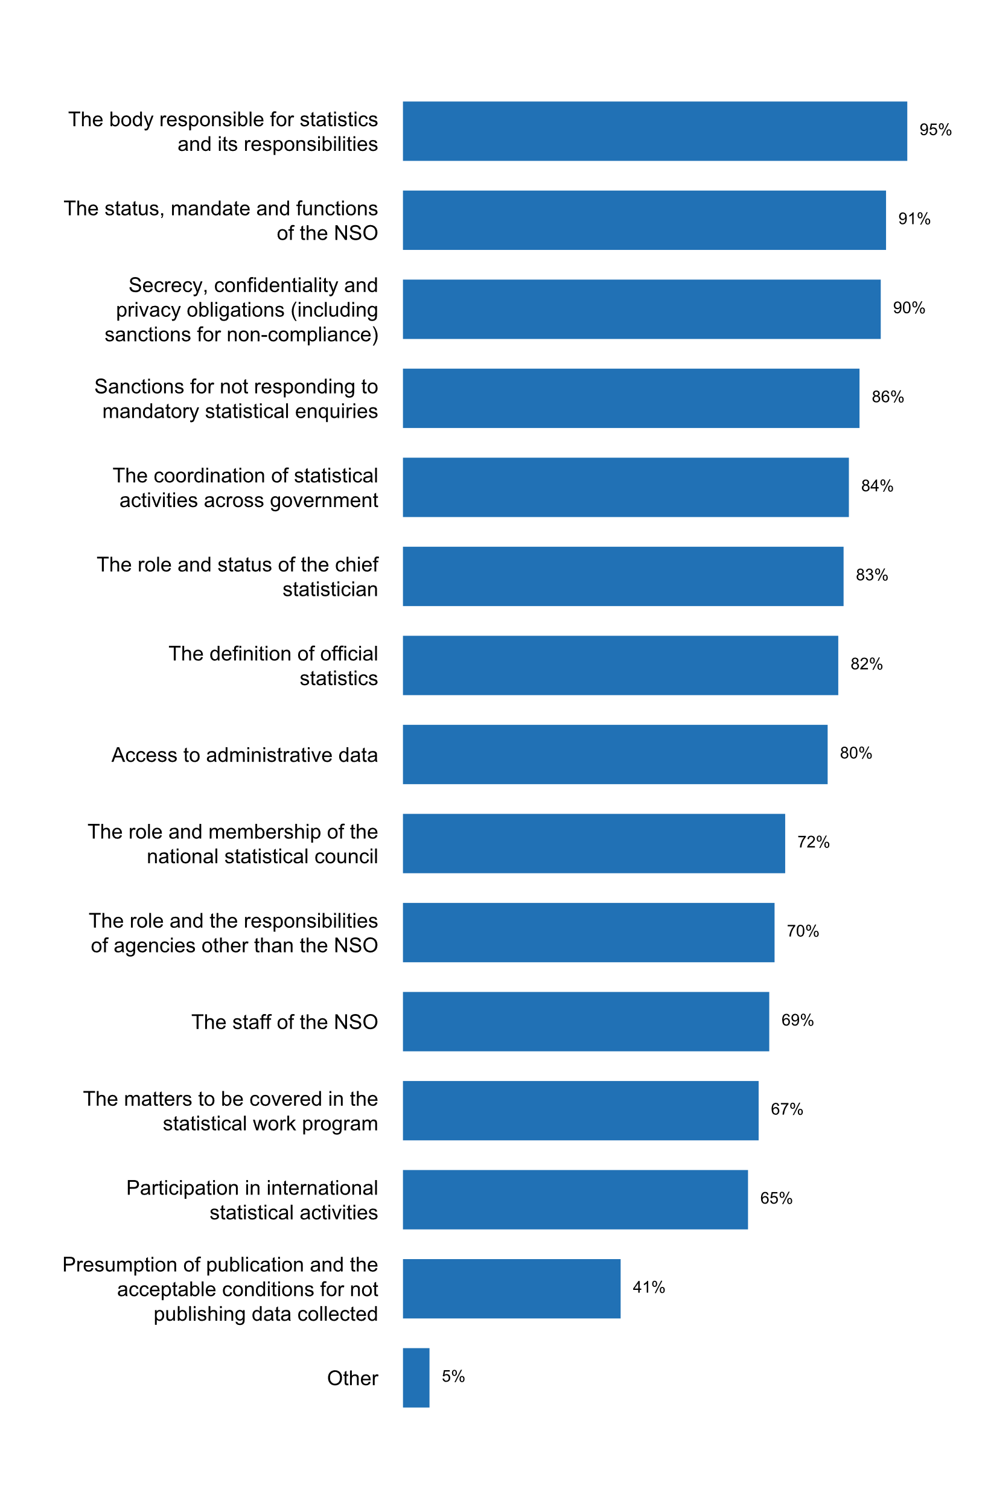

|  |  |  |  |  |  |  |
| --- | --- | --- | --- | --- | --- | --- |
| **Answer** | **Africa** | **Americas** | **Asia** | **Europe** | **Oceania** | **TOTAL** |
| The body responsible for statistics and its responsibilities | 17 | 12 | 22 | 33 | 4 | **88** |
| The status, mandate and functions of the NSO | 15 | 13 | 20 | 33 | 4 | **85** |
| Secrecy, confidentiality and privacy obligations (including sanctions for non-compliance) | 16 | 13 | 19 | 32 | 4 | **84** |
| Sanctions for not responding to mandatory statistical enquiries | 17 | 12 | 15 | 33 | 3 | **80** |
| The coordination of statistical activities across government | 17 | 11 | 18 | 28 | 4 | **78** |
| The role and status of the chief statistician | 15 | 10 | 18 | 30 | 4 | **77** |
| The definition of official statistics | 16 | 10 | 18 | 29 | 3 | **76** |
| Access to administrative data | 14 | 9 | 15 | 33 | 3 | **74** |
| The role and membership of the national statistical council | 17 | 9 | 13 | 26 | 2 | **67** |
| The role and the responsibilities of agencies other than the NSO | 13 | 6 | 18 | 25 | 3 | **65** |
| The staff of the NSO | 14 | 9 | 15 | 23 | 3 | **64** |
| The matters to be covered in the statistical work program | 9 | 9 | 14 | 27 | 3 | **62** |
| Participation in international statistical activities | 13 | 7 | 12 | 27 | 1 | **60** |
| Presumption of publication and the acceptable conditions for not publishing data collected | 8 | 3 | 7 | 17 | 3 | **38** |
| Other | 1 | 2 | 1 | 1 |  | **5** |

|  |  |  |  |  |  |  |
| --- | --- | --- | --- | --- | --- | --- |
| **Answer** | **Africa** | **Americas** | **Asia** | **Europe** | **Oceania** | **TOTAL** |
| The body responsible for statistics and its responsibilities | 100 | 92 | 92 | 94 | 100 | **95** |
| The status, mandate and functions of the NSO | 88 | 100 | 83 | 94 | 100 | **91** |
| Secrecy, confidentiality and privacy obligations (including sanctions for non-compliance) | 94 | 100 | 79 | 91 | 100 | **90** |
| Sanctions for not responding to mandatory statistical enquiries | 100 | 92 | 63 | 94 | 75 | **86** |
| The coordination of statistical activities across government | 100 | 85 | 75 | 80 | 100 | **84** |
| The role and status of the chief statistician | 88 | 77 | 75 | 86 | 100 | **83** |
| The definition of official statistics | 94 | 77 | 75 | 83 | 75 | **82** |
| Access to administrative data | 82 | 69 | 63 | 94 | 75 | **80** |
| The role and membership of the national statistical council | 100 | 69 | 54 | 74 | 50 | **72** |
| The role and the responsibilities of agencies other than the NSO | 76 | 46 | 75 | 71 | 75 | **70** |
| The staff of the NSO | 82 | 69 | 63 | 66 | 75 | **69** |
| The matters to be covered in the statistical work program | 53 | 69 | 58 | 77 | 75 | **67** |
| Participation in international statistical activities | 76 | 54 | 50 | 77 | 25 | **65** |
| Presumption of publication and the acceptable conditions for not publishing data collected | 47 | 23 | 29 | 49 | 75 | **41** |
| Other | 6 | 15 | 4 | 3 |  | **5** |

* Access to administrative data is not specifically mentioned by any law but it is mentioned that the Statistician-General can collect any data. Presumption on publication: there is a general provision that the Statistician-General can discontinue any data collection process.
* Creation of sectoral statistical committees, and cross-posting of PSA staff in other agencies to provide technical assistance
* Designation of NSO as coordinator of NSS; Conditions under which microdata access may be granted
* Role of Minister responsible; Oath of office (secrecy); Provisions for sharing and disclosure
* Statistical classifications to be applied by NSO and other concerned authorities; Quality management system in the NBS and other producers of official statistics

**Plot_53_Q07.2a.svg**

**Agencies other than NSO whose role and responsibilities are covered by the law**

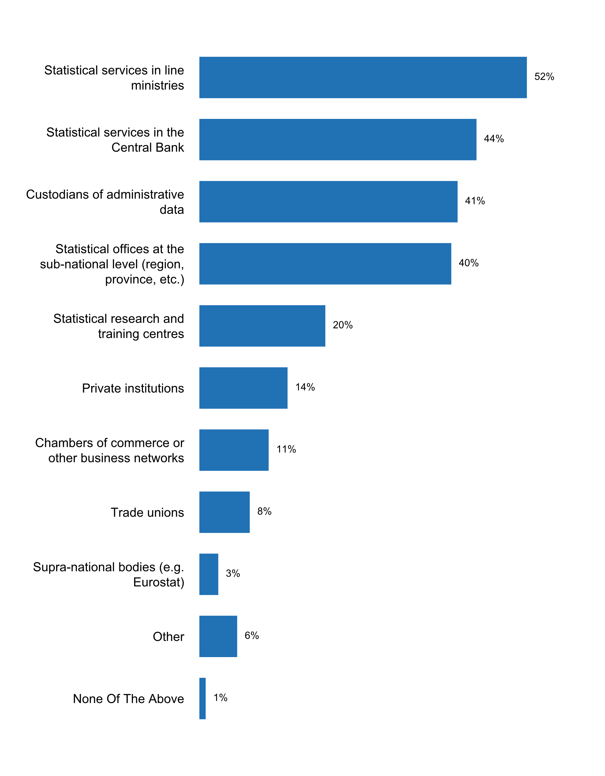

|  |  |  |  |  |  |  |
| --- | --- | --- | --- | --- | --- | --- |
| **Answer** | **Africa** | **Americas** | **Asia** | **Europe** | **Oceania** | **TOTAL** |
| Statistical services in line ministries | 13 | 4 | 13 | 16 | 2 | **48** |
| Statistical services in the Central Bank | 11 | 3 | 10 | 17 |  | **41** |
| Custodians of administrative data | 7 | 3 | 12 | 14 | 2 | **38** |
| Statistical offices at the sub-national level (region, province, etc.) | 8 | 4 | 13 | 11 | 1 | **37** |
| Statistical research and training centres | 7 | 3 | 7 | 1 | 1 | **19** |
| Private institutions | 6 | 1 | 5 | 1 |  | **13** |
| Chambers of commerce or other business networks | 3 | 1 | 5 | 1 |  | **10** |
| Trade unions | 3 |  | 4 |  |  | **7** |
| Supra-national bodies (e.g. Eurostat) | 1 |  | 1 | 1 |  | **3** |
| Other |  | 1 | 1 | 3 | 1 | **6** |
| None Of The Above |  |  |  | 1 |  | **1** |

|  |  |  |  |  |  |  |
| --- | --- | --- | --- | --- | --- | --- |
| **Answer** | **Africa** | **Americas** | **Asia** | **Europe** | **Oceania** | **TOTAL** |
| Statistical services in line ministries | 76 | 31 | 54 | 46 | 50 | **52** |
| Statistical services in the Central Bank | 65 | 23 | 42 | 49 |  | **44** |
| Custodians of administrative data | 41 | 23 | 50 | 40 | 50 | **41** |
| Statistical offices at the sub-national level (region, province, etc.) | 47 | 31 | 54 | 31 | 25 | **40** |
| Statistical research and training centres | 41 | 23 | 29 | 3 | 25 | **20** |
| Private institutions | 35 | 8 | 21 | 3 |  | **14** |
| Chambers of commerce or other business networks | 18 | 8 | 21 | 3 |  | **11** |
| Trade unions | 18 |  | 17 |  |  | **8** |
| Supra-national bodies (e.g. Eurostat) | 6 |  | 4 | 3 |  | **3** |
| Other |  | 8 | 4 | 9 | 25 | **6** |
| None Of The Above |  |  |  | 3 |  | **1** |

* Australian Institute for Health and Welfare (AIHW) which is a statutory body
* Other ELSS agencies (National Documentation Centre, Hellenic Telecommunications and Post Commission)
* Please, see: https://statistiques.public.lu/en/actors/statec/legalbasis/LawSTATEC.pdf. Statec's law covers the missions of the Committee on Public Statistics which is made up of representatives of administrations, ministries and observatories active in holding, producing and disseminating statistics.
* State institutions, which provide official statistics
* Statistical services under line ministries which are gazetted under the Statistics Act
* The informants

**Plot_53_Q07.3.svg**

**How the NSO has encouraged respondents to answer surveys during the past five years**

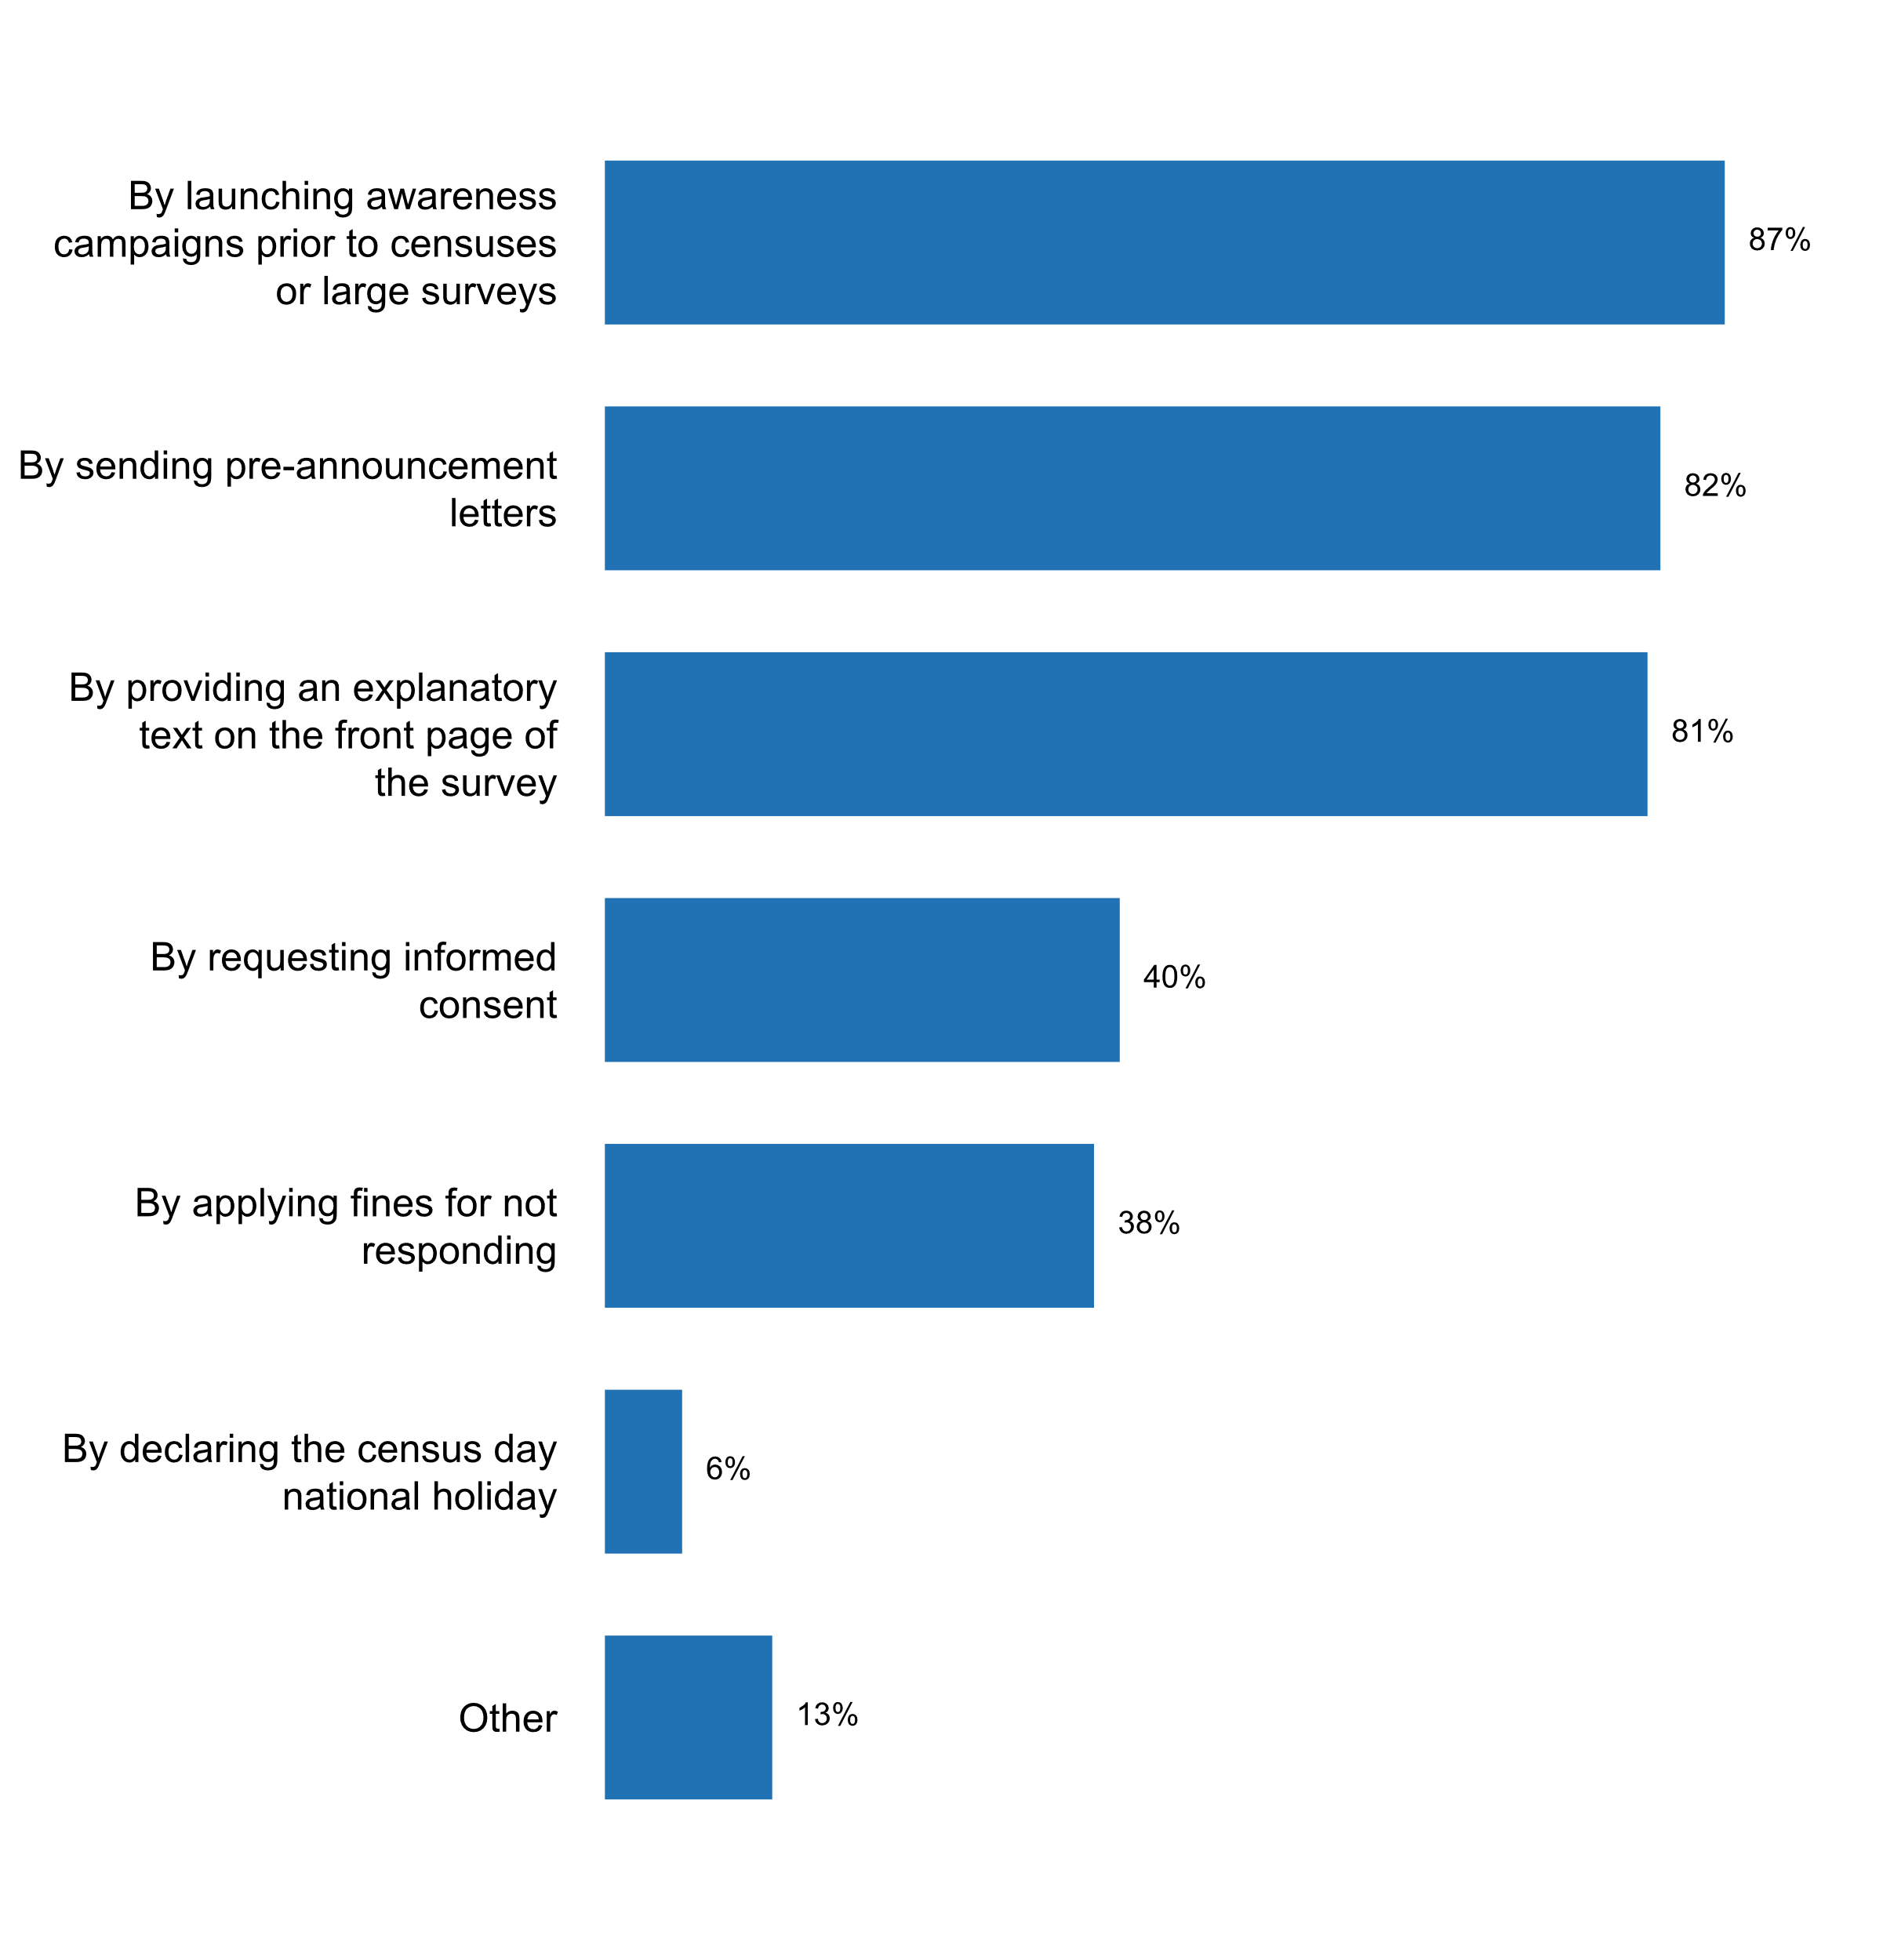

|  |  |  |  |  |  |  |
| --- | --- | --- | --- | --- | --- | --- |
| **Answer** | **Africa** | **Americas** | **Asia** | **Europe** | **Oceania** | **TOTAL** |
| By launching awareness campaigns prior to censuses or large surveys | 17 | 11 | 22 | 28 | 3 | **81** |
| By sending pre-announcement letters | 12 | 10 | 18 | 33 | 3 | **76** |
| By providing an explanatory text on the front page of the survey | 14 | 9 | 18 | 31 | 3 | **75** |
| By requesting informed consent | 6 | 6 | 7 | 16 | 2 | **37** |
| By applying fines for not responding | 5 | 1 | 7 | 20 | 2 | **35** |
| By declaring the census day national holiday | 2 | 1 | 3 |  |  | **6** |
| Other |  | 3 | 3 | 6 |  | **12** |

|  |  |  |  |  |  |  |
| --- | --- | --- | --- | --- | --- | --- |
| **Answer** | **Africa** | **Americas** | **Asia** | **Europe** | **Oceania** | **TOTAL** |
| By launching awareness campaigns prior to censuses or large surveys | 100 | 85 | 92 | 80 | 75 | **87** |
| By sending pre-announcement letters | 71 | 77 | 75 | 94 | 75 | **82** |
| By providing an explanatory text on the front page of the survey | 82 | 69 | 75 | 89 | 75 | **81** |
| By requesting informed consent | 35 | 46 | 29 | 46 | 50 | **40** |
| By applying fines for not responding | 29 | 8 | 29 | 57 | 50 | **38** |
| By declaring the census day national holiday | 12 | 8 | 13 |  |  | **6** |
| Other |  | 23 | 13 | 17 |  | **13** |

* By following up with non-responders
* By sending statistics back to the respondens where they can see where they are positioned in relation to the statistical result is done in a few cases
* HBS uses a reward practice for respondents providing detailed answers according the agenda.
* In some statistical surveys targeted at households incentives are given to the respondents
* Incentives (promotional items) to respondents
* Incentives for participation (entry into national raffles); training survey staff in how to encourage participation by reluctant respondents
* Mandatory to respond for surveys conducted under the Statistics Act
* National Statistics Day on 20 October
* The Census Bureau makes plant visits to talk to non-respondants for certain surveys, like M3.
* The respondent's calendar is posted on Belstat's official website, as well as a schedule of primary data collection in electronic form that contains information on the start date and the deadline for statistical reports collection for each statistical survey for each reporting period; The online report collection provides the possibility for respondent to view an individual list of required reporting forms.
* sending paper reminders, telephone reminders, visiting companies
* social media and announcement in public places

**Plot_54_Q07.4 .svg**

**Person/office within the government to whom the head of the NSO reports**

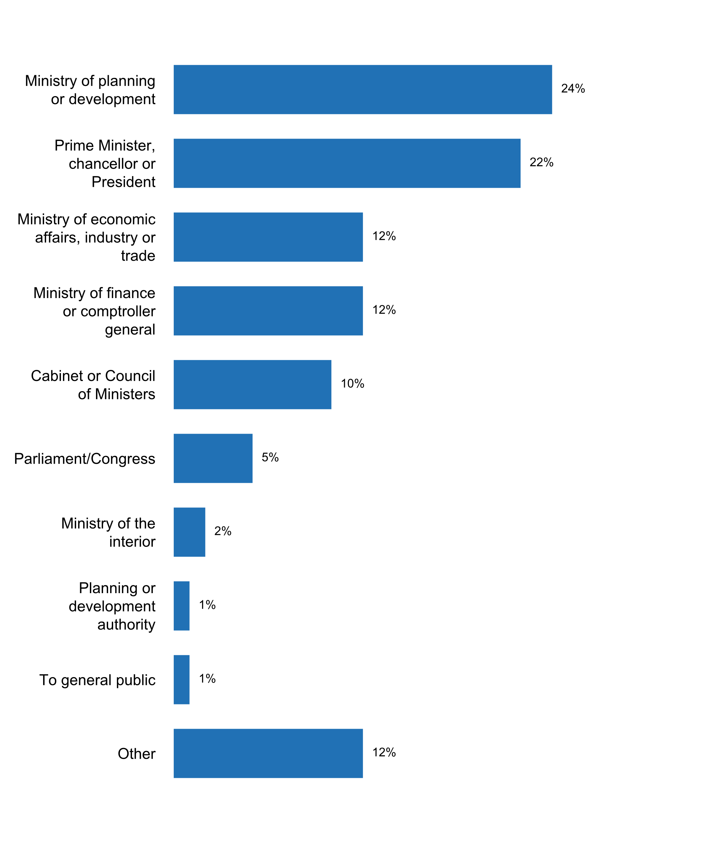

|  |  |  |  |  |  |  |
| --- | --- | --- | --- | --- | --- | --- |
| **Answer** | **Africa** | **Americas** | **Asia** | **Europe** | **Oceania** | **TOTAL** |
| Ministry of planning or development | 11 | 2 | 7 | 1 | 1 | **22** |
| Prime Minister, chancellor or President |  | 3 | 6 | 11 |  | **20** |
| Ministry of economic affairs, industry or trade |  | 2 | 3 | 6 |  | **11** |
| Ministry of finance or comptroller general | 4 | 1 | 1 | 5 |  | **11** |
| Cabinet or Council of Ministers | 2 |  | 3 | 3 | 1 | **9** |
| Parliament/Congress |  | 1 | 1 | 3 |  | **5** |
| Ministry of the interior |  |  |  | 2 |  | **2** |
| Planning or development authority |  |  | 1 |  |  | **1** |
| To general public |  |  | 1 |  |  | **1** |
| Other |  | 4 | 1 | 4 | 2 | **11** |

|  |  |  |  |  |  |  |
| --- | --- | --- | --- | --- | --- | --- |
| **Answer** | **Africa** | **Americas** | **Asia** | **Europe** | **Oceania** | **TOTAL** |
| Ministry of planning or development | 65 | 15 | 29 | 3 | 25 | **24** |
| Prime Minister, chancellor or President |  | 23 | 25 | 31 |  | **22** |
| Ministry of economic affairs, industry or trade |  | 15 | 13 | 17 |  | **12** |
| Ministry of finance or comptroller general | 24 | 8 | 4 | 14 |  | **12** |
| Cabinet or Council of Ministers | 12 |  | 13 | 9 | 25 | **10** |
| Parliament/Congress |  | 8 | 4 | 9 |  | **5** |
| Ministry of the interior |  |  |  | 6 |  | **2** |
| Planning or development authority |  |  | 4 |  |  | **1** |
| To general public |  |  | 4 |  |  | **1** |
| Other |  | 31 | 4 | 11 | 50 | **12** |

* Australian Treasury
* Consejo Directivo del INEC
* Generally to the Prime Minister (first answer) and to the Statistical Council as regards the annual program of statistical surveys of official statistics
* Head of the State Services
* Heads of US statistical agencies usually report to their Department.
* Minister of Prime Minister's Office
* Ministry of Economic Development
* Ministry of Finance and Economic Development
* Ministry of Treasury and Finance
* the Presidency of the Council of Ministers (artt.14 and 24 of statistical law)
* the head of the NSO reports to the Ministry of economy and finances

**Plot_55_Q07.5 .svg**

**A Freedom of Information or Access to Information law covers the NSS**

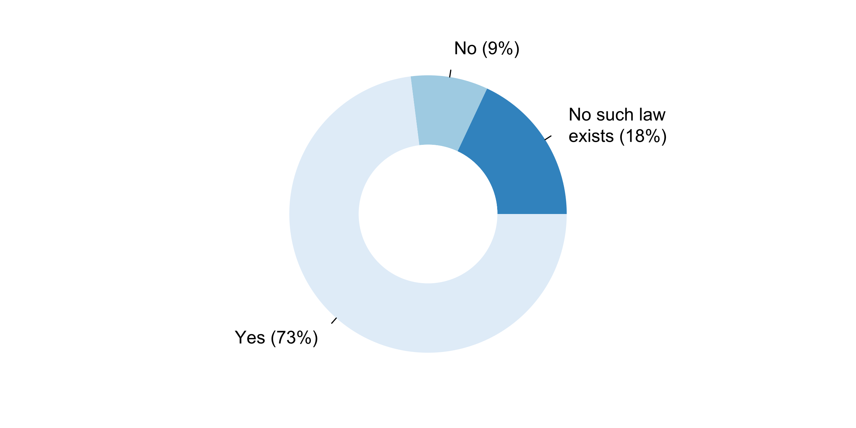

|  |  |  |  |  |  |  |
| --- | --- | --- | --- | --- | --- | --- |
| **Answer** | **Africa** | **Americas** | **Asia** | **Europe** | **Oceania** | **TOTAL** |
| No such law exists | 3 | 1 | 8 | 4 | 1 | **17** |
| No | 1 | 3 | 1 | 2 | 1 | **8** |
| Yes | 13 | 9 | 15 | 29 | 2 | **68** |

|  |  |  |  |  |  |  |
| --- | --- | --- | --- | --- | --- | --- |
| **Answer** | **Africa** | **Americas** | **Asia** | **Europe** | **Oceania** | **TOTAL** |
| No such law exists | 18 | 8 | 33 | 11 | 25 | **18** |
| No | 6 | 23 | 4 | 6 | 25 | **9** |
| Yes | 76 | 69 | 63 | 83 | 50 | **73** |

**Regulations affect the functioning of the NSOs published on the website**

|  |  |  |  |  |  |  |
| --- | --- | --- | --- | --- | --- | --- |
| **Answer** | **Africa** | **Americas** | **Asia** | **Europe** | **Oceania** | **TOTAL** |
| NSO does not have a website |  |  |  | 1 |  | **1** |
| No | 4 | 5 | 6 | 3 | 1 | **19** |
| Yes | 13 | 8 | 18 | 31 | 3 | **73** |

|  |  |  |  |  |  |  |
| --- | --- | --- | --- | --- | --- | --- |
| **Answer** | **Africa** | **Americas** | **Asia** | **Europe** | **Oceania** | **TOTAL** |
| NSO does not have a website |  |  |  | 3 |  | **1** |
| No | 24 | 38 | 25 | 9 | 25 | **20** |
| Yes | 76 | 62 | 75 | 89 | 75 | **78** |

**Additional comments on challenges to the implementation of Principle 7**

* comprehensive legislative provisions guiding the activity of NBS and NSS are in place, ensuring proper activity of both;- GLOS was used for the development of the national law on official statistics
* 7.6. The legal framework of the SEN is published, but not the legislation and administrative guidelines issued by the Government and which must be complied by the INEC.
* Additional info for 7.5 - Process of preparing statistics or carrying out research (official statistics) is exempted from Personal Data Protection Act 2010 (Law of Malaysia)
* Although we have a National Statistics Coordination Committee, it is not legislated and other data producers' statistical functions are not governed by the Statistics Law
* Cf. Lois et règlements du SSN (http://www.ansd.sn/index.php?option=com_docman&Itemid=259)
* Law of statistics sarees is due to 1972 and there is a new law discussed in the state Council has not acknowledges after
* Most legislation related US statistics is covered by Statistical Policy Directive #3.Relevant legislation are published on agency websites.Here is an example from the Census Bureau's Title 13, 26 and Confidentiality :https://www.census.gov/history/www/reference/privacy_confidentiality/privacy_and_confidentiality_2.html
* Need to Revise the law to be inclusive
* Nil
* None
* Norway is currently in process of revising the Statistics Act from 1989. It is foreseen that a new legal act will be implemented 1 to 2 years from now. The new legal act will most likely be more detailed when it comes to the national statistical system, the coordination role of the NSO and the establishment of a national statistical program.
* Please, see: https://statistiques.public.lu/en/actors/statec/legalbasis/index.html
* Stats NZ operates under the authority of the Statistics Act 1975. Our work is guided by the following legislation: Statistics Act 1975 â€“ our role, responsibilities, and authority. Privacy Act 1993 “ we protect your personal information. Official Information Act 1982 “ we make official information available while maintaining personal privacy. Public Records Act 2005 â€“ we keep full and accurate records, and provide access to records of long-term value. Stats NZ is currently working with the government to review our legislation as it is outdated and not fit for purpose in a modern data environment.
* THE LAXW STATISTICAL IS NOT KNOWN BY ANYONE
* The Information Bill is to be tabled before parliament by the relevant Ministry.
* The big challenge is the approval of revised legal framework.
* The current statistical law dates from 1976, so its updating is essential for the proper functioning of the INEC and other entities that produce statistical information, on issues of functions of the INEC, the NSS and the National Council of Statistics and Census, as well as the fact of being an independent entity with technical, professional and financial autonomy.
* The new Law on Official Statistics has entered into force on 9 April 2018 and it is fully based on GSL, and posted on the website at https://www.armstat.am/file/doc/99509428.pdf.
* The norms of the Law on State Statistics of the Republic of Belarus complies with the norms of the Generic Law on Official Statistics developed by the United Nations Economic Commission for Europe.
* There is still very little knowledge and understanding by National leaders on the roles and functions of NSO therefore resources allocate seem to be less despite the many data collection activities we perform every year.
* To review existing law to meet current needs
* We do not have further comments about this principle.
* http://www.inege.gq/wp-content/uploads/2018/11/Reglamento-Organico-y-Funcional-del-INEGE.pdf
* none
* the new law define official statistics and chef statistician

**Plot_56_Q08.1.svg**

**Agencies other than the NSO which produce official statistics on behalf of the government**

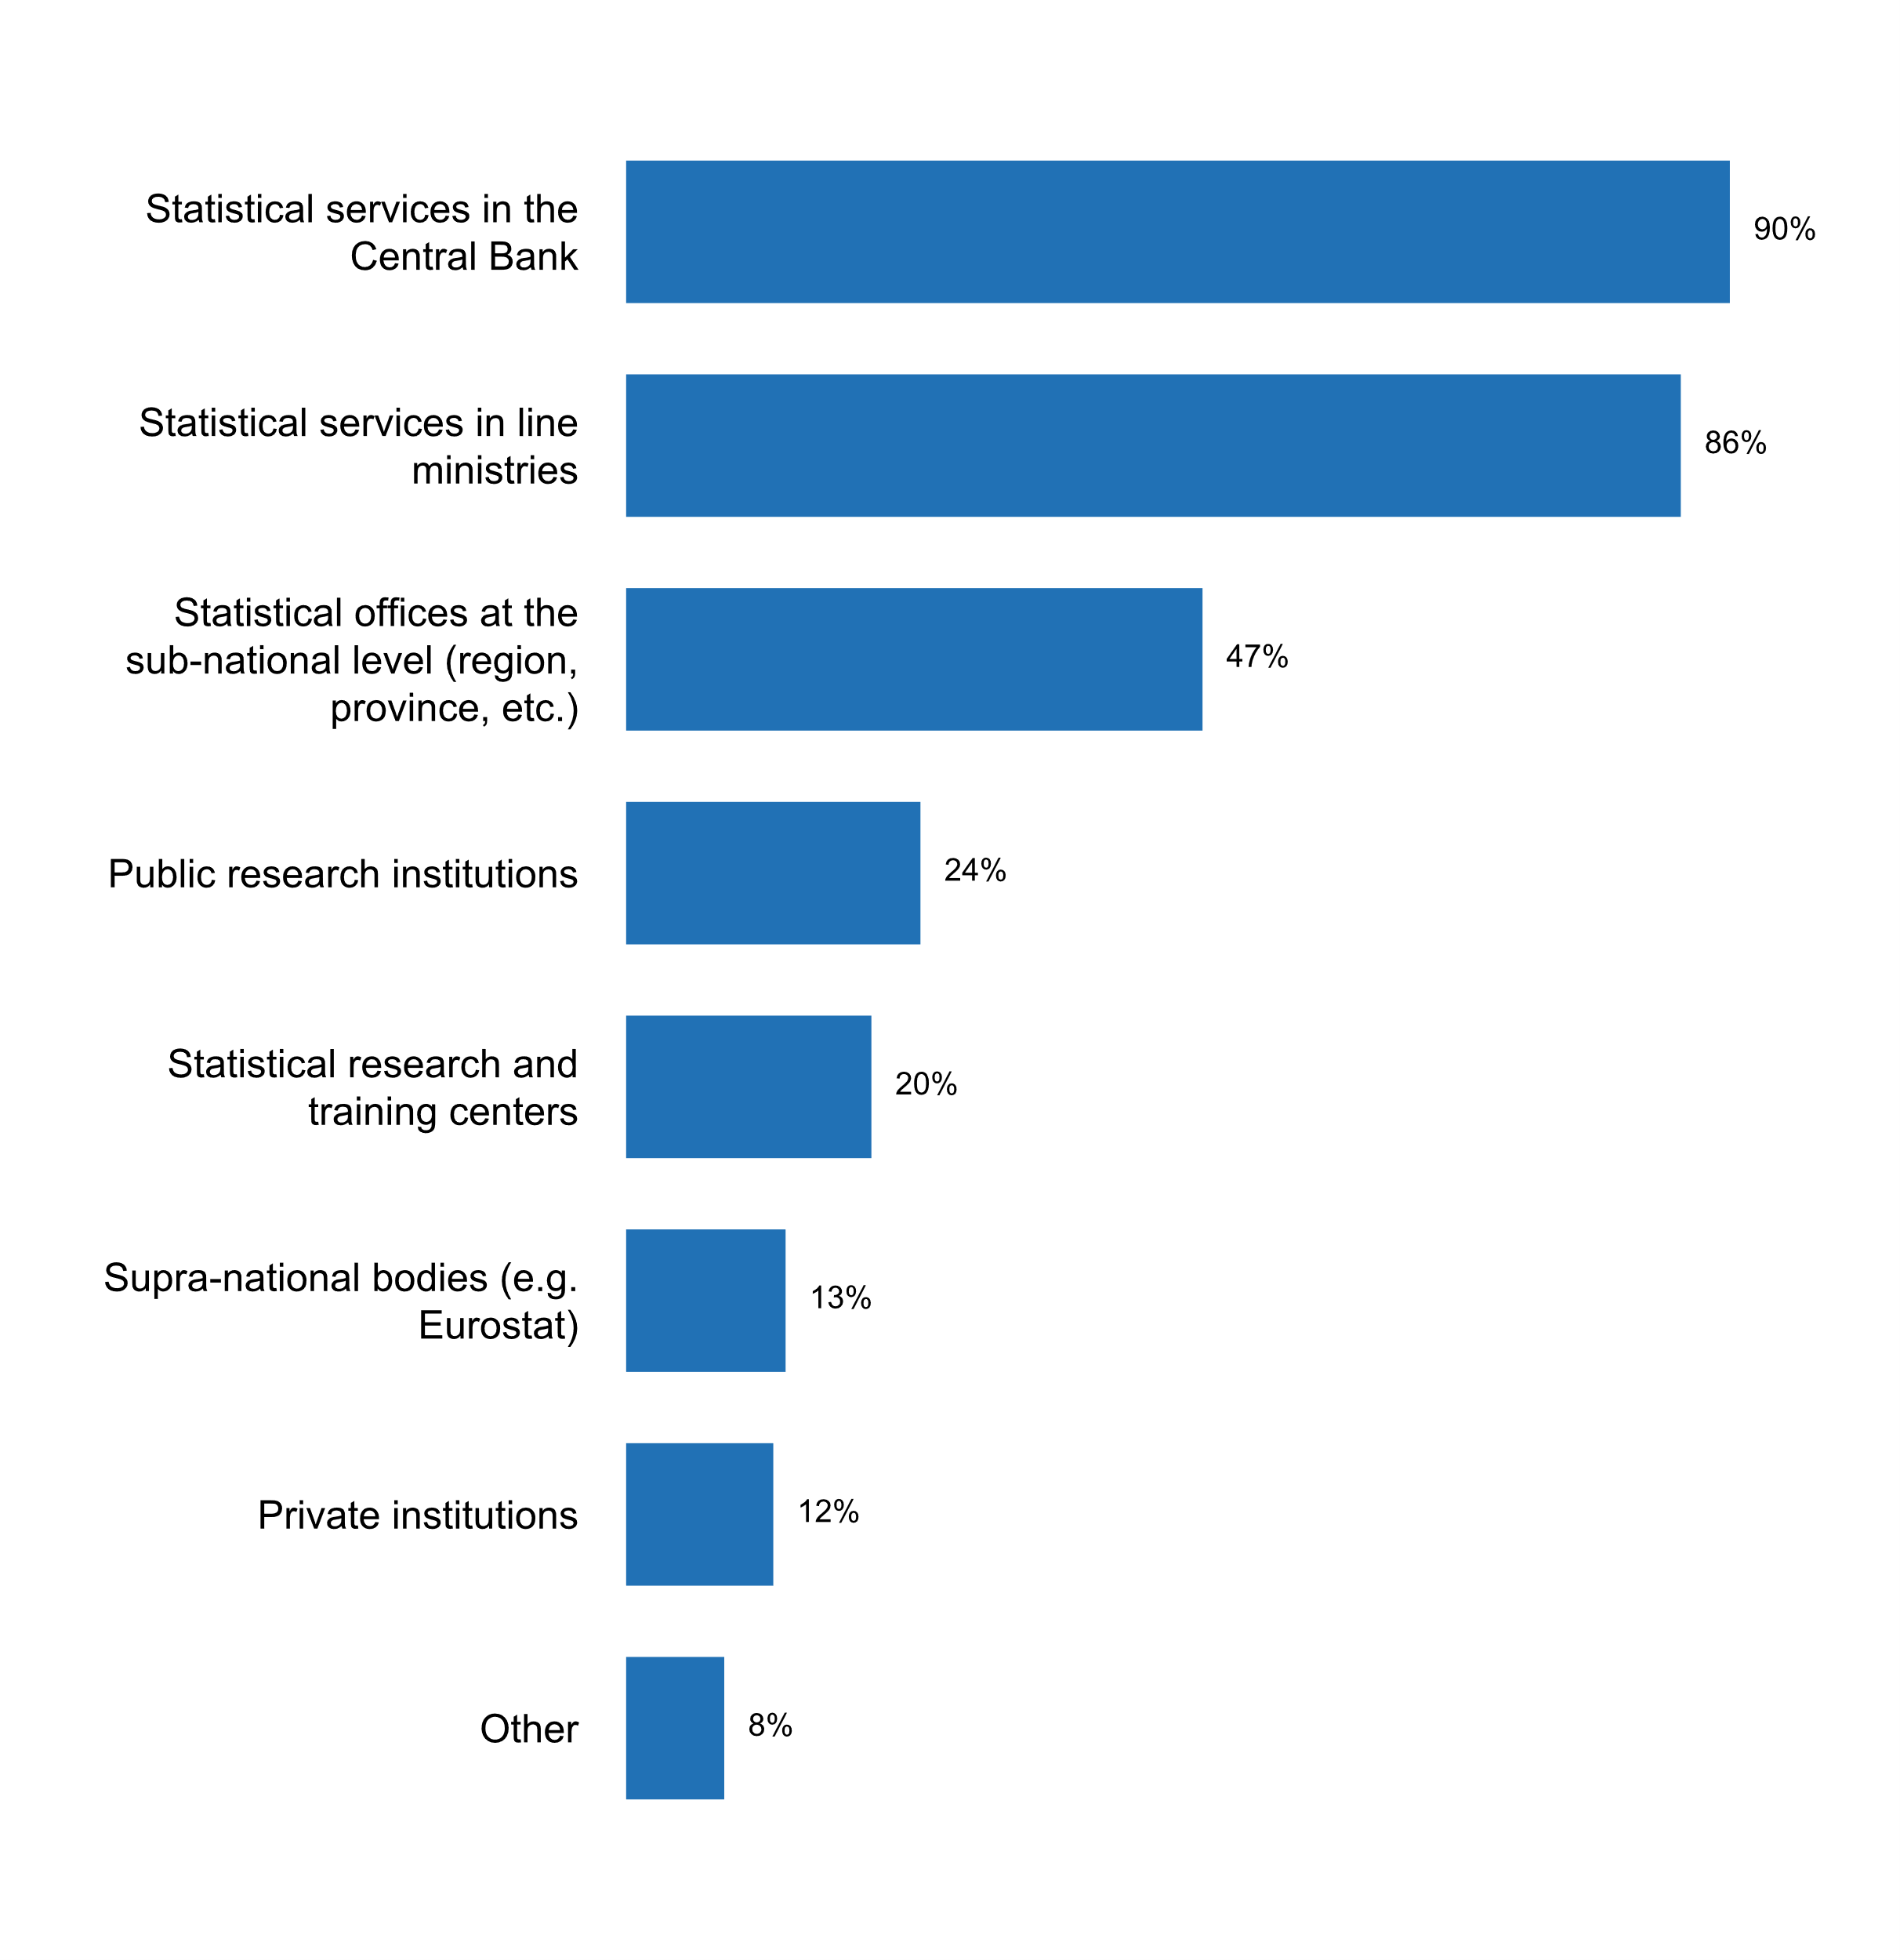

|  |  |  |  |  |  |  |
| --- | --- | --- | --- | --- | --- | --- |
| **Answer** | **Africa** | **Americas** | **Asia** | **Europe** | **Oceania** | **TOTAL** |
| Statistical services in the Central Bank | 17 | 12 | 23 | 29 | 3 | **84** |
| Statistical services in line ministries | 14 | 12 | 24 | 26 | 4 | **80** |
| Statistical offices at the sub-national level (region, province, etc.) | 9 | 4 | 14 | 15 | 2 | **44** |
| Public research institutions | 6 | 4 | 4 | 7 | 1 | **22** |
| Statistical research and training centers | 5 | 4 | 8 | 1 | 1 | **19** |
| Supra-national bodies (e.g. Eurostat) | 2 | 2 | 1 | 7 |  | **12** |
| Private institutions | 3 | 4 | 3 | 1 |  | **11** |
| Other | 1 | 1 |  | 5 |  | **7** |

|  |  |  |  |  |  |  |
| --- | --- | --- | --- | --- | --- | --- |
| **Answer** | **Africa** | **Americas** | **Asia** | **Europe** | **Oceania** | **TOTAL** |
| Statistical services in the Central Bank | 100 | 92 | 96 | 83 | 75 | **90** |
| Statistical services in line ministries | 82 | 92 | 100 | 74 | 100 | **86** |
| Statistical offices at the sub-national level (region, province, etc.) | 53 | 31 | 58 | 43 | 50 | **47** |
| Public research institutions | 35 | 31 | 17 | 20 | 25 | **24** |
| Statistical research and training centers | 29 | 31 | 33 | 3 | 25 | **20** |
| Supra-national bodies (e.g. Eurostat) | 12 | 15 | 4 | 20 |  | **13** |
| Private institutions | 18 | 31 | 13 | 3 |  | **12** |
| Other | 6 | 8 |  | 14 |  | **8** |

* List of institutions managing official statistics in Lithuania can be found at https://www.stat.gov.lt/en/oficialiaja-statistika-tvarkancios-institucijos
* NSO Delegate Bodies
* ONA:s
* State institutions, which provide official statistics
* Statistical units in public agencies, eg. the immigration authority, Directorate of Fisheries, Public Health Institute etc.
* The term official statistics is new in Denmark. In our new statistical law it is possible for other institutions than the NSO upon request, to produce official statistics. So far no institutions outside the NSO produce official statistics in Denmark
* statutory/regulatory authorities and government corporations

**Plot_57_Q08.2.svg**

**Activities currently being implemented for coordinating the NSS**

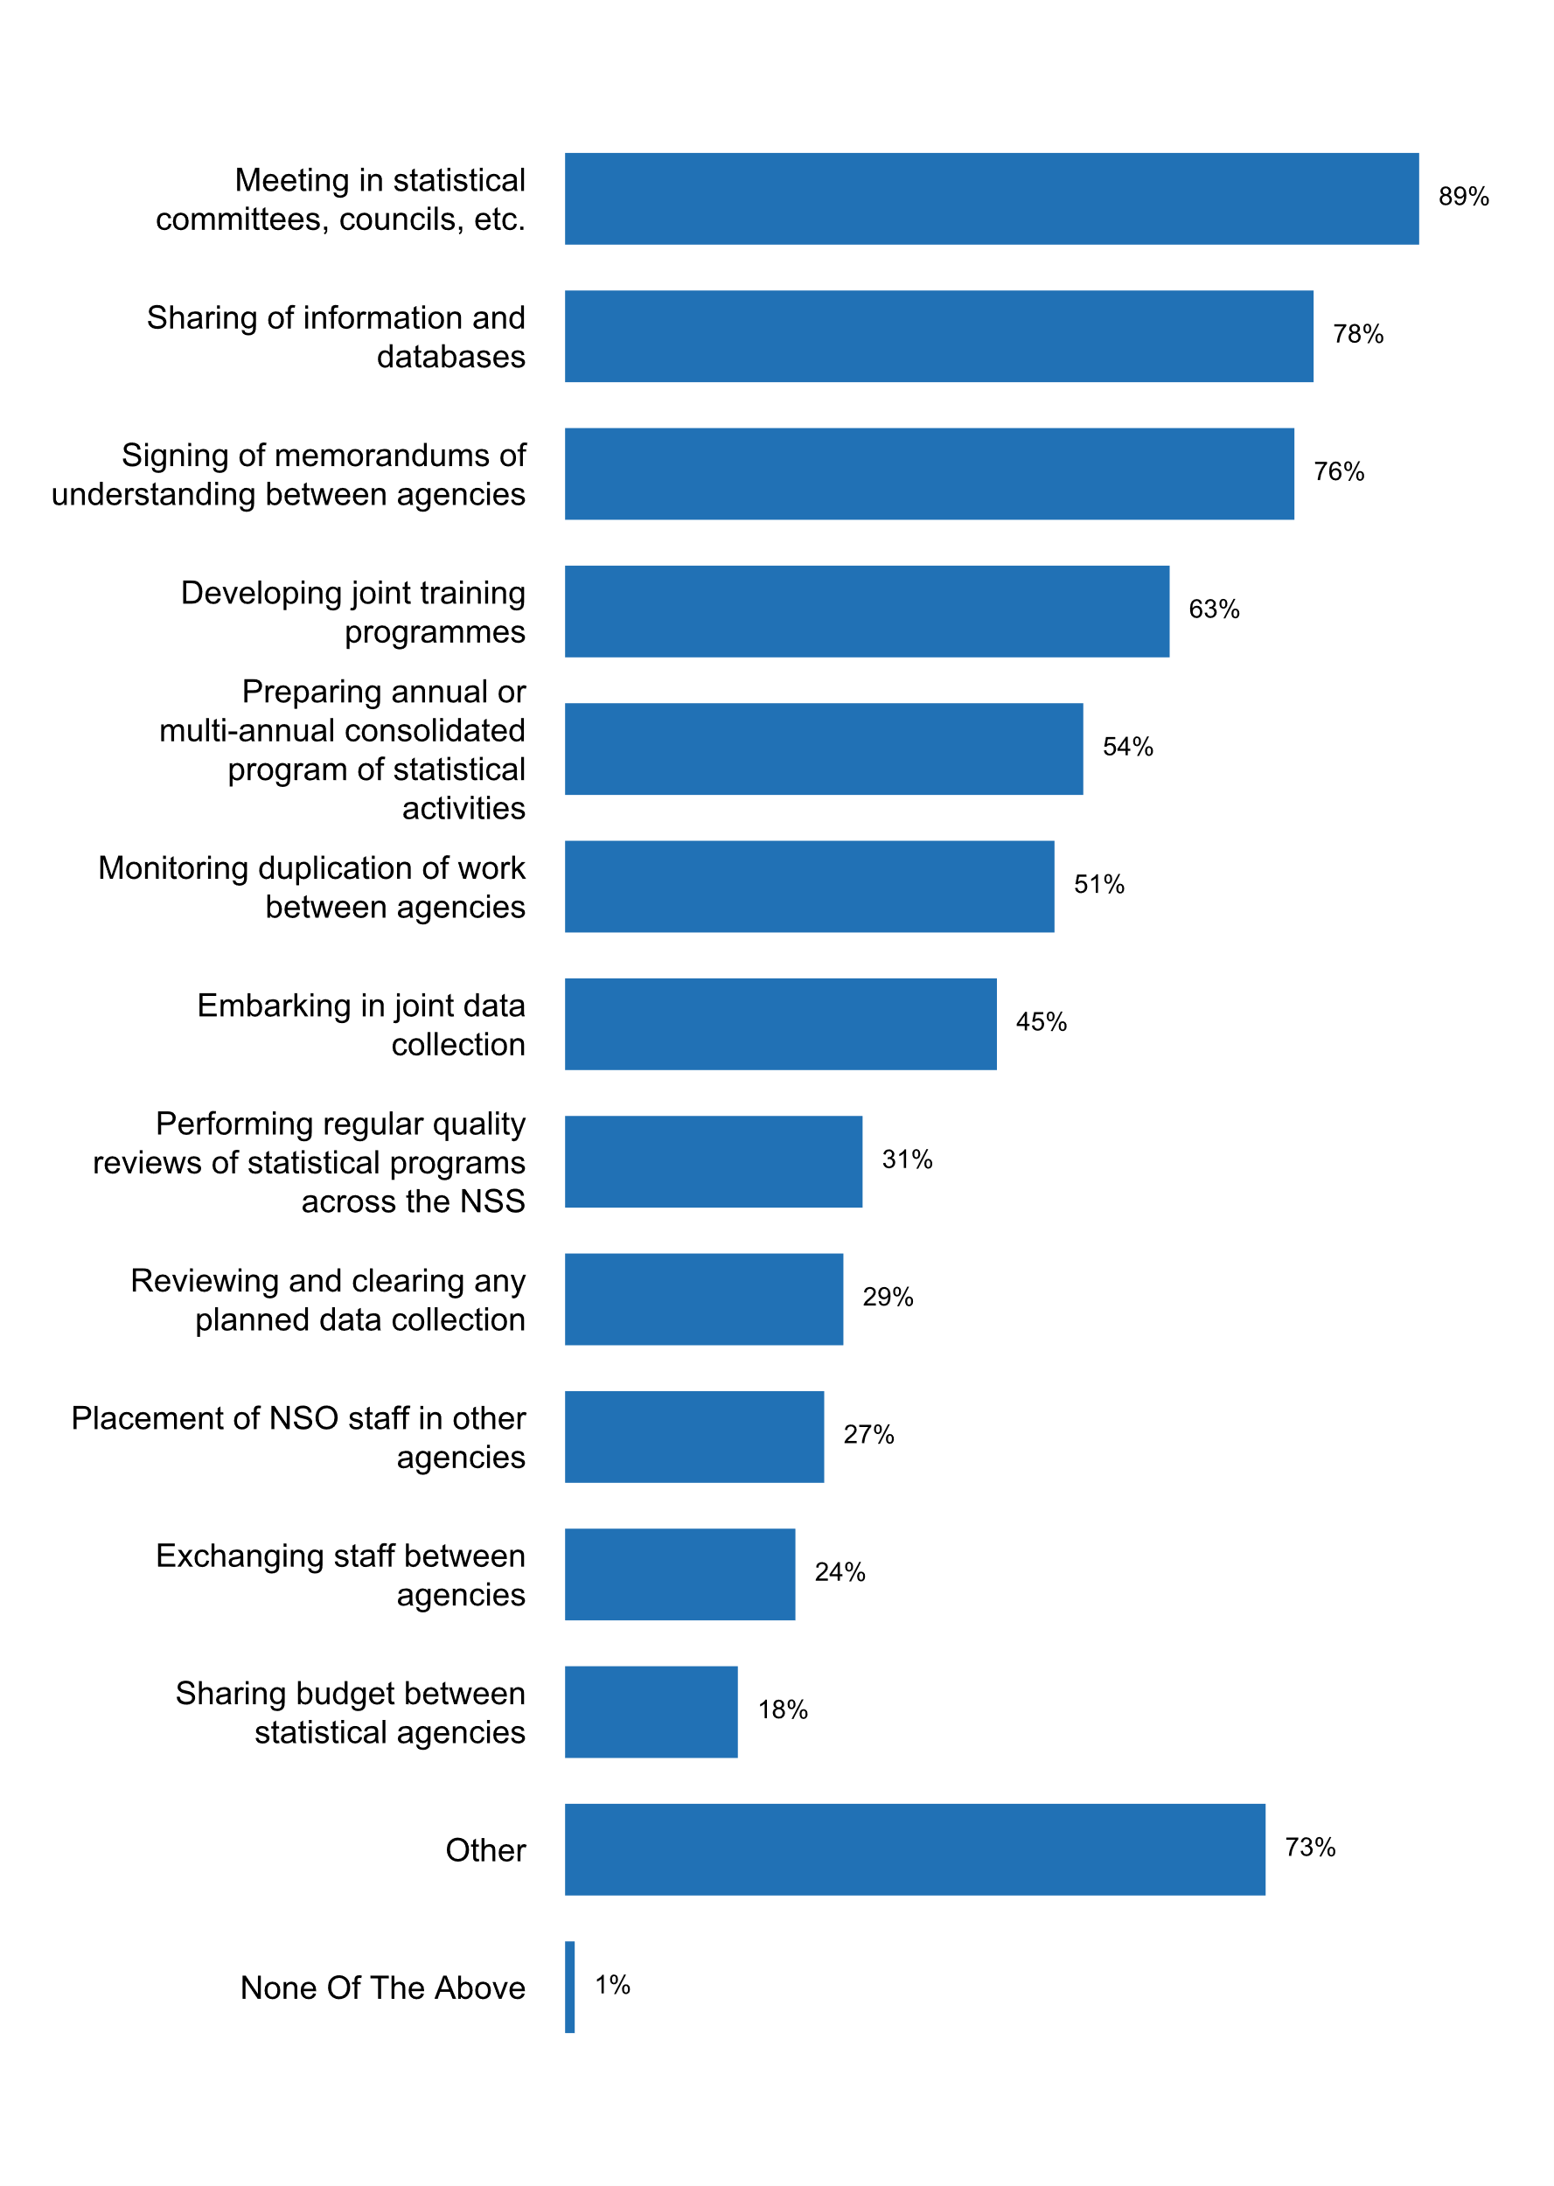

|  |  |  |  |  |  |  |
| --- | --- | --- | --- | --- | --- | --- |
| **Answer** | **Africa** | **Americas** | **Asia** | **Europe** | **Oceania** | **TOTAL** |
| Meeting in statistical committees, councils, etc. | 15 | 12 | 22 | 32 | 2 | **83** |
| Sharing of information and databases | 13 | 11 | 22 | 24 | 3 | **73** |
| Signing of memorandums of understanding between agencies | 13 | 11 | 19 | 24 | 4 | **71** |
| Developing joint training programmes | 11 | 7 | 21 | 17 | 3 | **59** |
| Preparing annual or multi-annual consolidated program of statistical activities | 9 | 6 | 12 | 23 |  | **50** |
| Monitoring duplication of work between agencies | 9 | 5 | 13 | 19 | 1 | **47** |
| Embarking in joint data collection | 9 | 5 | 10 | 16 | 2 | **42** |
| Performing regular quality reviews of statistical programs across the NSS | 4 | 4 | 7 | 12 | 2 | **29** |
| Reviewing and clearing any planned data collection | 5 | 2 | 9 | 11 |  | **27** |
| Placement of NSO staff in other agencies | 9 | 4 | 7 | 3 | 2 | **25** |
| Exchanging staff between agencies | 7 | 2 | 7 | 4 | 2 | **22** |
| Sharing budget between statistical agencies | 5 | 3 | 4 | 2 | 3 | **17** |
| Other | 12 | 10 | 18 | 25 | 3 | **68** |
| None Of The Above |  |  |  | 1 |  | **1** |

|  |  |  |  |  |  |  |
| --- | --- | --- | --- | --- | --- | --- |
| **Answer** | **Africa** | **Americas** | **Asia** | **Europe** | **Oceania** | **TOTAL** |
| Meeting in statistical committees, councils, etc. | 88 | 92 | 92 | 91 | 50 | **89** |
| Sharing of information and databases | 76 | 85 | 92 | 69 | 75 | **78** |
| Signing of memorandums of understanding between agencies | 76 | 85 | 79 | 69 | 100 | **76** |
| Developing joint training programmes | 65 | 54 | 88 | 49 | 75 | **63** |
| Preparing annual or multi-annual consolidated program of statistical activities | 53 | 46 | 50 | 66 |  | **54** |
| Monitoring duplication of work between agencies | 53 | 38 | 54 | 54 | 25 | **51** |
| Embarking in joint data collection | 53 | 38 | 42 | 46 | 50 | **45** |
| Performing regular quality reviews of statistical programs across the NSS | 24 | 31 | 29 | 34 | 50 | **31** |
| Reviewing and clearing any planned data collection | 29 | 15 | 38 | 31 |  | **29** |
| Placement of NSO staff in other agencies | 53 | 31 | 29 | 9 | 50 | **27** |
| Exchanging staff between agencies | 41 | 15 | 29 | 11 | 50 | **24** |
| Sharing budget between statistical agencies | 29 | 23 | 17 | 6 | 75 | **18** |
| Other | 71 | 77 | 75 | 71 | 75 | **73** |
| None Of The Above |  |  |  | 3 |  | **1** |

* A selection of other national statistical authorities are also monitored by the European Statistical System's Peer Reviews
* Agreement with the National Central Bank
* Bilateral meetings with line ministries
* Cooperation at professional/working level
* Development of a website for the statistical system
* Meeting with the responsible of the research institutions to share knowledge and experience
* Monitoring by ELSTAT of the compliance of ELSS agencies with the European Statistics Code of Practice, in the framework of the obligation of ELSTAT provided for in the Greek Statistical Law to certify as
* Providing technical assistance and statistical advice on use of data
* Share resources between entities to execute statistical operations
* Sharing of information and also attachment of staff of other institutions to the NSO
* Signing of contracts on cooperation and data exchange for official statistics purposes.
* The statistical offices of the federation and the lender are preparing consolidated programs of statistical activities, including regular quality reviews, but this is not the case for the entire NSS so far.
* This is done for European statistics - official statistics is

**Plot_58_Q08.3.svg**

**Frequency of meetings between producers of official statistics during the past five years**

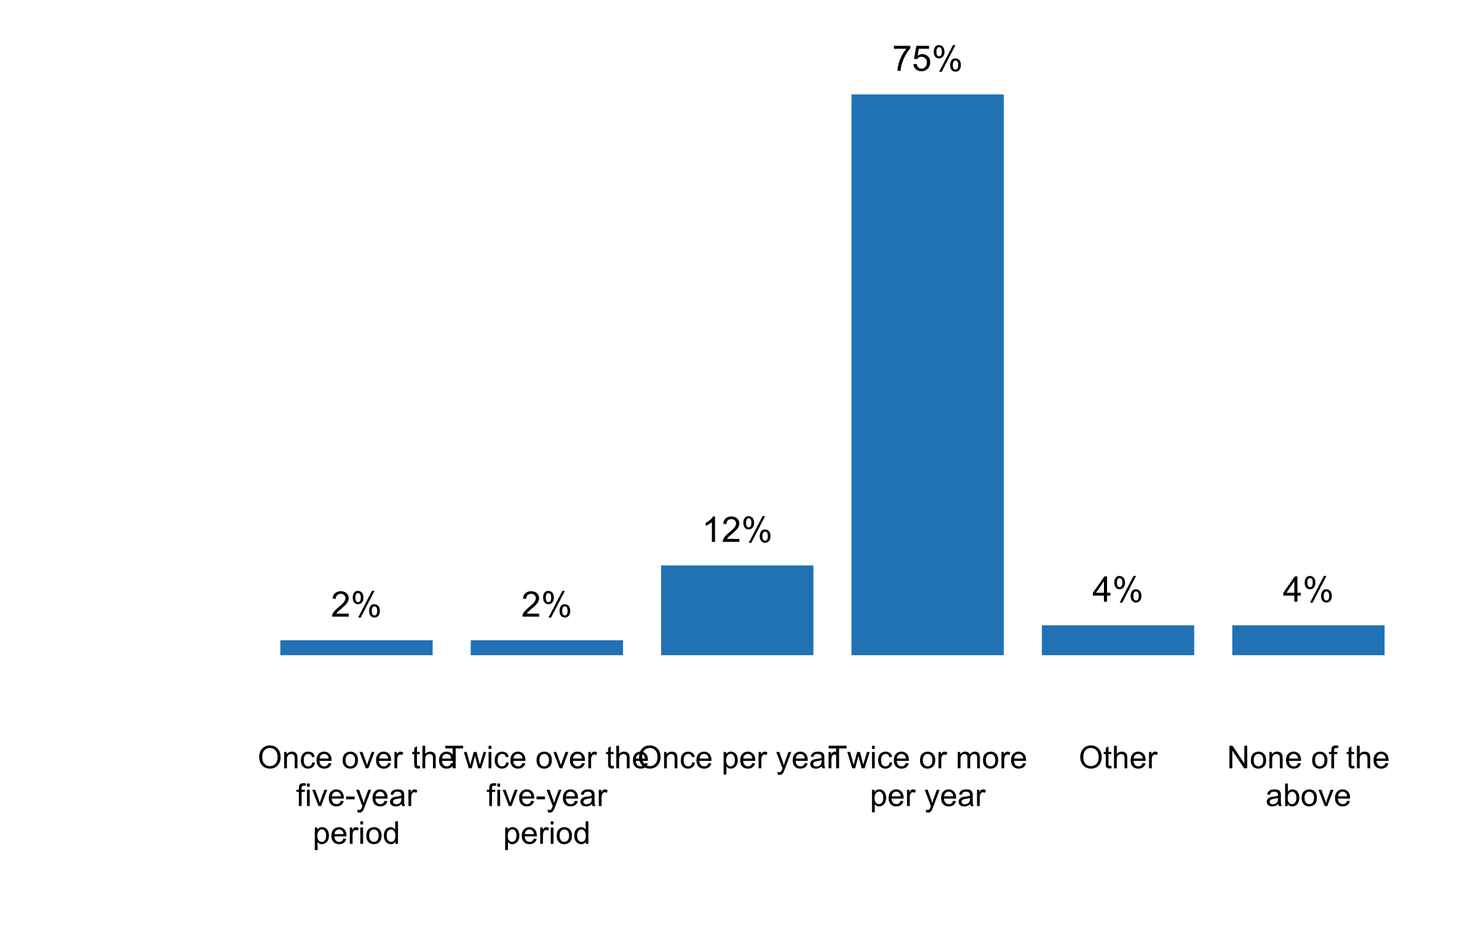

|  |  |  |  |  |  |  |
| --- | --- | --- | --- | --- | --- | --- |
| **Answer** | **Africa** | **Americas** | **Asia** | **Europe** | **Oceania** | **TOTAL** |
| Once over the five-year period | 2 |  |  |  |  | **2** |
| Twice over the five-year period |  | 1 | 1 |  |  | **2** |
| Once per year | 2 | 1 | 3 | 5 |  | **11** |
| Twice or more per year | 13 | 9 | 19 | 25 | 4 | **70** |
| Other |  | 2 |  | 2 |  | **4** |
| None of the above |  |  | 1 | 3 |  | **4** |

|  |  |  |  |  |  |  |
| --- | --- | --- | --- | --- | --- | --- |
| **Answer** | **Africa** | **Americas** | **Asia** | **Europe** | **Oceania** | **TOTAL** |
| Once over the five-year period | 12 |  |  |  |  | **2** |
| Twice over the five-year period |  | 8 | 4 |  |  | **2** |
| Once per year | 12 | 8 | 13 | 14 |  | **12** |
| Twice or more per year | 76 | 69 | 79 | 71 | 100 | **75** |
| Other |  | 15 |  | 6 |  | **4** |
| None of the above |  |  | 4 | 9 |  | **4** |

* At least once a month, the heads of the primary 13 US statistical agencies meet with the US Chief Statistician.
* Central bank once a year, others less frequently
* For EU statistics; once a year
* Over the past two years, approximately twice per year as part of IDB funded project for organizing and strengthening the NSS

**Plot_59_Q08.4.svg**

**How is dissemination coordinated across the NSS**

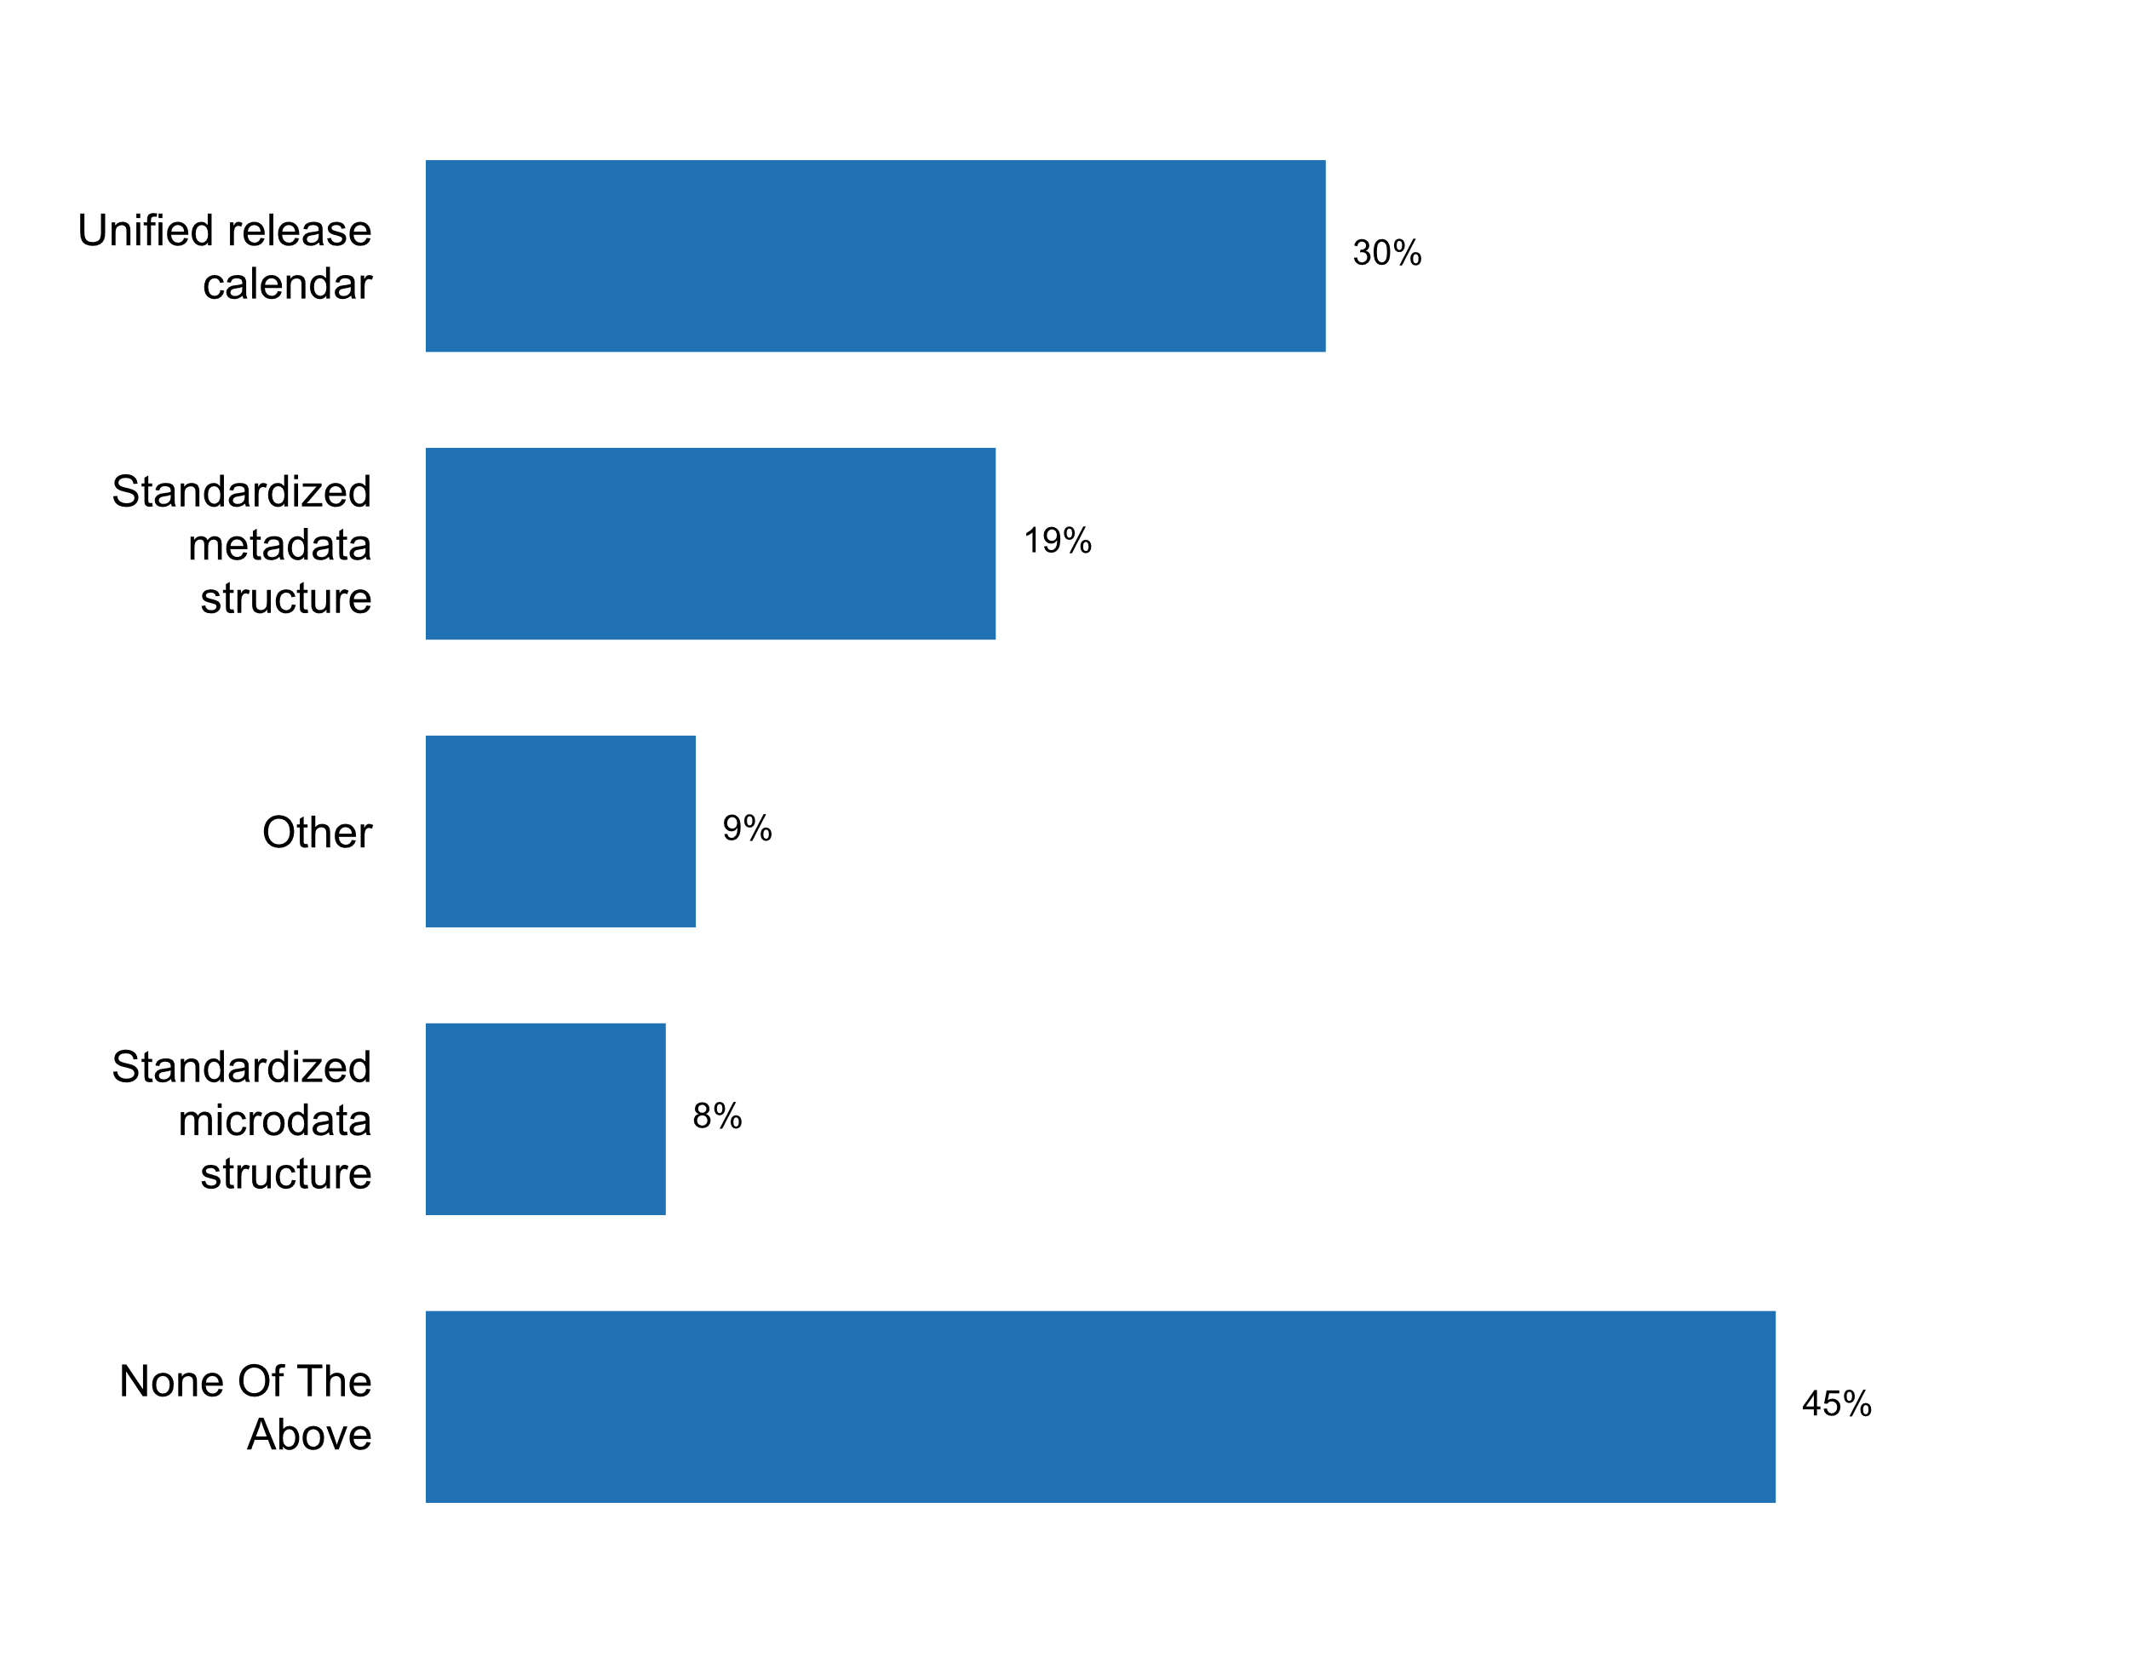

|  |  |  |  |  |  |  |
| --- | --- | --- | --- | --- | --- | --- |
| **Answer** | **Africa** | **Americas** | **Asia** | **Europe** | **Oceania** | **TOTAL** |
| Unified release calendar | 7 | 2 | 9 | 10 |  | **28** |
| Standardized metadata structure | 3 | 2 | 6 | 7 |  | **18** |
| Other |  | 1 | 4 | 2 | 1 | **8** |
| Standardized microdata structure | 1 | 2 | 1 | 3 |  | **7** |
| None Of The Above | 8 | 8 | 6 | 17 | 3 | **42** |

|  |  |  |  |  |  |  |
| --- | --- | --- | --- | --- | --- | --- |
| **Answer** | **Africa** | **Americas** | **Asia** | **Europe** | **Oceania** | **TOTAL** |
| Unified release calendar | 41 | 15 | 38 | 29 |  | **30** |
| Standardized metadata structure | 18 | 15 | 25 | 20 |  | **19** |
| Other |  | 8 | 17 | 6 | 25 | **9** |
| Standardized microdata structure | 6 | 15 | 4 | 9 |  | **8** |
| None Of The Above | 47 | 62 | 25 | 49 | 75 | **45** |

* ARC under DOSM
* Data dissemination is dictated by the producing agencies.
* Dissemination calendar is at NSO level only.
* Key statistics are released in Yearbook of Statistics and Economic Survey of Singapore
* Research Data Centres of official statistics, coordinated between the Federal Statistical Office and the Research Data Centre of the Statistical Offices of the Federal States.
* There is no coordinated dissemination portal
* coordination is implemented indirectly through the principles of the Code of Practice;
* meeting, training

**Plot_60_Q08.5.svg**

**Existence of a central data portal where different members of the NSS publish official statistical data**

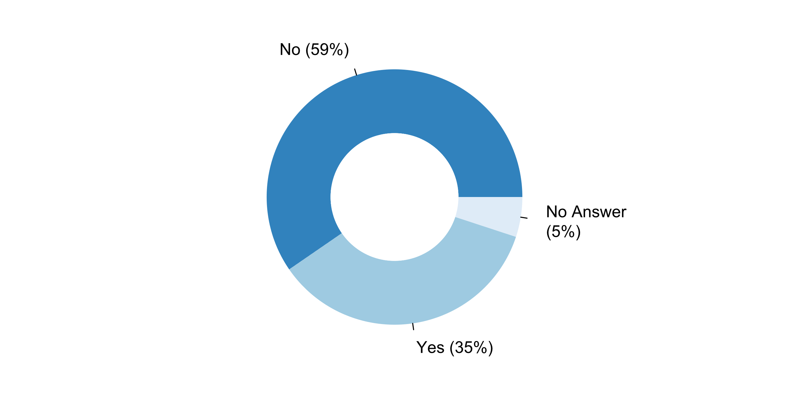

|  |  |  |  |  |  |  |
| --- | --- | --- | --- | --- | --- | --- |
| **Answer** | **Africa** | **Americas** | **Asia** | **Europe** | **Oceania** | **TOTAL** |
| No | 10 | 9 | 11 | 22 | 3 | **55** |
| Yes | 7 | 4 | 9 | 12 | 1 | **33** |

|  |  |  |  |  |  |  |
| --- | --- | --- | --- | --- | --- | --- |
| **Answer** | **Africa** | **Americas** | **Asia** | **Europe** | **Oceania** | **TOTAL** |
| No | 59 | 69 | 46 | 63 | 75 | **59** |
| Yes | 41 | 31 | 38 | 34 | 25 | **35** |

***Details of data portal where different members of the NSS publish official statistical data***

* A range of public sector data produced by Australian Government departments is also available on data.gov.au. Data.gov.au is a product of the Australian Government's Declaration of Open Government and enables access to data published by Australian Government departments and public institutions. Most of the data available is free of charge and can be visualised using the in-built mapping tools. Individuals and organisations are encouraged to use the data on this site for research, study or applications that add value to the global community. In addition to open datasets, data.gov.au includes information about unpublished public sector data and data available for purchase.
* All data is published on the data.gov.ie portal
* At the beginning of 2013, Statistics Lithuania introduced the society with the Official Statistics Portal. The purpose of the Official Statistics Portal is to afford an opportunity for users to easily find all official statistical information prepared by the country's producers of official statistics in one place and to use it handily, expand the possibilities of indicator analysis and representation. Statistics Lithuania administers the Official Statistics Portal, where users can find statistical information in various forms, order statistical information, publications. Link to the Portal: https://osp.stat.gov.lt/pradinis
* At the statistical portal (https://statistiques.public.lu/) the different members of the NSS publish their data and statistical studies.
* Central data portal mentioned in point 8.5 concerns the services of official statistics which are Statistics Poland President, as well as directors of statistical offices and units supervised by the Statistics Poland President. Moreover, open data website is provided by Ministry of Digital Affairs.
* Compendium of Statistics published by the NSO
* Data published through the Zimbabwe statistics database
* IMF OPENDATA PLATFORM
* Is currently under development and will be presented on 16 November 2018
* NSO collects the data from the producers of official statistics and posts them on the portal
* NSO provides databases for censuses and surveys conducted by CAPMAS via its' website by annual subscriptions.
* Official Statistics Portal http://www.officialstatistics.gov.tr/?q=en
* Open data
* Open data portal: https://data.gov.ua/
* Please refer to the SingStat Website (www.singstat.gov.sg) and SingStat Table Builder (www.singstat.gov.sg/tablebuilder)
* The National Public Statistics Hub, which is still in its pilot phase, is a system for sharing, integrating and disseminating harmonized data and metadata produced by actors of the National Statistical Sistem (SISTAN) and within the Sistem, using the international standard SDMX (ISO 17369:2013). See: http://www.sistan.it/index.php?id=580
* The central release calendar and corresponding portals in Wales, Scotland and Northern Ireland include links through to all official statistical data. Individual departments also provide their own data portals for subject-specific outputs, and the NSO has a dedicated web platform with API support for statistical data dissemination, but this does not cover all outputs produced across UK ogvernment.UK government has a central data portal data.gov.uk, which contains open data statistical outputs. Once again, this is not an exhaustive set.
* The home of the US Government's open data is: DATA.gov. However, data releases are available at the data producing agency's site.
* The portal of NSO is ready to publish statistical products from other national producers of official statistics.
* There is Open Data Portal Slovenia (OPSI) available via https://podatki.gov.si/. At the moment, most of the data are published by SURS, partly also by other members of NSS. The goal is to publish all statistics from all NSS members and also from other state bodies in Slovenia on this portal in the future.
* There is a National Information System (SNI) administered by the body responsible for national planning in which all entities report the information they produce.
* Transportation Data Hub; SDG Data Hub; Government of Canada Open Data portal; Environment Canada Federal Sustainable Development Site; Public Health Agency website; Natural Resources Canada website; Employment and Social Development Canada website.
* data.gov.my (Malaysia Open Data platform)
* government open data portal data.gov.hr
* https://data.gov.ph/
* https://www.data.gouv.frThe portal is not limited to NSS members.
* https://www.statistikportal.de/
* we provide login credential to manage their data in the portal
* www.data.gov.bn
* [www.statsenegal.comhttp://anads.ansd.sn/index.php/cataloghttp://nso.senegal.opendataforafrica.org/rarkwmf/national-summary-data-page-nsdphttp://sigstat.ansd.sn/http://senegal.opendataforafrica.org/](http://www.statsenegal.comhttp://anads.ansd.sn/index.php/cataloghttp://nso.senegal.opendataforafrica.org/rarkwmf/national-summary-data-page-nsdphttp://sigstat.ansd.sn/http://senegal.opendataforafrica.org/)

***Reasons/challenges explaining lack of data portal where different members of the NSS publish official statistical data***

* - lack of financial, human and technical resources delayed the establishment of a unified data portal for official statistics;- unified data portal required integrated multi-annual and annual statistical works programs and integrated release calendars. It
* A single official statistics portal has not been created. At the same time, Belstat's official website provides links to official statistical information published on the websites of authorized producers of official statistics.
* An NSS portal is presently being developed for the NSO, which will serve as both a repository of statistics from various NSS agencies as well as a dissemination tool for NSS indicators. This should be ready for piloting in the first quarter of 2019.
* Colombia currently is working on this development. At this moment, there is a website in which the NSS could find different information about the coordination instrument: https://www.sen.gov.co/
* Due to legal challenges, logistic challenges, and lack of adequate infrastructure.
* Each member of the NSS has its own web site.
* Faiblesse des ressources financières.
* It is currently under development.
* Lack of IT resources
* Main challenges are the lack of coordination and scarce resources.
* Ministries have their own data portals for disseminating the statistics
* NSDS needs to be implemented first.
* NSS has not been formalized. However three agencies provide macro-economic data and they adhere to the IMF's e-GDDS and therefore publish through a National Summary Data Page
* Not yet implemented due to financial and technical constraint.
* On the website of HCSO there is a subpage with direct links to the statistical products of the members of the Official Statistical Service. This page is accessible here (the majority of the content only in Hungarian): http://www.ksh.hu/hssz The implementation of a central data portal is the biggest challenge.
* Planned activity but not yet realized
* Resource constraints
* Statistical Centre of Iran has plans to develop a comprehensive integrated system called IRANSTARS to collect administrative data from different government agencies.
* The NSO is working in the development of a data portal for his statistical information. Maybe when we have one, we will request the other members of the NSS to publish their data there.
* The need to standardize administrative data
* The site of ELSTAT includes the links that refer to the websites of the ELSS agencies, in which they publish their statistics.
* There are two producers of official statistics in Estonia - the Statistics Estonia and the National Bank. Both of them have their own web-site for dissemination of statistics. Specialization is very clear -- balance of payments statistic versus all the other statistics.
* There is as such no NSS in Denmark, but a portal is planned for the future when other institutions than the NSO will produce official statistics in Denmark.
* There is no central data portal, since every institution or ministry publishes data on their own website. The challenge is to have interconnected Hubs.
* There was a portal previously which was for the Official Statistics System but it was not well supported or used. Eventually, it was discontinued. Stats NZ is the main portal for official statistics. A portal for open data across government contains a catalogue of datasets however this is broader than official statistics.
* Under discussion.
* WE DON'T HAVE A STATISTICAL INFORMATION SYSTEM EFFECTIVE
* We are still in the process of drafting a national strategy for development of statistics.
* We have the plan to develop a new project that includes the module of Web Portal to Disseminate Official Statistics data of our Country by our Custom developed that will be consistent with the NSS Concept.
* Work in progress
* difficult to coordinate. plan to have in the future.
* limited finance

**Plot_61_Q09.1.svg**

**Version of the SNA currently used**

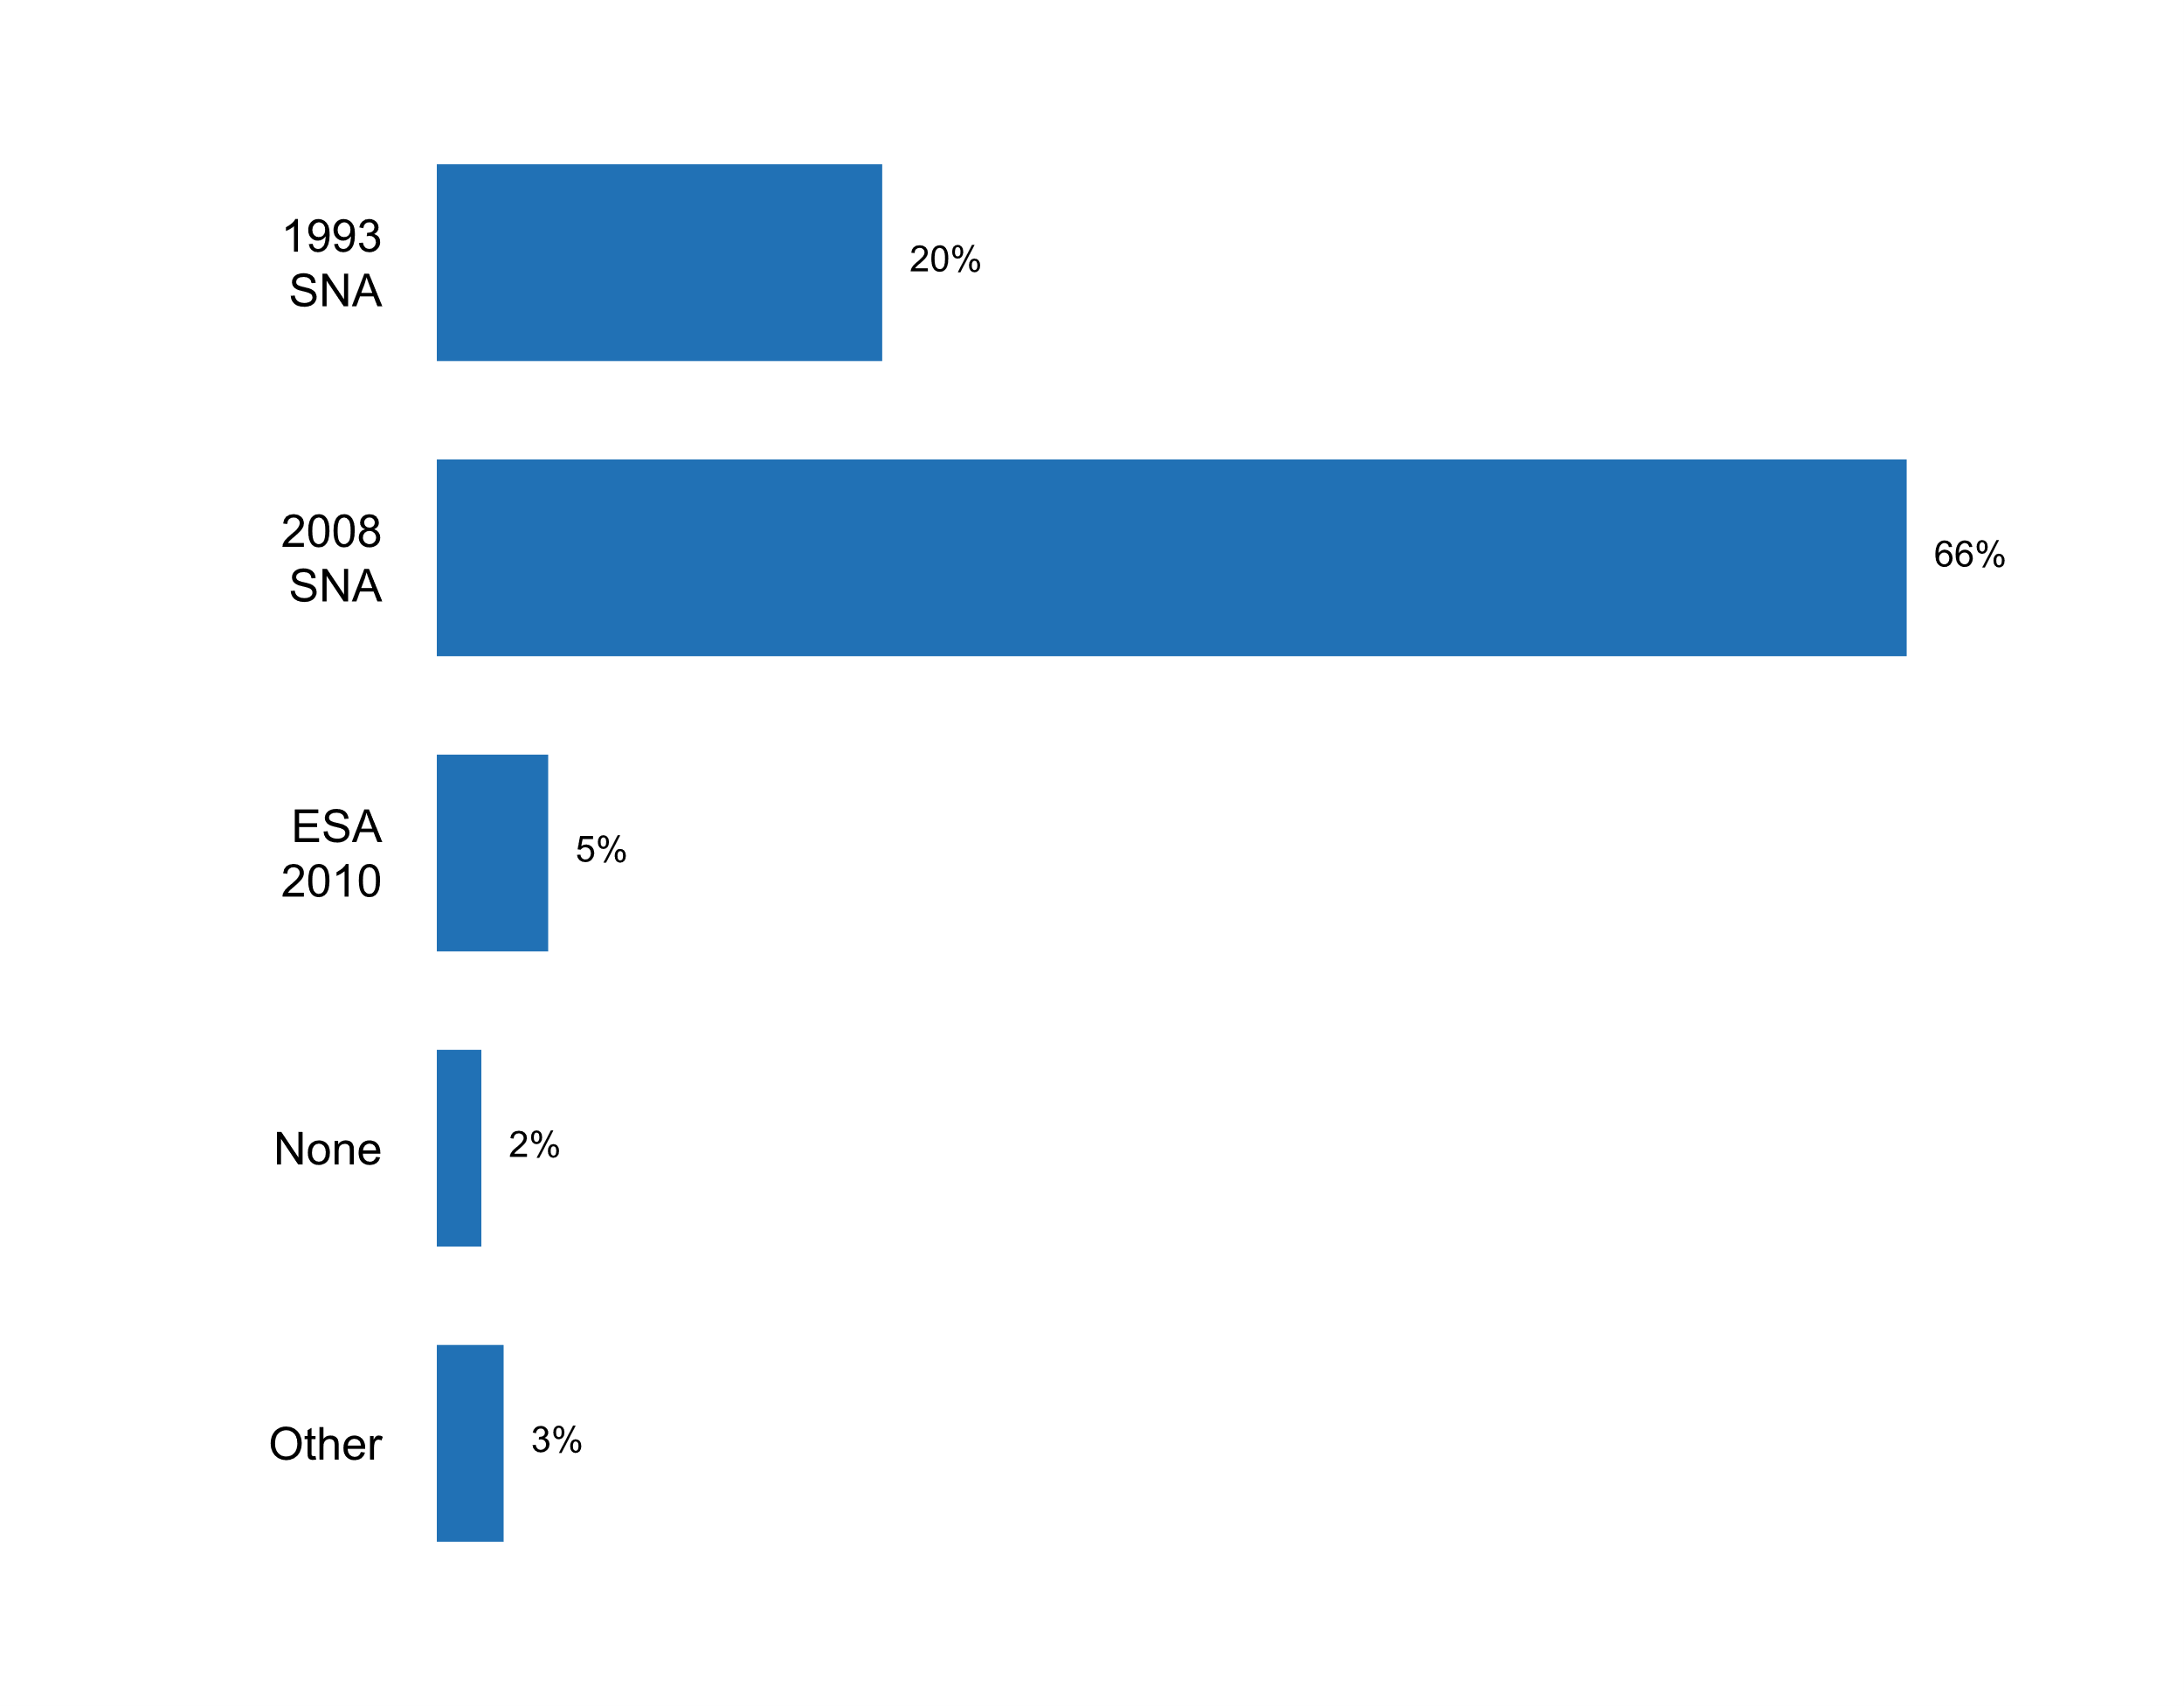

|  |  |  |  |  |  |  |
| --- | --- | --- | --- | --- | --- | --- |
| **Answer** | **Africa** | **Americas** | **Asia** | **Europe** | **Oceania** | **TOTAL** |
| 1993 SNA | 10 | 3 | 6 |  |  | **19** |
| 2008 SNA | 7 | 9 | 15 | 26 | 4 | **61** |
| ESA 2010 |  |  |  | 5 |  | **5** |
| None |  | 1 |  | 1 |  | **2** |
| Other |  |  | 1 | 2 |  | **3** |

|  |  |  |  |  |  |  |
| --- | --- | --- | --- | --- | --- | --- |
| **Answer** | **Africa** | **Americas** | **Asia** | **Europe** | **Oceania** | **TOTAL** |
| 1993 SNA | 59 | 23 | 25 |  |  | **20** |
| 2008 SNA | 41 | 69 | 63 | 74 | 100 | **66** |
| ESA 2010 |  |  |  | 14 |  | **5** |
| None |  | 8 |  | 3 |  | **2** |
| Other |  |  | 4 | 6 |  | **3** |

* 1993 and 2008
* I don't know
* Please see comment 9.1a

***Details on version of SNA currently used***

* 2008 SNA will be apply in second quarter of 2019.
* Australia's national accounts statistics are compiled in accordance with international standards contained in the System of National Accounts, 2008 (SNA08). Australia's application of these SNA standards is described in Australian System of National Accounts: Concepts, Sources and Methods (cat. no. 5216.0). The current version of this product reflects the SNA08 concepts and was released in March 2016. This publication outlines major concepts and definitions, describes sources of data and methods used to derive annual and quarterly estimates for major aggregates at current prices and in chain volume terms, and discusses the accuracy and reliability of the national accounts. In addition, it includes documentation on input-output tables, financial accounts, capital stock, productivity measures, balance sheets and state accounts.
* By agreeing upon a work agenda with the OECD, and under the accompaniment of the International Monetary Fund, Colombia managed to update a new base for the System of National Accounts and release it in 2018. The new base of national accounts presented several innovative aspects for the users of the NSS, in terms of the best international practices, specifically, elements such as the following were highlighted: The revision and inclusion of international recommendations proposed by the 2008 SNA, such as the treatment of financial intermediation services indirectly measured (FISIM), the measurement of research and development as gross fixed capital formation, the explicit calculation of the non-observed economy, and the institutional classification of the financial sector, among others. The incorporation of goods in process and works in progress in the measurement of agriculture and livestock activities as well as construction; also, the valuation of the capital services in the production associated with the investment in slow-maturing crops.
* Conversion to SNA 2008 is currently being undertaken
* Currently NSO applies version 1993 SNA with SNA 2008 amendments (partial implementation)
* ESA 2010
* ESA 2010 also used. Gross Domestic Product by Production Approach: In 2016, 1998-2016 period has been revised. Note: Because of the transition from ESA-95 to ESA-2010, using new sub-accounts based on 2012 Supply-Use and Input-Output Tables in calculation, integration of new administrative records and survey results into the accounting system 2009 based chain linked GDP volume indices have been started to be produced. Gross Domestic Product by Income Approach: In 2016, 1998-2006 period has been revised. Note: Because of the updates in quarterly accounting by the addition of administrative records from Revenue Administration and Social Security Institution, GDP by income method has been revised.
* ESA2010
* EU Regulation ESA 2010 which is based on 2008 SNA
* European Union version ESA
* Hungary is a Member State of the European Union thus has implemented the European System of Accounts - ESA2010.
* Il existe une nouvelle version du SCN 2008
* In Germany, the 2014 major revision involves a thorough revision of the entire national accounting system, as is always the case in major revisions. The Federal Statistical Office has therefore recalculated all national accounts aggregates in full detail back to 1991. The main purpose of the 2014 major revision of national accounts was to implement the new European System of National and Regional Accounts (ESA 2010). The ESA 2010 itself is based on the worldwide SNA 2008.
* In compilation of National Accounts, Romania use the Regulation 543/2013 of European Parliament and of Council on the European System of National and Regional accounts in the EU, named ESA 2010 is roughly compatible with SNA 2008.
* In practice ESA2010 is used.
* In transition from SNA 1993 to SNA 2008, with support from CARICOM, CARTAC and Statistics Canada.
* Is currently working on the application system 2008 completed than 60%
* It has adapted to the country.
* It has to be mentioned that ESA2020 is used (disseminating statistics on national level and providing data to Eurostat). Data published on the statistical portal correspond to the concepts of SEC2010.
* La Cote d'Ivoire est en train réaliser le Changement de l'année de base et de mettre en place SCN 2008.
* Les comptes nationaux 2015 et 2016 produits avec la nouvelle année de base (2014) ont utilisé le SCN 2008.Cf. http://www.ansd.sn/ressources/methodes/Mise%20en%20oeuvre%20du%20changement%20annee%20de%20base_vf_bis.pdf
* Mexico implements 55 of the 57 recommendations of the 2008 SNA.
* NSS is in transition process to 2008 version.
* National Accounts
* National Accounts of Armenia, 2017 published on 20 November 2017 and posted on the website at https://www.armstat.am/en/?nid=81&id=1981
* Nil
* Partially 2008 SNA is also implemented in some sectors of the economy
* Polish national accounts are compiled according to the European System of National and Regional Accounts in the European Union (ESA2010), introduced by Regulation (EU) No 549/2013 of the European Parliament and of the Council of 21 May 2013. ESA2010 in the EU is the equivalent of worldwide System of National Accounts SNA2008.
* Se utiliza el Sistema de Cuentas Nacionales 2008 (SCN 2008) que es la àºltima versià³n de la norma estadà­stica internacional para las cuentas nacionales, adoptada por la Comisià³n de Estadà­stica de las Naciones Unidas (UNSC). Cabe seà±alar que es la actualizacià³n del SCN 1993.
* Since January 1, 2016, the main provisions of the 2008 SNA have been introduced into statistical practice, annual and quarterly indicators of the national accounts system have been recalculated back to 2009, sectoral national accounts of the Republic of Belarus have been developed; production account and income generation account have also been calculated by economic activity
* Some components of SNA 2008 are implemented. The country is in the process of rebasing GDP to align to SNA 2008. A strategy of moving from 1993 to 2008 has been developed and is being currently implemented.
* Some recommendations of the 2008 SNA will be implemented in the ongoing overall revision and rebasing of the Philippine SNA.
* Stats NZ implemented 2008 SNA from November 2014 starting with the Annual National Accounts and flowing through to the quarterly National Accounts.
* Technical assistance is being provided in this area by CARTAC and Statistics Canada. It is expected to complete transition to 2008 SNA by the end of 2019.
* That is the 2008 version
* The Central Bank is the entity in charge of preparing the national accounts, the version they use in their last change of base year is the SNA 2008.
* The ESA 2010 is broadly consistent with the SNA 2008
* The European System of Accounts 2010 (ESA 2010) is the system of national accounts and regional accounts used by members of the European Union. National accounts provide information to analyze the structure of economies and their development over time. They contain a wide range of statistics describing an economy in various ways. National accounts data are compiled according to ESA 2010 methodology.
* The SNA is used as the overall conceptual framework. Singapore has adopted the major recommendations of the 2008 SNA.
* The US National Accounts is produced by the US Bureau of Economic Analysis: https://www.bea.gov/national/sna-and-nipas
* The national accounts are produced in line with international standards, most notably the European System of Accounts 2010 (ESA2010) that is enforced for all European Union (EU) member states through an EU regulation. ESA2010 is in turn consistent with the United Nations System of National Accounts 2008 (SNA08).
* This is for the rebasing and production of the GDP estimates for 2007 to 2016
* This year, NBS started applying the SNA 2008 in the production of main macroeconomic estimates.
* Transition to the SNA 2008 is planned in 2019. Transition to NACE Rev. 2 and general revision of time series is planned in 2019 as well.
* Transitioning to 2008 SNA is in progress
* We are in the process of migrating into SNA 2008
* We calculate GDP and GRDP
* We currently use partial SNA 2008, but we plan to fully apply SNA 2008 in the future.
* We have expressed commitment to use SNA 2008
* We issued The china's System of National Accounts (2016) in July 2017,which conform to the 2008 SNA.
* We use ESA 2010 that is the European of SNA2008
* We use the UN SNA 1993 with the base year in 2006
* use of ISIC Rev4, CPC etc
* we are moving from 1993 to 2008
* we are planning to implement SNA 2008 in 2020
* we use ESA 2010, with derogations granted to a new member state which expire in 2020.
* we work to integrate SNA2008
* www.depd.gov.bn

**Plot_62_Q09.2.svg**

**Extent to which Principles and Recommendations for Population and Housing Censuses, Rev. 3 (for census undertaken after 2015) or Rev. 2 (for census undertaken before 2015) are being implemented in the latest census programme**

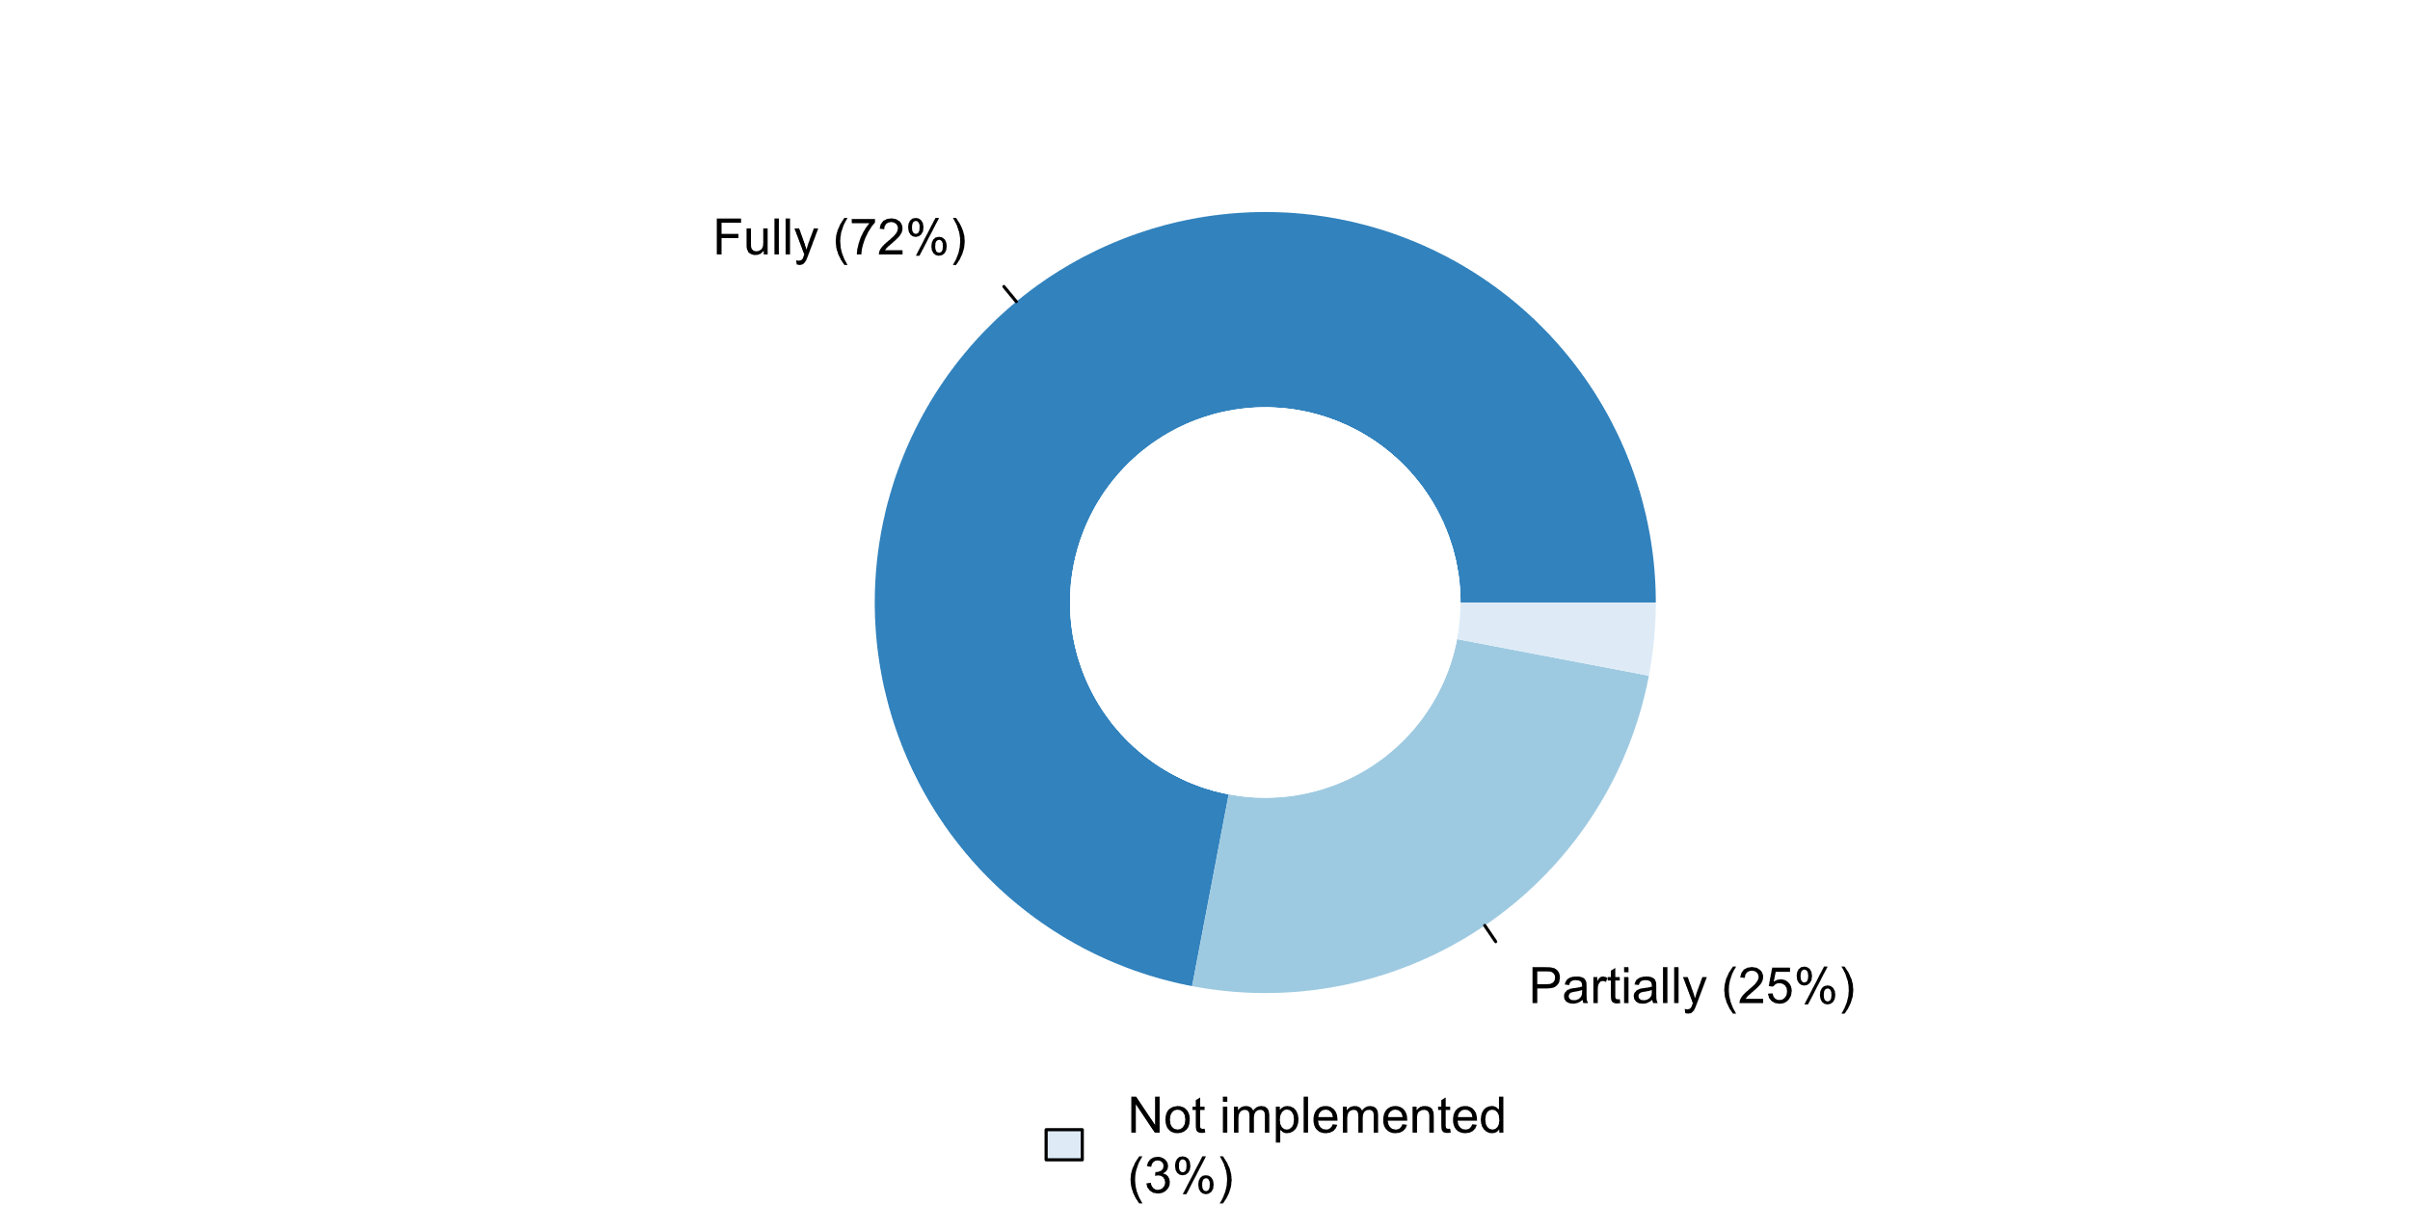

|  |  |  |  |  |  |  |
| --- | --- | --- | --- | --- | --- | --- |
| **Answer** | **Africa** | **Americas** | **Asia** | **Europe** | **Oceania** | **TOTAL** |
| Fully | 15 | 9 | 12 | 27 | 4 | **67** |
| Partially | 2 | 3 | 12 | 6 |  | **23** |
| Not implemented |  | 1 |  | 2 |  | **3** |

|  |  |  |  |  |  |  |
| --- | --- | --- | --- | --- | --- | --- |
| **Answer** | **Africa** | **Americas** | **Asia** | **Europe** | **Oceania** | **TOTAL** |
| Fully | 88 | 69 | 50 | 77 | 100 | **72** |
| Partially | 12 | 23 | 50 | 17 |  | **25** |
| Not implemented |  | 8 |  | 6 |  | **3** |

***Main reasons/challenges explaining why principles and Recommendations for Population and Housing Censuses, Rev. 3 (for census undertaken after 2015) or Rev. 2 (for census undertaken before 2015) are being implemented partially or not implemented in the latest census programme***

* Concepts are already in programs, so, this question is not applicable to US Population and Housing Censuses.
* Due to the use of administrative registers we can't always implement fully the definitions as mentioned in the principles and recommendations.
* Employment questions are not adopted since Labor Force Surveys are undertaken quarterly; Geographic constraints
* Eurostat recommendations and European Regulations are followed
* Implementing up to Milestone 2. Main challenge is data availability
* In the Census round 2011, data on housing topics were collected for core and derived topics which were included in REGULATION (EC) No 763/2008 OF THE EUROPEAN PARLIAMENT AND OF THE COUNCIL of 9 July 2008 on population and housing censuses. The derived topics not included in the regulation were omitted mainly due to: lack of interest in data by domestic users (ex. Bedrooms-number of, Lighting and / or electricity-type of), lack of comparability with the Census round 2001. Simultaneously, Poland participated in works on Recommendations for the 2010 and 2020 Censuses of Population and Housing managed by United Nations Economic Commission for Europe. We are consistent with methodology described in this document.
* Nil
* Some topics are adapted/adjusted (appropriately) to the context of Thailand.
* The NSO gives priority to the use of European or National Standards.
* The last census 1997 did not implementing after a result of security conditions that experienced Iraq
* The latest recommendation is used as the overall conceptual framework. Singapore has adopted the major recommendations of the Population and Housing Censuses, Rev. 3.
* The recommendations have been reviewed thoroughly by national committee and most of the recommendation were considered
* We adhere to all key principles, but do not apply all the recommended core content.
* We conduct Register-based Census. The only deviation from the Recommendations is the core topic Labour force status - it is not possible to implement the proposed Chart 4 (Labour Force Survey questions to determine employed, unemployed and persons outside the labour force using prescribed questions). But the difference between register-based labour force status and LFS labour force status in Slovenia is not statistically significant.
* We do not implement housing census until now.
* budget and sources
* the NSO is drafting a new law on Population and Housing, which is expected to be approved within 2019 by the Parliament. With the entering into force of this law, the principles and recommendations will be fully compliant.

**Plot_63_Q09.3.svg**

**Use of the International Classification of Activities for Time Use Statistics 2016 (ICATUS 2016)**

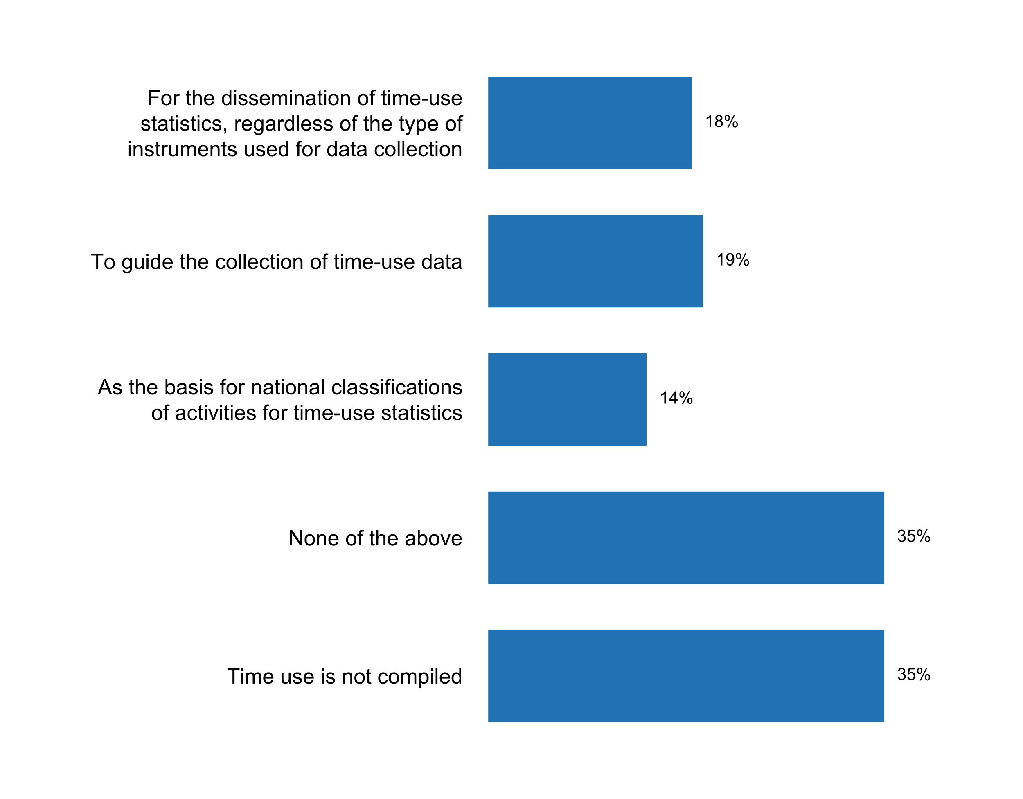

|  |  |  |  |  |  |  |
| --- | --- | --- | --- | --- | --- | --- |
| **Answer** | **Africa** | **Americas** | **Asia** | **Europe** | **Oceania** | **TOTAL** |
| For the dissemination of time-use statistics, regardless of the type of instruments used for data collection | 3 | 2 | 7 | 5 |  | **17** |
| To guide the collection of time-use data | 5 | 3 | 5 | 5 |  | **18** |
| As the basis for national classifications of activities for time-use statistics | 3 |  | 5 | 5 |  | **13** |
| None of the above | 5 | 5 | 8 | 13 | 2 | **33** |
| Time use is not compiled | 7 | 5 | 9 | 10 | 2 | **33** |

|  |  |  |  |  |  |  |
| --- | --- | --- | --- | --- | --- | --- |
| **Answer** | **Africa** | **Americas** | **Asia** | **Europe** | **Oceania** | **TOTAL** |
| For the dissemination of time-use statistics, regardless of the type of instruments used for data collection | 18 | 15 | 29 | 14 |  | **18** |
| To guide the collection of time-use data | 29 | 23 | 21 | 14 |  | **19** |
| As the basis for national classifications of activities for time-use statistics | 18 |  | 21 | 14 |  | **14** |
| None of the above | 29 | 38 | 33 | 37 | 50 | **35** |
| Time use is not compiled | 41 | 38 | 38 | 29 | 50 | **35** |

***Details on use of the International Classification of Activities for Time Use Statistics 2016 (ICATUS 2016)***

* ACL HETUS 2008 (Activity Coding List for Harmonised European Time Use Surveys) was used for the previous TUS.For 2019-2020 survey ACL HETUS 2018 will be used.
* Armstat has conducted the only TUS in October 2008. Unfortunately, we could not conduct the second round of TUS due to lack of financial resources, in case of availability of resources Armstat is committed to conduct TUS using ICATUS 2016.
* Colombia is currently is carrying out for the adopting and adapting of the International Classification of Activities for Time Use Statistics 2016 (ICATUS 2016)
* En el aà±o 2010, se ejecutà³ la encuesta del uso del tiempo que se ha permitido realizar la Cuenta Satélite del Trabajo en el marco del Sistema de Cuentas Nacionales.
* I do not have information to respond to this question by your survey deadline of November 30.
* ICATUS 2016 is being used in the ongoing Time-Use Survey (October 2018 - September 2019)
* Il est nécessaire de renforcer les capacités à  ce niveau et d'obtenir un soutien financier pour l'enquàªte sur l'emploi du temps.
* In the Employment module of an household survey, Time Use is captured
* Italy uses the Activity Coding List (ACL) included in the HETUS guidelines. Italy is participating in the ACL review conducted by the Eurostat TUS Working Group, and one of the goals is to make it more comparable with ICATUS16. For the release of the e-book "Report on life times. Work, reconciliation, gender equality and subjective well-being", due out in January 2019, Istat have nevertheless harmonized the outputs foreseen in the UNECE 2013 guidelines, using the ICATUS16 definitions at the first digit level.
* Last time the survey on time use statistics was conducted in 2003, as a pilot survey.
* NSO uses Time Use: Paid and Unpaid Work (2005).
* New Zealand is currently exploring the potential use of this classification for the next Time Use Survey.
* Nil
* Norway has not compiled time use statistics since 2010 but depending on funding, it will be done in 2-3 years. Then HETUS will be the guiding classification.
* Not Applicable
* ONS has not carried out a new time use survey since 2014-15. That survey was compliant with the European HETUS standard. We do have further time use work in development, but this is still at the planning stage.
* On the 20th November 2018, the Minister for Women the Honourable Kelly O'Dwyer MP, announced the Women's Economic Security Statement. As part of this package the Australian Bureau of Statistics will reinstate the Time Use Survey (TUS). The ABS will receive $10.4 million to develop and conduct the survey, last run in 2006. These funds include the design, development and implementation of an electronic diary (in addition to a paper diary). The initial survey will be conducted in 2020-21 followed by a smaller ongoing annual survey that will build up the evidence base over time. As the development and consultation around this survey is still in the early stages, we cannot state definitively whether it will implement ICATUS 2016
* PCBS implemented the second survey of time use in 2012/2013 using (ICATUS 2010) and the third survey will be in 2022/2023, then we will use the (ICATUS 2016).
* Poland uses Harmonized European Time Use Surveys Activity Coding List.
* Questionnaire developed in line with the classifications of Time use.
* Some questions on time use are included in some household surveys
* Statistical Centre of Iran is localizing the ICATUS 2016 and is going to prepare the list of time use activities and will use it in collecting related data in future.
* The "Time Use" survey was conducted for the first time in Luxembourg in 2014, among 2,100 people aged 10 to 74. This survey, recommended by EUROSTAT, consists of collecting detailed schedules from a representative sample of the resident population. The survey was realised according the guidelines of the Harmonised European Time Use Surveys (HETUS).
* The ICATUS 2016 was produced after StatCan's collection of its last Time Use survey in 2015. StatCan participated in the development of the 2016 ICATUS and will probably use it for its next Time Use collection planned in 2022. The GSS modernizing team is looking into using it for a test on subjective wellbeing where a telephone application will be developed and used to collect respondents' activities throughout the day.
* The UN Classification ICATUS 2016 will not be used in the next Time Use Survey in Germany (and not even before, since the last survey took place in 2012/13). Since Germany is integrated into the European Statistical System, the national classification of activities is based on the "Activity Coding List (ACL)" of the Harmomized European Time Use Survey (HETUS). According to Eurostat, the ACL of the next HETUS data round 2020 will not be replaced by ICATUS 2016; Nor will it build on the structure of ICATUS 2016. It is possible, however, that individual key components of the ICATUS 2016 will be included in the ACL of HETUS 2020. As part of the revised HETUS Guidelines 2018, the ACL of HETUS 2020 is expected to be adopted by the end of February 2019.
* The country has been adopted the classification.
* The last National Survey on Time Use was carried out in 2014. We use the regional Cautal Classification.
* The last Time Use Survey was carried out in 2011-2012, using HETUS 2008.For the next TUS the ICATUS is going to be used. No specific data for it was set yet.
* The last compilation of Time use statistics was in 2010. These statistics were published according to a national classification. For the next exercise of compiling Time use statistics, the NSO will use a classification that shall allow them to be compatible with the European nomenclature HETUS and the International classification ICATUS and to maintain the coherence with previous data.
* Time Use Statistics will be conducted in 2019. ICATUS 2016 will be used for the upcoming survey. The preparation for the survey is underway.
* Turkish Statistical Institute (TurkStat) is a member of the Time Use Survey Working Group held by Eurostat and the participation has been provided to the meetings since 2013. Accordingly, TurkStat implemented Time Use Survey (TUS) for the first time in 2006 in harmony with Harmonised European Time Use Survey (HETUS) 2002 Guideline. The second application was implemented on 1 August 2014 - 31 July 2015 by using HETUS 2008 Guideline as a reference document. TUS, 2014-2015 micro data and metadata file set was prepared and transferred by TurkStat to Eurostat HETUS Database 2010 for the first time. Consequently, activity coding list and location of activity coding list recommended in HETUS guideline were used as classification of activity in TurkStat. There are some differences between ICATUS and HETUS activity list. It can be understood that its reason is for classifying the activities based on the concept of productive/non-productive activities following the System of National Accounts (SNA) framework in ICATUS 2016. It can be seen that the activities were grouped by taking reference of their aims and intentions in ICATUS 2016. This methodology seems logical and beneficial. In the future this subject will be more important, so more countries may use this activity list.
* Unable to answer question 9.2 and 9.3
* Used to guide the classification of the activities to be covered
* We are yet to compile time use statistics
* We currently use ICATUS trial version, but we plan to apply ICATUS 2016 in 2019.
* We have not implemented any time use survey except for LFS and OWS
* We implemented Time Use Survey in May 2018.
* We've been using the ILO Employment classifications
* When state statistics bodies conducted a Time Use Survey, the activities of household members were coded in compliance with the Classification of Activities for the Time Use Survey. The classification was developed based on recommendations for harmonizing European time use surveys of the European Commission. The activities are classified in three levels (groups, subgroups, types). For this, the sequential coding method was applied, the code length was three numeric decimal digits. Groups are consistently detailed into subgroups and activities.
* last TUS was organized in 2013
* no budget allocation
* we are conducting a pilot Time Use Survey

**Plot_64_Q09.4.svg**

**Existence of a programme on EEA\***

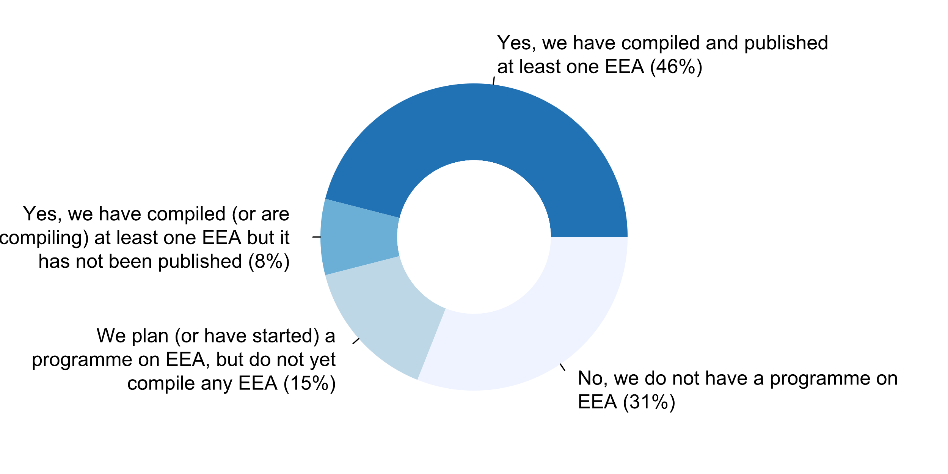

|  |  |  |  |  |  |  |
| --- | --- | --- | --- | --- | --- | --- |
| **Answer** | **Africa** | **Americas** | **Asia** | **Europe** | **Oceania** | **TOTAL** |
| Yes, we have compiled and published at least one EEA | 2 | 6 | 9 | 23 | 3 | **43** |
| Yes, we have compiled (or are compiling) at least one EEA but it has not been published | 2 |  | 1 | 4 |  | **7** |
| We plan (or have started) a programme on EEA, but do not yet compile any EEA | 6 |  | 4 | 3 | 1 | **14** |
| No, we do not have a programme on EEA | 7 | 7 | 10 | 5 |  | **29** |

|  |  |  |  |  |  |  |
| --- | --- | --- | --- | --- | --- | --- |
| **Answer** | **Africa** | **Americas** | **Asia** | **Europe** | **Oceania** | **TOTAL** |
| Yes, we have compiled and published at least one EEA | 12 | 46 | 38 | 66 | 75 | **46** |
| Yes, we have compiled (or are compiling) at least one EEA but it has not been published | 12 |  | 4 | 11 |  | **8** |
| We plan (or have started) a programme on EEA, but do not yet compile any EEA | 35 |  | 17 | 9 | 25 | **15** |
| No, we do not have a programme on EEA | 41 | 54 | 42 | 14 |  | **31** |

**Plot_65_Q09.5.svg**

**SDMX currently in use**

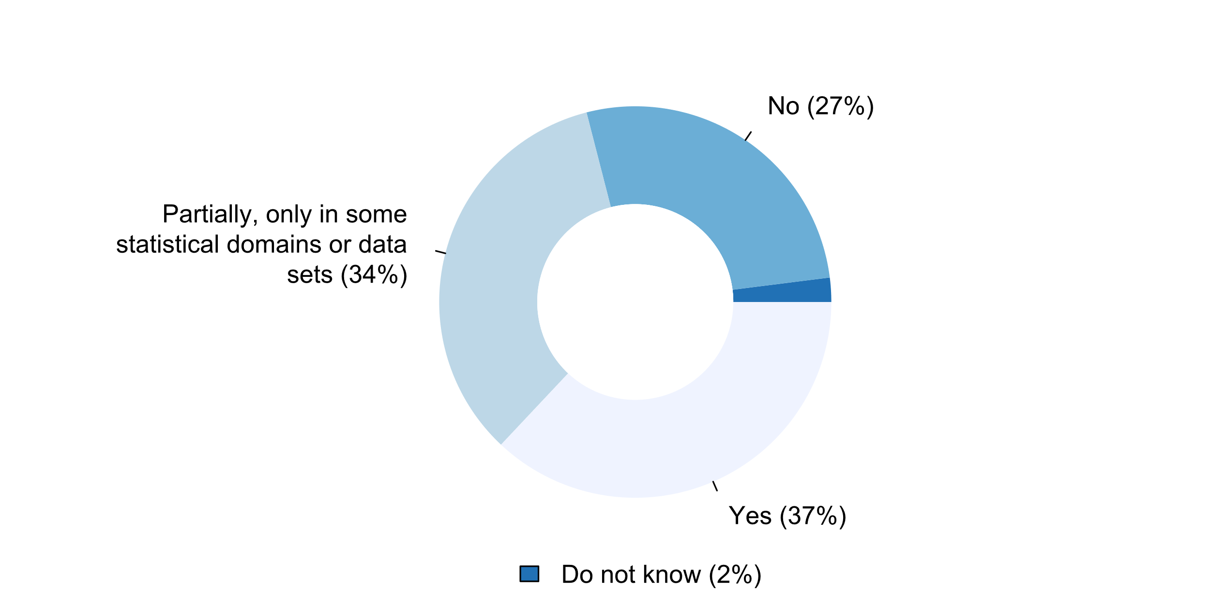

|  |  |  |  |  |  |  |
| --- | --- | --- | --- | --- | --- | --- |
| **Answer** | **Africa** | **Americas** | **Asia** | **Europe** | **Oceania** | **TOTAL** |
| Do not know | 1 | 1 |  |  |  | **2** |
| No | 7 | 2 | 13 | 2 | 1 | **25** |
| Partially, only in some statistical domains or data sets | 7 | 6 | 7 | 11 | 1 | **32** |
| Yes | 2 | 4 | 4 | 22 | 2 | **34** |

|  |  |  |  |  |  |  |
| --- | --- | --- | --- | --- | --- | --- |
| **Answer** | **Africa** | **Americas** | **Asia** | **Europe** | **Oceania** | **TOTAL** |
| Do not know | 6 | 8 |  |  |  | **2** |
| No | 41 | 15 | 54 | 6 | 25 | **27** |
| Partially, only in some statistical domains or data sets | 41 | 46 | 29 | 31 | 25 | **34** |
| Yes | 12 | 31 | 17 | 63 | 50 | **37** |

***Details or examples on the use of SDMX***

* 1) Implemented SDMX-RI 2.1 within the BNSI for some statistical domains;2) Implemented ESMS metadata structure for all datasets;3) Implemented ESQRS structure for some statistical domains
* As I said before: We use ESMS, (Euro SDMX Metadata Structure) the European adaptation of SDMX. You could check it in: https://www.ine.es/dynt3/metadatos/en/index.html
* CSB implements SDMX according to the Eurostat plan. It is used in government finance statistics, quarterly national accounts, annual national accounts, producer price indices, consumer price indices, wage statistics, social statistics, trade and services statistics, industrial and construction statistics, and enterprise structural innovation statistics.
* Data on inflation, GDP, Finance, etc. are converted in SDMX format and uploaded in the NSDP in the National Statistics Bureau website.
* Destatis participates in the international initiative SDMX in connection with the transmission of national statistical results to Eurostat. The introduction takes place successively for individual statistics. Eurostat would like to make all statistic deliveries available in SDMX format. Basically, Destatis supports the use of SDMX because Eurostat provides this as a metadata Standard for European data deliveries.
* Dissemination: - SDMX API to access the IStat dissemination database (http://sdmx.istat.it/SDMXWS/) - SDDS Plus (https://www.istat.it/nsdp/) - Eurostat Census Hub Reporting: Istat has an internal cross-cutting SDMX architecture for data reporting (e. NA, JVS, LCI, STS, etc.)
* For all statistics transmitted to Eurostat and IMF (SDDS+) SDMX is used. For transmission of Balance of Payments data to the OECD SDMX is used.
* Implementation proceeds in accordance with Eurostat schedule (in National Accounts, Foreign Trade, STS...).
* In EU cooperation
* It is used for the transmission of employment data and the Consumer Price Index (CPI) to the OECD.
* Mainly SDMX-IR is used and, in some cases, SDMX converter. SDMX-IR has more than 130 data-sets mapped. Most of them are National accounts, and Short-term statistics.
* Most ABS data is accessible to other NSOs and international organisations through the ABS website. Analysts from international organisations can also access ABS data through customised requests or confidentialised unit record files. The ABS is committed to responding to international questionnaires. Additionally, the ABS has an online product called ABS.Stat that presents data in a searchable, flexible and dynamic way. ABS.Stat provides data in a machine-processable format using the Statistical Data and Metadata Standard (SDMX) allowing machine-to-machine mechanisms for accessing and sharing ABS data, particularly to other NSO and international organisations. By 2019, ABS data and metadata will be instantly available upon release and updated in customer environments via an automated machine-to-machine access channel, without the need for any intervention.
* National accounts etc.
* ONS does provide SDMX formatted data via its APIs and the National Online Manpower Information System (NOMIS). We also provide data in the JSON-STAT format.
* Please go to our website at www.sbs.gov.ws and see for yourself and refer to SDMX - National Summary Data page.
* Prodcom Statistics
* Romania use SDMX standards - according to ESA 2010 for National Accounts Tables. Excel templates are converted with SDMX Converter. Data are directly transmitted from National Accounts Department through eDAMIS transmission program. Partially for job vacancy survey/ labor cost index.
* SDMX has been used in MDGs indicators like literacy, Labor force, poverty etc.,
* SDMX used in connection with our subscription to eGDDS
* SORS implemented Eurostat SDMX-RI within the information system (IS) for data dissemination, which provides possibility to generate appropriate SDMX file for any international institution according to their DSDs. At this moment, SORS transmits datasets to Eurostat in SDMX format for NAMAIN, STS, LCI and TEC domain. At the same time, all SORS datasets available on IMF e-GDDS web page for Serbia or http://www.stat.gov.rs/en-US/NSDP-Serbia were produce using the same information system (IS) for data dissemination. To provide tool for creating reference metadata and quality reports for national needs as well as for metadata and QR transmission to Eurostat, SORS developed national reference metadata system (RZSMETA) fully compliant with SIMS 2.0. Through RZSMETA users have possibility to download prepared metadata or QR in SDMX format and upload it in ESS MH and vice versa.
* Se viene utilizando para hacer transferencia de informacià³n para datos de Cuentas Nacionales y Comercio Exterior.
* Statistics Canada uses SDMX to fulfil a number of different use cases across the organization. 1) Statistics Canada publishes a large number of data tables in a variety of different formats. The SDMX format is one of the data formats available to the general public. A SDMX-ML data (compact format) file and the accompanying DSD (Data Structure Definition) file is available at release time for the disseminated data tables through our website www.statcan.gc.ca. The SDMX files are also available on the Canadian Open Data Portal which is available at the following website http://open.canada.ca.2) Statistics Canada has an obligation to supply data to many international organizations such as OECD, IMF, UN, World Bank, etc. Currently Statistics Canada is providing data in a SDMX format which aligns to the following internationally approved global data structure definitions for the following domains; a. OECD â€“ Main Aggregates b. OECD â€“ Sector Accounts. OECD â€“ Supply Use Tables. IMF â€“ Balance of Payments. IMF â€“ SDDS+3) Statistics Canada uses SDMX to facilitate and manage data exchanges to fulfil the needs of our Fiscal Arrangements program. The government of Canada permanently offers financial support to the provincial and territorial governments to help them fund social programs and services. There are 4 major transfer programs: Canada Health Transfer (CHT), Canada Social Transfer (CST), Equalization and the Territorial Financing Formula. These 4 transfer programs are regulated by the Fiscal Arrangements Act. Statistics Canada is responsible for the preparation and delivery of data related to the Fiscal Arrangements. The Public Sector Statistics Division is responsible to collect and assemble data from over 40 different data sources from Statistics Canada and to finalize a number of certificates to the Canadian Department of Finance.
* The service provides data and statistical metadata in the SDMX format, through the web service mechanism - the PULL method and the service transmits data and statistical metadata in the SDMX format, through the EDAMIS platform - the PUSH method. The service is used by international institutions, eg UN, OECD and EUROSTAT.
* The tables from the output database are possible to download in the format of SDMX-XML, as open standards such as SDMX-XML and SDMX-JSON are available in .STAT.ESMS (SDMX Cross-Domain Concepts.
* We are using SDMX Converter for transforming .csv files to .ml files which are send to Eurostat through eDamis. When Eurostat prepares DSDs on a new domain, we start to test and use it. On some domains SRMX-RI is used (National Accounts and Census Hub).For the dissemination of STS data on the IMF website we are using SDMX Converter.
* We have an experience working on SDMX Project on UNSD-DFID to provide data exchange using SDMX (Source reference: http://data.un.org/CountryData/) Those are MDGs Data for Exchange on UN Country Data website.
* data portal is providing APIs based on SDMX as well as National Summary Page.
* e-GDDS

***Main reasons/challenges explaining the lack of use of SDMX***

* Belstat is currently exploring the possibility of using SDMX for data transmission to the Eurasian Economic Commission, a national reporting platform for SDGs is being developed using the SDMX standard, which will be launched in early 2019. The main problems related to SDMX implementation are as follows: â€¢ insufficient training of NSS professionals; â€¢ lack of description of DSD structures from the Eurasian Economic Commission; â€¢ lack of technical assistance.
* Capacity and capability
* Lack of resources and knowledge
* Lack of resources.
* Lack of staff and other resources especially time as we are a very small office.
* Our plan is to explore the use of SDMX in the coming years.
* PCBS uses Accelerated Data Program (ADP).
* Technical and infrastructure Barrier.
* The NSO is preparing necessary conditions for the use of SMDX.
* The SDMX is in the process of implementation.
* The system uses the statistical currently in the document the dues: 1. the model the standard for production of statistical 2. the general framework of the data meta 3.puf seeks to use sdmx in his work
* This has to be considered in the overall context of data release in anonymised / open data format through a forthcoming e-business plan to revamp the processes of the office by optimising on Information Technology. Also, training on SDMX is required.
* To be explore for future considerations.
* We are working with the IMF to be part of the e-GDDS, after that we will start to use SDMX
* We do not have proper metadata base at the moment.
* lack of technical capacity on the use of SDMX
* not yet but we are intending to start using it in the very near future
* à€ ce jour, rien n'est prévu par rapport à  cela. Nous avons besoin de renforcer les capacités à  ce niveau

**Plot_66_Q10.1.svg**

**Types of international cooperation activities the NSS engages in**

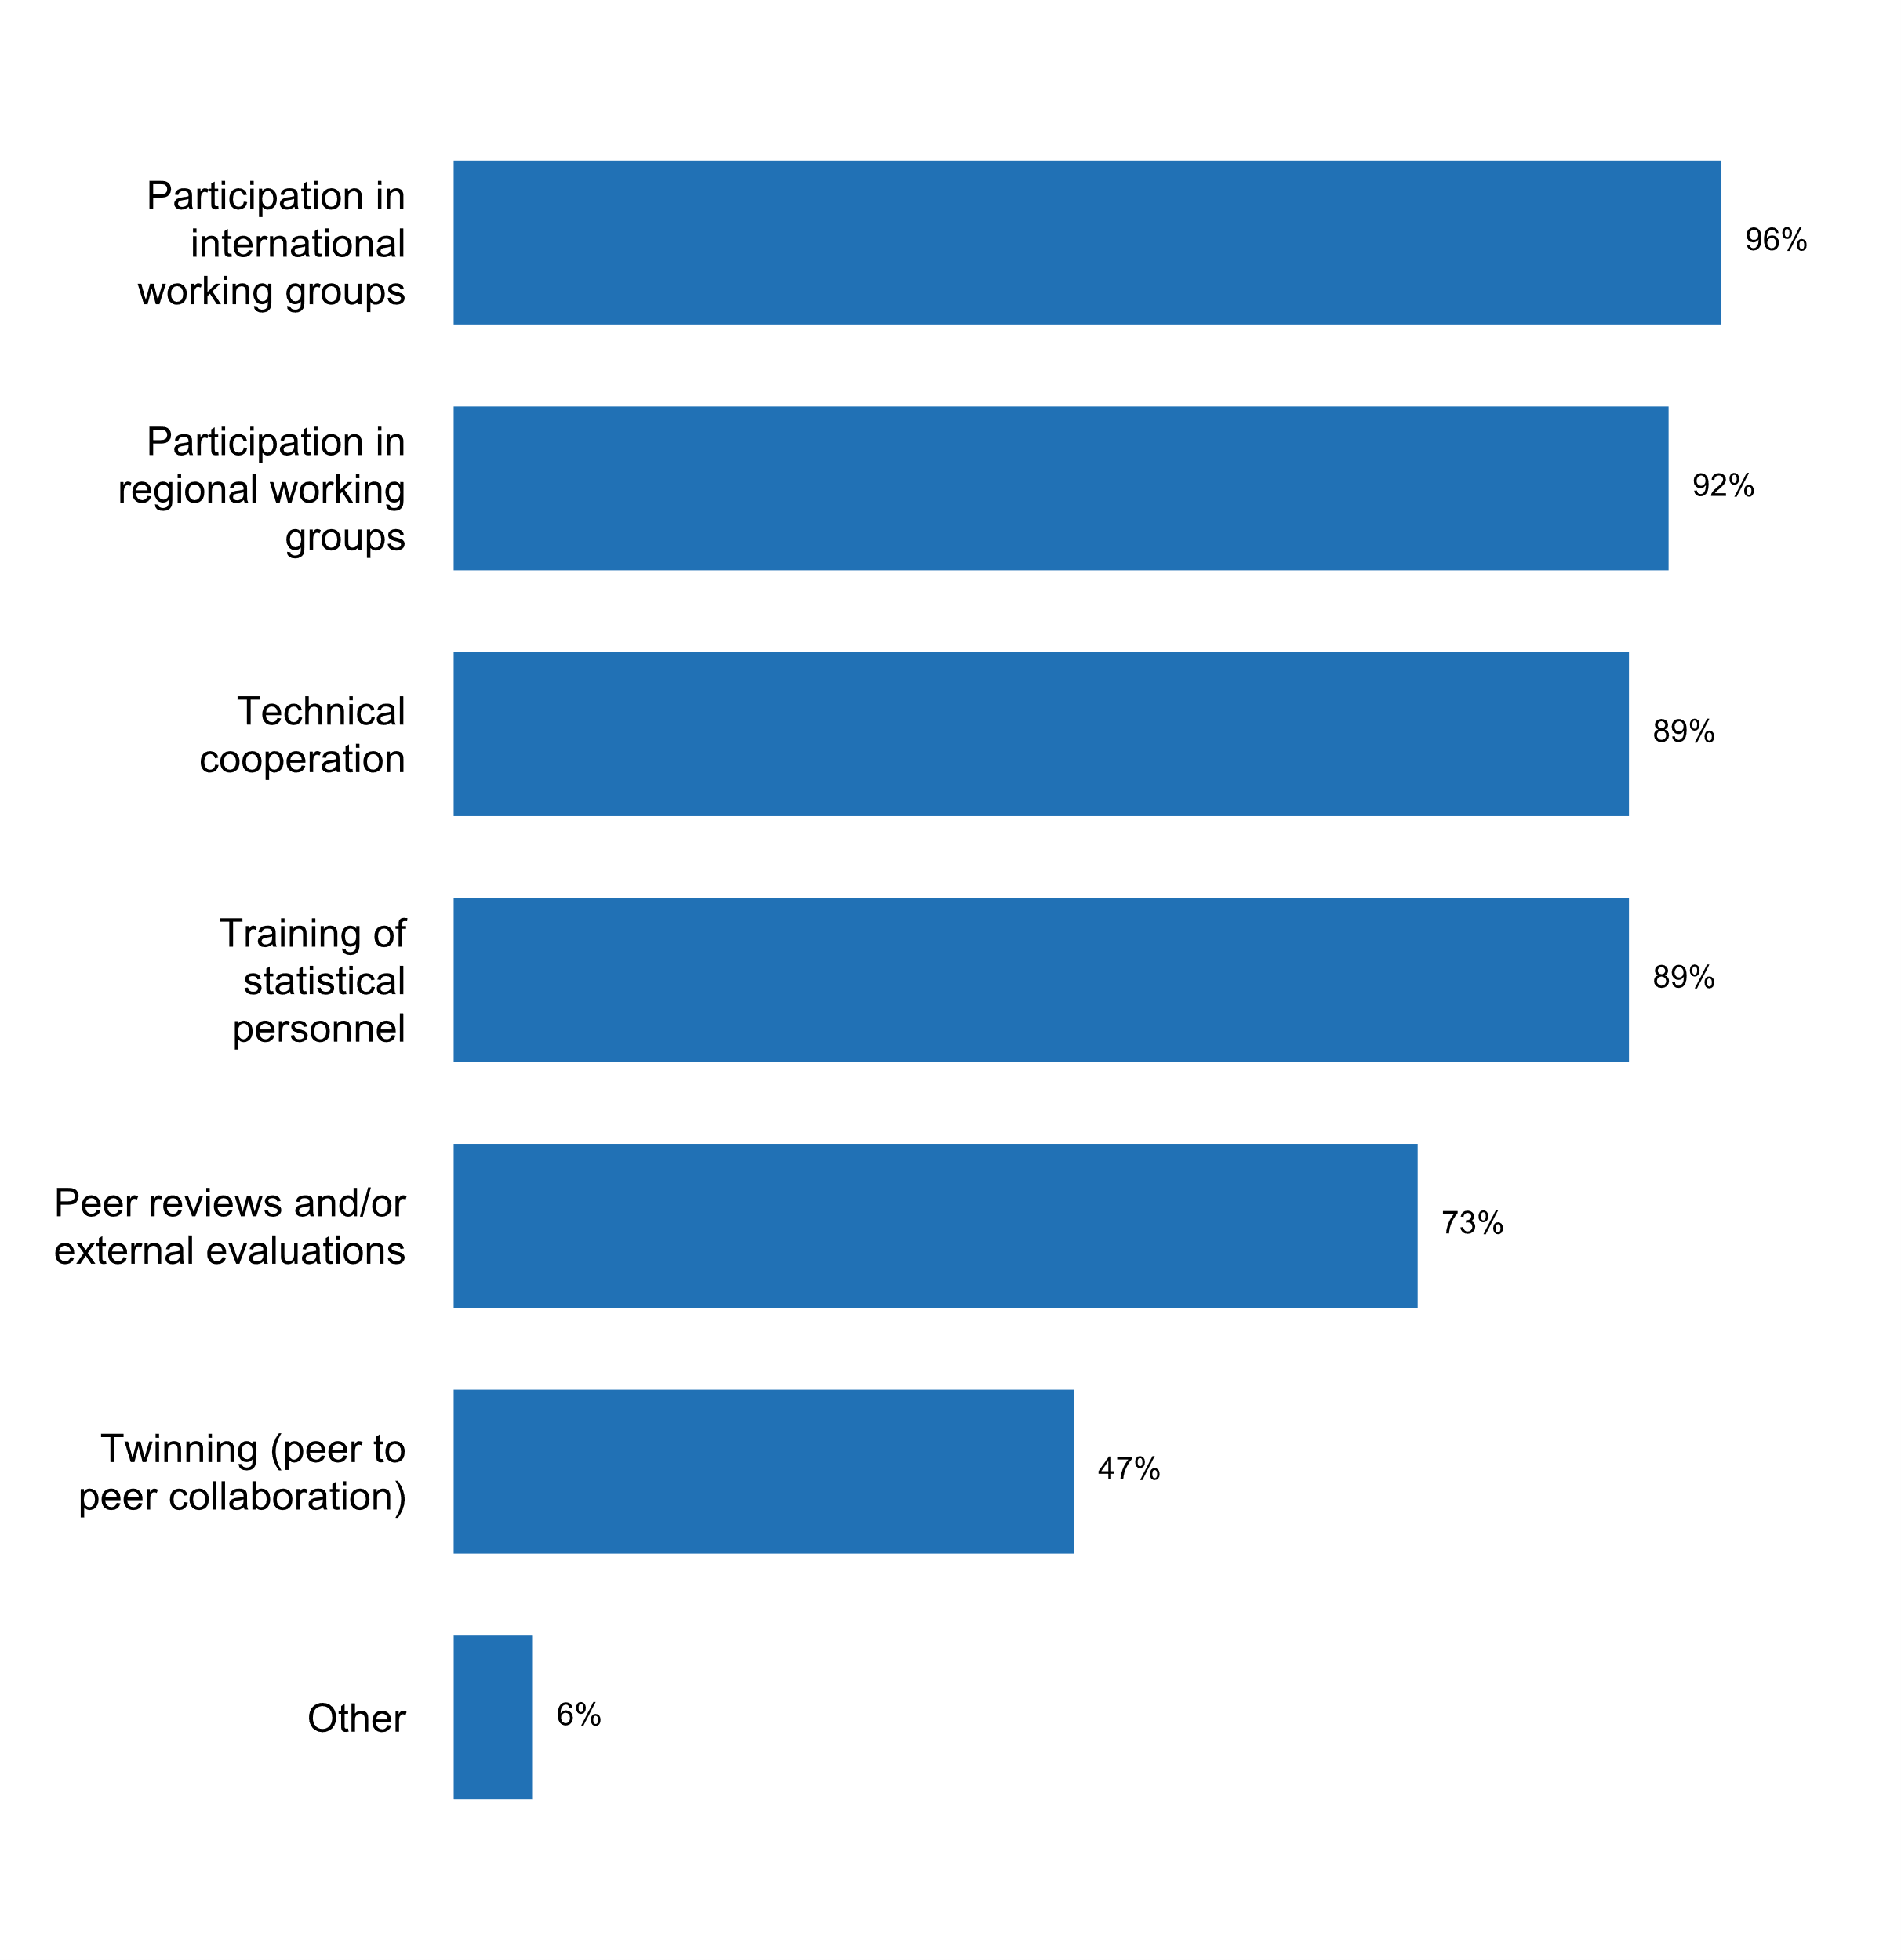

|  |  |  |  |  |  |  |
| --- | --- | --- | --- | --- | --- | --- |
| **Answer** | **Africa** | **Americas** | **Asia** | **Europe** | **Oceania** | **TOTAL** |
| Participation in international working groups | 16 | 11 | 23 | 35 | 4 | **89** |
| Participation in regional working groups | 16 | 12 | 23 | 31 | 4 | **86** |
| Technical cooperation | 15 | 13 | 20 | 31 | 4 | **83** |
| Training of statistical personnel | 16 | 12 | 20 | 31 | 4 | **83** |
| Peer reviews and/or external evaluations | 13 | 6 | 17 | 29 | 3 | **68** |
| Twinning (peer to peer collaboration) | 10 | 6 | 10 | 14 | 4 | **44** |
| Other |  | 1 | 2 | 3 |  | **6** |

|  |  |  |  |  |  |  |
| --- | --- | --- | --- | --- | --- | --- |
| **Answer** | **Africa** | **Americas** | **Asia** | **Europe** | **Oceania** | **TOTAL** |
| Participation in international working groups | 94 | 85 | 96 | 100 | 100 | **96** |
| Participation in regional working groups | 94 | 92 | 96 | 89 | 100 | **92** |
| Technical cooperation | 88 | 100 | 83 | 89 | 100 | **89** |
| Training of statistical personnel | 94 | 92 | 83 | 89 | 100 | **89** |
| Peer reviews and/or external evaluations | 76 | 46 | 71 | 83 | 75 | **73** |
| Twinning (peer to peer collaboration) | 59 | 46 | 42 | 40 | 100 | **47** |
| Other |  | 8 | 8 | 9 |  | **6** |

* Bileteral co-operation with different countries (Memorandum of Understanding)
* More than 300 business trips are organized each year (and the number is increasing- 386 in 2017). Moreover, Statistics Poland hosts incoming delegations (around 30 a year). We have not yet entered yet into twinning projects. Visits within TAIEX as well as bilateral cooperation within Polish Aid programme were undertaken.
* Study visits to NSOs
* Through the statistical certification system, external evaluations are promoted among peers and other United Nations agencies.
* hosting many international events like UN World Data Forum
* participation in different international projects

**Ways in which international cooperation has affected the functioning of your NSS**

* It has improved the NSS over the years and also improve the status of the NSO
* 1. Organizing training workshops and courses, 2. Providing technical advices and consultations.
* Absolutely.We are members of the European Union. We work closely with Eurostat and the European institutions and countries.But we also work with the rest of relevant international statistical institutions as OECD, United Nations, IMF, etc.
* Active engagement in the statistical co-operation through European and international bodies, involvement in international projects and activities lead to accumulation of best practices later on applied in developing strategies of the NSI and optimization of the institutional set-up, upgrading of data collection, processing and dissemination processes, adopting and promoting the best international standards, methodologies and procedures, introduction of internationally recognized quality framework and improvement of quality and comparability of statistics, etc.Reputation of the SL as a trustworthy and professional institution, ready to provide inputs to the ESS, UN and OECD activities and share best practices with other statistical agencies, gained.Expertise of staff raised, motivation of young employees strengthened.The network of colleagues and partners expanded within the ESS and international level and in implementing the joint projects.
* Awareness and knowledge on international standards and requirements as concerning the production of official statistics allow NBS staff to set targets (in the NSDS) and implemented the last recommendations;2012 AGA recommendations led to a new law on
* Better quality of data production
* Brinda capacitacià³n que repercute en el mejoramiento de la calidad de los datos.
* Building international statistical capability: The ABS is funded by the Australian Department of Foreign Affairs and Trade (DFAT) to deliver initiatives under the aid program through bilateral arrangements with NSOs under DFAT's regional economic governance initiatives. The ABS also partners with DFAT to support regional statistical capability development and institutional strengthening under the Australian Government's foreign policy priorities and aid program, assisting to enhance economic governance, regional security and stability, improve institutions, promote prosperity and enhance accountability. At the time of this assessment, the ABS supports five long-term partnerships to provide technical assistance and statistical leadership support. These partnerships are with: ï‚· Indonesia; ï‚· Timor-Leste; ï‚· Papua New Guinea; ï‚· Fiji; and ï‚· the Pacific region. The Australian Statistician has signed a Memorandum of Understanding (MOU) with the counterpart Chief Statistician for most of these programs, which articulates the partnership principles, mutual obligations and the parameters of our engagement with each country. For example, Statistics Indonesia and the ABS have had agreements in place for over 20 years and recently signed a milestone five-year agreement broadening the collaboration of statistical activities.
* Built capacity and other positive effects and impulses
* By training workshops and conferences
* Capacity building by participating in the training courses, workshops, conferences, as well as the surveys common international comparison and develop the skills of statistical analysis
* Development of technical capacities in statistical methodologies, use of technologies and geographic systems.
* Enable DOSM to learn from the best practices of the advanced countries as well as DOSM sharing its expertise with other countries via SESRIC, ASEAN, ESCAP, WTO and so on.
* Enhancement in data compilation, reducing data gaps, and streamlining data processes.
* Exposures of Staffs, learning, sharing, cooperation strengthen.
* Foreign assignments and activities of employees are supported and promoted. The goal is to give employees the chance to actively improve their proffecional skills in close co-operation with experts from other NSO's.
* HCSO and some members of the NSS regularly participate in international technical cooperation programmes aimed at producing, developin and, improving statistical products, processes, and dissemination. In the last few years HCSO took a leading role in a number of international projects, experts of the NSS are often invited as speakers to different regional workshops and seminars.
* INEGI has enriched its methodologies, data collection activities and working process in general by actively participating in international meetings. At the same time, INEGI has shared its experiences and assisted countries that require training or advice in specific areas.
* INSTAT has participated and organized several activities in national and international level by increasing the image of NSS with a special focus to Official Statistics. Also INSTAT has established dedicated working groups with Donors which are regularly organised.
* Improve the methods and processes of statistical production
* Improvement of the quality of statistics in statistical domains.
* Improving compliance with ESS and UN Statistical System; upgrading individual knowledge and skills of employees; possibility to exchange views with other NSIs, especially throw bilateral cooperation.
* In the improvement of the methodology;Promoting the capacity building.
* In the past two years, technical cooperation has assisted the SIB greatly in moving forward its work on the organizing and strengthening of the NSS as well as the improvement of its national accounts methodology. More generally, technical cooperation has been utilized to build capacity within the Institute and improve the quality of its core statistics and data collection methodologies.
* International Cooperation plays a key role in and is a driving force that dives us opportunity to be changed and developed
* International cooperation had contributed to improving Georgia's statistical system and had resulted in better quality and more comparable data. Regular assessments in most areas of statistical production are made through international cooperation. International partners (such as the IMF, Eurostat, Statistics Sweden, USDA and others) conduct regular missions and provide assessment of the existing situation and recommendations for future work.
* International cooperation has had three key elements:1. Ensuring New Zealand meets its international obligations,2. Influencing the direction of statistical frameworks, methodologies and classifications, and 3. Sharing the knowledge, tools and technology and learning from others to accelerate developments and innovation.
* International cooperation promotes the development and implementation of international standards and frameworks, enabling StatCan to provide a consistent and coherent picture of the Canadian economy, society and environment. It supports evidence-based policy and allows Canadian decision makers to draw valid and necessary comparisons between Canada's performance and that of other countries. Strong, internationally comparable statistics allow Canadians to make informed decisions affecting their own lives and futures. Knowledge and experience gained through various international activities supports the development of a modern, engaged, self-reliant and innovative work force. International knowledge-sharing offers unique opportunities for employees to explore other countries' tools and methods, and fosters innovation at Statistics Canada.
* International cooperation was a key element that supported INDEC's recent recovery, and its enhancement is both a short and long term strategic line of action of the NSO.
* It assisted the NSA to improve and subsequently the NSS (indirectly)
* La coopération internationale a connu le système statistique national.
* Learning by the exchange and sharing of experiences
* National statistical programs are aligned with international strategies on statistics. International commitments are adhered to and monitored as to compliance.
* Participation in technical working groups with UN organizations and other countries has widen the perspective of many NSO managers. Most NSOs operate within limited resources to perform their agency mission; in many cases, this means meeting non-negotiable data/media releases on a monthly, quarterly or annual basis, as well as researching improvement methodologies.In many cases, UN requests involve lengthy surveys and/or require special calculations. For example, when detail data at disaggregate levels are requested, I suspect ratios are applied to calculate the "splits"... which may or may not normally meet the quality standards of the agency's regularly-released data. Although, notations are made for transparency reasons, I do not think the UN entities pay that much attention to it.Increasing the understanding of where and why all the UN requests come from will lead to more cooperation.
* Positive Applying of the international standers Enhance quality Networking
* Positivement, Cela a donné unesprit d'ouverure sur d'autres et de partage d'éxpérience, apercu sur le fonctionnement des autres SNN.
* Regional assistance particularly from CARTAC has been crucial in our transitioning to international standards through hands-on training, peer reviews and recommendations/advices
* Technical assistance in a variety of areas has helped to build capacity in a number of agencies including the NSO
* Technical support and finance support
* Thanks to cooperation with international organizations and foreign statistical offices in the course of consistent implementation of medium-term strategic programmes for the development of state statistics, we managed to create a legal framework, a system of statistical indicators and a methodology of their compilation based on international standards and rules.
* The CSB participates in development of international / ESS standards. Taking part in international cooperation activities helps the CSB employees be informed. The CSB takes into account global development trends when developing its Development Strategy.
* The NSO is learning and trying to implement the knowledge for a better functioning of the SSN. For example, we are working in a dissemination strategy. An expert of the World Bank is working in the prelimary docuement.
* The Polish official statistics operates within statistical systems of international organizations, that Poland is a member of: the statistical system of the UN and its regional commission (UNECE), the ESS functioning within the European Union as well as the statistical system of the OECD. The cooperation with international organizations covers not only fulfilment of Statistics Poland commitment to provide regularly statistical data to the databases of international organizations, but also involvement in analysis and surveys conducted by those organizations and participating in works regarding improvement of quality of statistics as well as ensuring international data comparability. The international cooperation is in many cases the driving force of innovation, standardisation and a reason for producing new statistics. It also has a positive effect on the quality of published statistics due to peer reviews and quality control by / reports to international organisations. It should be noted that the involvement of Statistics Poland in actions undertaken in the international fora, and active participation in the law-making process, elaboration of indicators definitions and classifications, guarantees the influence on their shape and facilitates their quick and easy implementation in the Polish statistical regime. In a broader context it leads to ensuring that the Polish official statistics provide the high-quality and internationally comparable statistical information.
* The bilateral, regional and multilateral cooperation was, over the time, starting with 1990, one of the important engine of the progress achieved by the Romanian National Statistical Institute. The harmonization of the norms, standards, classifications with the European and International ones, the taking over of the important models of good practices in official statistics were essential objectives that guided the Romanian National Statistical Institute activity. Nowadays, Romanian National Statistical Institute is acting as a member of both the European Statistical System and Global Statistical System, assuming an active role.
* The harmonization and improvement of the quality of information and the processes of statistical production.
* The members of the NSS, in the framework of the international statistical governance, follow the recommendations and cooperate with the international statistical bodies for the production and dissemination of statistics.
* The organization has benefited from South to South Cooperation
* The twining program with ABS is a successful model for PNG over the past 4 years.
* To improve statistical methodology and statistical releases in general by learning about good practices.Has helped/is helping in the development of the National Statistical System.
* TurkStat has has benefited from EU based programmes and projects from 2003 on. Besides being the beneficiary side of such programmes, TurkStat has been supporting technical assistance programmes and international projects for long. Main target groups are such as Caucasian, Central Asian, Balkan, Middle East, Northern Africa, and Islamic countries and TurkStat's experience in international cooperation as donor institution dates back to early 1990's. Apart from these programmes, the experts of TurkStat have participated in many working groups of Eurostat, UN and UNECE. The participation in these groups contributed a lot to knowledge and experience of these experts and mediately their colleagues. Memberships in the Bureaus of CES (2013-2015) and Committee on Statistics and Statistical Policy (CSSP) 2015 were also interesting experiences both from the view of high level administration of TurkStat and experts.
* UT is very important
* Un renforcement du volume et de la qualité des statistiques produites.
* Very beneficial, primarily Nordic cooperation and European cooperation.
* We believe that the international cooperation has transformed the NSS. We were a major receiver of cooperation before the accession and now we try to return the favour by participating in international cooperation activities as provider.
* We learn experience and lessons from our internatinal peers and use them in the reform of statistical surveys and system management.
* We value international collaboration enormously. It has enabled us to work with other NSIs to solve common problems, develop common standards and share knowledge and expertise.
* capacity building of NSS staff
* expanding existing knowledge in order to improve statistics in Bosnia and Herzegovina
* in a positive way.

**Plot_67_Q10.3.svg**

**Existence of donor coordination mechanism or basket fund for statistics (if country receives support from donors)**

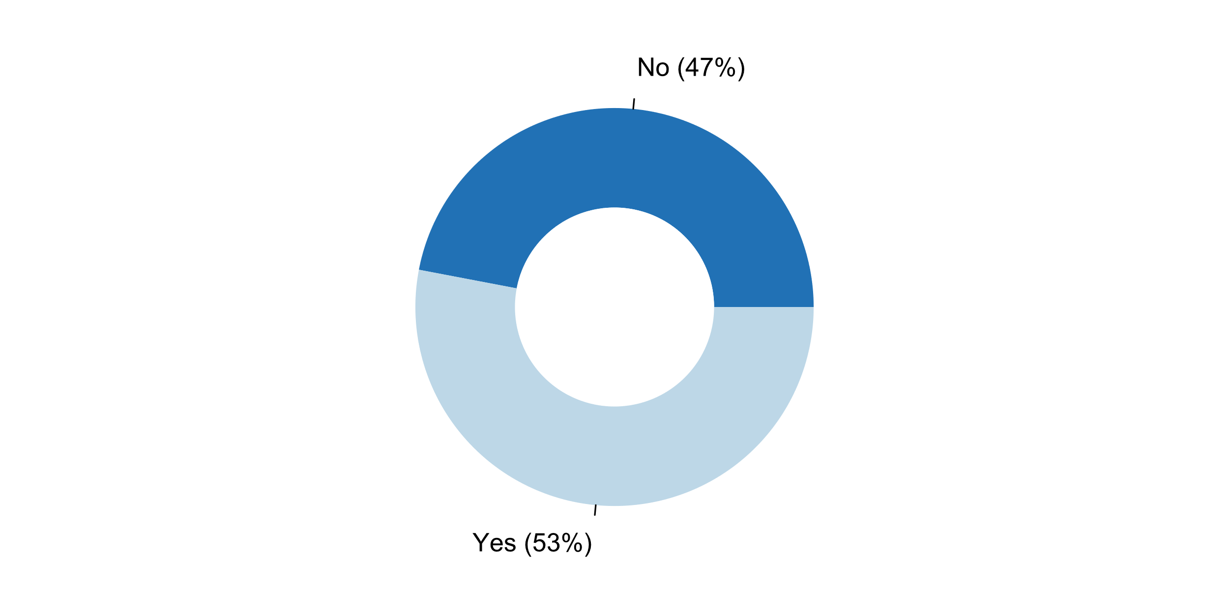

|  |  |  |  |  |  |  |
| --- | --- | --- | --- | --- | --- | --- |
| **Answer** | **Africa** | **Americas** | **Asia** | **Europe** | **Oceania** | **TOTAL** |
| N/A | 1 | 5 | 7 | 19 | 1 | **33** |
| No | 7 | 6 | 5 | 7 | 3 | **28** |
| Yes | 9 | 2 | 12 | 9 |  | **32** |

|  |  |  |  |  |  |  |
| --- | --- | --- | --- | --- | --- | --- |
| **Answer** | **Africa** | **Americas** | **Asia** | **Europe** | **Oceania** | **TOTAL** |
| N/A | 6 | 38 | 29 | 54 | 25 | **35** |
| No | 41 | 46 | 21 | 20 | 75 | **30** |
| Yes | 53 | 15 | 50 | 26 |  | **34** |

***Details on donor coordination mechanism or basket fund for statistics***

* A donor coordination mechanism is regulated through the Steering Committee
* AfDB, AU, PAS support some of our activities
* At the Ministry of Finance
* By funding surveys that provide data on sustainable development indicators or economic, social and environmental indicators
* Coordination is done by Eurostat according to our needs and various donors.
* EU: Twinning, TAIEX, etc.
* EXISTENCE OF A STATISTICAL CAPACITY BUILDING PROJET
* European structural funds and grants awarded by the European Commission.
* Germany receives support from the EU - for the "Feasibility Study for Setting up a Large Cases Unit (LCU) within the Statistical System of Germany" (EU Structural Reform Support Programme) - for the implementation of new methods of production of European statistics (EU Grants to provide financial support in different statistical Areas)
* Individual donors fund specific programs, no basket funding exists.
* MEETING
* MICS survey supported by UNICEF and SEEA: OCEAN Account supported by ESCAP
* Mediante suscripcià³n de acuerdos y convenios.
* NSO has received support from donors. One of coordination mechanism in place is "Trust Fund" that is a financial platform reached through agreement or memorandum of understanding between NSO and donors/partners.
* PCBS is using a basket fund which we call the (Core funding Group) (CFG). This group was first started in 2003 and included many mind-like donors who believed in the importance of supporting our core activities to maintain sustainability. The CFG concept has proved to be a successful model in terms of reporting, efficiency and Program monitoring and evaluation.
* Statistical Centre of Iran receives some financial support from UN agencies in Iran.
* Statistics Sector Coordination Group was formed and periodically meeting is being organized.
* Task Force within the UN system, including Armstat that coordinates capacity building activities on SDGs.
* Technical assistance for the development of SEEA and SUT
* The Ministry of Economic Planning and National Planning Commission always has a national Donors Forum on an annual basis.
* The coordination mechanism for receipt and use of international technical assistance is regulated by the Presidential Decree On international technical assistance provided to the Republic of Belarus No. 460 of 22 October 2003.
* The country has a mechanism established by the international cooperation departments of the Ministry of National Planning and Economic Policy (Mideplà¡n) and the Ministry of Foreign Affairs.
* There is donor questionnaire from Eurostat.
* Through data for development group meetings
* Turkey's EU candidacy in 1999 was a breakpoint in TurkStat for capacity building efforts. Turkstat has benefited from EU Programmes (national and multi-beneficiary) a lot. Upgrading the Statistical System of Turkey (USST) Programmes Phases I-II-III (2003-2014) and IPA projects have contributed to TurkStat and its staff.
* Under governments structure, a specific unit is in charge to coordinate the donor's contribution in national level. Within INSTAT's structural organization, a specific unit implement the coordination of projects covered by donors for statistical activities under INSTAT's responsibility.
* WB, UN, GIZ, ADB...
* through MOU with Donors

***Main reasons/challenges for lack of donor coordination mechanism or basket fund for statistics***

* 1. Our NSO has to compete with all other line ministries in getting funds to support our annual activities. This means every year we make funding proposals to government through the Cabinet Development Committee to endorse our proposal and it is the role of the Ministry of Finance to seek funds for our statistical activities if approved. It is the same for all other line ministries.2. We also have bilateral relationships with other donors that we can seek funding or technical opportunities if approved funding is not sufficient.
* A ce jour, ce mécanisme n'existe pas. Chaque partenaire technique financier est intéressé par un domaine spécifique. Dans certains cas, certains partenaires unissent leurs forces pour mettre leurs actions en synergie.
* ALL Donor funding is coordinated by the Ministry of Finance and Economic Development including other activities other than statistics. As for Statistics development we don’t have a coordinated framework, however in implementing the Botswana NSDS , through that process we are able to see which sector is receiving funding for statistics. It is work in progress.
* According to current Statistical Act CBS can't receive any support from donors (only from EC in Grants, etc.) as we can only use national budget resources devoted for statistical production.
* Cayman Islands as an Associate Member of CARICOM (being an Overseas British Territory) is not qualified to receive financial assistance from DFID and other organizations providing support to CARICOM Members.
* Chaque bailleur finance les projets statistiques qui l'intéresse. Il existe cependant un Comité de coordination des bailleurs de la statistique.
* Currently, all the activities of the office are fully funded by the Government. But we do receive technical assistance in the form of capacity development mainly.
* Eligibility criteria
* INEGI has its own budget carry out its statistical and geographical program.
* It is forbidden by Statistical and General Public Laws.
* It was not set up yet
* NSO has direct contacts with international donors.
* No comments
* No donors
* No regular or mechanism in place but it is a need-based request.
* No statistical law
* Not needed so far.
* The NSO budget is mainly done by Government, sometimes NSO mobilize resources from partners such as World Bank.
* The lack of formal NSS
* We are not part of the target group, we are a member of the European Union.
* une étude relative á  la mise en place d'un mécanisme institutionnel et organisationnel du fond de développement de la statistique a été réalisée ne 2017. cependant ce fond n'est pas encore en place.
* we have received technical and financial assistance from the WB Trust Fund for Statistical Capacity Building, the Asian Development Bank and the EU-ASEAN COMPASS Project

**Plot_68_Q10.4.svg**

**The NSO participates in or contributes to organizations or partnerships whose purpose is to promote open data**

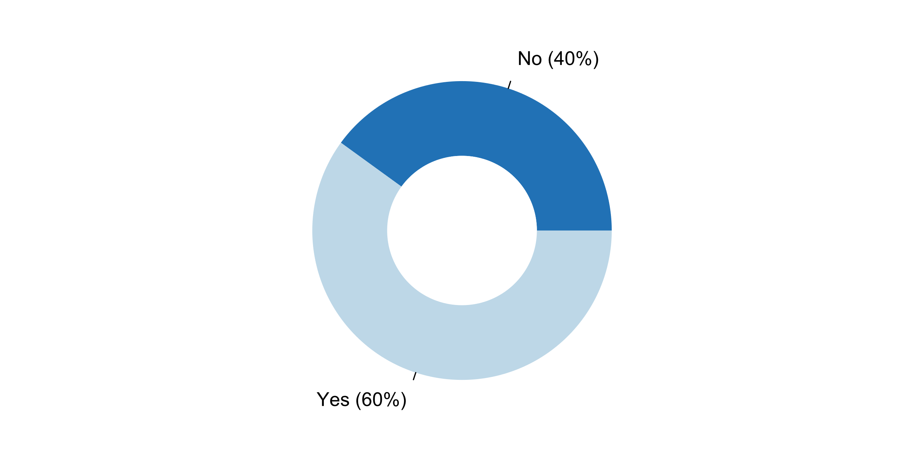

|  |  |  |  |  |  |  |
| --- | --- | --- | --- | --- | --- | --- |
| **Answer** | **Africa** | **Americas** | **Asia** | **Europe** | **Oceania** | **TOTAL** |
| No | 6 | 4 | 12 | 14 | 1 | **37** |
| Yes | 11 | 9 | 12 | 21 | 3 | **56** |

|  |  |  |  |  |  |  |
| --- | --- | --- | --- | --- | --- | --- |
| **Answer** | **Africa** | **Americas** | **Asia** | **Europe** | **Oceania** | **TOTAL** |
| No | 35 | 31 | 50 | 40 | 25 | **40** |
| Yes | 65 | 69 | 50 | 60 | 75 | **60** |

***Organizations or partnerships whose purpose is to promote open data in which the NSO participates or contributes***

* ASEAN Community Statistical System (ACSS) Commitment
* According to the Strategy of Electronic Administration Development, one of the strategic goals of the Government of the Republic of Serbia for the period from 2015 to 2018 is the opening of data of public institutions for their re-use. For the implementation of this important strategic goal, the Government of the Republic of Serbia formed the Open Data Working Group (for planning and coordination of activities related to the opening of data of public institutions). Statistical Office of the Republic of Serbia is one of the active members. In order to improve the quality and availability of statistical data, the SORS is very dedicated to the development and improvement of dissemination, which includes the development of a statistical OpenData portal as an integral part of the national OpenData infrastructure of the Republic of Serbia.
* Autoroute de l'information africaine (AIA)
* CCS
* Conutry Stat
* Cooperation with ICT Ministry in implementing egovernance based Open Access to Data Act.
* CountryStat with FAO
* Digital Government Development Agency (Public Organization) (DGA)
* ESSnet "Linked Open Statistics"-consortium of 4 NSIs-Bulgaria, France, Ireland, Italy; BNSI-Consortium coordinator
* ESSnet linked open statistics in Eurostat
* EU and the national registry in Iceland
* Eurostat ESSNET on Linked open statistics
* GSA (https://www.DATA.gov)
* Global Partnership on Open Data for Development
* Government of Canada Open Data
* MAMPU
* ODIN
* OGP
* On the national level we cooperate especially with the Ministry of the Interior and some of the universities (Charles University, University of Economics Prague). We collaborate also with state administration offices and foundations supporting data opening (e.g. Otakar Motejl Foundation). On the international level we share experience with other NSOs (particularly Statistical Office of the Slovak Republic).
* Open Data
* Open Data For Africa; Open Data Watch; OPAL;
* Open Data Initiative
* Open Data Inventory (ODIN)
* Open Data NZ
* Open Data Watch
* Open Data Watch (ODW), The Open Data Committee which formed by the Palestinian Cabinet.
* Open data watch
* Participating in the National Open Government Commission; in the GPSDD and in the Center for International Strategic Thinking (CEPEI).
* Public Data Commission and Regional Statistical Development Work (as mentioned above in International Engagement)
* RAIC
* SingStat Website's Terms of Use (http://www.singstat.gov.sg/terms-of-use) are in line with open data licence and practices.
* Statistical classification
* Statistics Mauritius participates/contributes to the National Open Data Portal, an initiative of the Ministry of Technology, Communication and Innovation and the National Computer Board.
* Supports http://hack4.no/#
* Swiss Open Data Government program
* The EU project DIGICOM
* The e-GDDS
* There is an Open Data Portal Slovenia (OPSI) available via https://podatki.gov.si/. At the moment, most of the data are published by SURS, partly also by other members of NSS. The goal is to publish all statistics from all NSS members and also from other state bodies in Slovenia on this portal in the future.
* Tsinghua China Data Center
* UK Open Data Institute (ODI) https://theodi.org
* UN - Friends of the Chair - Fundamental Principles of Official Statistics (FoC-FPOS) & Eurostat â€“ DIGICOM Project in the scope of Linked Open Data
* We are part of UN WG on big data
* World Data Forum / IODC
* all who request us to Support
* data.gov.ro
* http://date.gov.md/ckan/en/organization?page=2
* http://www.opendata.lu/
* partnership with the ICT department
* takes part in the Open Data Inventory (ODIN); is a member of the commission on acceptance of work on creation of the national open data portal.

**Plot_69_Q11.5_rev.svg**

**How long did it take to fill out this questionnaire (in hours)?**

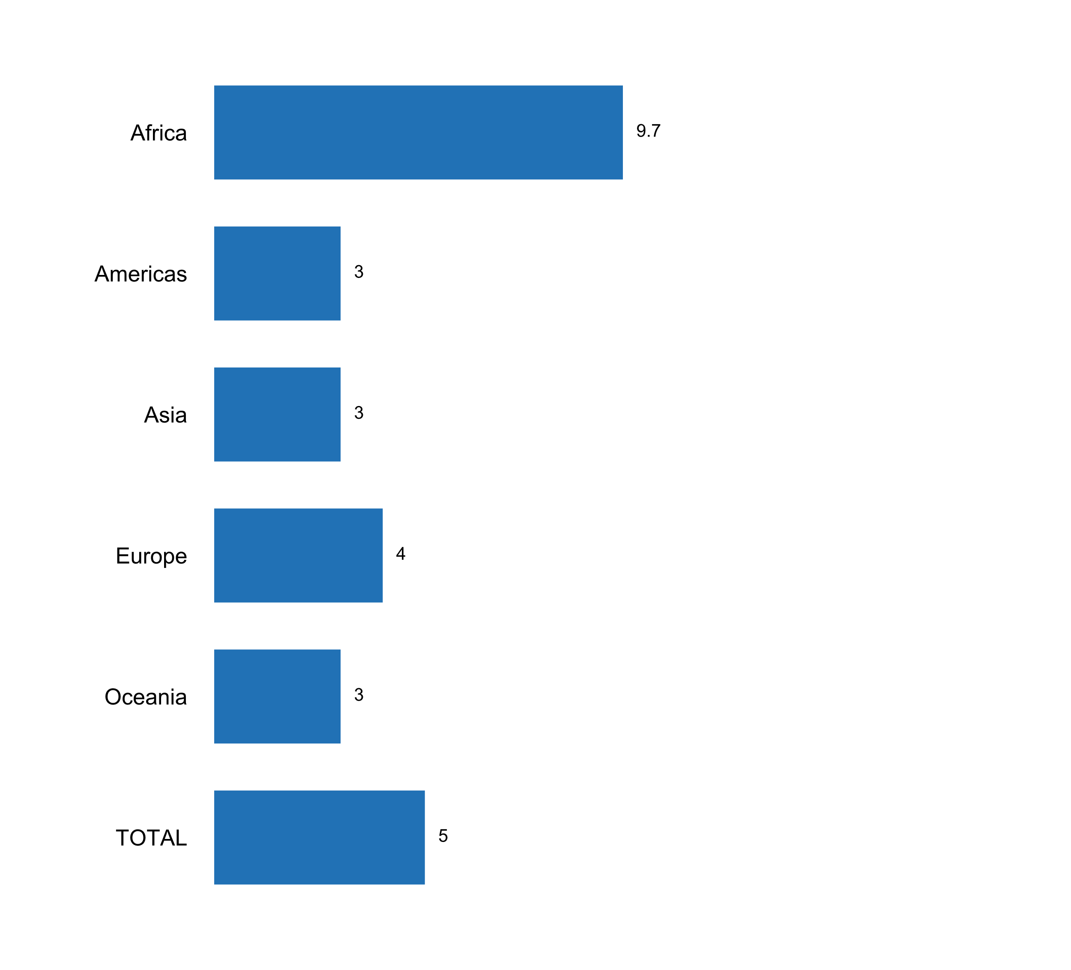

|  |  |  |  |  |  |  |
| --- | --- | --- | --- | --- | --- | --- |
| **Answer** | **Africa** | **Americas** | **Asia** | **Europe** | **Oceania** | **TOTAL** |
|  | 9.7 | 2.9 | 3.0 | 4.4 | 3.3 | 4.7 |